# CPU_Scheduling_Algorithms

Run the project with 'flutter run --no-sound-null-safety' in terminal.

Project is not completed Yet :)

SS of project:

Splash Screen:

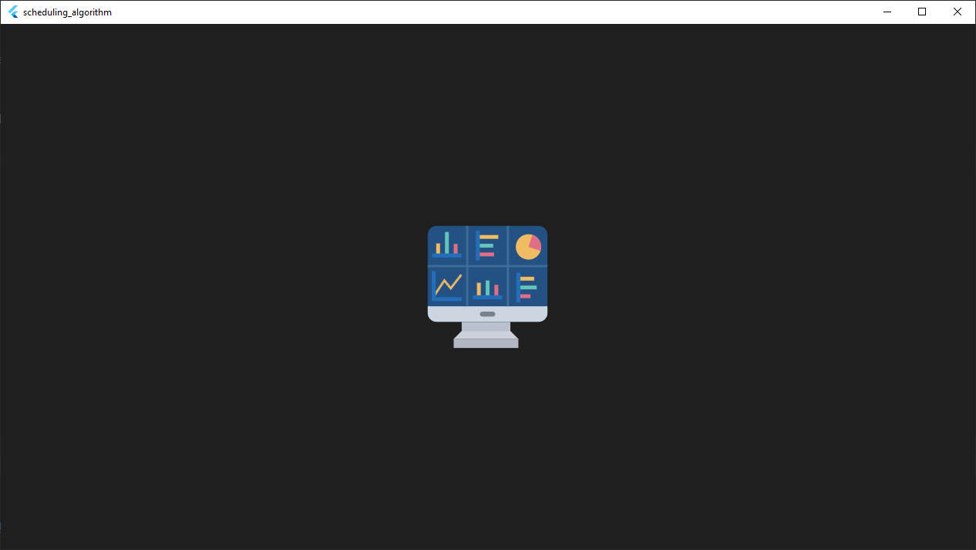

HomePage

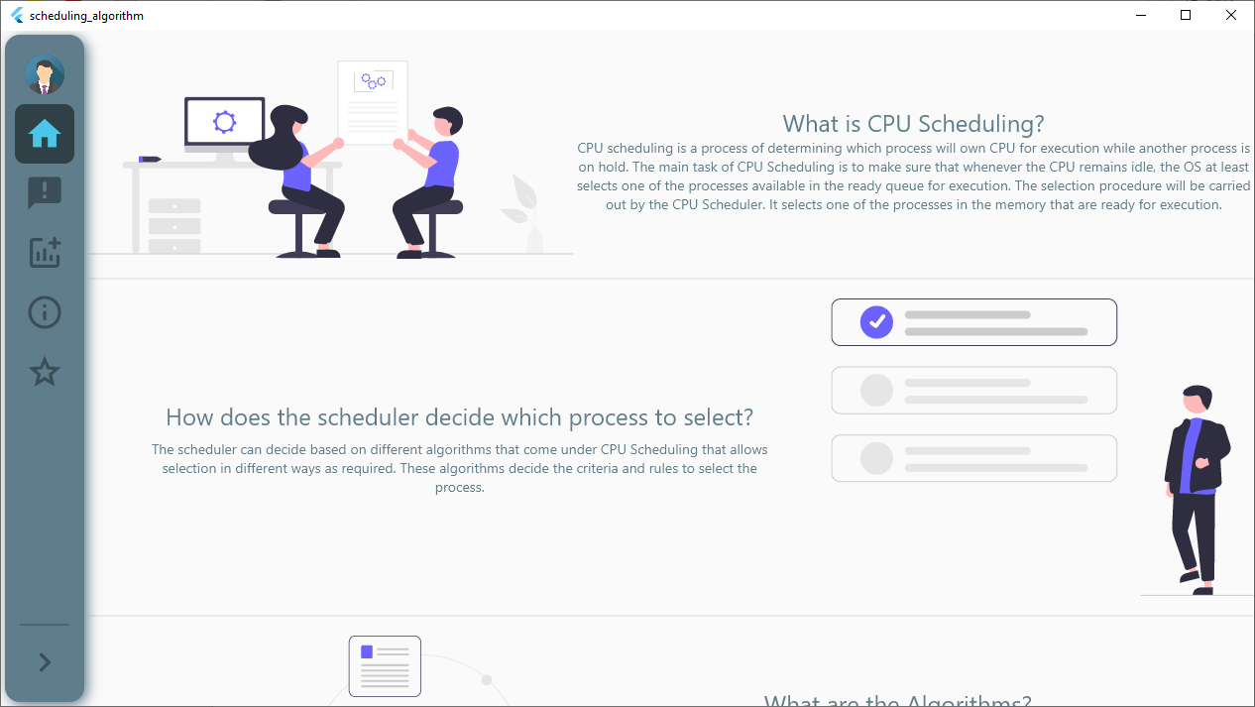

SideNavigation:

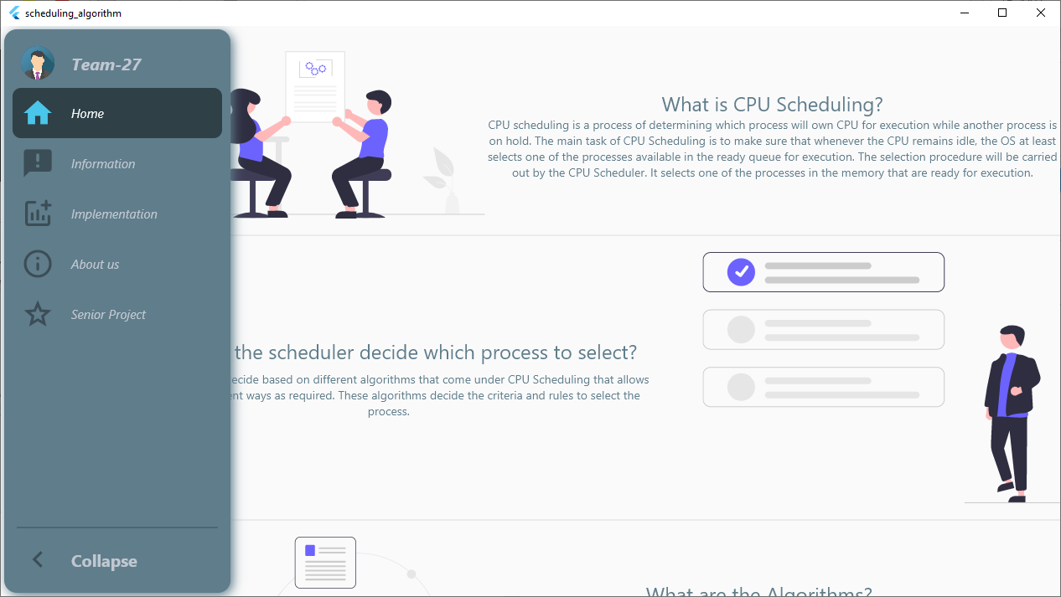

InformationPage

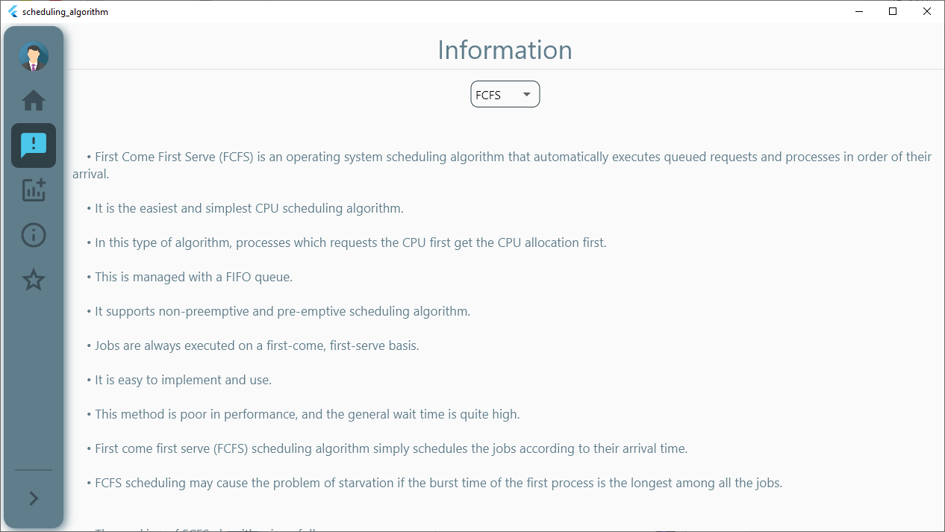

ImplementationPage:

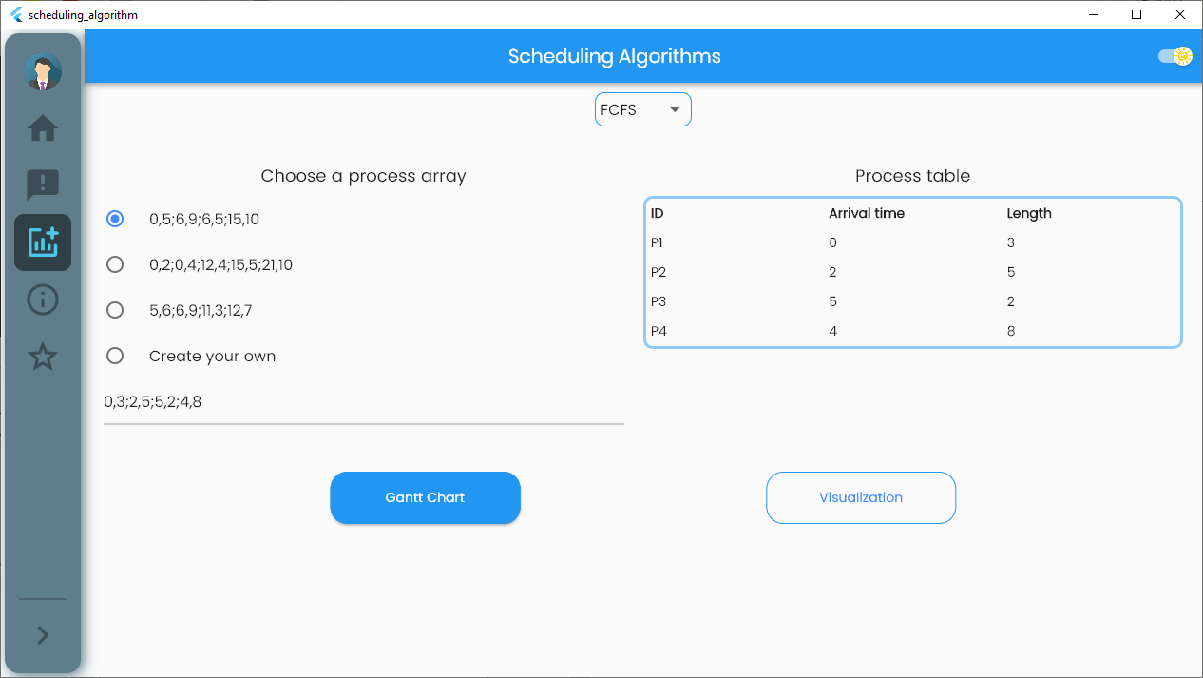

DarkTheme:

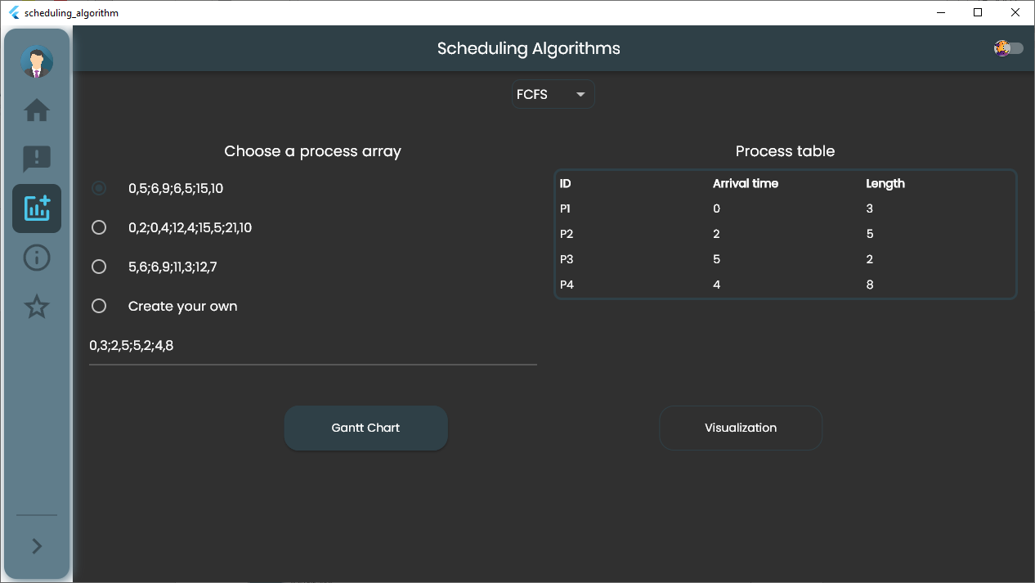

GanttChart:

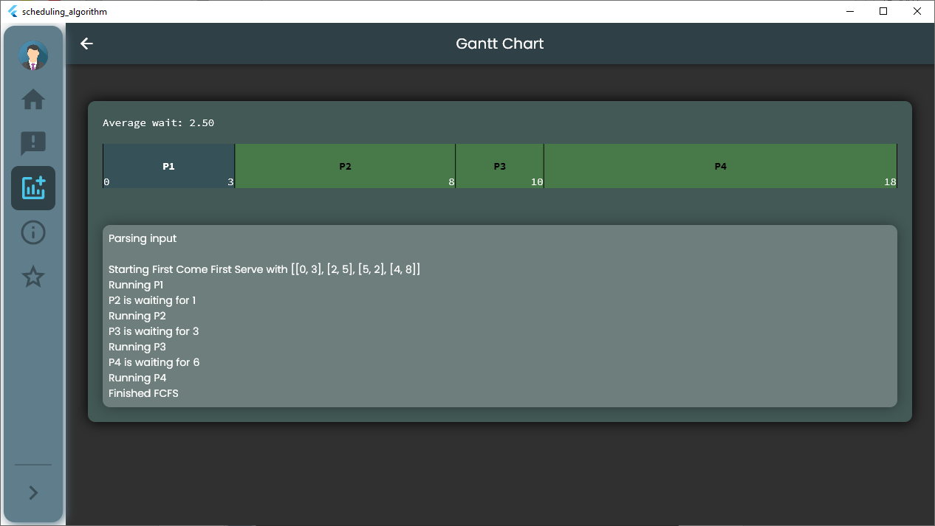

VisulizationPage:

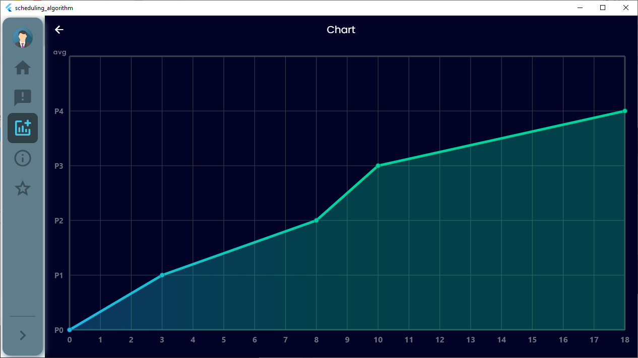

Visulization-Avg:

