

**Wireless Status Display on the Classroom.**

|  |  |
| --- | --- |
| **Version**  **Status**  **Date** | 0.2  Draft  20-Feb-2015 |

|  |  |
| --- | --- |
|  |  |

**Confidentiality Notice**

Copyright (c) 2015 eInfochips. - All rights reserved

This document is authored by eInfochips and is eInfochips intellectual property, including the copyrights in all countries in the world. This document is provided under a license to use only with all other rights, including ownership rights, being retained by eInfochips. This file may not be distributed, copied, or reproduced in any manner, electronic or otherwise, without the express written consent of eInfochips.

Contents

1 Document Details 3

1.1 Revision & Approval History 3

1.2 Definition, Acronyms and Abbreviations 3

1.3 References 4

2 introduction 5

2.1 Purpose of the Document 5

2.2 Intended Audience 5

3 system overview 5

3.1 Overview 5

3.2 Scope………………………………………………………………………………………………………10

4 functional RequiREment………………………………………………………..11

5 External Interface ……………………………………………………………….13

5.1 User Interface 13

5.2 Hardware Interface 13

5.3 Software Interface 13

6 Acceptance Criteria 14

6.1 Overall Acceptance Criteria 14

6.2 Acceptance Test Scenarios 14

7 Special user requirements 15

7.1 Performance Requirements 15

7.2 Portability..........................................................................................................................15

7.3 Usability............................................................................................................................15

7.4 Maintainability..................................................................................................................15

7.5 Installation.........................................................................................................................15

7.6 User training......................................................................................................................15

8 ASsumptions 17

# 1 Document Details

## Revision & Approval History

|  |  |  |  |  |  |  |
| --- | --- | --- | --- | --- | --- | --- |
| **Version** | **Author** | | **Reviewer** | | **Approver** | |
| **Name** | **Date**  **(DD-MM-YYYY)** | **Name** | **Date**  **(DD-MMM-YYYY)** | **Name** | **Date**  **(DD-MM-YYYY)1.0** |
| Draft 0.1 | Jagir Mehta | 06-Feb-15 | Miss Prerna Paliwal |  | *-* | *-* |
| Draft 0.2 | Jagir Mehta | 20-Feb-15 | Miss Prerna Paliwal |  |  |  |
|  |  |  |  |  |  |  |
|  |  |  |  |  |  |  |
|  |  |  |  |  |  |  |
|  |  |  |  |  |  |  |

| **Version** | **Description of Change** |
| --- | --- |
| Draft 0.1 | Texts Alignment & Formatting |
| Draft 0.2 | Change in requirement |
|  |  |

## Definition, Acronyms and Abbreviations

| Definition/Acronym/Abbreviation | Description |
| --- | --- |
| LCD Display | Liquid Crystal Display used to display messages. |
|  |  |

## References

| No. | Document | Version | Remarks |
| --- | --- | --- | --- |
|  |  |  |  |
|  |  |  |  |
|  |  |  |  |

# Introduction

## Purpose of the Document

The purpose of this document is to describe the project Wireless status display out-side the class room. This document will give detailed information about the functionalities, features and use of the system. Thus this document will make it easy for developer, tester and the end user to understand the system.

## Intended Audience

This SRS document is intended for:-

1. **Developers:** To keep in check that what they are developing is according to the requirements specified in this document.
2. **Testers:** This document will help the testers as it will provide all the functionalities.
3. **Users:** This document will help the user to understand the system so that they can use it properly without any problem.

# 

# system overview

**3.1 Overview**

The overview generally consists of the purpose, objective and benefits of the Wireless status display outside the class room.

To display status of the class room outside it, we will create a stand-by Application that will keep Database of schedule of everyday. This Application will send this data via Zig-bee to the LCD Display which is wired connected to the Development Board.

This system is Beneficial as it manages available projectors, sound system & free class rooms in an efficient way.

This project uses an Arduino Development Board which receives message coming from server via Zig-bee & passes it serially to LCD display Board. And it changes message after some time to follow schedule of whole day.

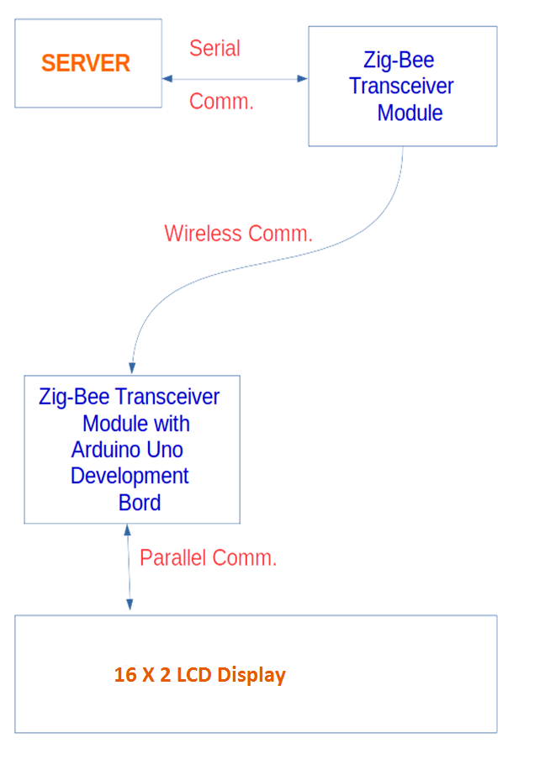

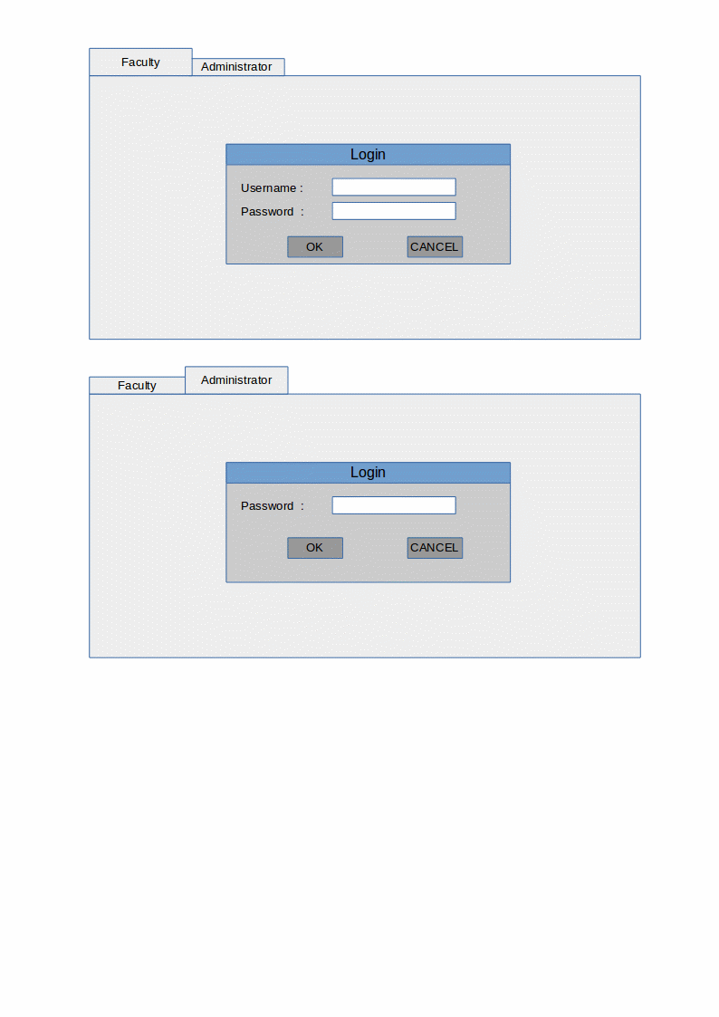

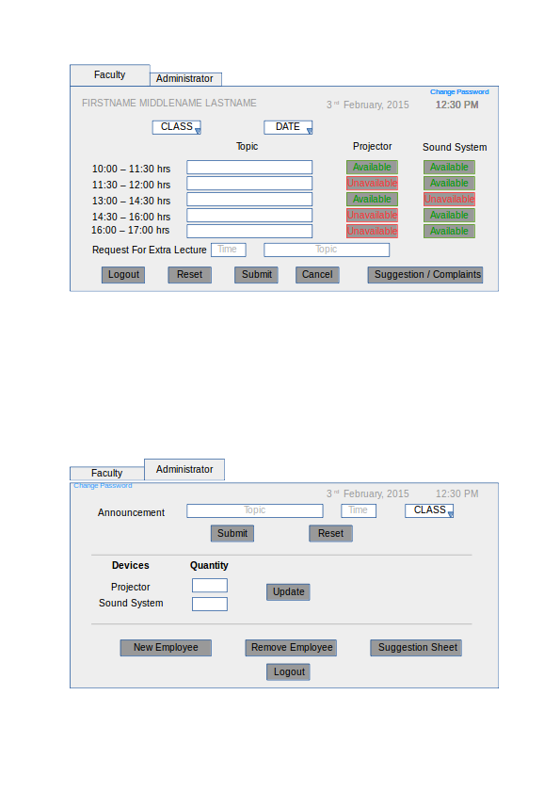

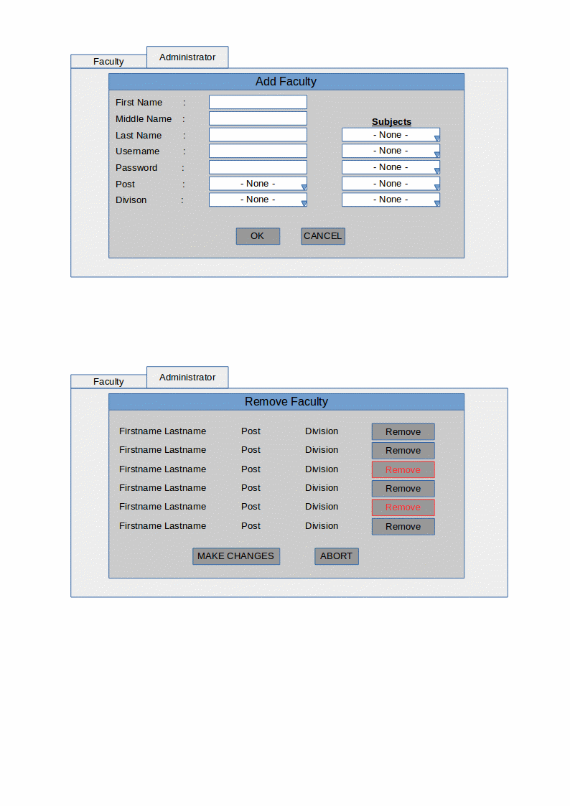

## 3.2 Scope

This System will be used in various Institutes. In future we will add few more functionality in this project. Likewise Automatic update in schedule, we will put more no of Displays and connect it to a single server & manage the schedule of all displays with a single server.

The cost of implementation includes a onetime cost of Arduino board, Zig-Bee Module and a LCD Display Board.

This system also useful in hospitals to display for occupied devices, to show operation is on- going, to display which doctor is in the operation theater etc.

In future this system can be expand as touch screen display and also two-way display to Display about announcement in-side the class.

# functional Requirement

## 4.1 LCD Display

|  |  |
| --- | --- |
| Term | Description |
| REQ ID | RQ01 |
| Purpose | To Display data coming from Arduino board. |
| Input(s) | Data from Arduino Board. |
| Output(s) | Output will be name of lecturer and subject of lecture continue inside the classroom. Along with Date & Time. |
| Process | As per correct time server sends data to micro-controller, it should be able to display the message without any mistake on the board. The micro-controller checks it & passes it to LCD display for displaying the messages. |
| Preloaded Values | Preloaded value for the system will be current date & time. |

**4.2 Zig-Bee Module**

|  |  |
| --- | --- |
| Term | Description |
| REQ ID | RQ02 |
| Purpose | To Build a communication channel between server and Arduino board to send/receive data. |
| Input(s) | Formatted message string from server application. |
| Output(s) | Serially transmits data coming from server with particular baud rate. |
| Process | As per data coming from server it encode it & send it serially to another module. |

**4.3 Arduino Uno Development Board**

|  |  |
| --- | --- |
| Term | Description |
| REQ ID | RQ03 |
| Purpose | To Display data on lcd in proper manner as coming in serial and output is parallel. |
| Input(s) | Data string from Zig-Bee module. |
| Output(s) | Encoded Data as coming from Zig-Bee on serial port and send it on display parallel. |
| Process | As serial data coming from server it decodes data & send it parallel to the LCD Display. |

**4.4 GUI Application**

**4.4.1 Faculty End**

|  |  |
| --- | --- |
| Term | Description |
| REQ ID | RQ04.1 |
| Purpose | Front end for Faculty member. |
| Access Restrictions | Only valid users can access their account. |
| Process | - User have to enter valid User name & password  - User is required to enter the schedule of the current day as well as he can update the same for the whole ongoing week.  - User also has facility to provide suggestions and also request the administrator for extra-lectures. |
| Mandatory Fields | User name and Password |

**4.4.2 Administrator End**

|  |  |
| --- | --- |
| Term | Description |
| REQ ID | RQ04.2 |
| Purpose | Front end for Administrator of the institute.. |
| Access Restrictions | Only administrator can access his/her account. |
| Process | - Administrator has to enter valid password.  - Here he/she can manage the accounts of existing as well as new faculties.  - He can also manage the announcements and the allocation of resources. |
| Mandatory Fields | Password |

# External Interface

## User Interface

The user interface will be a stand-by application where the user will be handling the inputs to the Wireless Display. It is here where the allocation of available resources as well as scheduling of display text will happen.

## Hardware Interface

The system has an LCD Display connected to the micro controller which reads and then displays the data transmitted by the Server. The Server has a Zig-Bee module attached with it to communicate with the wireless displays.

The Wireless status display system would be an LCD Display which would show messages to indicate the status e.g. lecture going in the class, availability of the class for another lecture, Date, Time, Announcements etc.

## Software Interface

The Software used will be a C# programmed Windows application capable of running on Windows vista and later.

6 Acceptance Criteria

**6.1 Overall Acceptance Criteria**

The project must perform according to the specifications and must fulfill all the requirements mentioned in the requirements section.

**6.2 Acceptance Test Scenarios**

To be added later.

# 7 Special user requirements

## 7.1 Performance Requirements

The Wireless status display system should be capable of displaying the schedule perfectly in-time without fail. The Display enough bright that could be visible to standard distance.

The records must be stored in the memory properly and accurately so that it can be accessed anytime.

The system should be able to handle all classrooms and must not malfunction if number of classrooms increases.

**7.1.1 Zig-Bee Module**

|  |  |
| --- | --- |
| Parameter | Performance Requirement |
| Portability | The Module should be portable and can be installed anywhere by making minor changes in the program. |
| Usability | The Device should be easy to use as it connects to another device that should be simple task. |
| Reliability | The device should be reliable. |
| Maintainability | This device must be easily extend able to add new features as and when required by making minor changes. |
| Installation | The installation of this device should easy as it requires a simple 5 volt DC and can be fitted outside the class as it is compact. |
| Standards | The project Wireless status display System will follow coding standards as defined by eiTRA / eInfochips.  Development language – Arduino C |

**7.1.2 Arduino Development Board**

|  |  |
| --- | --- |
| Parameter | Performance Requirement |
| Portability | The Board should be portable and can be installed anywhere by making minor changes in the program. |
| Usability | The Board should be easy to use as one only need to know about libraries & functions of the IDE. |
| Reliability | The device should be reliable. |
| Maintainability | This Board must be easily extend able to add new features as and when required by making minor changes. |
| Installation | The installation of this Board should easy as it requires a simple 5 volt DC and can be fitted outside the class as it is compact. |
| Standards | The project Wireless status display System will follow coding standards as defined by eiTRA / eInfochips.  Development language – Arduino C |

7.1.4 GUI Application

|  |  |
| --- | --- |
| Parameter | Performance Requirement |
| Security | The Application should be secure for every user. |
| Usability | The application should be easy to use and all the back end working complications should be hidden from the user. |
| Reliability | The application should be reliable. |
| Backup and Recovery | This application must not lose any data stored by the user especially the data of the working staff. |
| Installation | The installation of this software requires Windows platform (Windows 7 or higher). |
| Standards | The project Wireless status display System will follow coding standards as defined by eiTRA / eInfochips.  Development language – C# |

**8 Assumptions**

This section states the assumptions which are required for the project to run successfully.

1. The System must have access to Power Supply.
2. It should have access to server via Zig-Bee all the time.
3. The Arduino should have enough memory to store the records/schedule of whole day.
4. The Distance between Both devices are enough to cover.