1. **INTRODUCTION**

## PROJECT SUMMARY

The Wireless Status Display System uses the Zig-Bee technology. The Two Zig-Bee modules one of which is attached to the Arduino Board and other to a remote server which is programmed to send the data wirelessly. The Wireless connection is made using the two XBee S2 modules ([IEEE 802.15.4 standard](http://en.wikipedia.org/wiki/IEEE_802.15.4)) which is attached to the Arduino and Server (having C# application). The C# application is connected to a SQLite database which stores the employee information and the lecture records. Upon receiving data from C# application Arduino will display an entry to the LCD. Now this record will be updated to add the lecture time of the lecturer whenever he/she has lecture at any classroom. Also System is capable of displaying Announcements and to store schedule of a week in early. The System stores records of resources like speaker, mic, projector, etc.

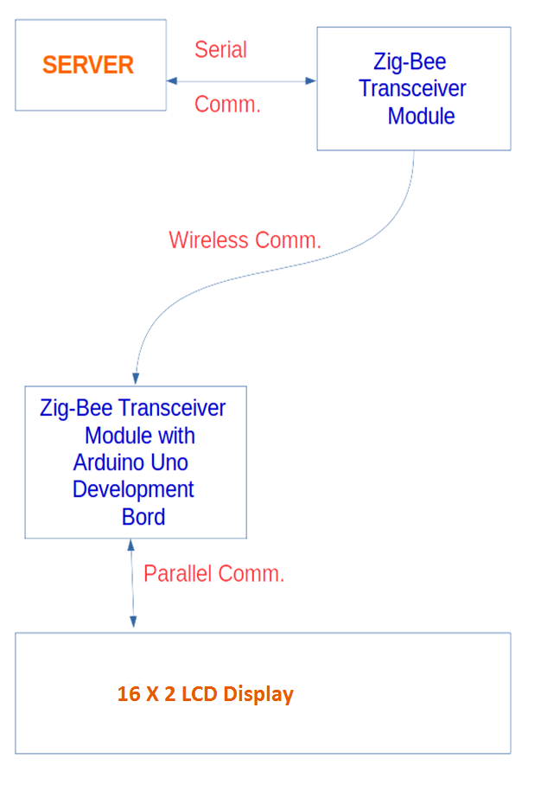Fig 1.1 Block Diagram of the System

* 1. **PURPOSE**

The purpose of this project is to eliminate the traditional way of displaying schedule of the classroom. This system is very much useful at institutes & organizations to know about classroom status without disturbing the class. Also it is helpful in managing the available resources (Speaker, Mic, Projector etc.).

* 1. **OBJECTIVE**

The objective of Wireless Status Display system is to automate the process of displaying schedule of lectures by using ZigBee technology. The system must be capable of storing the lecture records in a database and provide functionalities for searching and report generation to the administrator.

* 1. **SCOPE**

This System will be used in various Institutes. In future we will add few more functionalities in this project. Likewise updating of Schedule online will be possible and in addition we will put more no of Displays and connect it to a single server & manage the schedule of all displays with a single server. The cost of implementation includes a onetime cost of Arduino board, Zig-Bee Module and a LCD Display Board.

**1.5 TOOLS AND TECHNOLOGY**

* Arduino Board
* Zig-Bee Module
* LCD Display
* Arduino IDE v1.0.6.
* Visual Studio 2013.
* Proteus 8 Professional.