## 2. PROJECT MANAGEMENT

**2.1 PROJECT PLANNING**

**2.1.1 Project Development Approach and justification**

This project is developed using iterative water fall model. We used this model because it supports backtracking. If there are some changes in previous phase then we can backtrack and add the new functionality. So this model saved the development time.

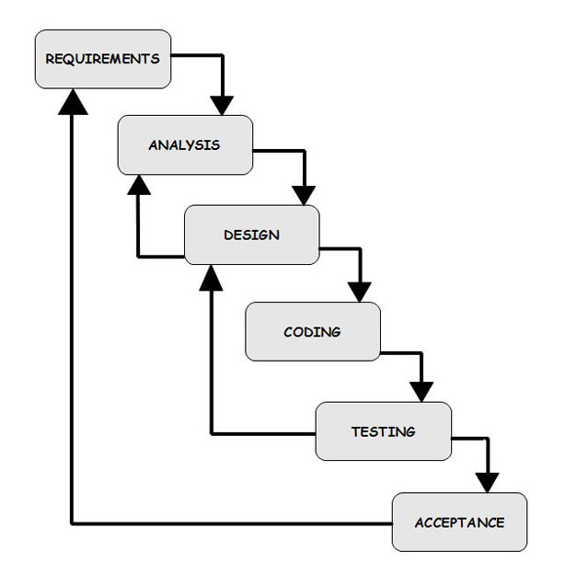

Fig 2.1 Iterative Waterfall Model

**2.1.2 Project Effort and Time, Cost Estimation**

The Constructive Cost Model (COCOMO) is an algorithmic [software cost estimation model](http://en.wikipedia.org/wiki/Estimation_in_software_engineering) developed by [Barry W. Boehm](http://en.wikipedia.org/wiki/Barry_Boehm). The model uses a basic [regression](http://en.wikipedia.org/wiki/Regression_analysis) formula with parameters that are derived from historical project data and current as well as future project characteristics.

Basic COCOMO computes software development effort (and cost) as a function of program size. Program size is expressed in estimated thousands of source lines of code ([SLOC](http://en.wikipedia.org/wiki/Source_lines_of_code))

COCOMO applies to three classes of software projects:

* Organic projects - "small" teams with "good" experience working with "less than rigid" requirements
* Semi-detached projects - "medium" teams with mixed experience working with a mix of rigid and less than rigid requirements
* Embedded projects - developed within a set of "tight" constraints. It is also combination of organic and semi-detached projects.(hardware, software, operational, ...)

**Effort resource, cost, project duration estimation**

The basic COCOMO equations take the form

**Effort Applied (E)** = ab (KLOC)bb **[**[person-months](http://en.wikipedia.org/w/index.php?title=Person-month&action=edit&redlink=1)**]**

**Development Time (D)** = cb (Effort Applied)db **[months]**

Where, KLOC is the estimated number of delivered lines (expressed in thousands) of code for project. The coefficients *ab*, *bb*, *cb* and *db* are given in the following table:

|  |  |  |  |  |
| --- | --- | --- | --- | --- |
| **Software project** | ***ab*** | ***bb*** | ***cb*** | ***db*** |
| Organic | 2.4 | 1.05 | 2.5 | 0.38 |
| Semi-detached | 3.0 | 1.12 | 2.5 | 0.35 |
| Embedded | 3.6 | 1.20 | 2.5 | 0.32 |

Table 2.1 Cost Estimation Model

**Estimation method used: embedded**

**Effort Applied (E)** = 3.60* (KLOC)1.20 **[** [person-months](http://en.wikipedia.org/w/index.php?title=Person-month&action=edit&redlink=1) **]**

**=** 3.60(3)1.20

**=** 13.45 Person-Month

**2.1.3 Roles and Responsibilities**

This project will be developed by two Engineers. Each of them will have different roles and responsibilities towards the project. Each individual has specific task to be completed within a particular time frame. One of them will be responsible for developing the c# application and another will be programming the Arduino board to receive data from sent via Zigbee.

**2.2 PROJECT SCHEDULING**

**Gantt Chart**

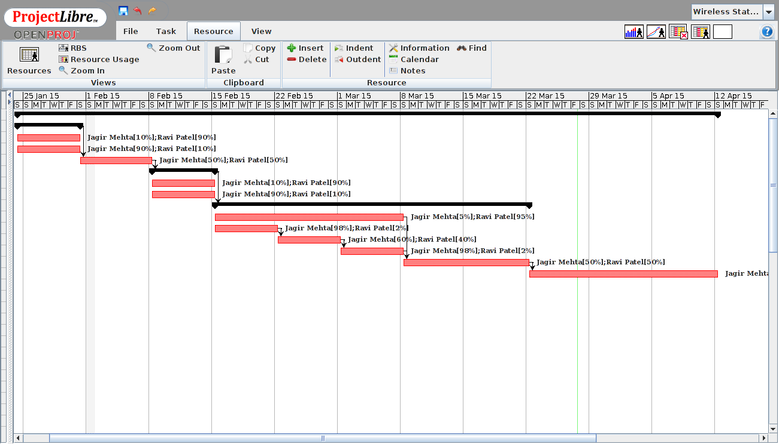

Fig 2.2 Gantt Chart

**Work Breakdown Structure**

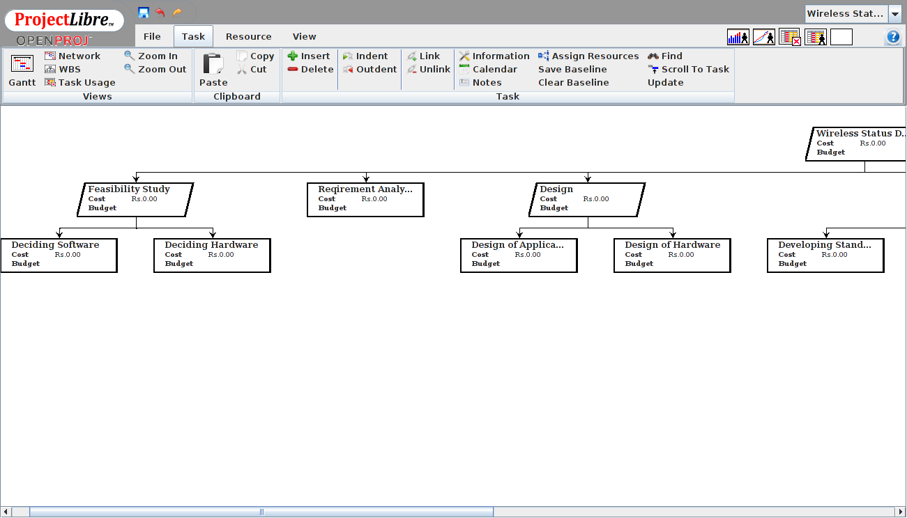

Fig 2.3 Work Breakdown Structure (1)

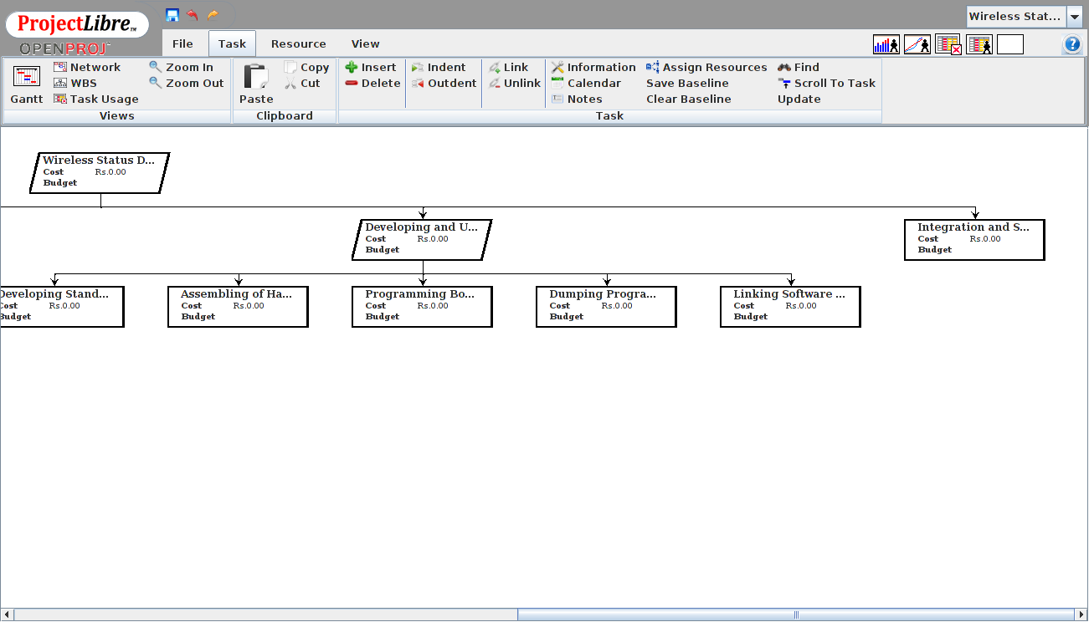

Fig 2.4 Work Breakdown Structure (2)

**Network Chart**

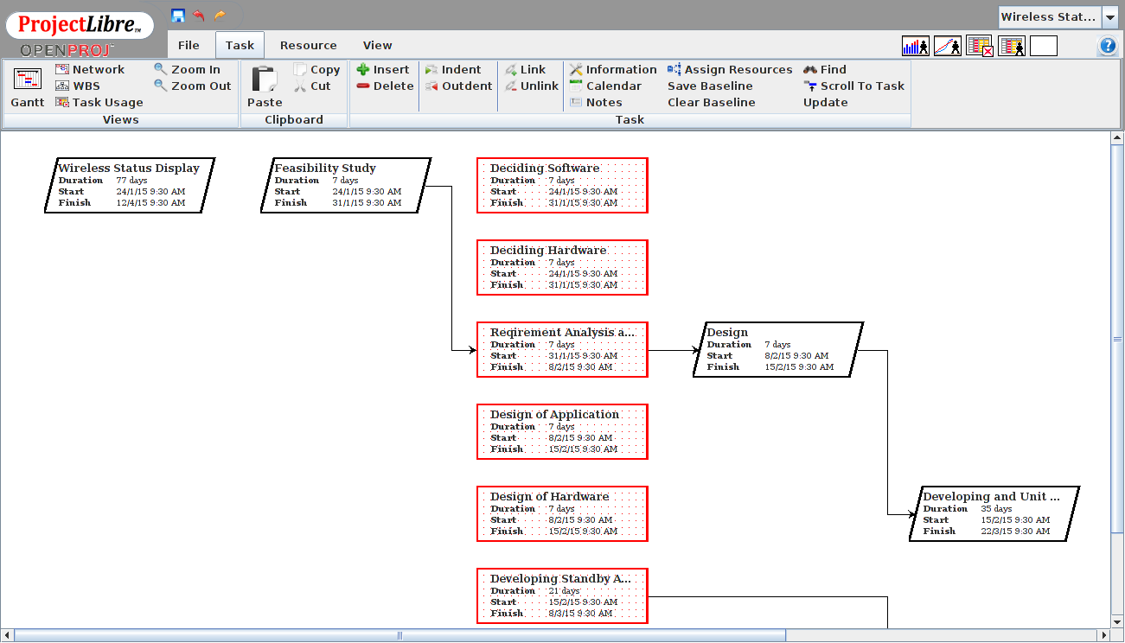

Fig 2.5 Network Chart (1)

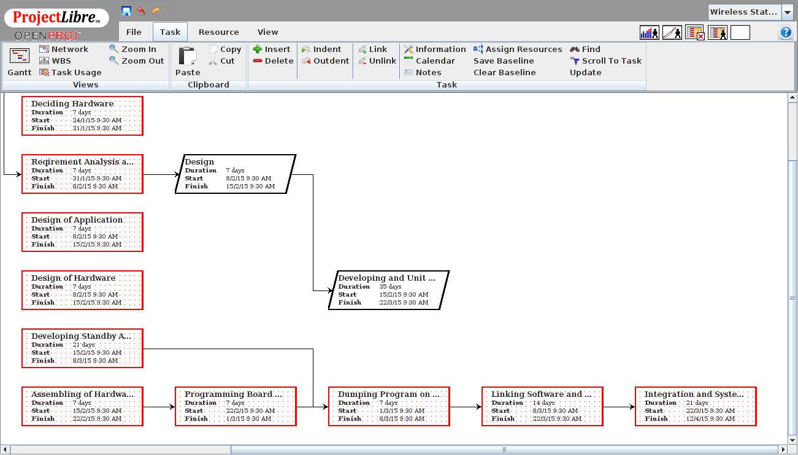

Fig 2.2.5 Network Chart (2)