**4. SYSTEM ANALYSIS**

**4.1 STUDY OF CURRENT SYSTEM**

The existing scheduling system is manual and is taken on paper and hence consumes lot of time. As we are aware that traditionally if anyone wants to know about the occupancy of a classroom, resources availability etc. it can’t do so without disturbing the class. Also the administrative person needs to maintain the schedule daily. Problem with existing system is that every day one needs to update schedule and one needs to keep a record of all available resources.

**4.2 PROBLEMS AND WEAKNESSES OF CURRENT SYSTEM**

* There is a chance of data loss.
* The size of LCD is quite small and hence impractical to use.
* The application is not made online.
* Security is the major issue of the existing system.

**4.3 REQUIREMENTS OF NEW SYSTEM**

**4.3.1 FUNCTIONAL REQUIREMENTS**

**4.3.1.1 LCD Display**

|  |  |
| --- | --- |
| Term | Description |
| REQ ID | RQ01 |
| Purpose | To Display message coming from Arduino |
| Input(s) | Message from Arduino Board |
| Output(s) | Output will be name of lecturer inside the classroom. Along with Date & Time. |
| Process | As per correct rime server sends micro-controller data should be displayed on the board. The micro-controller checks it & passes it to LCD display for displaying the messages. |
| Preloaded Values | Preloaded value for the system will be current date & time. |
| Constraints | Maximum 40 characters can be displayed in a single line |

## 4.3.1.2 Zig-Bee Module

|  |  |
| --- | --- |
| Term | Description |
| REQ ID | RQ02 |
| Purpose | To Build a communication channel between server and Arduino board to send/receive data. |
| Input(s) | Formatted message string from server application. |
| Output(s) | * Serially transmits data coming from server with particular baud rate. * Intercepts the transmitted data and send it serially to the Arduino Development board |
| Process | * As per data coming from server it encodes it & sends it wirelessly to another Zigbee module. * On the receiver end it receives the data send via the sender and forwards it to the Arduino development board. |
| Mandatory Fields | It is mandatory that the application is able to pass data on serial port with same baud rate as Zigbee is working on. |
| Pre-Loaded Values | Personal Area Network id (PAN id), destination address, baud rate according with application. |
| Data Latency Period | The time taken to send a bit is 17 micro seconds. |
| Data Rate | Baud rate : 57600 bits/sec |
| Constraints | Only 200 characters at maximum can be sent in one go. |

## 4.3.1.3 Arduino Uno Development Board

|  |  |
| --- | --- |
| Term | Description |
| REQ ID | RQ03 |
| Purpose | To Display data on LCD in proper manner as coming in from Zigbee serially |
| Input(s) | Data string from Zigbee module. |
| Output(s) | Forward the received data to the LCD. |
| Process | As serial data arrives, it decodes it & sends it to the LCD Display. |
| Pre-Loaded Value | Program for receiving serial data, processing it & passing it to LCD Display. |
| Default Values | Display “einfochips Training And Research Academy” if there is no data on serial port. |
| Data Rate | Baud rate : 57600 bits/sec |
| Constraints | Not many LCDs can be connected to a single Arduino board. |

**4.3.1.4 GUI Application**

**4.3.1.4.1 Faculty End**

|  |  |
| --- | --- |
| Term | Description |
| REQ ID | RQ04.1 |
| Purpose | Front end for Faculty member. |
| Access Restrictions | Only valid users can access their account. |
| Process | - User have to enter valid User name & password  - User is required to enter the schedule of the current day as well as he can update the same for the whole ongoing week.  - User also has facility to provide suggestions and also request the administrator for extra-lectures. |
| Mandatory Fields | User name and Password |

**4.3.1.4.2 Administrator End**

|  |  |
| --- | --- |
| Term | Description |
| REQ ID | RQ04.2 |
| Purpose | Front end for Administrator of the institute.. |
| Access Restrictions | Only administrator can access his/her account. |
| Process | - Administrator has to enter valid password.  - Here he/she can manage the accounts of existing as well as new faculties.  - He can also manage the announcements and the allocation of resources. |
| Mandatory Fields | Password |

**4.3.2 Non Functional Requirements**

## 4.3.2.1 Performance Requirements

The Wireless status display system should be real time i.e. any change in schedule will prompt to the display as soon as possible. The scrolling should be such a way that whole line can be read at once not too slow and not too fast. Then the time taken to send the data to the C# application will be dependent on the connection speed. The time for storing the data to the database will be in terms of milliseconds.

**4.3.2.2 Portability**

The system is portable and can be installed anywhere by making minor changes in the program.

**4.3.2.3 Usability**

The system is easy to use as it involves peer to peer connection between server and receiver. The administrator will be provide with a user friendly GUI so he/she will be able to use the C# application easily.

**4.3.2.4 Maintainability**

This system must easily be extendable to add new features as and when required by making minor changes.

**4.4 FEASIBILITY STUDY**

**4.4.1 Does the system contribute to the overall objectives of the organization?**

Yes, the system does contribute to the overall objective of the organization.

**4.4.2 Can the system be implemented using the current technology and within the given cost and schedule constraints?**

Yes, the system can be implemented using the current technology and within the given cost and schedule constraints.

### 4.4.3 Can the system be integrated with other systems which are already in place?

Yes, the only change to be made is in the application for the administrator.

**4.5 ACTIVITY DIAGRAM**

**Activity Diagram for Administrator**

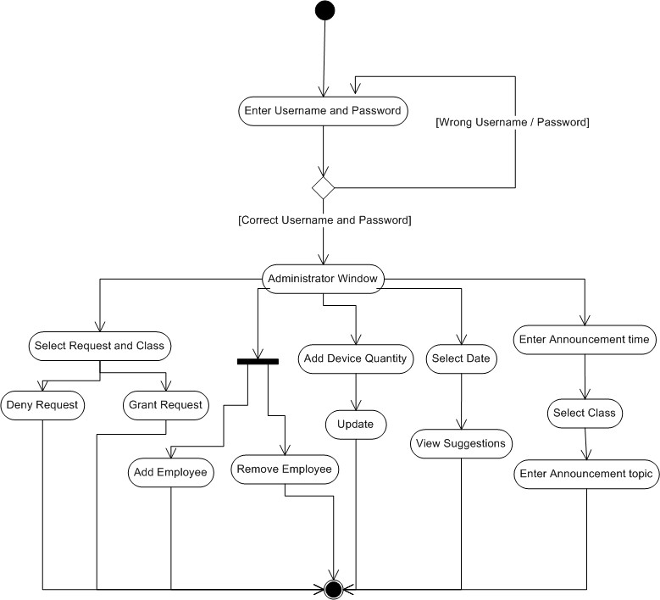

Fig 4.1 Activity Diagram for Administrator

**Activity Diagram for Faculty**

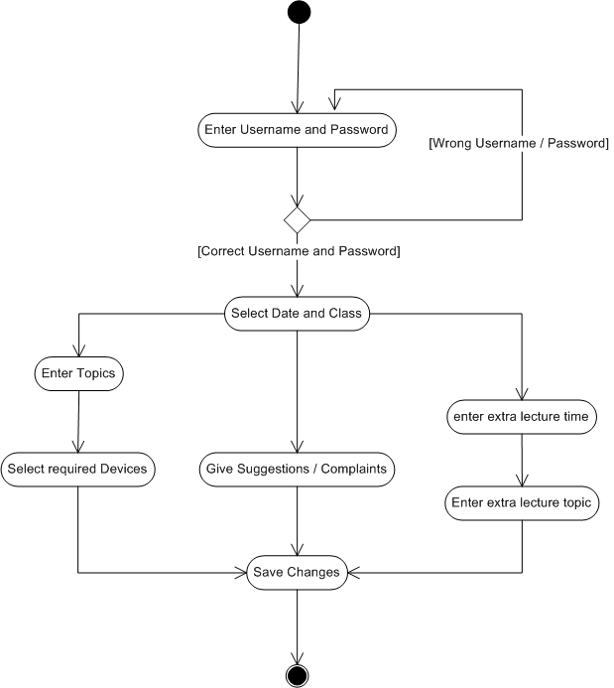

Fig 4.2 Activity Diagram for Faculty

**4.6 FEATURES OF NEW SYSTEM**

* The system is beneficial as it will eliminate the traditional file paper schedule displaying system.
* It will also save lot of time and effort as the adding new events and updating it will take few seconds.
* It also aims at building accuracy in resource management electronically and reducing human error so that the records are accurate and correct.
* All data are stored in database in organized manner.

**4.7 USE CASE DIAGRAM**

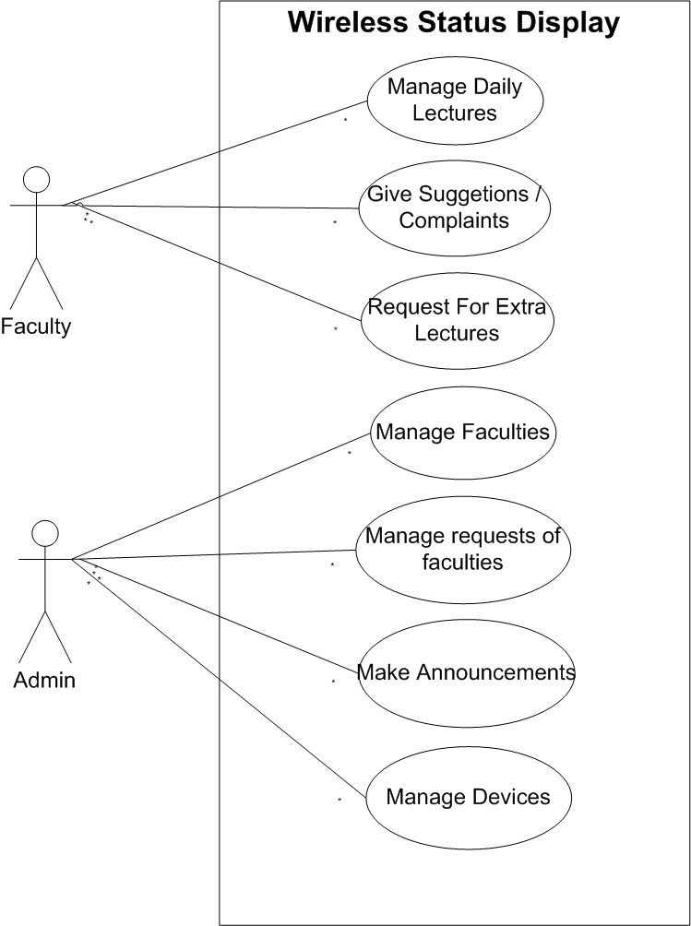

Fig 4.3 Usecase Diagram

**4.8 CLASS DIAGRAM**

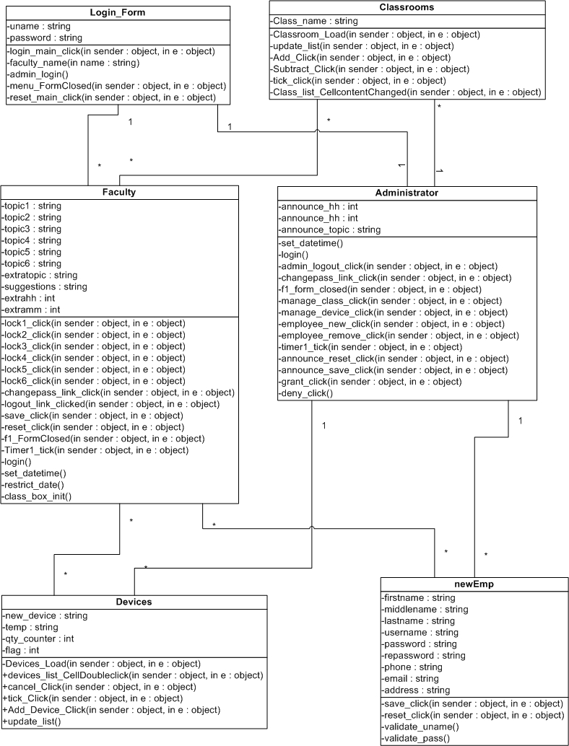

Fig 4.4 Class Diagram