**5. SYSTEM DESIGN**

**5.1 SYSTEM APPLICATION DESIGN**

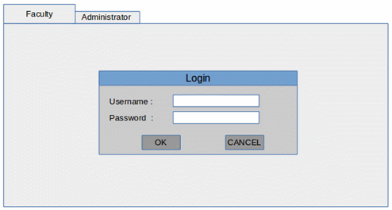

Fig 5.1 Login Page for Faculty

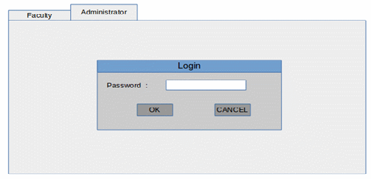

Fig 5.2 Login Page for Administrator

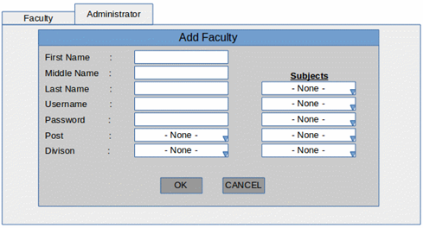

Fig 5.3 Add Faculty Window

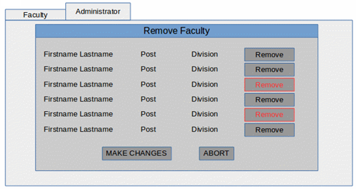

Fig 5.4 Remove Faculty Window

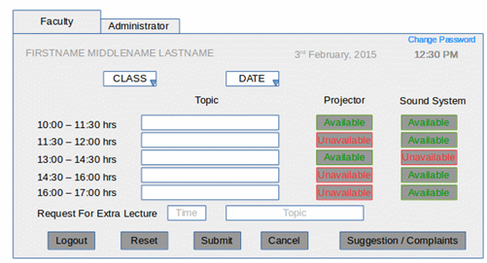

Fig 5.5 Faculty Window

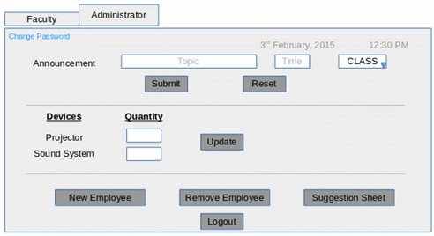

Fig 5.6 Administrator Window

**5.2 DATABASE DESIGN**

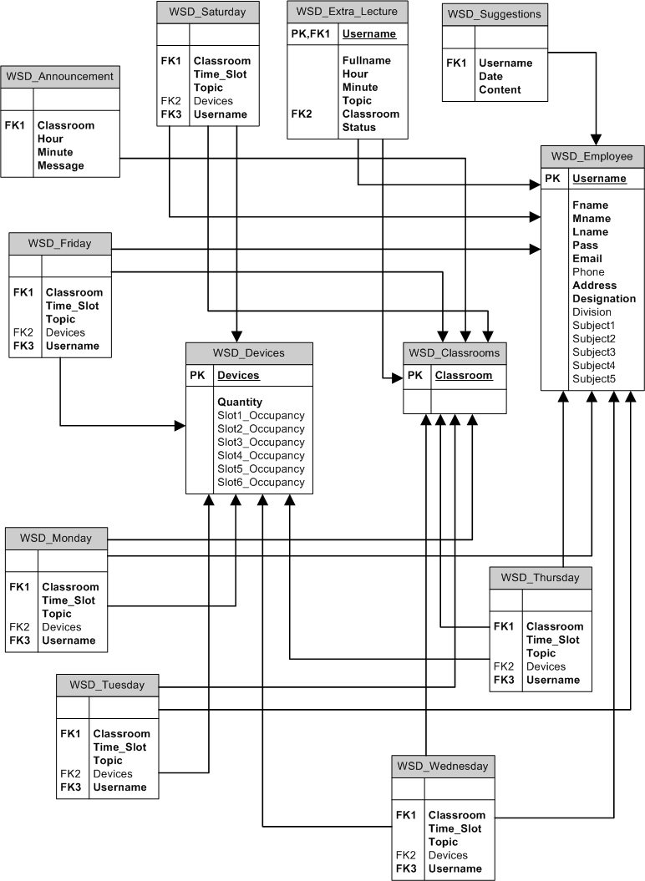

Fig 5.7 Database Diagram