Build a Django Project for Player Data Management
Create a Django web application with the following specifications:
Project Structure
- Project name: playerproject
- App name: playerapp
Navigation Requirements
- Every page must include a navbar with:
  - Home → Displays all player records
  - Welcome → Opens a static welcome page
2. On clicking Welcome, show the text:

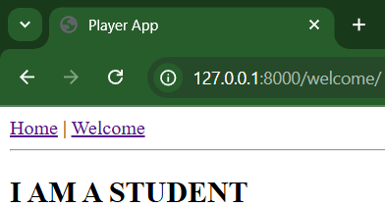
- On clicking Home, show a table of all players with fields:
- Name. Test Innings Runs, actions: Edit and Delete
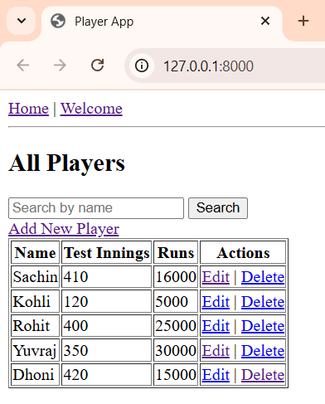
- Include a search box on the Home page to filter players by: Name
  - For example, enter name Sachin in search box:
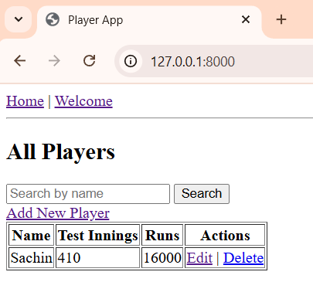
If no result is found, show:
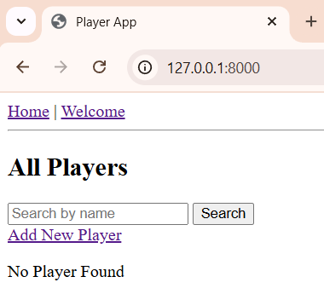
- add_player
- HTML form to add a new player (fields: name, innings, runs)
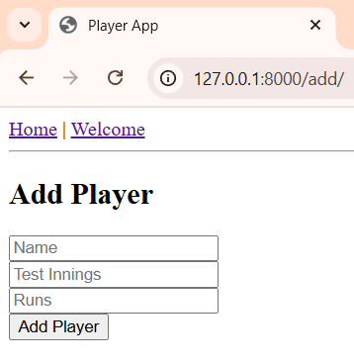
- Save and redirect to Home

- edit_player
- HTML form pre-filled with player data for editing
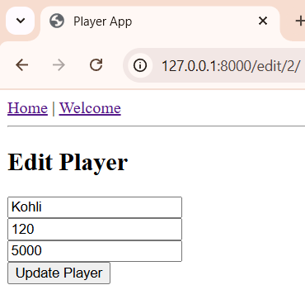
- Save and redirect to Home
- delete_player
- Delete the selected player record
- welcome
- Display a static message "I AM A STUDENT"
- Model Fields
Define a Player model with: name (CharField), test_innings (IntegerField), runs (IntegerField)
- Superuser Requirement
Create a superuser with:
- Username: Your Roll Number
- Password: Your Enrollment Number

