* 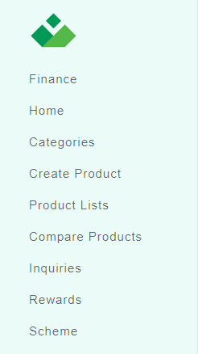Menu ordering at [www.veloce.market](http://www.veloce.market)
* When Portal opened by unregistered visitor

1. Home
2. Categories
3. Compare Products (Ask for login / register)
4. Inquiries (Ask for login / register)
5. Rewards (Ask for login / register)
6. Finance (Ask for login / register)
7. Sell with us (Ask for login / register)
8. Login / Register

* Portal opened by Initially registered user L-0

1. Home
2. Categories
3. Compare Products (Ask to complete L-1 info)

(You or customer has not completed your profile! You need to complete the remaining elements to be able to use this platform: )

1. Inquiries
2. Rewards
3. Finance
4. Sell with us (Ask for L-2 registration)

(You or customer has not completed your profile! You need to complete the remaining elements to be able to use this platform: )

* Portal opened by L-1 user with approval

1. Home
2. Categories
3. Compare Products
4. Inquiries
5. Rewards
6. Finance
7. Sell with us (Ask for L-2 registration)

* Portal opened by L-2 and L-3 user with approval

1. Home
2. Categories
3. Compare Products
4. Inquiries
5. Rewards
6. Finance
7. My listed products [Product Lists old ]
8. Create Product
9. Finance Scheme [if user already product uploaded then only show this ]

* User information in header dropdown at [www.veloce.market](http://www.veloce.market)

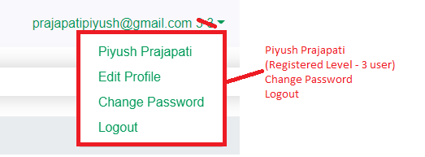

* Cases for to show Registration level at user information dropdown for logged in user

|  |  |  |  |
| --- | --- | --- | --- |
| **Level of Info** | **Submitted** | **Approved** | **Registration Level to show at dropdown** |
| Level – 1 | N | N | Registered Level – 0 user |
| Level – 1 | Y | N | Registered Level – 0 user |
| Level – 1 | Y | Y | Registered Level – 1 user |
| Level – 2 | N | N | Registered Level – 1 user |
| Level – 2 | Y | N | Registered Level – 1 user |
| Level – 2 | Y | Y | Registered Level – 2 user |
| Level – 3 | N | N | Registered Level – 2 user |
| Level – 3 | Y | N | Registered Level – 2 user |
| Level – 3 | Y | Y | Registered Level – 3 user |

* 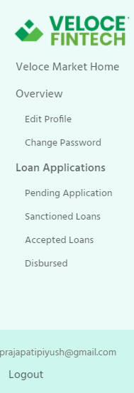Menu ordering at [www.velocefintech.com](http://www.velocefintech.com)
* When Portal opened by unregistered visitor

1. Veloce Market Home
2. Loan applications (Ask for login / register)

Pending Applications (Ask for login / register)

Sanctioned (Ask for login / register)

Accepted (Ask for login / register)

Disbursed (Ask for login / register)

1. Login / Register

* When Portal opened by L – 1/2/3 registered user

1. Veloce Market Home
2. Loan applications

(Show all available applications along with status wise filter)

Pending Applications

Sanctioned

Accepted

Disbursed

* When Portal opened by registered lender user

1. Veloce Market Home
2. Loan applications

(Show all available applications along with status wise filter)

Pending Applications

Sanctioned

Accepted by dealer

Disbursed

* User information in header dropdown at [www.velocefintech.com](http://www.velocefintech.com)

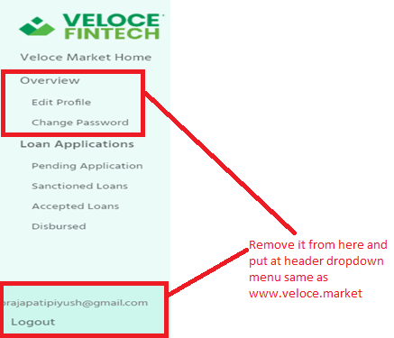

* Cases for to show Registration level at user information dropdown for logged in user

|  |  |  |  |
| --- | --- | --- | --- |
| **Level of Info** | **Submitted** | **Approved** | **Registration Level to show at dropdown** |
| Level – 1 | N | N | Registered Level – 0 user |
| Level – 1 | Y | N | Registered Level – 0 user |
| Level – 1 | Y | Y | Registered Level – 1 user |
| Level – 2 | N | N | Registered Level – 1 user |
| Level – 2 | Y | N | Registered Level – 1 user |
| Level – 2 | Y | Y | Registered Level – 2 user |
| Level – 3 | N | N | Registered Level – 2 user |
| Level – 3 | Y | N | Registered Level – 2 user |
| Level – 3 | Y | Y | Registered Level – 3 user |
| Lender Info | N | N | Lender – Approval Pending |
| Lender Info | Y | N | Lender – Approval Pending |
| Lender Info | Y | Y | Approved Lender |

1. Category and subcategory and product name display on category page.

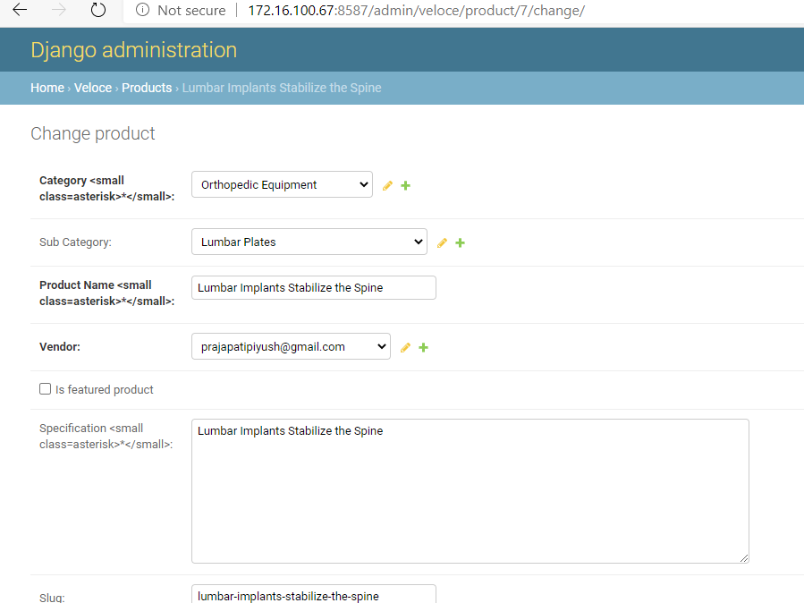

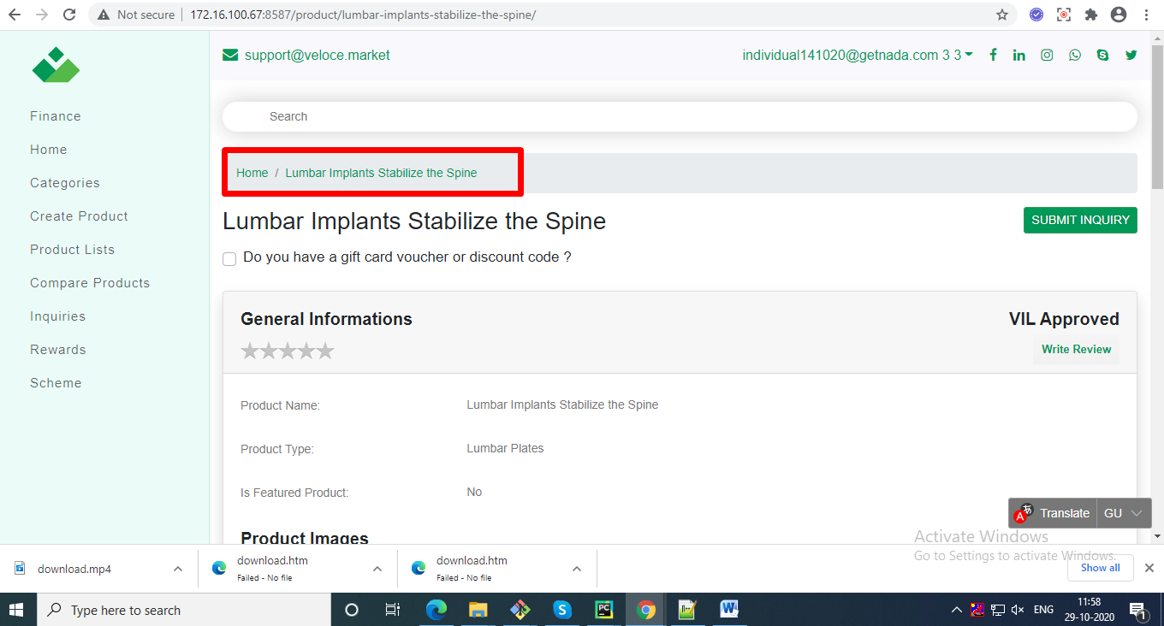

1. Compare product change as per cardekho site

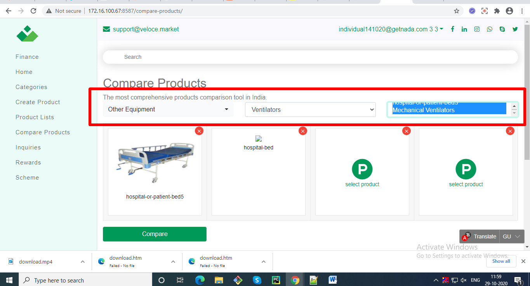

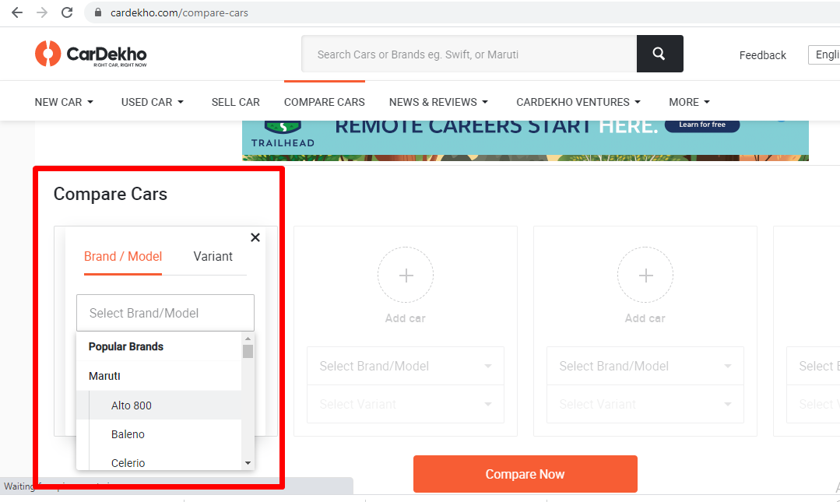

1. On Veloce Fintech page remove “Overview” from menu and move “Edit Profile” and “Change password” move on top same as Market portal.

