Advanced Data Analysis and Visualization in Logistics
Yuva Intern – Logistics Data Analyst
Student Name: Ravipati Sai Sushma
Hypothetical dataset generated for educational analysis
This report performs exploratory data analysis (EDA), descriptive statistics, correlation analysis, multiple logistics visualizations, interpretation, and recommendations using a hypothetical 3,000-shipment dataset.

1. Objective
The objective is to analyze a hypothetical logistics dataset, identify patterns in delivery performance and transportation cost, visualize trends and relationships, and translate the findings into practical logistics decision-support insights.

2. Data Simulation and Structure
The dataset contains 3,000 synthetic shipment records. Key variables include delivery times, shipment volume, transportation cost, distance, region, transport mode, carrier, shipment type, on-time status, and customer satisfaction. The values are simulated and do not represent a real company.
Variable | Purpose
Shipment_ID | Identifier
Ship_Date | Shipment date
Region | Geographic segment
Transport_Mode | Transport method
Shipment_Type | Service category
Carrier | Carrier
Distance_km | Distance
Volume_Units | Shipment volume
Expected_Delivery_Days | Planned duration
Actual_Delivery_Days | Observed duration
Delivery_Delay_Days | Delay beyond expected
Transport_Cost_INR | Transport expenditure

3. Python Tools and Analytical Method
Python is used with pandas for grouping, aggregation and profiling, NumPy for numerical calculations, and Matplotlib for visualization. The workflow is: simulate data → profile → calculate central tendencies → analyze distributions → compare groups → examine relationships → interpret findings → recommend actions.
import pandas as pd
import numpy as np
import matplotlib.pyplot as plt
df = pd.read_csv("hypothetical_logistics_dataset.csv")
print(df.info())
print(df.describe())
print(df.isna().sum())

4. Central Tendencies and Descriptive Statistics
The mean actual delivery time is 6.73 days; median is 6.38 days. Average transport cost is INR 5,844. The overall on-time rate is 74.8%. These measures establish the baseline for later comparisons.
Metric | count | mean | std | min | 25% | 50% | 75% | max
Distance_km | 3000.00 | 888.59 | 530.24 | 117.60 | 502.32 | 767.60 | 1144.95 | 3000.00
Volume_Units | 3000.00 | 76.82 | 55.37 | 5.00 | 39.00 | 62.00 | 97.00 | 609.00
Actual_Delivery_Days | 3000.00 | 6.73 | 2.60 | 0.50 | 4.92 | 6.38 | 8.32 | 16.51
Delivery_Delay_Days | 3000.00 | 0.57 | 0.75 | 0.00 | 0.00 | 0.19 | 1.00 | 4.16
Transport_Cost_INR | 3000.00 | 5843.66 | 5081.68 | 425.00 | 2632.50 | 4415.50 | 7268.00 | 46615.00
Customer_Satisfaction | 3000.00 | 7.71 | 1.37 | 1.00 | 6.97 | 7.95 | 8.71 | 10.00
numeric = ["Distance_km","Volume_Units","Actual_Delivery_Days",
"Delivery_Delay_Days","Transport_Cost_INR","Customer_Satisfaction"]
print(df[numeric].describe().T)
print(df[numeric].agg(["mean","median","std","min","max"]))

5. Distribution Analysis
A histogram is appropriate for showing the distribution and variability of delivery time. It helps identify the normal operating range and the long-delay tail that may contain SLA exceptions.
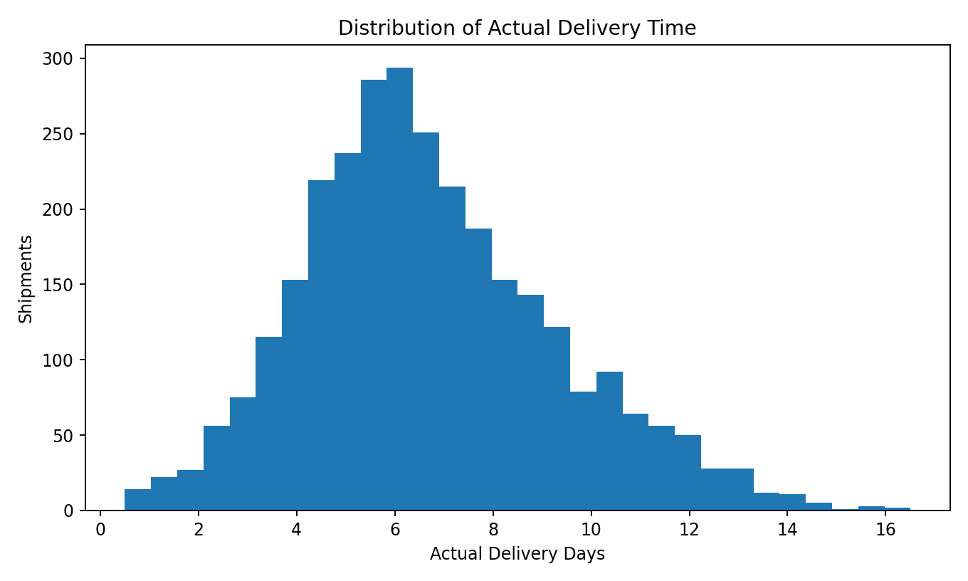
Insight: shipments in the upper tail should be investigated by carrier, region, route, mode and shipment type.
plt.hist(df["Actual_Delivery_Days"], bins=30)
plt.xlabel("Actual Delivery Days"); plt.ylabel("Shipments")
plt.title("Distribution of Actual Delivery Time"); plt.show()

6. Trend Analysis
A line chart is used because time-series visualization makes month-to-month changes visible. Tracking delivery time and on-time performance together helps identify periods of operational deterioration.
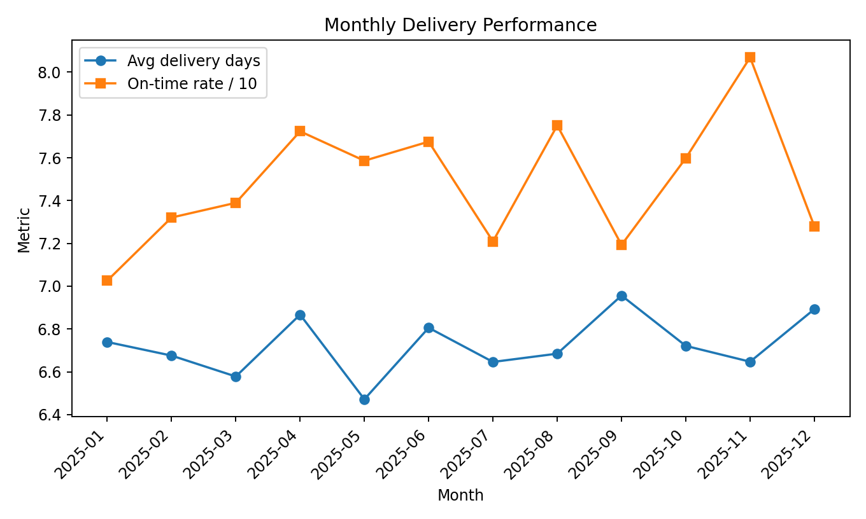
Insight: months with weaker service levels should be examined for volume, capacity, regional, carrier or route effects.
monthly = df.groupby(df["Ship_Date"].dt.to_period("M")).agg(
Avg_Delivery=("Actual_Delivery_Days","mean"),
On_Time_Rate=("On_Time","mean")).reset_index()
plt.plot(monthly["Avg_Delivery"]); plt.show()

7. Regional Cost Analysis
A bar chart is suitable for comparing discrete regions. Average transport cost can highlight regions where route length, mode mix, carrier mix or shipment characteristics may require investigation.
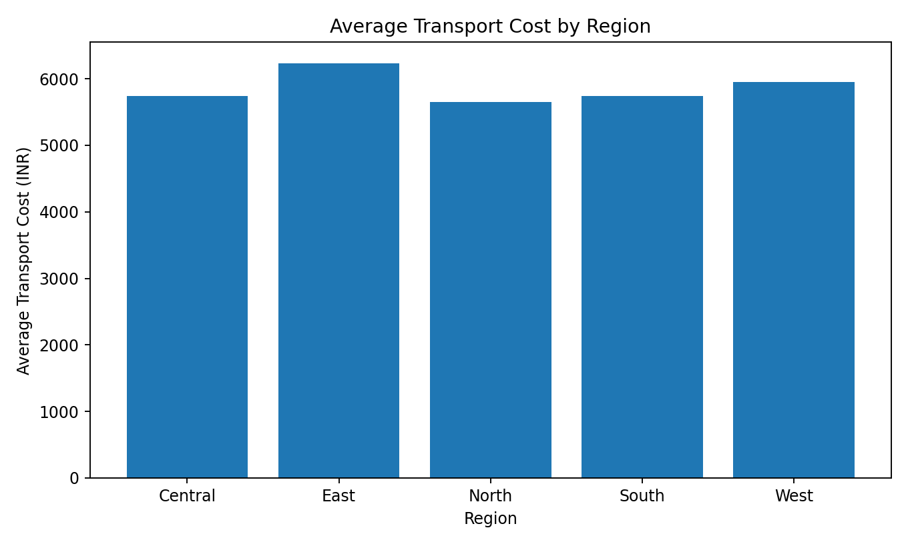
Insight: higher-cost regions should be diagnosed using distance, volume, mode and carrier information before taking corrective action.
region_cost = df.groupby("Region")["Transport_Cost_INR"].mean()
region_cost.plot(kind="bar")
plt.ylabel("Average Transport Cost (INR)")
plt.show()

8. Distance and Transportation Cost
A scatter plot is appropriate for two continuous variables. The simulated Pearson correlation between distance and transport cost is 0.66, showing a positive association in this dataset. Correlation is an association, not proof of causation.
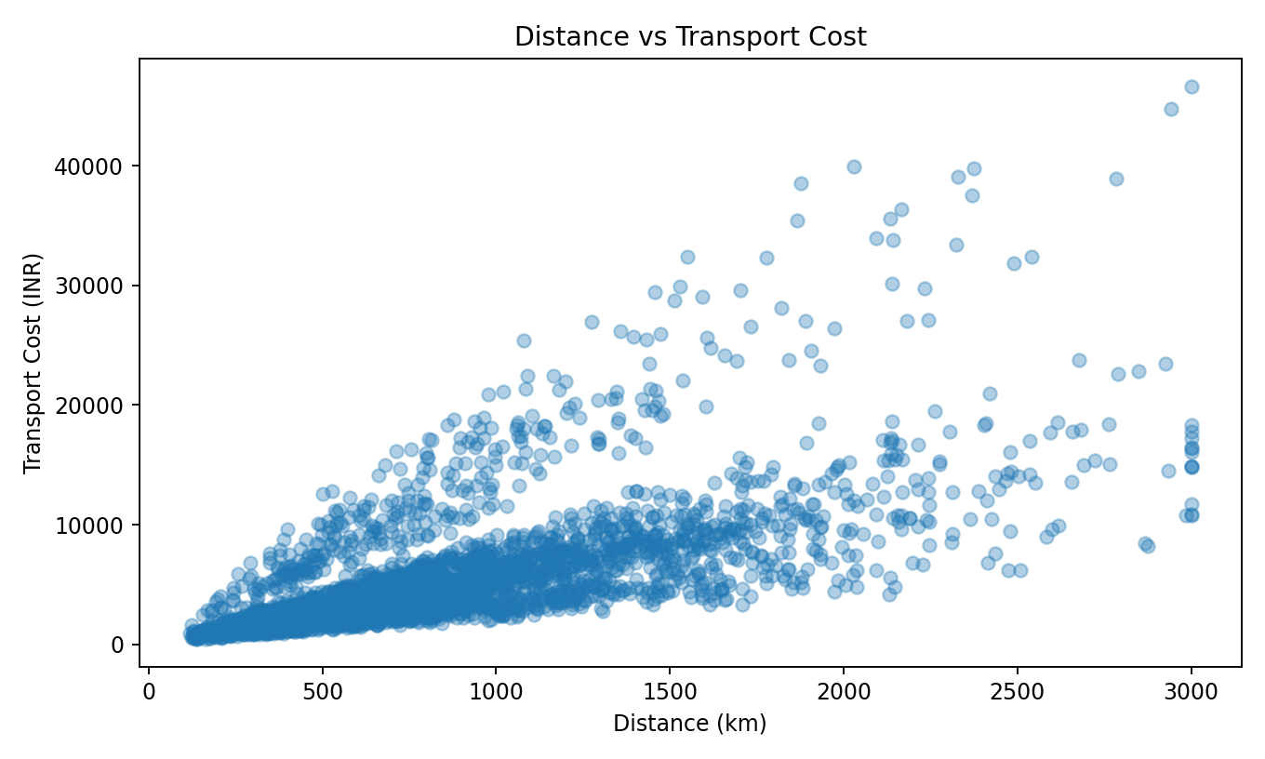
plt.scatter(df["Distance_km"], df["Transport_Cost_INR"], alpha=0.35)
plt.xlabel("Distance (km)"); plt.ylabel("Transport Cost (INR)")
plt.title("Distance vs Transport Cost"); plt.show()

9. Transport Mode Comparison
A bar chart compares average delivery duration by transport mode. This supports service-level discussions because different modes may involve different speed, capacity and cost trade-offs.
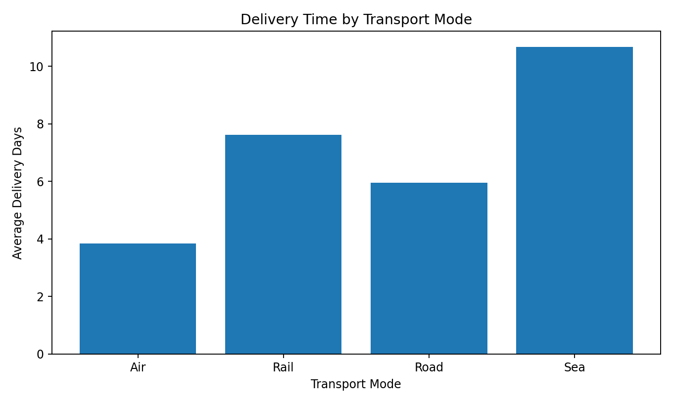
Insight: mode selection should consider shipment urgency and SLA as well as cost. The simulated results are not real-world benchmarks.
mode_delivery = df.groupby("Transport_Mode")["Actual_Delivery_Days"].mean()
mode_delivery.plot(kind="bar")
plt.ylabel("Average Delivery Days"); plt.show()

10. Correlation Analysis
A correlation matrix provides a compact view of pairwise linear relationships among numeric logistics measures. It can help identify candidate variables for deeper analysis and predictive modelling.
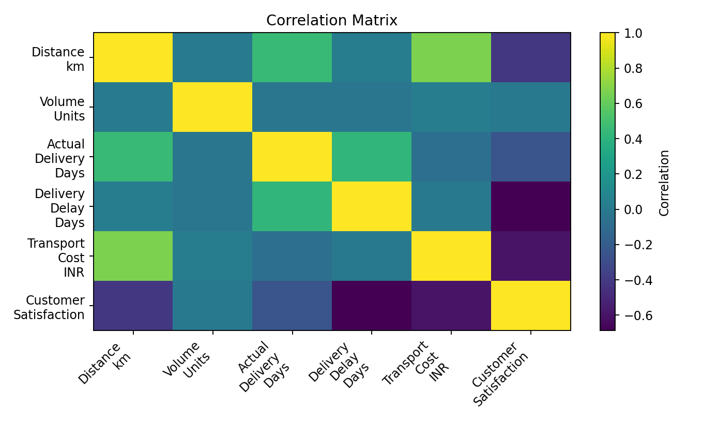
corr = df[["Distance_km","Volume_Units","Actual_Delivery_Days",
"Delivery_Delay_Days","Transport_Cost_INR",
"Customer_Satisfaction"]].corr()
plt.imshow(corr); plt.colorbar(); plt.show()

11. Key Analytical Insights
- Overall on-time delivery rate: 74.8%, with average delivery duration of 6.73 days.
- Average transport cost is approximately INR 5,844 per shipment.
- Distance has a positive simulated relationship with transport cost (correlation 0.66).
- Long-tail delivery times are useful exception candidates for root-cause analysis.
- Regional cost differences should be investigated together with distance, shipment volume, mode and carrier mix.
- Transport-mode comparisons reveal operational trade-offs; mode should be selected according to service requirements rather than cost alone.

12. Potential Bottlenecks
Potential bottleneck | Investigation
Long delivery tail | Carrier/route/region analysis
High-cost region | Compare distance and mode mix
Long routes | Route and consolidation analysis
Mode/service mismatch | Compare urgency with selected mode
Monthly deterioration | Review volume and capacity in affected months

13. Recommendations
- Create an exception dashboard for shipments exceeding the agreed delivery SLA.
- Monitor regional cost and delivery KPIs together instead of optimizing one metric in isolation.
- Use distance, volume, shipment type and transport mode as candidate cost-driver variables.
- Review transport-mode selection for urgent shipments using both service and incremental cost.
- Track monthly on-time performance to identify emerging deterioration early.
- For future predictive models, use time-aware validation where appropriate and avoid post-delivery variables that would cause data leakage.

14. Example End-to-End EDA Script
import pandas as pd
import matplotlib.pyplot as plt
df = pd.read_csv("hypothetical_logistics_dataset.csv")
print(df.shape)
print(df.describe())
print(df[["Actual_Delivery_Days","Transport_Cost_INR"]].agg(
["mean","median","std","min","max"]))
print(df.groupby("Region")["Transport_Cost_INR"].mean())
print(df.groupby("Transport_Mode")["Actual_Delivery_Days"].mean())
print(df[["Distance_km","Volume_Units",
"Actual_Delivery_Days","Transport_Cost_INR"]].corr())
df.groupby("Region")["Transport_Cost_INR"].mean().plot(kind="bar")
plt.show()

15. How Visualizations Support Logistics Decisions
Visualization | Purpose | Decision support
Histogram | Distribution and variability | Identify delay exceptions
Line chart | Time trend | Detect deterioration
Bar chart | Regional comparison | Prioritize investigation
Scatter plot | Cost-driver relationship | Support route/cost analysis
Mode comparison | Mode performance | Support mode selection
Correlation matrix | Variable relationships | Guide deeper modelling

16. Evaluation Criteria Mapping
Requirement | Evidence
Depth and clarity of EDA | Sections 4–10
Quality/relevance of visualizations | Six embedded visualizations with justification
Python tools and techniques | pandas, NumPy and Matplotlib code
Analytical conclusions and recommendations | Sections 11–13
Structure and professionalism | Organized DOC with headings, tables, figures, code and conclusion

17. Conclusion
This project demonstrates a complete logistics EDA workflow. Central tendencies, distributions, trends, group comparisons, scatter analysis and correlations turn shipment records into actionable questions about delivery reliability, cost drivers and bottlenecks. The next step would be predictive modelling or optimization using validated historical data, with careful attention to time-based validation and data leakage.

18. References and Tools
The dataset is hypothetical and generated specifically for this educational task. Tools used: Python, pandas, NumPy and Matplotlib.

