

SCHOOL OF COMPUTING

Department of Computer Science and Engineering

CERTIFICATE

This is to certify that the Cornerstone project work entitled “Railway Reservation Management System” is submitted by
PEDIREDDY RAVI | (25B11CS984)
Y AJAY | (25B11CS747)
V PAVAN | (25B11CS728)
T VISWAS | (26B21CS078)

in partial fulfillment of the requirements for the award of the B.Tech. degree in Computer Science and Engineering for the academic year 2026-2027.

Project Guide Head of the Department
Mrs. K Vydehi, M.Tech.,(Ph.D), Dr. Phani Sridhar Addepalli, Ph.D,
Assistant Professor, Assistant Professor,
Department of CSE Department of CSE

DECLARATION

We hereby declare that the Cornerstone project entitled “Railway Reservation Management System” is original and is submitted to ADITYA UNIVERSITY, Surampalem, in partial fulfillment of the requirements for the award of the B.Tech. Degree in Computer Science and Engineering. We further declare that this project work has not been submitted, either in full or in part, for the award of any degree in this or any other institution. We also confirm that this work complies with the Institutional Academic Integrity and AI Usage Policy

Place: Surampalem
Date: 30-09-2026
By
PEDIREDDY RAVI | (25B11CS984)
Y AJAY | (25B11CS747)
V PAVAN | (25B11CS728)
T VISWAS | (26B21CS078)

ACKNOWLEDGEMENT

It is with immense pleasure that we express our sincere gratitude to our Cornerstone Project Guide, Mrs. K Vydehi, Assistant Professor, who has guided us throughout the project. Her valuable support, encouragement, and guidance have greatly contributed to the successful completion of this work.
We would like to thank our Deputy Heads of the Department, Dr. Chandra Sekhar Kolli, Associate Professor, Dr Hari Jyothula, Associate Professor and Dr Pennada Siva Satya Prasad, Assistant Professor, Department of Computer Science and Engineering, for their support and valuable suggestions.
Our deepest thanks to our Head of the Department Dr. Phani Sridhar Addepalli, Assistant Professor, for his inspiration and for providing all the necessary facilities and resources required for this project.
We also extend our sincere thanks to Dr. M.V. Rajesh, Associate Dean, School of Computing for their encouragement and support during the course of our project.
We would like to express our sincere gratitude to Dr. G. Suresh, Registrar, Dr. A Ramesh, Pro Vice-Chancellor (Engineering & Sciences), Dr. S. Rama Sree, Pro Vice-Chancellor (Academics), Dr. M.B. Srinivas, Vice-Chancellor, Dr. M. Sreenivasa Reddy, Deputy Pro Chancellor and Management, Aditya University for providing excellent infrastructure and state-of-the-art laboratories.
Finally, we would like to thank the faculty members, lab technicians, non-teaching staff, and our friends who have directly or indirectly supported us in completing this Cornerstone project successfully.
TABLE OF CONTENTS
Certificate 1
Declaration 2
Acknowledgement 3
Table of Contents 4
Abstract 5
List of Figures 6
List of Tables 7
Acronyms 8
1. Introduction 9
2. System Analysis 10
3. Database Design 12
4. ER Diagram 13
5. Relational Schema 14
6. Table Design 15
7. Normalization 18
8. SQL Implementation 20
9. SQL Queries & Screenshots 24
10. Conclusion 35
11. Future Enhancements 35
References 35
ABSTRACT
The Railway Reservation Management System is a database-driven project developed to manage, in a centralized and organized manner, the information required for railway ticket reservation. Railway reservation involves passengers, trains, stations, train schedules, reservations and payments. When these records are maintained manually or in fragmented form, problems such as duplicate bookings, incorrect seat availability and data-entry errors can occur, and finding reservation history, payment details and train schedules becomes time-consuming.
To address these problems, a relational database has been designed and implemented in Oracle. The Entity Relationship (ER) model contains six entities – Passenger, Train, Station, Schedule, Reservation and Payment – connected through one-to-many and one-to-one relationships, with SCHEDULE acting as the associative table between TRAIN and STATION. The ER model is converted into six relational tables with primary keys, foreign keys and NOT NULL, UNIQUE and CHECK constraints that maintain data integrity.
Each table is populated with 15 sample records (90 records in total), and 7 basic and 8 advanced SQL queries – including joins, GROUP BY with HAVING, subqueries, NOT EXISTS, the RANK window function and CASE expressions – are executed to retrieve and analyse the data. The schema is then normalized up to the Third Normal Form (3NF) to remove redundancy. The system is intended for three types of users: the Admin, the Passenger and the Reservation Staff.
LIST OF FIGURES
S.No | Figure Description | Page No
1 | Figure 1. ER Diagram of Railway Reservation Management System | 13
2 | Figure 2. Output of Q1 – PASSENGER table (15 rows) | 24
3 | Figure 3. Output of Q2 – TRAIN table (15 rows) | 25
4 | Figure 4. Output of Q3 – STATION table (15 rows) | 25
5 | Figure 5. Output of Q4 – RESERVATION table (15 rows) | 26
6 | Figure 6. Output of Q5 – SCHEDULE table (15 rows) | 26
7 | Figure 7. Output of Q6 – PAYMENT table (15 rows) | 27
8 | Figure 8. Output of Q7 – Basic Query 1 (7 rows) | 27
9 | Figure 9. Output of Q8 – Basic Query 2 (6 rows) | 28
10 | Figure 10. Output of Q9 – Basic Query 3 (5 rows) | 28
11 | Figure 11. Output of Q10 – Basic Query 4 (4 rows) | 28
12 | Figure 12. Output of Q11 – Basic Query 5 (5 rows) | 29
13 | Figure 13. Output of Q12 – Basic Query 6 (5 rows) | 29
14 | Figure 14. Output of Q13 – Basic Query 7 (1 row) | 29
15 | Figure 15. Output of Q14 – Advanced Query 1 (15 rows) | 30
16 | Figure 16. Output of Q15 – Advanced Query 2 (10 rows) | 31
17 | Figure 17. Output of Q16 – Advanced Query 3 (2 rows) | 31
18 | Figure 18. Output of Q17 – Advanced Query 4 (6 rows) | 32
19 | Figure 19. Output of Q18 – Advanced Query 5 (3 rows) | 32
20 | Figure 20. Output of Q19 – Advanced Query 6 (10 rows) | 33
21 | Figure 21. Output of Q20 – Advanced Query 7 (13 rows) | 34
22 | Figure 22. Output of Q21 – Advanced Query 8 (3 rows) | 34
LIST OF TABLES
S.No | Table names | Page No
1 | Table 1. End Users | 10
2 | Table 2. Functional Requirements | 11
3 | Table 3. Requirements Specification | 11
4 | Table 4. Major Database Entities | 12
5 | Table 5. Relationships and Cardinality | 12
6 | Table 6. Relational Schema | 14
7 | Table 7. PASSENGER Table Structure | 15
8 | Table 8. TRAIN Table Structure | 15
9 | Table 9. STATION Table Structure | 15
10 | Table 10. SCHEDULE Table Structure | 16
11 | Table 11. RESERVATION Table Structure | 16
12 | Table 12. PAYMENT Table Structure | 16
13 | Table 13. Keys and Constraints | 17
14 | Table 14. Functional Dependencies and Normal Forms of the Final Schema | 19
ACRONYMS
- DBMS – Database Management System
- ER – Entity Relationship
- SQL – Structured Query Language
- DDL – Data Definition Language
- DML – Data Manipulation Language
- DQL – Data Query Language
- TCL – Transaction Control Language
- PK – Primary Key
- FK – Foreign Key
- UNF – Unnormalized Form
- 1NF – First Normal Form
- 2NF – Second Normal Form
- 3NF – Third Normal Form
- PNR – Passenger Name Record
- RAC – Reservation Against Cancellation
- UPI – Unified Payments Interface
- AC – Air Conditioned
- SL – Sleeper Class
- 3A – AC 3 Tier
- 2A – AC 2 Tier
- 1A – First AC
- CC – AC Chair Car
1. INTRODUCTION

1.1 Brief Information about the Project
The Railway Reservation Management System is a database application used to manage railway reservation activities efficiently. It maintains information about passengers, trains, stations, train schedules, reservations and payments. The project provides a centralized and structured way to store, manage, retrieve and maintain railway reservation information using a relational database implemented in Oracle.

1.2 Motivation and Contribution of Project
Motivation
- Railway reservation systems need to maintain passenger, train, station, schedule, reservation and payment information.
- Manual or fragmented records can cause duplicate bookings, incorrect seat availability and data-entry errors.
- Finding reservation history, payment details and train schedules can be time-consuming.
- A centralized database can make reservation operations more accurate, organized and efficient.
Contribution
- A complete ER model with entities, attributes, keys, relationships and cardinalities.
- Six Oracle tables created with primary key, foreign key, NOT NULL, UNIQUE and CHECK constraints.
- 15 sample records inserted in every table (90 records in total).
- 7 basic and 8 advanced SQL queries executed with their outputs.
- Normalization of the database up to Third Normal Form (3NF).

1.3 Objectives of the Project
- Maintain accurate passenger, train and station records.
- Manage train schedules and reservation availability.
- Record booking, cancellation and payment information.
- Reduce duplicate records and manual errors.
- Provide quick access to reservation history and reports.
- Improve data consistency, security and overall efficiency.

1.4 Scope of the Project
The scope of the Railway Reservation Management System covers database-oriented management of railway reservation information. The core scope includes passenger, train, station, schedule, reservation and payment data. The database can serve as the backend foundation for a railway reservation application and can later be extended with online payments, notifications, live train tracking and analytics.
2. SYSTEM ANALYSIS

2.1 Existing System
- Passenger, train, station, schedule, reservation and payment records are maintained manually or in fragmented form.
- Duplicate bookings can occur.
- Seat availability information can be incorrect.
- Data-entry errors are more likely.
- Finding reservation history, payment details and train schedules is time-consuming.

2.2 Proposed System
The proposed system uses a centralized relational database implemented in Oracle to organize railway reservation information into six related tables – PASSENGER, TRAIN, STATION, SCHEDULE, RESERVATION and PAYMENT. Primary keys and foreign keys establish the required relationships between the tables, and NOT NULL, UNIQUE and CHECK constraints keep the stored data valid. The system supports train and station management, schedule management, reservation and cancellation records, payment records and SQL-based retrieval of reservation history and reports.
- Centralized database
- Passenger record management
- Train and station management
- Schedule management
- Reservation and cancellation records
- Payment records
- SQL-based retrieval and reporting
- Referential integrity

2.3 End Users
Table 1. End Users
User | Role
Admin | Manages trains, stations, schedules, reservations, payments and reports.
Passenger | Searches trains, checks availability, makes reservations and views booking history.
Reservation Staff | Verifies passenger details, processes bookings/cancellations and updates records.

2.4 Functional Requirements
Table 2. Functional Requirements
Module | Functional Requirement
Admin Management | Admin login and train/station management.
Passenger Management | Passenger registration and record management.
Train Search and Availability | Train search and seat availability checking.
Reservation and Payment | Reservation, cancellation and payment processing.
Schedule and Reports | Schedule management and report generation.

2.5 Non-Functional Requirements
- Security and authentication – database access and privileges should be controlled for authorized users only.
- Reliability and data consistency – transactions should preserve a consistent database state.
- Fast response time and usability – queries should return results quickly and the stored information should be easy to understand and use.
- Scalability and backup/recovery – the design should support growth in passengers, trains, schedules and reservations, and data should be recoverable through backup.

2.6 Requirements Specification
Table 3. Requirements Specification
Category | Suggested Requirement
Hardware | Intel i3 or above; 4 GB RAM minimum; adequate storage; standard display and keyboard/mouse.
Operating System | Windows 10/11 or an equivalent supported platform.
Database | Oracle Database (the tables and queries are implemented in Oracle SQL).
3. DATABASE DESIGN

3.1 Major Entities
Table 4. Major Database Entities
Entity | Description
PASSENGER | Stores passenger information such as name, date of birth, gender, phone and email.
TRAIN | Stores train information such as train number, train name and train type.
STATION | Stores station information such as station name and location.
RESERVATION | Stores reservation (PNR) details such as booking date, journey date, class, status and fare, linked to a passenger and a train.
SCHEDULE | Stores the arrival time, departure time and platform of a train at a station; it is the associative table between TRAIN and STATION.
PAYMENT | Stores payment details such as payment date, amount, method and status for a reservation.

3.2 ER Model
The ER model represents the major entities of the Railway Reservation Management System and the relationships among them. Six entity sets are identified – Passenger, Train, Station, Reservation, Payment and Schedule – together with the relationship sets Makes (Passenger–Reservation), For (Reservation–Train), Has (Reservation–Payment), Has (Train–Schedule) and At (Schedule–Station). The complete ER diagram is shown in Section 4.

3.3 Relationships
Table 5. Relationships and Cardinality
Relationship | Cardinality | Description | How it is implemented
Passenger – Reservation (Makes) | 1:M | One passenger can make many reservations. | Reservation.Passenger_ID (FK → Passenger)
Train – Reservation (For) | 1:M | One train can have many reservations over different dates. | Reservation.Train_ID (FK → Train)
Reservation – Payment (Has) | 1:1 | Each reservation has one payment record in this project model. | Payment.PNR (FK, UNIQUE → Reservation)
Train – Schedule (Has) | 1:M | One train can have multiple schedule records. | Schedule.Train_ID (FK → Train)
Station – Schedule (At) | 1:M | One station can appear in multiple train schedules. | Schedule.Station_ID (FK → Station)
Train – Station (via Schedule) | M:N | A train halts at many stations and a station serves many trains. | Derived: SCHEDULE holds Train_ID and Station_ID

SCHEDULE is the associative (bridge) table: a train halts at many stations and a station serves many trains, so the M:N relationship between TRAIN and STATION is resolved through SCHEDULE.
4. ER DIAGRAM
The complete ER diagram of the Railway Reservation Management System is shown in Figure 1. Entity sets are drawn as rectangles, relationship sets as diamonds and attributes as ellipses. Primary key attributes are underlined, foreign key attributes are marked (FK), and the cardinality of each relationship is written beside the connecting lines.
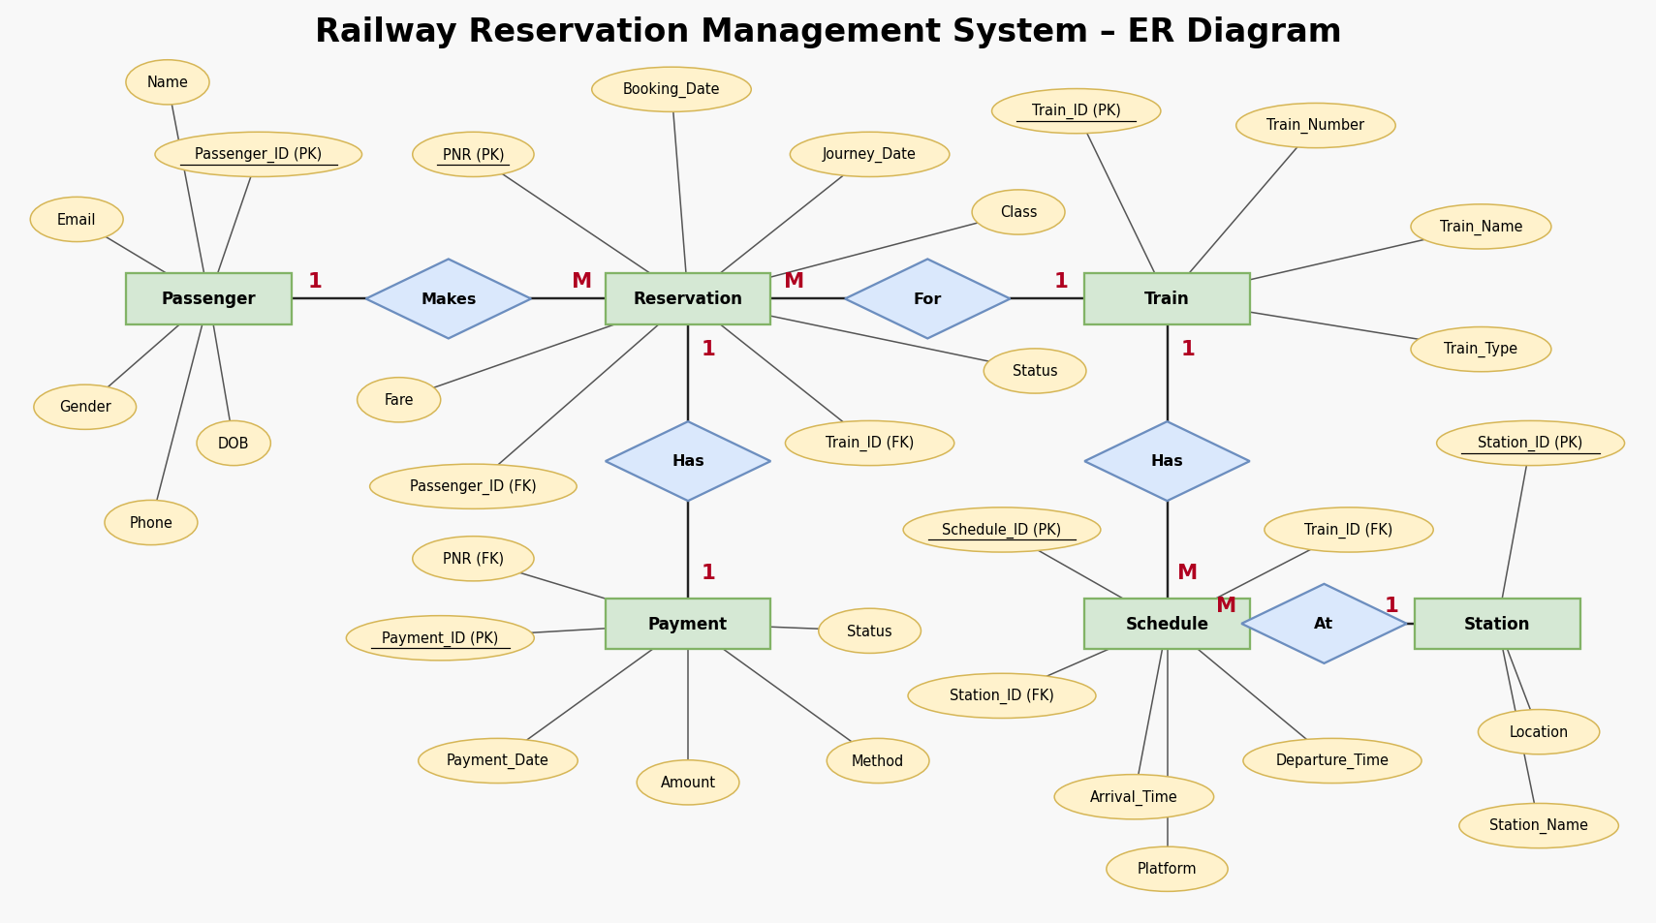
Figure 1. ER Diagram of Railway Reservation Management System
The relationship sets in the diagram are:
- Makes – Passenger (1) to Reservation (M).
- For – Reservation (M) to Train (1).
- Has – Reservation (1) to Payment (1).
- Has – Train (1) to Schedule (M).
- At – Schedule (M) to Station (1).
5. RELATIONAL SCHEMA
Table 6. Relational Schema
Relation | Relational Schema
PASSENGER | Passenger_ID (PK), Name, DOB, Gender, Phone, Email
TRAIN | Train_ID (PK), Train_Number, Train_Name, Train_Type
STATION | Station_ID (PK), Station_Name, Location
RESERVATION | PNR (PK), Booking_Date, Journey_Date, Class, Status, Fare, Passenger_ID (FK), Train_ID (FK)
SCHEDULE | Schedule_ID (PK), Arrival_Time, Departure_Time, Platform, Train_ID (FK), Station_ID (FK)
PAYMENT | Payment_ID (PK), Payment_Date, Amount, Method, Status, PNR (FK)

The relational tables are derived from the ER model. The RESERVATION relation references PASSENGER and TRAIN; the PAYMENT relation references RESERVATION; and the SCHEDULE relation references TRAIN and STATION and serves as the associative relation for the M:N relationship between TRAIN and STATION. Foreign keys establish the relationships between the related tables.
6. TABLE DESIGN

6.1 PASSENGER Table
Table 7. PASSENGER Table Structure
Attribute | Data Type | Constraint | Description
Passenger_ID | NUMBER(5) | PRIMARY KEY | Unique passenger identifier
Name | VARCHAR2(50) | NOT NULL | Passenger name
DOB | DATE | NOT NULL | Date of birth
Gender | CHAR(1) | CHECK (Gender IN ('M','F')) | Gender of the passenger (M/F)
Phone | VARCHAR2(10) | NOT NULL, UNIQUE | Passenger contact number
Email | VARCHAR2(60) | UNIQUE | Passenger email address

6.2 TRAIN Table
Table 8. TRAIN Table Structure
Attribute | Data Type | Constraint | Description
Train_ID | NUMBER(5) | PRIMARY KEY | Unique train identifier
Train_Number | VARCHAR2(5) | NOT NULL, UNIQUE | Train number
Train_Name | VARCHAR2(50) | NOT NULL | Train name
Train_Type | VARCHAR2(20) | CHECK (IN 'Rajdhani', 'Shatabdi', 'Duronto', 'Superfast', 'Vande Bharat', 'Express') | Type of the train

6.3 STATION Table
Table 9. STATION Table Structure
Attribute | Data Type | Constraint | Description
Station_ID | NUMBER(5) | PRIMARY KEY | Unique station identifier
Station_Name | VARCHAR2(50) | NOT NULL, UNIQUE | Station name
Location | VARCHAR2(60) | NOT NULL | Location of the station

6.4 SCHEDULE Table
Table 10. SCHEDULE Table Structure
Attribute | Data Type | Constraint | Description
Schedule_ID | NUMBER(5) | PRIMARY KEY | Unique schedule identifier
Train_ID | NUMBER(5) | NOT NULL, FK | References TRAIN
Station_ID | NUMBER(5) | NOT NULL, FK | References STATION
Arrival_Time | VARCHAR2(5) | NOT NULL | Arrival time at the station (HH:MM)
Departure_Time | VARCHAR2(5) | NOT NULL | Departure time from the station (HH:MM)
Platform | NUMBER(2) | CHECK (Platform > 0) | Platform number

6.5 RESERVATION Table
Table 11. RESERVATION Table Structure
Attribute | Data Type | Constraint | Description
PNR | NUMBER(10) | PRIMARY KEY | Unique reservation (PNR) number
Passenger_ID | NUMBER(5) | NOT NULL, FK | References PASSENGER
Train_ID | NUMBER(5) | NOT NULL, FK | References TRAIN
Booking_Date | DATE | NOT NULL | Date of booking
Journey_Date | DATE | NOT NULL | Date of journey
Class | VARCHAR2(3) | CHECK (IN 'SL', '3A', '2A', '1A', 'CC') | Travel class
Status | VARCHAR2(10) | CHECK (IN 'Confirmed', 'Waiting', 'RAC', 'Cancelled') | Reservation status
Fare | NUMBER(8,2) | CHECK (Fare > 0) | Fare amount

In addition, the table-level constraint chk_dates (CHECK Journey_Date >= Booking_Date) ensures that the journey date is never earlier than the booking date.

6.6 PAYMENT Table
Table 12. PAYMENT Table Structure
Attribute | Data Type | Constraint | Description
Payment_ID | NUMBER(5) | PRIMARY KEY | Unique payment identifier
PNR | NUMBER(10) | NOT NULL, UNIQUE, FK | References RESERVATION (one payment per reservation)
Payment_Date | DATE | NOT NULL | Date of payment
Amount | NUMBER(8,2) | CHECK (Amount > 0) | Amount paid
Method | VARCHAR2(15) | CHECK (IN 'UPI', 'Credit Card', 'Debit Card', 'Net Banking', 'Cash') | Payment method
Status | VARCHAR2(10) | CHECK (IN 'Success', 'Failed', 'Refunded') | Payment status

6.7 Keys and Constraints
Table 13. Keys and Constraints
Table | Primary Key | Foreign Key(s) | Other Constraints
PASSENGER | Passenger_ID | — | NOT NULL (Name, DOB, Phone); UNIQUE (Phone, Email); CHECK Gender IN (M,F)
TRAIN | Train_ID | — | UNIQUE Train_Number; CHECK Train_Type in allowed list
STATION | Station_ID | — | UNIQUE Station_Name; NOT NULL Location
RESERVATION | PNR | Passenger_ID → Passenger  Train_ID → Train | CHECK Class, Status, Fare > 0; CHECK Journey_Date >= Booking_Date
SCHEDULE | Schedule_ID | Train_ID → Train  Station_ID → Station | NOT NULL times; CHECK Platform > 0
PAYMENT | Payment_ID | PNR → Reservation | UNIQUE PNR (1:1); CHECK Amount > 0; CHECK Method, Status
7. NORMALIZATION
Normalization organizes data into related relations to reduce redundancy and update anomalies. For the Railway Reservation Management System, the data is separated into PASSENGER, TRAIN, STATION, SCHEDULE, RESERVATION and PAYMENT relations so that each relation stores information about a single subject.

7.1 Unnormalized Form (UNF)
In the unnormalized form, a passenger row stores several PNRs and trains in a single cell (repeating group).
Passenger_ID | Name | PNR_List | Train_List
101 | Arjun Reddy | 2609100001, 2609100008 | Howrah Rajdhani, Visakha Express
103 | Karthik Varma | 2609100003, 2609100012 | Kerala Express, Falaknuma Express

Problems in UNF
- Several PNR values and train names are stored in a single field (repeating group).
- A single reservation cannot be identified, searched or updated on its own.
- Passenger details would have to be repeated if each reservation were stored on a separate row.

7.2 First Normal Form (1NF)
- Each attribute contains a single atomic value.
- Repeating groups are removed.
- Every reservation is identified by a unique PNR, so the primary key is PNR.
PNR | Passenger_ID | Name | Train_Name
2609100001 | 101 | Arjun Reddy | Howrah Rajdhani
2609100008 | 101 | Arjun Reddy | Visakha Express
2609100003 | 103 | Karthik Varma | Kerala Express
2609100012 | 103 | Karthik Varma | Falaknuma Express

7.3 Second Normal Form (2NF)
- Non-key attributes must depend on the whole key.
SCHEDULE (Train_ID, Station_ID) with a composite key contains partial dependencies:
Train_ID | Station_ID | Train_Name | Station_Name | Arrival | Departure | Platform
1001 | 201 | Howrah Rajdhani | New Delhi | 16:50 | 17:00 | 3
1001 | 202 | Howrah Rajdhani | Howrah Junction | 09:55 | 10:05 | 9
1002 | 201 | Bhopal Shatabdi | New Delhi | 06:00 | 06:10 | 2

Train_ID → Train_Name and Station_ID → Station_Name depend on only part of the key, so there are partial dependencies.
So the relation is decomposed into 2NF:
TRAIN | STATION | SCHEDULE
Train_ID (PK), Train_Name | Station_ID (PK), Station_Name | Schedule_ID (PK), Train_ID (FK), Station_ID (FK), Arrival_Time, Departure_Time, Platform

This removes the partial dependencies; train and station names are stored only once.

7.4 Third Normal Form (3NF)
- Transitive dependencies are removed.
The relation Reservation_Flat contains transitive dependencies:
PNR | Passenger_ID | Passenger_Name | Train_ID | Train_Name | Train_Type | Fare
2609100001 | 101 | Arjun Reddy | 1001 | Howrah Rajdhani | Rajdhani | 3250
2609100008 | 101 | Arjun Reddy | 1010 | Visakha Express | Express | 1690
2609100011 | 111 | Venkatesh Rao | 1001 | Howrah Rajdhani | Rajdhani | 5400

PNR → Passenger_ID → Passenger_Name and PNR → Train_ID → Train_Name, Train_Type are transitive dependencies.
So the relation is decomposed into 3NF:
PASSENGER | TRAIN | RESERVATION
Passenger_ID (PK), Name, DOB, Gender, Phone, Email | Train_ID (PK), Train_Number, Train_Name, Train_Type | PNR (PK), Passenger_ID (FK), Train_ID (FK), Booking_Date, Journey_Date, Class, Status, Fare

Now the transitive dependencies are removed; passenger and train details are updated in one place only.

7.5 Final Schema Verified in 3NF
Table 14. Functional Dependencies and Normal Forms of the Final Schema
Table | Functional dependency | 1NF | 2NF | 3NF
PASSENGER | Passenger_ID → Name, DOB, Gender, Phone, Email | ✓ | ✓ | ✓
TRAIN | Train_ID → Train_Number, Train_Name, Train_Type | ✓ | ✓ | ✓
STATION | Station_ID → Station_Name, Location | ✓ | ✓ | ✓
RESERVATION | PNR → Passenger_ID, Train_ID, dates, Class, Status, Fare | ✓ | ✓ | ✓
SCHEDULE | Schedule_ID → Train_ID, Station_ID, times, Platform | ✓ | ✓ | ✓
PAYMENT | Payment_ID → PNR, Payment_Date, Amount, Method, Status | ✓ | ✓ | ✓

Every non-key attribute depends on the key, the whole key and nothing but the key. Redundancy is avoided and the PK–FK links keep the data consistent.
8. SQL IMPLEMENTATION

8.1 DDL – Data Definition Language
The following Oracle SQL DDL statements create the six tables of the Railway Reservation Management System with their primary keys, foreign keys and constraints.
CREATE TABLE Passenger (
Passenger_ID NUMBER(5) PRIMARY KEY,
Name VARCHAR2(50) NOT NULL,
DOB DATE NOT NULL,
Gender CHAR(1) CHECK (Gender IN ('M','F')),
Phone VARCHAR2(10) NOT NULL UNIQUE,
Email VARCHAR2(60) UNIQUE
);

CREATE TABLE Train (
Train_ID NUMBER(5) PRIMARY KEY,
Train_Number VARCHAR2(5) NOT NULL UNIQUE,
Train_Name VARCHAR2(50) NOT NULL,
Train_Type VARCHAR2(20) CHECK (Train_Type IN
('Rajdhani','Shatabdi','Duronto','Superfast',
'Vande Bharat','Express'))
);

CREATE TABLE Station (
Station_ID NUMBER(5) PRIMARY KEY,
Station_Name VARCHAR2(50) NOT NULL UNIQUE,
Location VARCHAR2(60) NOT NULL
);

CREATE TABLE Schedule (
Schedule_ID NUMBER(5) PRIMARY KEY,
Train_ID NUMBER(5) NOT NULL,
Station_ID NUMBER(5) NOT NULL,
Arrival_Time VARCHAR2(5) NOT NULL,
Departure_Time VARCHAR2(5) NOT NULL,
Platform NUMBER(2) CHECK (Platform > 0),
CONSTRAINT fk_sch_train FOREIGN KEY (Train_ID)
REFERENCES Train(Train_ID),
CONSTRAINT fk_sch_stn FOREIGN KEY (Station_ID)
REFERENCES Station(Station_ID)
);

CREATE TABLE Reservation (
PNR NUMBER(10) PRIMARY KEY,
Passenger_ID NUMBER(5) NOT NULL,
Train_ID NUMBER(5) NOT NULL,
Booking_Date DATE NOT NULL,
Journey_Date DATE NOT NULL,
Class VARCHAR2(3) CHECK (Class IN
('SL','3A','2A','1A','CC')),
Status VARCHAR2(10) CHECK (Status IN ('Confirmed',
'Waiting','RAC','Cancelled')),
Fare NUMBER(8,2) CHECK (Fare > 0),
CONSTRAINT chk_dates CHECK (Journey_Date >= Booking_Date),
CONSTRAINT fk_res_pass FOREIGN KEY (Passenger_ID)
REFERENCES Passenger(Passenger_ID),
CONSTRAINT fk_res_train FOREIGN KEY (Train_ID)
REFERENCES Train(Train_ID)
);

CREATE TABLE Payment (
Payment_ID NUMBER(5) PRIMARY KEY,
PNR NUMBER(10) NOT NULL UNIQUE,
Payment_Date DATE NOT NULL,
Amount NUMBER(8,2) CHECK (Amount > 0),
Method VARCHAR2(15) CHECK (Method IN ('UPI','Credit Card',
'Debit Card','Net Banking','Cash')),
Status VARCHAR2(10) CHECK (Status IN ('Success',
'Failed','Refunded')),
CONSTRAINT fk_pay_pnr FOREIGN KEY (PNR)
REFERENCES Reservation(PNR)
);

8.2 DML – Data Manipulation Language
Parent tables (Passenger, Train, Station) are loaded first, then Reservation, Schedule and Payment so that every foreign key finds its parent row. Each table holds 15 records (90 in total). The COMMIT statement (a Transaction Control Language command) makes the inserted data permanent.
INSERT INTO Passenger VALUES (101,'Arjun Reddy',TO_DATE('1998-04-12','YYYY-MM-DD'),'M',
'9848012345','arjun.reddy@gmail.com');
INSERT INTO Passenger VALUES (102,'Sneha Sharma',TO_DATE('2000-07-23','YYYY-MM-DD'),'F',
'9849123456','sneha.sharma@gmail.com');
INSERT INTO Passenger VALUES (103,'Karthik Varma',TO_DATE('1995-11-05','YYYY-MM-DD'),'M',
'9866234567','karthik.varma@gmail.com');
INSERT INTO Passenger VALUES (104,'Lakshmi Prasanna',TO_DATE('1992-02-18','YYYY-MM-DD'),'F',
'9867345678','lakshmi.prasanna@gmail.com');
INSERT INTO Passenger VALUES (105,'Rahul Verma',TO_DATE('1999-09-30','YYYY-MM-DD'),'M',
'9885456789','rahul.verma@gmail.com');
INSERT INTO Passenger VALUES (106,'Priya Nair',TO_DATE('2001-01-14','YYYY-MM-DD'),'F',
'9885567890','priya.nair@gmail.com');
INSERT INTO Passenger VALUES (107,'Sai Kiran',TO_DATE('1997-06-25','YYYY-MM-DD'),'M',
'9912678901','sai.kiran@gmail.com');
INSERT INTO Passenger VALUES (108,'Anjali Devi',TO_DATE('1990-12-08','YYYY-MM-DD'),'F',
'9912789012','anjali.devi@gmail.com');
INSERT INTO Passenger VALUES (109,'Mohammed Imran',TO_DATE('1994-03-19','YYYY-MM-DD'),'M',
'9959890123','mohammed.imran@gmail.com');
INSERT INTO Passenger VALUES (110,'Divya Chowdary',TO_DATE('2002-08-02','YYYY-MM-DD'),'F',
'9959901234','divya.chowdary@gmail.com');
INSERT INTO Passenger VALUES (111,'Venkatesh Rao',TO_DATE('1988-05-27','YYYY-MM-DD'),'M',
'9701012345','venkatesh.rao@gmail.com');
INSERT INTO Passenger VALUES (112,'Harika Yadav',TO_DATE('1996-10-11','YYYY-MM-DD'),'F',
'9701123456','harika.yadav@gmail.com');
INSERT INTO Passenger VALUES (113,'Suresh Kumar',TO_DATE('1985-07-07','YYYY-MM-DD'),'M',
'9640234567','suresh.kumar@gmail.com');
INSERT INTO Passenger VALUES (114,'Pooja Singh',TO_DATE('1999-04-21','YYYY-MM-DD'),'F',
'9640345678','pooja.singh@gmail.com');
INSERT INTO Passenger VALUES (115,'Naveen Babu',TO_DATE('2003-02-09','YYYY-MM-DD'),'M',
'9490456789','naveen.babu@gmail.com');

INSERT INTO Train VALUES (1001,'12301','Howrah Rajdhani','Rajdhani');
INSERT INTO Train VALUES (1002,'12002','Bhopal Shatabdi','Shatabdi');
INSERT INTO Train VALUES (1003,'12723','Telangana Express','Superfast');
INSERT INTO Train VALUES (1004,'12626','Kerala Express','Superfast');
INSERT INTO Train VALUES (1005,'12245','Howrah Duronto','Duronto');
INSERT INTO Train VALUES (1006,'20833','Visakhapatnam Vande Bharat','Vande Bharat');
INSERT INTO Train VALUES (1007,'12727','Godavari Express','Superfast');
INSERT INTO Train VALUES (1008,'12841','Coromandel Express','Superfast');
INSERT INTO Train VALUES (1009,'12760','Charminar Express','Express');
INSERT INTO Train VALUES (1010,'17015','Visakha Express','Express');
INSERT INTO Train VALUES (1011,'12717','Ratnachalam Express','Superfast');
INSERT INTO Train VALUES (1012,'12703','Falaknuma Express','Superfast');
INSERT INTO Train VALUES (1013,'12649','Karnataka Sampark Kranti','Express');
INSERT INTO Train VALUES (1014,'12009','Mumbai Shatabdi','Shatabdi');
INSERT INTO Train VALUES (1015,'22691','Bengaluru Rajdhani','Rajdhani');

INSERT INTO Station VALUES (201,'New Delhi','Delhi');
INSERT INTO Station VALUES (202,'Howrah Junction','Howrah, West Bengal');
INSERT INTO Station VALUES (203,'Chennai Central','Chennai, Tamil Nadu');
INSERT INTO Station VALUES (204,'Secunderabad Junction','Hyderabad, Telangana');
INSERT INTO Station VALUES (205,'Vijayawada Junction','Vijayawada, Andhra Pradesh');
INSERT INTO Station VALUES (206,'Visakhapatnam','Visakhapatnam, Andhra Pradesh');
INSERT INTO Station VALUES (207,'Mumbai CSMT','Mumbai, Maharashtra');
INSERT INTO Station VALUES (208,'Bengaluru City Junction','Bengaluru, Karnataka');
INSERT INTO Station VALUES (209,'Bhopal Junction','Bhopal, Madhya Pradesh');
INSERT INTO Station VALUES (210,'Nagpur Junction','Nagpur, Maharashtra');
INSERT INTO Station VALUES (211,'Guntur Junction','Guntur, Andhra Pradesh');
INSERT INTO Station VALUES (212,'Tirupati','Tirupati, Andhra Pradesh');
INSERT INTO Station VALUES (213,'Rajahmundry','Rajahmundry, Andhra Pradesh');
INSERT INTO Station VALUES (214,'Warangal','Warangal, Telangana');
INSERT INTO Station VALUES (215,'Thiruvananthapuram Central','Thiruvananthapuram, Kerala');

INSERT INTO Reservation VALUES (2609100001,101,1001,TO_DATE('2026-09-05','YYYY-MM-DD'),
TO_DATE('2026-10-10','YYYY-MM-DD'),'2A','Confirmed',3250);
INSERT INTO Reservation VALUES (2609100002,102,1003,TO_DATE('2026-09-06','YYYY-MM-DD'),
TO_DATE('2026-10-12','YYYY-MM-DD'),'SL','Confirmed',620);
INSERT INTO Reservation VALUES (2609100003,103,1004,TO_DATE('2026-09-07','YYYY-MM-DD'),
TO_DATE('2026-10-15','YYYY-MM-DD'),'3A','Confirmed',1780);
INSERT INTO Reservation VALUES (2609100004,104,1002,TO_DATE('2026-09-08','YYYY-MM-DD'),
TO_DATE('2026-10-11','YYYY-MM-DD'),'CC','Confirmed',1450);
INSERT INTO Reservation VALUES (2609100005,105,1006,TO_DATE('2026-09-09','YYYY-MM-DD'),
TO_DATE('2026-10-14','YYYY-MM-DD'),'CC','Waiting',1850);
INSERT INTO Reservation VALUES (2609100006,106,1007,TO_DATE('2026-09-10','YYYY-MM-DD'),
TO_DATE('2026-10-18','YYYY-MM-DD'),'3A','Confirmed',1120);
INSERT INTO Reservation VALUES (2609100007,107,1008,TO_DATE('2026-09-11','YYYY-MM-DD'),
TO_DATE('2026-10-20','YYYY-MM-DD'),'SL','Cancelled',710);
INSERT INTO Reservation VALUES (2609100008,101,1010,TO_DATE('2026-09-12','YYYY-MM-DD'),
TO_DATE('2026-10-22','YYYY-MM-DD'),'2A','RAC',1690);
INSERT INTO Reservation VALUES (2609100009,109,1005,TO_DATE('2026-09-13','YYYY-MM-DD'),
TO_DATE('2026-10-25','YYYY-MM-DD'),'3A','Confirmed',2100);
INSERT INTO Reservation VALUES (2609100010,110,1009,TO_DATE('2026-09-14','YYYY-MM-DD'),
TO_DATE('2026-10-16','YYYY-MM-DD'),'SL','Confirmed',540);
INSERT INTO Reservation VALUES (2609100011,111,1001,TO_DATE('2026-09-15','YYYY-MM-DD'),
TO_DATE('2026-10-28','YYYY-MM-DD'),'1A','Confirmed',5400);
INSERT INTO Reservation VALUES (2609100012,103,1012,TO_DATE('2026-09-16','YYYY-MM-DD'),
TO_DATE('2026-10-30','YYYY-MM-DD'),'3A','Cancelled',980);
INSERT INTO Reservation VALUES (2609100013,105,1011,TO_DATE('2026-09-17','YYYY-MM-DD'),
TO_DATE('2026-11-02','YYYY-MM-DD'),'SL','Confirmed',480);
INSERT INTO Reservation VALUES (2609100014,112,1003,TO_DATE('2026-09-18','YYYY-MM-DD'),
TO_DATE('2026-11-05','YYYY-MM-DD'),'2A','Waiting',1650);
INSERT INTO Reservation VALUES (2609100015,113,1015,TO_DATE('2026-09-19','YYYY-MM-DD'),
TO_DATE('2026-11-08','YYYY-MM-DD'),'3A','Confirmed',2650);

INSERT INTO Schedule VALUES (301,1001,201,'16:50','17:00',3);
INSERT INTO Schedule VALUES (302,1001,202,'09:55','10:05',9);
INSERT INTO Schedule VALUES (303,1002,209,'08:10','08:15',1);
INSERT INTO Schedule VALUES (304,1002,201,'06:00','06:10',2);
INSERT INTO Schedule VALUES (305,1003,204,'17:30','17:50',5);
INSERT INTO Schedule VALUES (306,1003,214,'19:20','19:22',2);
INSERT INTO Schedule VALUES (307,1004,215,'12:15','12:30',1);
INSERT INTO Schedule VALUES (308,1005,202,'20:05','20:20',8);
INSERT INTO Schedule VALUES (309,1006,206,'05:45','06:00',1);
INSERT INTO Schedule VALUES (310,1007,205,'21:10','21:15',4);
INSERT INTO Schedule VALUES (311,1008,203,'14:30','14:45',6);
INSERT INTO Schedule VALUES (312,1010,206,'18:00','18:15',3);
INSERT INTO Schedule VALUES (313,1011,212,'22:30','22:40',2);
INSERT INTO Schedule VALUES (314,1012,204,'06:30','06:40',10);
INSERT INTO Schedule VALUES (315,1015,208,'21:00','21:10',7);

INSERT INTO Payment VALUES (501,2609100001,TO_DATE('2026-09-05','YYYY-MM-DD'),3250,'UPI',
'Success');
INSERT INTO Payment VALUES (502,2609100002,TO_DATE('2026-09-06','YYYY-MM-DD'),620,'Debit Card',
'Success');
INSERT INTO Payment VALUES (503,2609100003,TO_DATE('2026-09-07','YYYY-MM-DD'),1780,
'Credit Card','Success');
INSERT INTO Payment VALUES (504,2609100004,TO_DATE('2026-09-08','YYYY-MM-DD'),1450,'UPI',
'Success');
INSERT INTO Payment VALUES (505,2609100005,TO_DATE('2026-09-09','YYYY-MM-DD'),1850,
'Net Banking','Success');
INSERT INTO Payment VALUES (506,2609100006,TO_DATE('2026-09-10','YYYY-MM-DD'),1120,'UPI',
'Success');
INSERT INTO Payment VALUES (507,2609100007,TO_DATE('2026-09-11','YYYY-MM-DD'),710,'Debit Card',
'Refunded');
INSERT INTO Payment VALUES (508,2609100008,TO_DATE('2026-09-12','YYYY-MM-DD'),1690,
'Credit Card','Success');
INSERT INTO Payment VALUES (509,2609100009,TO_DATE('2026-09-13','YYYY-MM-DD'),2100,
'Net Banking','Success');
INSERT INTO Payment VALUES (510,2609100010,TO_DATE('2026-09-14','YYYY-MM-DD'),540,'Cash',
'Success');
INSERT INTO Payment VALUES (511,2609100011,TO_DATE('2026-09-15','YYYY-MM-DD'),5400,
'Credit Card','Success');
INSERT INTO Payment VALUES (512,2609100012,TO_DATE('2026-09-16','YYYY-MM-DD'),980,'UPI',
'Refunded');
INSERT INTO Payment VALUES (513,2609100013,TO_DATE('2026-09-17','YYYY-MM-DD'),480,'Debit Card',
'Success');
INSERT INTO Payment VALUES (514,2609100014,TO_DATE('2026-09-18','YYYY-MM-DD'),1650,'UPI',
'Failed');
INSERT INTO Payment VALUES (515,2609100015,TO_DATE('2026-09-19','YYYY-MM-DD'),2650,
'Net Banking','Success');

COMMIT;

8.3 DQL – Data Query Language
The contents of every table are displayed using the following SELECT statements. The basic and advanced queries are given with their outputs in Section 9.
SELECT * FROM Passenger;
SELECT * FROM Train;
SELECT * FROM Station;
SELECT * FROM Reservation;
SELECT * FROM Schedule;
SELECT * FROM Payment;
9. SQL QUERIES & SCREENSHOTS
This section presents the SQL queries executed on the Railway Reservation Management System database. Queries Q1 to Q6 display the 15 records of each table, Q7 to Q13 are basic queries, and Q14 to Q21 are advanced queries using joins, GROUP BY with HAVING, subqueries, NOT EXISTS, the RANK window function and CASE expressions. The output of each query is shown below it.
Q1. Display all records of the PASSENGER table.
SELECT * FROM Passenger;
Output:
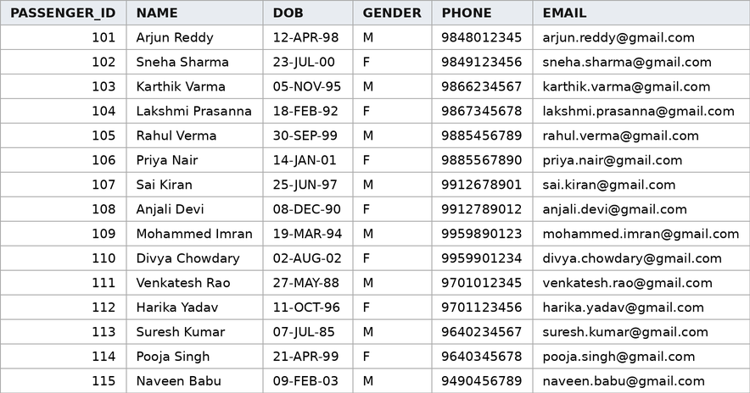
Figure 2. Output of Q1 – PASSENGER table (15 rows)
Q2. Display all records of the TRAIN table.
SELECT * FROM Train;
Output:
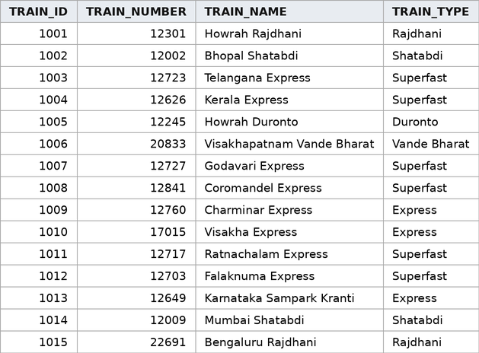
Figure 3. Output of Q2 – TRAIN table (15 rows)
Q3. Display all records of the STATION table.
SELECT * FROM Station;
Output:
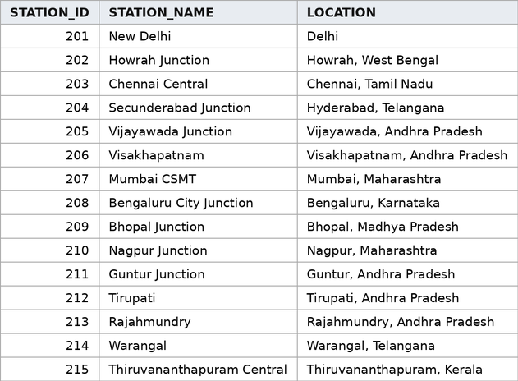
Figure 4. Output of Q3 – STATION table (15 rows)
Q4. Display all records of the RESERVATION table.
SELECT * FROM Reservation;
Output:
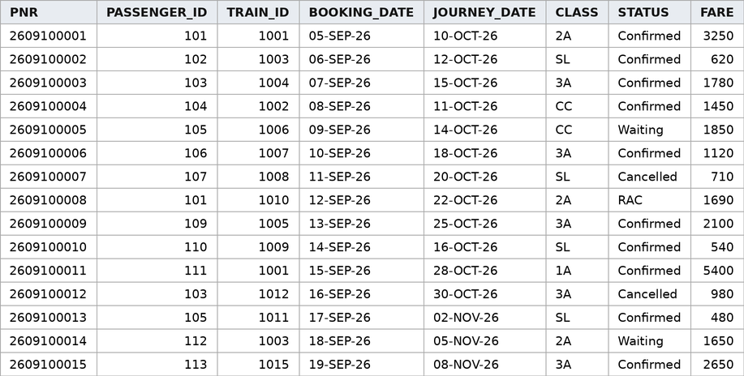
Figure 5. Output of Q4 – RESERVATION table (15 rows)
Q5. Display all records of the SCHEDULE table.
SELECT * FROM Schedule;
Output:
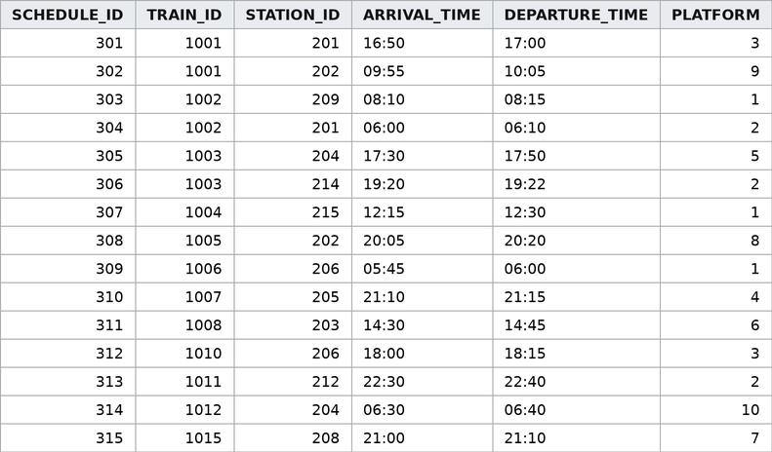
Figure 6. Output of Q5 – SCHEDULE table (15 rows)
Q6. Display all records of the PAYMENT table.
SELECT * FROM Payment;
Output:
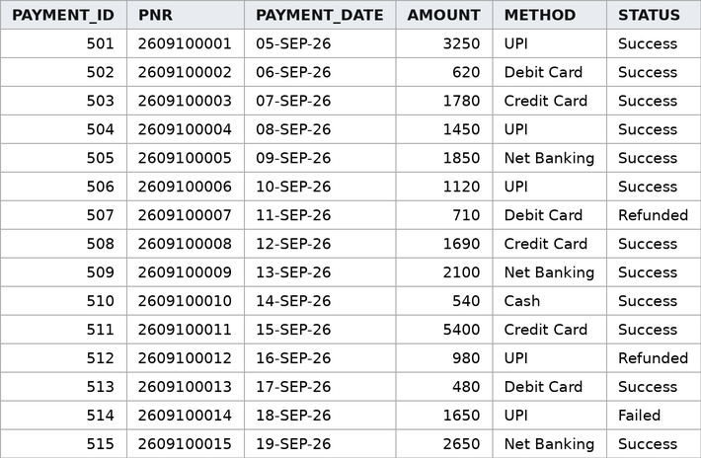
Figure 7. Output of Q6 – PAYMENT table (15 rows)
Q7. Basic Query 1: Display the names and phone numbers of all female passengers.
SELECT Name, Phone
FROM Passenger
WHERE Gender = 'F'
ORDER BY Name;
Output:
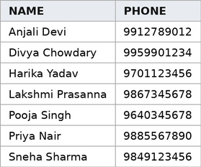
Figure 8. Output of Q7 – Basic Query 1 (7 rows)
Q8. Basic Query 2: List all Superfast trains with their train numbers.
SELECT Train_Number, Train_Name
FROM Train
WHERE Train_Type = 'Superfast';
Output:
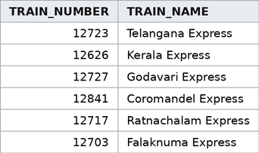
Figure 9. Output of Q8 – Basic Query 2 (6 rows)
Q9. Basic Query 3: Find confirmed reservations with fare greater than 1500.
SELECT PNR, Class, Status, Fare
FROM Reservation
WHERE Status = 'Confirmed'
AND Fare > 1500
ORDER BY Fare DESC;
Output:
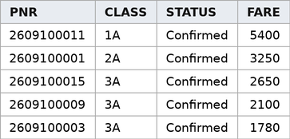
Figure 10. Output of Q9 – Basic Query 3 (5 rows)
Q10. Basic Query 4: Count the number of reservations for each status.
SELECT Status,
COUNT(*) AS Total_Reservations
FROM Reservation
GROUP BY Status;
Output:
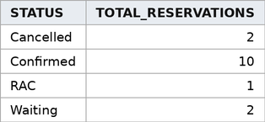
Figure 11. Output of Q10 – Basic Query 4 (4 rows)
Q11. Basic Query 5: Display all payments made through UPI.
SELECT Payment_ID, PNR, Amount
FROM Payment
WHERE Method = 'UPI';
Output:
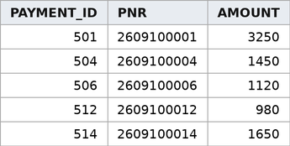
Figure 12. Output of Q11 – Basic Query 5 (5 rows)
Q12. Basic Query 6: List the stations located in Andhra Pradesh.
SELECT Station_Name, Location
FROM Station
WHERE Location LIKE '%Andhra Pradesh%';
Output:
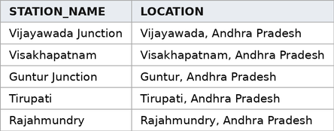
Figure 13. Output of Q12 – Basic Query 6 (5 rows)
Q13. Basic Query 7: Find total bookings, total fare, average fare and highest fare.
SELECT COUNT(*) AS Total_Bookings,
SUM(Fare) AS Total_Fare,
ROUND(AVG(Fare),2) AS Avg_Fare,
MAX(Fare) AS Max_Fare
FROM Reservation;
Output:
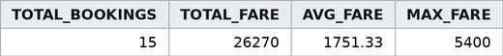
Figure 14. Output of Q13 – Basic Query 7 (1 row)
Q14. Advanced Query 1: Display each reservation with passenger name, train name, journey date, class and status (JOIN of 3 tables).
SELECT p.Name, t.Train_Name,
r.Journey_Date, r.Class, r.Status
FROM Reservation r
JOIN Passenger p
ON r.Passenger_ID = p.Passenger_ID
JOIN Train t
ON r.Train_ID = t.Train_ID
ORDER BY r.Journey_Date;
Output:
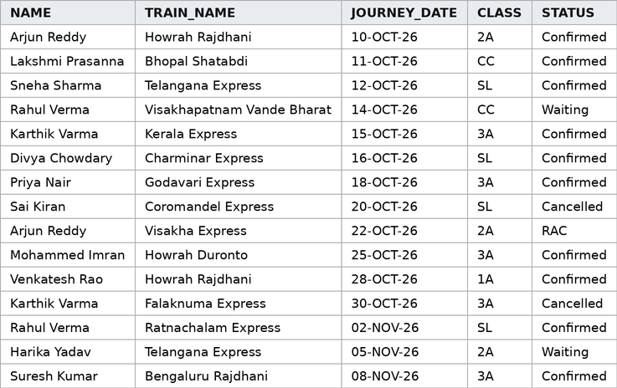
Figure 15. Output of Q14 – Advanced Query 1 (15 rows)
Q15. Advanced Query 2: Show payment details of passengers whose reservation is Confirmed and payment is Successful.
SELECT p.Name, r.PNR, py.Method,
py.Amount, py.Status
FROM Passenger p
JOIN Reservation r
ON p.Passenger_ID = r.Passenger_ID
JOIN Payment py ON r.PNR = py.PNR
WHERE r.Status = 'Confirmed'
AND py.Status = 'Success';
Output:
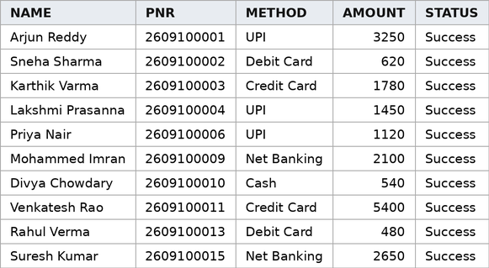
Figure 16. Output of Q15 – Advanced Query 2 (10 rows)
Q16. Advanced Query 3: Find train-wise successful bookings and revenue, showing only trains with revenue above 2500 (GROUP BY + HAVING).
SELECT t.Train_Name,
COUNT(r.PNR) AS Bookings,
SUM(py.Amount) AS Revenue
FROM Train t
JOIN Reservation r
ON t.Train_ID = r.Train_ID
JOIN Payment py ON r.PNR = py.PNR
WHERE py.Status = 'Success'
GROUP BY t.Train_Name
HAVING SUM(py.Amount) > 2500
ORDER BY Revenue DESC;
Output:
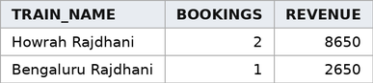
Figure 17. Output of Q16 – Advanced Query 3 (2 rows)
Q17. Advanced Query 4: List reservations whose fare is above the average fare (SUBQUERY).
SELECT r.PNR, p.Name, r.Fare
FROM Reservation r
JOIN Passenger p
ON r.Passenger_ID = p.Passenger_ID
WHERE r.Fare > (SELECT AVG(Fare)
FROM Reservation)
ORDER BY r.Fare DESC;
Output:
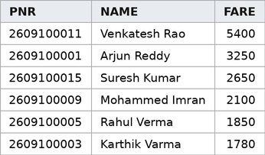
Figure 18. Output of Q17 – Advanced Query 4 (6 rows)
Q18. Advanced Query 5: Find passengers who have never made a reservation (NOT EXISTS).
SELECT p.Passenger_ID, p.Name
FROM Passenger p
WHERE NOT EXISTS (
SELECT 1 FROM Reservation r
WHERE r.Passenger_ID = p.Passenger_ID);
Output:
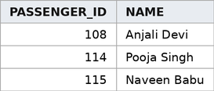
Figure 19. Output of Q18 – Advanced Query 5 (3 rows)
Q19. Advanced Query 6: Display train schedules at platforms 1 to 5 with train and station names.
SELECT t.Train_Name, s.Station_Name,
sc.Arrival_Time, sc.Departure_Time,
sc.Platform
FROM Schedule sc
JOIN Train t ON sc.Train_ID = t.Train_ID
JOIN Station s
ON sc.Station_ID = s.Station_ID
WHERE sc.Platform BETWEEN 1 AND 5
ORDER BY sc.Platform;
Output:
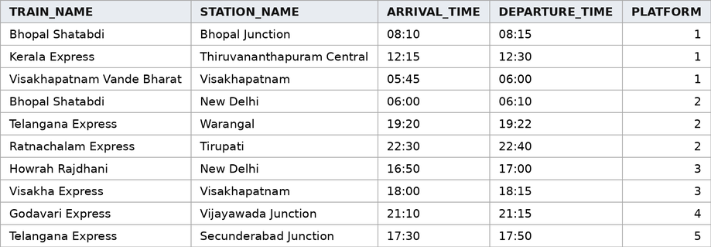
Figure 20. Output of Q19 – Advanced Query 6 (10 rows)
Q20. Advanced Query 7: Rank trains by number of reservations (INLINE VIEW + RANK window function).
SELECT Train_Name, Bookings,
RANK() OVER (ORDER BY Bookings DESC) AS Rnk
FROM (SELECT t.Train_Name, COUNT(*) AS Bookings
FROM Train t JOIN Reservation r
ON t.Train_ID = r.Train_ID
GROUP BY t.Train_Name)
ORDER BY Rnk, Train_Name;
Output:
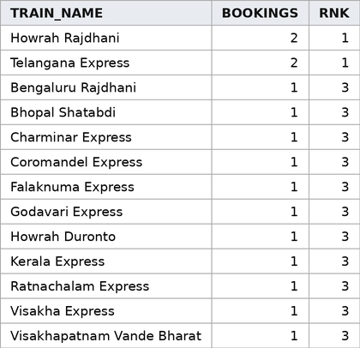
Figure 21. Output of Q20 – Advanced Query 7 (13 rows)
Q21. Advanced Query 8: Categorise fares as Low, Medium or High and show count and total per category (CASE).
SELECT CASE WHEN Fare < 1000 THEN 'Low'
WHEN Fare <= 2500 THEN 'Medium'
ELSE 'High' END AS Fare_Category,
COUNT(*) AS Reservations,
SUM(Fare) AS Total_Fare
FROM Reservation
GROUP BY CASE WHEN Fare < 1000 THEN 'Low'
WHEN Fare <= 2500 THEN 'Medium'
ELSE 'High' END;
Output:
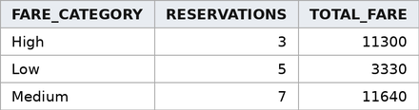
Figure 22. Output of Q21 – Advanced Query 8 (3 rows)
10. CONCLUSION
The Railway Reservation Management System provides a structured relational database solution for managing railway reservation operations. The ER model defines the required entities, attributes, keys, relationships and cardinalities, and the design organizes passengers, trains, stations, schedules, reservations and payments into six related tables. Primary keys, foreign keys and NOT NULL, UNIQUE and CHECK constraints keep the database organized and maintain valid relationships.
The database was implemented in Oracle with 15 sample records in every table (90 records in total), and 7 basic and 8 advanced SQL queries were executed and verified with their outputs. The schema was normalized up to Third Normal Form, so redundancy is avoided and passenger and train details are updated in one place only. The system can later be extended with online payments, notifications, live train tracking and analytics.
11. FUTURE ENHANCEMENTS
- Online payment integration for reservations.
- Notifications to passengers about booking, cancellation and payment status.
- Live train tracking.
- Analytics and report dashboards for railway reservation data.
- Role-based access for Admin, Passenger and Reservation Staff.
- Backup, recovery and stronger database security.
REFERENCES
- Project presentation: “Railway Reservation Management System – DBMS Project Review 1 and Review 2”, Department of Computer Science and Engineering, Aditya University, 2026.
- Korth, H. F., Silberschatz, A., and Sudarshan, S., Database System Concepts, McGraw Hill.
- Elmasri, R. and Navathe, S. B., Fundamentals of Database Systems, Pearson.
- Oracle Database Documentation, Oracle SQL Language Reference – https://docs.oracle.com/en/database/oracle/oracle-database/26/sqlrf/
- W3Schools, SQL Tutorial – https://www.w3schools.com/sql/

