|  |  |
| --- | --- |
| Internship Project Title | Automate detection of different emotions from paragraphs and predict overall emotion |
| Name of the Company | TCSion |
| Name of the Industry Mentor | Dr. Himdweep Walia |
| Name of the Institute | Amity Online University |
| Submitted By | Ravi Prakash Mishra |

|  |  |  |  |  |
| --- | --- | --- | --- | --- |
| Start Date | End Date | Total Effort (hrs.) | Project Environment | Tools used |
| 08/04/2024 | 25/07/2024 | 210 | Python, Jupyter Notebook | Pandas, NumPy, Scikit-learn, TensorFlow, Keras, Seaborn, Matplotlib |

**TABLE OF CONTENT**

1. Acknowledgements
2. Objective
3. Introduction / Description of Internship
4. Internship Activities
5. Approach / Methodology
6. Assumptions
7. Exceptions / Exclusions
8. Charts, Table, Diagrams
9. Algorithms
10. Challenges & Opportunities
11. Risk Vs Reward
12. Reflections on the Internship
13. Recommendations
14. Outcome / Conclusion
15. Enhancement Scope
16. Link to code and executable file
17. Research questions and responses

**1. Acknowledgements**

I am deeply grateful to my industry mentor, Dr. Himdweep Walia, whose guidance and unwavering support have been invaluable throughout my internship. Dr. Walia’s expertise and constructive feedback greatly enhanced my learning experience and contributed significantly to the successful completion of my project. I also extend my sincere thanks to TCSion and Amity Online University for offering me this invaluable opportunity. Their commitment to fostering educational and professional growth has been instrumental in my development. Furthermore, I would like to acknowledge the contributions of my colleagues and friends, whose insightful feedback and encouragement were crucial in navigating the challenges of the internship. Their support not only provided motivation but also enriched my understanding and approach to the tasks at hand.

**2. Objective**

The central aim of this internship project is to design, implement, and critically assess both machine learning and deep learning models specifically tailored for the task of emotional text classification. The project is driven by the objective of achieving exemplary performance across several key metrics, including accuracy, precision, recall, and F1-score. These metrics are essential for evaluating the reliability and effectiveness of the models in accurately categorizing text data based on emotional content. By focusing on these performance indicators, the project seeks to ensure that the developed models not only perform with high precision and recall but also maintain overall accuracy and balance, thereby confirming their robustness and practical applicability in real-world scenarios.

**3. Introduction / Description of Internship**

This internship is dedicated to the development and evaluation of text classification models, utilizing a range of both traditional machine learning techniques and cutting-edge deep learning approaches. The primary aim is to construct models that can effectively classify textual data into predefined categories, achieving high performance across various evaluation metrics.

The project begins with the preprocessing of textual data, which is a crucial initial step. This process involves several key activities to ensure that the text data is clean, uniform, and suitable for analysis. Tasks such as lowercasing, punctuation removal, tokenization, and the elimination of stop words are performed. These steps are vital for reducing noise and ensuring consistency in the data, which significantly impacts the performance of the subsequent models.

Once the text data is preprocessed, the project moves to the feature extraction phase. Here, the textual data is converted into numerical features that machine learning algorithms can interpret. This transformation is essential as it allows the models to process and learn from the data effectively. Techniques like Term Frequency-Inverse Document Frequency (TF-IDF) or word embeddings may be employed to represent the text data in a format suitable for machine learning and deep learning algorithms.

The core of the project involves applying various models to the prepared data. Traditional machine learning algorithms such as Logistic Regression, Naive Bayes, and Support Vector Machines (SVM) are used to create baseline models. Logistic Regression, known for its simplicity and efficiency, provides a linear approach to classification. Naive Bayes offers a probabilistic perspective, which is particularly useful for text classification tasks with large vocabularies. SVM, with its ability to handle complex decision boundaries, is employed to determine the optimal hyperplane for class separation.

In addition to these machine learning techniques, the project incorporates advanced deep learning models, specifically Long Short-Term Memory (LSTM) networks. LSTMs are designed to handle sequential data and capture long-term dependencies, which is crucial for understanding context and nuance in text. This makes them particularly effective for more complex classification tasks where the context of words and phrases plays a significant role.

The final phase of the project involves evaluating the performance of each model. Metrics such as accuracy, precision, recall, and F1-score are used to assess how well each model performs in classifying text data. Accuracy measures the proportion of correct classifications, while precision and recall provide insights into the model's ability to correctly identify positive cases and avoid false positives. The F1-score, which combines precision and recall, offers a balanced view of the model’s performance.

The significance of text classification is vast, impacting various real-world applications. For instance, spam detection systems rely on text classification to filter out unwanted emails, sentiment analysis tools use it to gauge the emotional tone of text, and topic categorization helps in organizing content based on subject matter. Each of these applications highlights the practical importance of developing robust and effective text classification models, demonstrating the relevance and impact of the work undertaken during this internship.

**4. Internship Activities**

**4.1 Data Collection -** The initial phase of the project was centered around the crucial task of data collection, which laid the foundation for building a robust and effective model. To ensure comprehensive coverage and diversity, datasets were gathered from a variety of sources. This approach was essential for capturing a wide range of text samples, thereby enhancing the model’s ability to generalize across different contexts and scenarios.

The data collection process involved three main components. First, the training data was assembled, consisting of labeled text samples. These samples were meticulously curated to provide a representative basis for training the models. The training data is pivotal as it directly influences the learning process, enabling the models to understand patterns and relationships within the text.

Next, the testing data was set aside. This dataset was reserved exclusively for evaluating the performance of the trained models. It plays a critical role in assessing how well the model performs on new, unseen data, thereby providing an unbiased measure of its effectiveness and generalization capabilities.

Finally, the validation data was utilized during the training phase. This dataset served two key purposes: fine-tuning hyperparameters and assessing the model’s performance on a subset of unseen data. By doing so, it helped in optimizing the model’s parameters and preventing overfitting, ensuring that the model’s performance was robust and reliable across different data samples.

Overall, the strategic collection and use of these datasets were fundamental in developing a model that is both accurate and versatile. The comprehensive and well-structured approach to data collection ensured that the models could be trained effectively, evaluated rigorously, and validated thoroughly, paving the way for successful text classification.

**4.2 Data Preprocessing** - Preprocessing the text data was a crucial and foundational step in preparing it for further analysis. The first stage of preprocessing involved converting all text to lowercase. This standardization process was necessary to ensure uniformity across the dataset. By transforming every character to lowercase, we eliminated inconsistencies arising from different capitalizations. This uniformity helped in accurately analyzing and processing the text data without the interference of case-sensitive discrepancies.

Following the conversion to lowercase, the next step involved removing punctuation marks. Punctuation, such as commas, periods, and exclamation points, was stripped from the text. This step was essential for cleaning the data and reducing any extraneous noise that could interfere with the analysis. Punctuation marks often serve grammatical functions but do not contribute significant semantic value in text classification tasks. Therefore, their removal helped streamline the text and focused the analysis on the core content.

Once the text was cleaned of punctuation, the process continued with tokenization. Tokenization involved splitting the text into individual words or tokens. This step is fundamental for breaking down the text into manageable and analyzable components. By dividing the text into tokens, each word could be treated as a separate entity, allowing for a more detailed and granular examination of the text. Tokenization is a key process in text analysis as it prepares the text for further computational processing, such as feature extraction and model training.

In addition to tokenization, the removal of stop words was another critical preprocessing step. Stop words are common words that appear frequently in the text but do not carry significant meaning in the context of text classification. Words like "the," "and," and "in" are examples of stop words that often do not contribute to the analytical goals of the text. By removing these stop words, we were able to focus on the more meaningful and informative parts of the text. This refinement process helps enhance the relevance of the data and improves the effectiveness of subsequent analysis and modeling.

Overall, these preprocessing steps were integral to preparing the text data for analysis. Lowercasing standardized the text, punctuation removal cleaned it, tokenization broke it into analyzable parts, and stop words removal focused the analysis on essential content. Each step was carefully executed to ensure the data was optimally prepared for accurate and effective text classification.

**4.3 Feature Extraction -** Feature extraction is a crucial phase in the text data processing pipeline, aimed at converting raw textual information into a numerical format that machine learning algorithms can effectively utilize. This transformation is necessary because machine learning models generally require numerical inputs to perform calculations and generate predictions. In this project, the feature extraction process was accomplished using the Term Frequency-Inverse Document Frequency (TF-IDF) vectorizer.

The TF-IDF vectorizer is a powerful tool for transforming text into numerical vectors. It operates on the principle of quantifying the importance of each word within the dataset. The method works in two main stages: calculating term frequency and inverse document frequency. Term Frequency (TF) measures how frequently a word appears in a document. This metric helps identify words that are common within a specific document. However, high frequency does not necessarily indicate a word's significance across the entire dataset.

To address this, the TF-IDF vectorizer also incorporates Inverse Document Frequency (IDF). IDF measures the importance of a word by considering how common or rare it is across the whole dataset. Words that appear frequently across many documents are given lower importance because they are less informative. Conversely, words that appear in fewer documents are assigned higher importance as they are more indicative of the unique content within those documents.

The combination of TF and IDF results in a numerical representation of the text that reflects both the local significance of words within individual documents and their global relevance across the entire dataset. This representation is crucial for machine learning algorithms, as it translates the qualitative content of the text into quantitative data that models can analyze and interpret.

By transforming the raw text data into these TF-IDF vectors, the feature extraction process ensures that the text is represented in a manner that captures the nuances of word importance and relevance. This numerical format allows machine learning algorithms to process the text data effectively, facilitating accurate analysis and prediction. Thus, feature extraction through TF-IDF plays a fundamental role in enabling machine learning models to work with text data in a meaningful way.

**4.4 Model Development -** The model development phase was integral to tackling the text classification problem, involving the creation and training of several distinct models to achieve effective classification performance. Following is a brief introduction of the models that we have used, however we will study these models in detail as and when we go deeper.

**4.4.1 Logistic Regression** - Logistic Regression was one of the first models developed due to its straightforward yet powerful nature. This linear model is commonly used for both binary and multiclass classification tasks. Logistic Regression operates by estimating the probabilities of different classes based on a linear combination of input features. It is favored for its interpretability, which allows for clear insights into the relationship between the features and the predicted outcomes. Additionally, its computational efficiency makes it suitable for large datasets, although it may not capture complex patterns as effectively as more sophisticated models.

4.4.2 **Naive Bayes** - Naive Bayes was another model employed in this project, distinguished by its probabilistic approach to classification. Based on Bayes' theorem, Naive Bayes operates under the assumption that features are conditionally independent given the class label. This assumption simplifies the computation of probabilities, making Naive Bayes particularly effective for text classification tasks where this independence approximation holds reasonably well. Its simplicity and efficiency make it a strong choice for handling text data, especially when computational resources are limited.

**4.4.3 Support Vector Machines -** Support Vector Machines (SVMs) were also utilized for their robust classification capabilities. SVMs excel in finding the optimal hyperplane that separates different classes with maximum margin, which is crucial for achieving high classification accuracy. This ability to handle complex decision boundaries makes SVMs particularly effective in scenarios where the classes are not linearly separable. By mapping the input features into higher-dimensional space using kernel functions, SVMs can manage intricate patterns in the data, providing a powerful classification tool.

In addition to these traditional models, **Long Short-Term Memory (LSTM)** networks were developed to enhance the handling of sequential data. As a type of **recurrent neural network (RNN)**, LSTMs are specifically designed to capture long-term dependencies and contextual relationships within sequences. This capability is essential for understanding the context and nuances in text data, where the meaning of a word or phrase often depends on its surrounding words. LSTMs mitigate the vanishing gradient problem that affects standard RNNs, enabling them to maintain relevant information across longer sequences and improving their performance on tasks that require an understanding of context.

Each of these models was carefully developed and trained to address the specific needs of the text classification task, leveraging their unique strengths to contribute to the overall effectiveness of the classification system.

**4.4 Hyperparameter Tuning -** Hyperparameter tuning was a crucial step in enhancing the performance of each model, ensuring that they operate at their optimal settings. This process was carried out using GridSearchCV, a methodical approach designed to identify the best hyperparameters for each model.

GridSearchCV operates by exploring a predefined set of hyperparameter values for each model. The essence of this approach lies in its exhaustive search strategy, which involves specifying a grid of possible values for each hyperparameter and then systematically evaluating every combination of these values. This comprehensive search allows for a thorough exploration of the parameter space, ensuring that all potential configurations are considered.

For each combination of hyperparameters, GridSearchCV trains and evaluates the model using cross-validation. This means that the data is split into several subsets, or folds, and the model is trained on some of these folds while being tested on the remaining fold. This process is repeated for each combination of hyperparameters, and the performance metrics are averaged to obtain a reliable estimate of the model’s performance. By doing so, GridSearchCV helps to mitigate the risk of overfitting and provides a robust assessment of how different hyperparameter settings impact the model’s performance.

The result of this systematic search is the identification of the hyperparameter configuration that yields the best performance according to the chosen evaluation metric, such as accuracy, precision, recall, or F1-score. This optimal set of hyperparameters is then used to retrain the model on the entire training dataset, ensuring that it is fine-tuned to achieve the highest possible performance.

By utilizing GridSearchCV for hyperparameter tuning, each model was rigorously tested against a variety of parameter settings, allowing for a meticulous refinement process. This approach ensures that the models are not only well-calibrated but also capable of delivering the best possible results in the given classification task.

**4.5 Model Evaluation -** Model evaluation was a multi-faceted process that involved a range of metrics to thoroughly assess the performance and effectiveness of each classification model. Each metric provided a different perspective on how well the models were performing in terms of accuracy, precision, recall, and overall effectiveness.

**Accuracy** was the first metric considered, as it provides a straightforward measure of how many of the total predictions made by the model were correct. This metric is crucial for understanding the general performance of the model, indicating the proportion of correct predictions out of all predictions made. However, accuracy alone does not account for the balance between different classes, especially in cases where there are imbalances in class distribution.

**Precision** was then calculated to assess the quality of positive identifications made by the model. Precision measures the proportion of true positive identifications relative to the total number of positive identifications. In other words, it tells us how many of the instances classified as positive were actually correct. High precision indicates that the model makes fewer false positive errors, which is particularly important in applications where false positives can be costly or problematic.

**Recall** was evaluated next, focusing on the model’s ability to identify all relevant instances within the dataset. Recall measures the proportion of actual positives that were correctly identified by the model. This metric highlights the model’s effectiveness in capturing all relevant cases, even if it means including some incorrect predictions. High recall is crucial in scenarios where missing relevant instances could have significant negative consequences.

The **F1 Score** was used to provide a comprehensive view of model performance by balancing both precision and recall. The F1 Score is the harmonic mean of precision and recall, offering a single metric that combines both aspects into one measure of performance. This balance is particularly useful in scenarios where both precision and recall are important, and it helps to ensure that improvements in one metric do not come at the expense of the other.

To further enhance the evaluation, confusion matrices were employed to provide a detailed visualization of each model’s performance across different classes. A confusion matrix displays the number of true positives, true negatives, false positives, and false negatives for each class, allowing for a nuanced understanding of how well the model is performing in distinguishing between different classes. This visual tool helps in identifying patterns of misclassification and areas where the model may need improvement.

Overall, the combination of these metrics provided a comprehensive assessment of each model’s performance, ensuring that all aspects of the classification task were thoroughly evaluated and understood. This approach allowed for a detailed analysis of how well each model performed and highlighted areas for potential improvement.

**5. Approach / Methodology**

The methodology adopted for this project involved a systematic approach encompassing several key steps to ensure comprehensive data processing, insightful exploratory data analysis, effective text vectorization, and robust model building and training. Each phase of the methodology was designed to address different aspects of the text classification task, ensuring that the final models were well-trained and capable of delivering high performance.

**Data Processing** was the foundational step in the methodology. This phase involved collecting and preparing the raw data to make it suitable for analysis. It began with data collection, where diverse datasets were sourced to ensure that the model would be exposed to a broad range of text samples. This diversity was crucial for building a robust model that could generalize well across different types of text. Following data collection, preprocessing was undertaken to clean and standardize the data. This involved converting all text to lowercase to maintain uniformity, removing punctuation to reduce noise, and tokenizing the text to split it into individual words or tokens. Stop words, which are common but non-informative words, were also removed to focus on the more meaningful parts of the text. These preprocessing steps were essential for ensuring that the data was clean and consistent, thereby enhancing the quality of the input for subsequent analysis.

**Exploratory Data Analysis** (EDA) was the next step, where the data was analyzed to gain insights into its structure and characteristics. EDA involved examining the distribution of text samples, identifying any patterns or anomalies, and understanding the relationships between different features. This phase was critical for uncovering insights that could inform the choice of features and models. By visualizing the data and performing statistical analyses, potential issues such as class imbalances or inconsistencies in the data were identified and addressed.

**Text Vectorization** was another crucial step, transforming the raw text data into a numerical format that machine learning algorithms could process. This was achieved using the Term Frequency-Inverse Document Frequency (TF-IDF) vectorizer. The TF-IDF method calculates the importance of each word within the context of the entire dataset, converting text into numerical vectors that reflect the relative importance of each word. This transformation enabled the machine learning models to analyze and interpret the text data effectively. The choice of TF-IDF for vectorization was motivated by its ability to capture the significance of words based on their frequency and distribution across the documents.

**Model Building and Training** involved developing and fine-tuning various machine learning and deep learning models to classify the text data. Several models were employed, each with its own strengths and characteristics. Logistic Regression, a simple yet effective linear model, was used for its interpretability and efficiency in handling both binary and multiclass classification tasks. Naive Bayes, a probabilistic classifier based on Bayes' theorem, was chosen for its effectiveness with text data and its assumption of feature independence. Support Vector Machines (SVMs) were utilized for their capability to find the optimal hyperplane that separates different classes, making them a powerful classification tool. Long Short-Term Memory (LSTM) networks, a type of recurrent neural network (RNN), were also developed to capture long-term dependencies in sequential data, enhancing the model’s ability to understand context within the text.

**Hyperparameter Tuning** was conducted to optimize the performance of each model. This process involved using GridSearchCV to systematically explore a range of parameter values and identify the optimal settings for each model. By evaluating different combinations of hyperparameters, GridSearchCV ensured that each model was fine-tuned to achieve the best possible performance.

**Model Evaluation** was the final step, where the performance of each model was assessed using a variety of metrics. Accuracy, precision, recall, and the F1 Score were calculated to evaluate the effectiveness of the models. Additionally, confusion matrices were used to visualize and describe the performance of each classification model, providing a comprehensive view of how well the models performed across different classes. This thorough evaluation helped in understanding the strengths and limitations of each model and guided the selection of the most effective approach for the text classification task.

Following are the details of different functions:

**5.1. Data Loading and Preprocessing Functions**

**5.1.1 Loading Data -** The load_data function is pivotal in the data preparation process as it facilitates the initial step of importing data from a CSV file into a Pandas DataFrame. This function is called with the path to the CSV file, and it reads the contents into a structured DataFrame format. By converting the raw data into a DataFrame, the function enables users to work with a tabular data structure that supports efficient data manipulation and analysis. The DataFrame serves as the foundation for subsequent data processing steps, allowing for easy access and organization of the data. This structured format is essential for performing various data operations, such as cleaning, exploration, and model training.

**5.1.2 Text Cleaning -** The clean_text function is responsible for preparing the text data by performing several crucial cleaning operations. The function first converts all characters in the text to lowercase, which standardizes the text and eliminates any discrepancies due to case differences. This uniformity is crucial for accurate text analysis, as it ensures that words are treated consistently regardless of their original casing. Following the conversion to lowercase, the function removes punctuation and special characters using regular expressions. This step is important for eliminating extraneous symbols that could introduce noise into the data, thereby ensuring that the text is clean and focused on the essential content. The cleaned text produced by this function is then ready for further processing, such as tokenization or analysis.

**5.1.3 Data Preprocessing** - The preprocess_data function extends the text-cleaning process to an entire DataFrame, applying the clean_text function to each entry in the 'text' column. This comprehensive preprocessing step is vital for ensuring that all text data is consistently cleaned and prepared for analysis. By targeting the 'text' column, the function standardizes the text across the entire dataset, removing unwanted characters and formatting issues that could affect the quality of the data. The cleaned text data is then in a uniform format, making it suitable for subsequent analyses or machine learning tasks. This preprocessing ensures that the text data is as clean and reliable as possible, reducing the potential for errors and improving the overall quality of the data used in later stages of the project.

**5.1.4 Label Encoding -** The encode_labels function is designed to convert categorical labels into a numerical format that can be processed by machine learning algorithms. This function utilizes a LabelEncoder to transform categorical labels into integer values, which are then subjected to one-hot encoding. One-hot encoding generates a binary matrix where each category is represented by a unique vector, allowing machine learning models to interpret and learn from categorical data effectively. This transformation is crucial for models that require numerical inputs, as it enables the algorithms to process categorical labels in a way that aligns with their computational requirements. The resulting binary matrix facilitates the training of machine learning models by providing a numerical representation of categorical data.

**5.1.5 Data Splitting -** The split_data function is essential for preparing the data for machine learning tasks by dividing a DataFrame into features and labels. This function extracts the 'text' column to serve as the feature set and the 'label' column to act as the target variable. The separation of features and labels is a critical step in the data preparation process, as it allows the model to learn from the features (text data) and make predictions based on the target labels. By clearly delineating features and labels, this function ensures that the data is organized in a way that supports effective model training and evaluation. The ability to split data into features and labels is fundamental for developing machine learning models that can be trained and tested on distinct portions of the dataset, ultimately leading to more accurate and reliable predictions.

**5.2. Exploratory Data Analysis (EDA) Functions**

**5.2.1 Label Distribution Visualization** - The plot_label_distribution function plays a crucial role in understanding the distribution of labels within the dataset. This function generates a count plot, which visually represents the frequency of each label across the dataset. By examining the count plot, one can quickly identify any imbalances among the different classes. For instance, if some labels are significantly underrepresented compared to others, it may indicate a need for data augmentation or rebalancing techniques. The function also includes an option to save the generated plot to a specified file path. If no file path is provided, the plot is displayed directly, allowing for immediate visual inspection. This visualization helps in assessing the dataset's composition, guiding the subsequent steps in data processing and model training.

**5.2.2 Text Length Distribution Visualization** - The plot_text_length_distribution function offers valuable insights into the variability of text lengths within the dataset. It accomplishes this by creating a histogram that illustrates the distribution of text lengths. The function first calculates the length of each text entry, which is then used to plot the histogram. This visualization helps in understanding the range and distribution of text lengths, which can be important for tailoring preprocessing steps and model configurations. For example, if the text lengths vary widely, it might be necessary to implement padding or truncation to ensure consistency in model input. Like the label distribution plot, this function also provides an option to save the histogram to a file, facilitating documentation and further analysis.

**5.2.3 Word Cloud Visualization -** The plot_word_cloud function provides a visually engaging way to explore the most frequently occurring words in the dataset through a word cloud. A word cloud is a graphical representation where the size of each word reflects its frequency in the text data. By generating a word cloud, this function enables a quick overview of the prominent terms and their relative importance within the dataset. This visualization is particularly useful for identifying key themes and trends in the text data. It can also help in detecting common words or phrases that may need to be addressed during preprocessing, such as removing stop words or handling synonyms. The function includes an option to save the word cloud to a specified file, making it easy to incorporate this visual representation into reports or presentations.

**5.3 Text Vectorization Functions**

**5.3.1 Tokenization and Padding** - The tokenize_and_pad function is a critical step in preparing text data for machine learning models. This function begins by performing tokenization, which involves breaking down text into individual words or tokens and mapping these tokens to numerical indices. Tokenization allows for the conversion of textual data into a format that can be easily processed by algorithms. This mapping is typically based on the frequency of words within the dataset, where more frequent words are assigned lower indices and less frequent ones receive higher indices.

Following tokenization, the function applies padding to ensure that all text sequences have the same length. Padding involves adding special tokens to sequences that are shorter than the desired length, thereby standardizing the input size. This step is essential because most machine learning models, especially deep learning models like LSTMs and CNNs, require fixed-length inputs for consistent processing. By padding sequences, the function ensures that the text data is uniform, which helps in maintaining the integrity of the input data and improving the efficiency of model training and evaluation.

**5.3.2 TF-IDF Vectorization -** The tfidf_vectorize function employs the Term Frequency-Inverse Document Frequency (TF-IDF) method to convert text data into numerical vectors. TF-IDF is a powerful text vectorization technique that measures the importance of a word in a document relative to its frequency across a collection of documents or corpus. The term frequency (TF) component calculates how frequently a word appears in a document, while the inverse document frequency (IDF) component adjusts the term frequency based on how common or rare the word is across all documents in the corpus.

By combining these two measures, TF-IDF provides a weighted representation of each word, highlighting terms that are significant within specific documents but not too common across the entire corpus. This numerical representation reflects both the relevance and uniqueness of words, making it a valuable tool for text classification and information retrieval. The tfidf_vectorize function transforms the raw text data into these TF-IDF vectors, which can then be fed into machine learning models to analyze and predict text-related outcomes effectively. This approach enhances the model's ability to discern important features from the text data and improves overall classification performance.

**5.4. Model Building and Training Functions**

**5.4.1 Training and Evaluating the Logistic Regression Model**

**Setting Up Hyperparameters:**

The process begins with defining a set of hyperparameters for the Logistic Regression model. This step is crucial for optimizing the model's performance by experimenting with different configurations. In this case, two hyperparameters are specified: C and solver. The C parameter, which controls the regularization strength, is varied across a range of values: 0.01, 0.1, 1, 10, and 100. Smaller values of C indicate stronger regularization, which can prevent overfitting by penalizing large coefficients, while larger values allow for less regularization and may lead to a better fit on the training data but with a higher risk of overfitting. The solver parameter determines the algorithm used for optimization during model training. Three options are provided: 'newton-cg', 'lbfgs', and 'liblinear'. Each solver has different characteristics and computational requirements, affecting the training process and convergence speed.

**Training the Model:**

The train_ml_model function is then invoked with the Logistic Regression model and the specified hyperparameters. This function performs several key tasks: it trains the model using the training data (X_train_tfidf and y_train_int) and evaluates its performance on the testing data (X_test_tfidf and y_test_int). The training involves fitting the Logistic Regression model to the training dataset, which consists of feature vectors represented in the TF-IDF format and corresponding integer-encoded labels. The model adjusts its internal parameters according to the chosen hyperparameters and the training data, aiming to learn patterns that will enable it to make accurate predictions on new, unseen data.

**Evaluating Model Performance:**

After training, the model's performance is assessed to determine its effectiveness. This evaluation is conducted using the testing dataset, which allows for measuring how well the model generalizes to data it has not encountered during training. The accuracy of the model is computed as a key performance metric, reflecting the proportion of correctly predicted instances out of the total number of predictions made. The train_ml_model function returns both the trained Logistic Regression model and its accuracy score, providing a quantitative measure of how well the model performs in classifying text data. This information is crucial for comparing the Logistic Regression model's performance with other models and understanding its suitability for the given classification task.

**5.4.2 Training and Evaluating the Naive Bayes Model**

**Setting Up Hyperparameters:**

The first step in the process involves defining hyperparameters for the Naive Bayes model, specifically the alpha parameter for the Multinomial Naive Bayes classifier. This parameter is used for smoothing the probabilities calculated by the model, which helps in handling cases where some words may not appear in the training data but do appear in the testing data. The smoothing effect is controlled by the value of alpha. In this case, three different values are considered: 0.5, 1.0, and 1.5. Each value represents a different degree of smoothing, with larger values providing more smoothing. The choice of alpha affects the model's ability to generalize and handle unseen data.

**Training the Model:**

The train_ml_model function is employed to train the Naive Bayes model with the specified hyperparameters. This function facilitates the training process by fitting the Multinomial Naive Bayes model to the training data, which includes feature vectors represented in the TF-IDF format and integer-encoded labels. The training process involves applying the Naive Bayes algorithm to learn from the data, using the provided alpha values to adjust the model's parameters and enhance its performance. The goal is to determine the optimal value of alpha that allows the model to best capture the underlying patterns in the text data.

**Evaluating Model Performance:**

Once the model is trained, its performance is evaluated using the testing dataset. This step assesses how well the Naive Bayes model generalizes to new, unseen data. The evaluation focuses on the accuracy metric, which measures the proportion of correct predictions made by the model out of the total number of predictions. The train_ml_model function returns both the trained Naive Bayes model and its corresponding accuracy score. This score provides insight into the model's effectiveness in classifying text data and helps compare its performance against other models in terms of accuracy. By analyzing the accuracy, one can assess how well the Naive Bayes model performs for the given text classification task and determine its suitability for deployment in practical scenarios.

**5.4.3 Training and Evaluating the SVM Model**

**Defining Hyperparameters:**

The initial step in training the Support Vector Machine (SVM) model involves setting up a range of hyperparameters. In this case, two key hyperparameters are defined: C and kernel. The C parameter, which can take on values such as 0.01, 0.1, 1, 10, and 100, controls the trade-off between achieving a low training error and minimizing the classification error on the test data. A lower value of C creates a softer margin, allowing for more misclassifications on the training set, while a higher value of C results in a harder margin with fewer misclassifications. The kernel parameter specifies the type of kernel function used by the SVM. The options provided are 'linear' and 'rbf' (radial basis function). The linear kernel is used for linearly separable data, while the rbf kernel can handle non-linear data by mapping it into a higher-dimensional space.

**Training the Model:**

The train_ml_model function is used to train the SVM model with the specified hyperparameters. This function involves fitting the Support Vector Machine to the training data, which includes feature vectors in TF-IDF format and integer-encoded labels. During training, the SVM algorithm attempts to find the optimal hyperplane that separates different classes in the data. The choice of hyperparameters, including the value of C and the kernel type, plays a critical role in determining the model’s performance. The function systematically evaluates different combinations of these hyperparameters to identify the best configuration for the SVM model.

**Evaluating Model Performance:**

After training the model, its performance is assessed using the testing dataset. This evaluation step measures how well the trained SVM model generalizes to new, unseen data. The accuracy metric is used to determine the proportion of correctly classified instances out of the total number of predictions. The train_ml_model function returns both the trained SVM model and its accuracy score. This accuracy score reflects how effectively the model has learned from the training data and how well it performs on the test data. Evaluating the SVM model's accuracy provides valuable insights into its ability to correctly classify text data, and it helps in comparing its performance with other models, ultimately guiding decisions on the model's suitability for practical applications.

**5.4.4 Building an LSTM Model**

**Constructing the LSTM Architecture:**

The build_lstm_model function is designed to create a sophisticated Long Short-Term Memory (LSTM) neural network tailored for text classification tasks. LSTM networks are a type of recurrent neural network (RNN) that excels in processing and making predictions based on sequential data, such as text. The function begins by defining the structure of the LSTM model, which is a multi-layered architecture optimized to handle complex text classification challenges.

**Embedding Layer:**

The first component of the LSTM model is the embedding layer. This layer transforms the input text, represented as integer indices, into dense vectors of fixed size. Each word in the vocabulary is mapped to a dense vector that captures semantic relationships and contextual meanings. The embedding layer learns these dense representations during training, which allows the model to leverage rich word embeddings that encode more nuanced features of the text compared to simple one-hot encoding. This representation is crucial for improving the model’s ability to understand and classify text based on the meanings of words and their contexts.

**Bidirectional LSTM Layer:**

Next, the model incorporates a Bidirectional LSTM layer. This layer consists of two LSTM networks running in parallel—one processing the text sequence from the beginning to the end (forward direction) and the other from the end to the beginning (backward direction). By processing the text in both directions, the Bidirectional LSTM can capture dependencies and contextual information from both the past and future parts of the sequence. This approach is particularly useful in text classification because it allows the model to understand the context more comprehensively, improving its ability to classify text based on both preceding and succeeding words.

**Dense Output Layer:**

Following the Bidirectional LSTM layer, the model includes a Dense output layer. This layer is responsible for generating the final classification predictions. It uses a softmax activation function, which outputs probabilities for each class. The softmax function converts the raw output scores from the Dense layer into probabilities that sum up to one, allowing the model to assign a probability to each class and make a final classification decision based on the highest probability.

**Compiling the Model:**

Once the model architecture is defined, the build_lstm_model function compiles the model to prepare it for training. It uses categorical cross-entropy as the loss function, which is suitable for multi-class classification problems. Categorical cross-entropy measures the difference between the predicted probabilities and the actual class labels, guiding the model to minimize this difference during training. Additionally, the model is optimized using the Adam optimizer, an efficient algorithm that adjusts the learning rate dynamically based on the training progress. The combination of categorical cross-entropy loss and the Adam optimizer ensures that the LSTM model is effectively trained to achieve high accuracy in classifying text data.

Overall, the build_lstm_model function constructs a robust LSTM neural network that integrates advanced components to handle text classification tasks effectively. The embedding layer provides rich word representations, the Bidirectional LSTM captures contextual information, and the Dense output layer delivers accurate classification results. The model’s compilation with categorical cross-entropy and Adam optimization ensures a well-rounded approach to training and evaluating the LSTM model.

**5.4.5 Building a CNN Model**

**Designing the CNN Architecture:**

The build_cnn_model function is responsible for constructing a Convolutional Neural Network (CNN) tailored for the task of text classification. CNNs, traditionally used for image processing, have been effectively adapted for text classification due to their ability to capture spatial hierarchies and patterns within sequences. This function outlines a multi-layered CNN architecture designed to process and classify text data efficiently, leveraging convolutional operations and pooling mechanisms to extract meaningful features from the text.

**Embedding Layer:**

The architecture begins with an embedding layer, which plays a critical role in converting raw text data into a format that the CNN can process. In this layer, text input, typically represented as sequences of word indices, is transformed into dense vectors of fixed size. These dense vectors capture the semantic meanings of words, allowing the model to learn rich word representations during training. By embedding words into dense vectors, the CNN can effectively leverage semantic similarities and contextual information inherent in the text, which enhances the model's performance in classification tasks.

**1D Convolutional Layer:**

Following the embedding layer, the model incorporates a 1D convolutional layer. This layer applies convolutional filters across the sequence of embedded word vectors to detect patterns and features in the text. Unlike traditional 2D convolutions used in image processing, 1D convolutions are designed to handle sequential data, capturing local patterns such as phrases or key sequences of words. The convolutional filters slide across the text data, extracting features such as word n-grams, which are crucial for identifying specific patterns or semantic structures within the text. By learning these features, the CNN can differentiate between various types of text data and improve its classification accuracy.

**Global Max Pooling Layer:**

After the convolutional layer, the model includes a global max pooling layer. This layer is designed to reduce the dimensionality of the feature maps generated by the convolutional layer. It works by selecting the maximum value from each feature map, effectively summarizing the most important features across the entire sequence. The global max pooling layer helps to mitigate the risk of overfitting by reducing the number of parameters in the model and emphasizing the most significant features detected by the convolutional filters. This dimensionality reduction step is crucial for maintaining computational efficiency while preserving the key information necessary for accurate classification.

**Dense Layers for Classification:**

The CNN model concludes with a series of dense layers that perform the final classification task. These layers take the pooled features and process them through fully connected neurons, enabling the model to make predictions based on the extracted features. The dense layers typically include one or more hidden layers followed by an output layer with a softmax activation function. The softmax function converts the raw output scores into probabilities for each class, allowing the model to make a final classification decision based on the highest probability. This approach ensures that the CNN can accurately classify text into the appropriate categories.

**Compiling the Model:**

As with the LSTM model, the CNN model is compiled with categorical cross-entropy as the loss function and the Adam optimizer for training. Categorical cross-entropy is well-suited for multi-class classification problems, as it measures the difference between predicted probabilities and actual class labels. The Adam optimizer adjusts the learning rate dynamically during training, helping the model converge more quickly and efficiently. Together, these choices ensure that the CNN model is optimized for high performance in text classification tasks.

In summary, the build_cnn_model function constructs a CNN that effectively processes and classifies text data. The embedding layer provides rich word representations, the 1D convolutional layer extracts important patterns, and the global max pooling layer reduces dimensionality. The dense layers handle the final classification, while categorical cross-entropy and the Adam optimizer guide the training process. This well-rounded architecture allows the CNN to perform robustly and accurately in classifying text data.

**Training and Evaluating BiLSTM and CNN Model:**

The `train_and_evaluate_model` function handles the training and evaluation of a deep learning model. It employs early stopping to prevent overfitting by halting training when validation loss ceases to improve. The function trains the model using the provided training and validation data, evaluates it on test data, and saves the trained model to a file. It returns the training history, test loss, and test accuracy, which are crucial for assessing model performance.

These functions collectively support the end-to-end process of data preparation, analysis, and modeling, ensuring that each step from data loading to model evaluation is handled effectively.

**5.5 Hyperparameter Tuning -** To maximize the performance of each model, hyperparameter tuning was performed using GridSearchCV. This process involved exploring a range of parameter values systematically to identify the best settings for each model. By evaluating various combinations of hyperparameters, GridSearchCV ensured that each model was fine-tuned to achieve optimal performance, enhancing the overall accuracy and effectiveness of the classification.

**5.6 Model Evaluation** - Model evaluation was conducted using a range of metrics to thoroughly assess performance. Accuracy was measured to determine the proportion of correct predictions overall. Precision was evaluated to assess the accuracy of positive identifications. Recall was examined to gauge the proportion of actual positives that were correctly identified. The F1 Score, which balances precision and recall, provided a comprehensive measure of model performance. Additionally, confusion matrices were used to visualize the results, offering a detailed breakdown of the model’s performance across different classes. This multifaceted evaluation approach ensured a thorough understanding of how well each model performed and highlighted areas for improvement.

**6. Assumptions**

Several critical assumptions underpinned the development and evaluation of the models in this project. Firstly, it is assumed that the dataset accurately reflects real-world scenarios. This assumption is crucial as it implies that the data used for training and testing the models is representative of the types of text data the models will encounter in practical applications. By ensuring that the dataset encompasses a diverse range of text samples, the models are better equipped to generalize and perform well in real-world settings.

Secondly, the accuracy and reliability of the dataset labels are fundamental to the effectiveness of the models. It is assumed that the labels associated with the text samples are precise and dependable. This accuracy in labeling ensures that the models learn from correctly identified examples, which directly impacts the quality of the model's predictions. Reliable labels help in building models that can accurately classify new, unseen data based on the patterns learned during training.

Finally, it is assumed that the models chosen for this text classification task are well-suited to the nature of the problem. Each model was selected based on its ability to handle text data effectively and its suitability for the specific classification challenges posed by the dataset. This includes leveraging models with proven performance in text classification, such as Logistic Regression, Naive Bayes, Support Vector Machines (SVM), and Long Short-Term Memory (LSTM) networks. The selection process was guided by the models’ ability to manage text data and their historical performance in similar tasks, ensuring that the approaches employed are appropriate for achieving accurate and reliable classification results.

**7. Exceptions / Exclusions**

In the scope of this project, certain advanced techniques and methods were deliberately excluded due to practical constraints and project requirements. Notably, advanced models such as transformers, including BERT (Bidirectional Encoder Representations from Transformers), were not incorporated into the model development process. The decision to exclude these models was primarily driven by computational limitations. Transformers, while offering state-of-the-art performance in many natural language processing tasks, require substantial computational resources for both training and inference. These resources include high-performance hardware and extensive processing time, which were beyond the available capacity for this project. Consequently, the focus was shifted to models that, while potentially less advanced, were more feasible within the project's computational constraints.

Additionally, no data augmentation techniques were applied to the dataset. Data augmentation methods, which involve artificially expanding the dataset by creating modified versions of existing samples, were not utilized in this project. The absence of data augmentation was a deliberate choice, reflecting a strategic decision to work with the original dataset as provided. Data augmentation can enhance model performance by introducing variability and increasing the amount of training data; however, the project scope and resources did not encompass these techniques. By forgoing data augmentation, the project maintained a focus on evaluating and optimizing models within the confines of the existing data, ensuring that the findings and performance metrics reflect the models' capabilities with the available dataset.

**8. Charts, Tables, Diagrams**

**8.1 Exploratory Data Analysis**

**8.1.1 Detailed Explanation of Label Distribution Chart:**

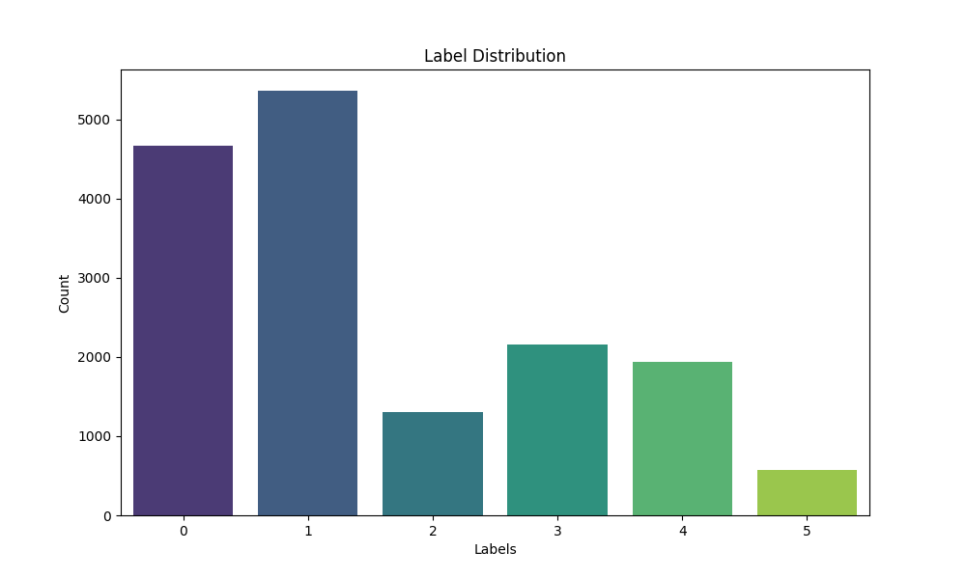

The label distribution chart presented provides a visual representation of the frequency of each label within our dataset. This dataset categorizes text data into six distinct emotional labels: Sad, Happy, Love, Anger, Fear, and Surprise. The X-axis of the chart enumerates these labels from 0 to 5, while the Y-axis quantifies the number of instances assigned to each label.

**Label 0**, representing Sad, comprises approximately 4500 instances, making it one of the more prevalent categories in the dataset. This significant representation indicates a substantial amount of text data classified under this emotion, suggesting either a high occurrence of this sentiment in the source data or a tendency in the annotation process to identify and label expressions of sadness frequently.

**Label 1**, denoting Happy, is the most dominant category with about 5500 instances. This prevalence suggests that the dataset contains a considerable amount of text data that conveys happiness. The large volume of data in this category can be advantageous for training models to recognize positive emotions accurately, though it also contributes to the overall imbalance in the dataset.

**Label 2**, associated with Love, is represented by around 1000 instances, making it one of the least frequent categories. This lower frequency can present challenges in training robust models to detect expressions of love, as the model will have less data to learn from.

**Labels 3 and 4**, corresponding to Anger and Fear respectively, each have approximately 2000 instances. While these categories are less frequent than Sad and Happy, they are more common than Love and Surprise. The moderate frequency of these labels indicates a need for careful model training to ensure these emotions are recognized effectively without being overshadowed by the more dominant categories.

**Label 5**, signifying Surprise, has the fewest instances at around 500. This minimal representation highlights a significant imbalance and points to a potential difficulty in training models to accurately identify surprise. The scarcity of data in this category can lead to underfitting, where the model fails to generalize well to new data expressing this emotion.

**Implications of Imbalanced Dataset**

The evident imbalance in label distribution poses a critical challenge for developing accurate and fair machine learning models. Models trained on imbalanced data tend to be biased towards the majority classes, leading to poor performance on minority classes. For instance, a model might perform exceptionally well in predicting Happy sentiments but fail to accurately identify Love or Surprise due to their lower representation in the dataset.

**Strategies for Addressing Imbalance**

To mitigate the adverse effects of data imbalance, several strategies can be employed. Resampling techniques such as oversampling the minority classes (Love and Surprise) or undersampling the majority classes (Happy and Sad) can help achieve a more balanced dataset. Alternatively, implementing class weights in the model training process can make the model pay more attention to the minority classes. This adjustment ensures that errors in predicting minority classes are penalized more heavily, thereby encouraging the model to improve its performance on these underrepresented categories.

**Evaluation Metrics for Imbalanced Data**

When dealing with imbalanced datasets, traditional evaluation metrics such as accuracy may not provide a complete picture of the model’s performance. It is crucial to incorporate additional metrics such as precision, recall, and F1-score. Precision measures the accuracy of the positive predictions, recall assesses the model’s ability to identify all positive instances, and F1-score provides a harmonic mean of precision and recall. These metrics offer a more comprehensive evaluation, particularly for minority classes, and are essential for ensuring the model performs well across all categories.

We can say that the label distribution chart underscores the need for addressing data imbalance to develop robust and fair machine learning models. By employing appropriate resampling techniques, adjusting class weights, and utilizing comprehensive evaluation metrics, we can improve the model’s ability to accurately classify text data across all emotional labels.

**8.1.2 Detailed Explanation of Distribution of Emotions Chart**

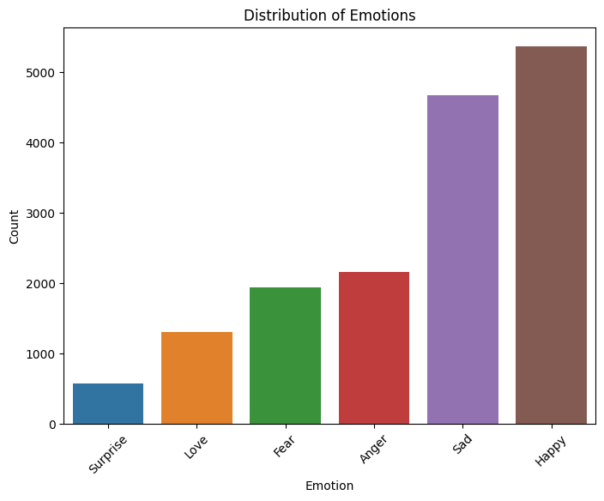

The "Distribution of Emotions" chart provides a comprehensive visualization of the frequency of different emotional labels within the dataset. The X-axis represents the six emotion categories—Surprise, Love, Fear, Anger, Sad, and Happy—while the Y-axis denotes the count of instances for each emotion.

**Observations:**

**1. Surprise:** The emotion category "Surprise" is the least represented in the dataset, with just around 500 instances. This low count indicates that surprise-related expressions are relatively rare in the data source. Such a low representation can pose challenges for training machine learning models, as they may struggle to accurately identify and classify instances of surprise due to insufficient training examples.

**2. Love:** The "Love" category has approximately 1000 instances. While this count is higher than that of Surprise, it is still relatively low compared to other emotions. This indicates that expressions of love are not as frequent in the dataset. Consequently, the model may require additional techniques such as data augmentation or synthetic data generation to improve its performance on this emotion category.

**3. Fear:** With around 2000 instances, the "Fear" category has a moderate representation. This suggests that fear-related expressions are more common than love and surprise but still less frequent than some of the other emotions. The moderate count provides a better foundation for the model to learn from, although it is important to ensure the model does not become biased towards the more prevalent emotions.

**4. Anger:** The "Anger" category is also represented by approximately 2000 instances. Similar to Fear, this moderate frequency indicates a balanced presence in the dataset. However, the dataset's overall imbalance means that the model's ability to accurately classify anger will depend on how well it handles the disproportionately larger categories.

**5. Sad:** "Sad" is one of the more prevalent emotions in the dataset, with about 4500 instances. This substantial count signifies that expressions of sadness are relatively common in the data source. The high representation provides a robust foundation for the model to learn from and accurately classify sadness. However, it also contributes to the dataset's overall imbalance, which needs to be addressed to prevent bias towards this category.

**6. Happy:** The emotion "Happy" is the most dominant category, with approximately 5500 instances. This high frequency suggests that expressions of happiness are very common in the dataset. While this abundance ensures the model can learn to classify happy instances with high accuracy, it also risks overshadowing the less frequent emotions, potentially leading to a biased model that performs poorly on minority classes.

**8.1.3 Detailed Explanation of Text Length Distribution Chart**

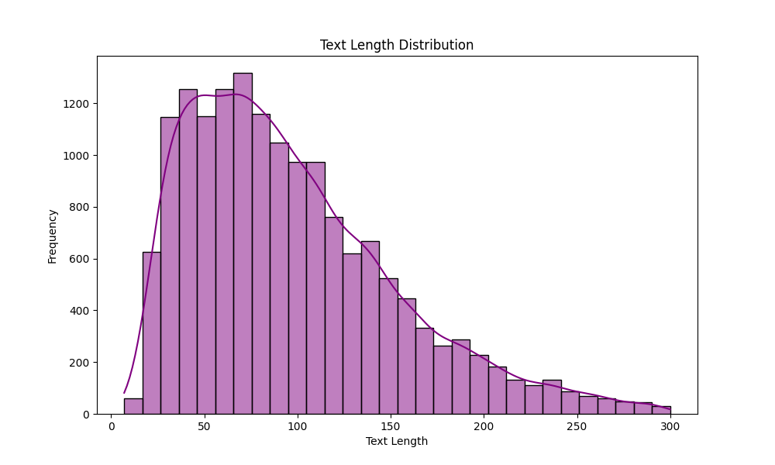

The "Text Length Distribution" chart provides a comprehensive visualization of the frequency of different text lengths within the dataset. The x-axis represents the text length measured in characters, ranging from 0 to 300, while the y-axis denotes the count of instances for each text length.

**Observations:**

**Peak Frequency:** The chart shows that the text lengths between approximately 50 to 80 characters have the highest frequency, with around 1200 instances at the peak. This indicates that most texts in the dataset are of this length. The high count in this range suggests that the dataset predominantly consists of relatively short texts, which could be typical of certain types of text data like tweets or short messages.

**Right Skew:** The distribution is right-skewed, as evidenced by the gradual decline in frequency after the peak. Text lengths longer than 80 characters become progressively less common. This skewness indicates that while short texts are very common, longer texts are much rarer. The right tail extends towards higher text lengths, up to 300 characters, but with significantly lower frequencies.

**Rapid Decline:** There is a rapid decline in frequency after the peak, particularly noticeable beyond 100 characters. Text lengths in the range of 100 to 150 characters show a substantial decrease in instances, suggesting that texts of such lengths are not as frequent in the dataset. This rapid decline highlights a clear preference for shorter texts within the data source.

**Long Tail:** Although the majority of texts are short, the chart shows a long tail extending to the right, indicating the presence of some much longer texts. These longer texts, ranging up to 300 characters, occur with much lower frequency. The density plot confirms this observation by gradually tapering off as text lengths increase, emphasizing the rarity of long texts.

**Density Plot:** The density plot overlaid on the histogram provides a smoothed view of the text length distribution. It helps in visualizing the general trend without the granularity of individual histogram bins. The plot peaks around 60-70 characters and then steadily declines, reinforcing the observation that shorter texts are far more common than longer ones.

**Implications of Text Length Distribution**

The clear predominance of short texts and the right-skewed distribution have several implications for text processing tasks. Models and algorithms designed to handle this data must be optimized for shorter text lengths, which are the most frequent. However, they must also be capable of effectively processing the occasional longer texts, despite their lower frequency. This skewed distribution can influence the design of preprocessing steps, such as text padding and truncation, ensuring that the majority of texts are handled efficiently while not neglecting the longer ones.

**Strategies for Addressing Skewed Distribution**

To effectively handle the skewed distribution of text lengths, several strategies can be employed:

**Text Padding and Truncation:** Standardizing text lengths by padding shorter texts and truncating longer ones can help in maintaining uniform input sizes for models. This is particularly useful for neural networks and other algorithms that require fixed input dimensions.

**Data Augmentation:** Generating synthetic data to balance the distribution can help in providing more training examples for less frequent text lengths. Techniques such as back-translation and paraphrasing can be used to create new text instances with varied lengths.

**Class Weights:** Adjusting class weights during model training can help in giving more importance to less frequent text lengths. This approach ensures that the model does not become biased towards the more prevalent shorter texts.

**Evaluation Metrics:** Employing metrics such as precision, recall, and F1-score, in addition to accuracy, provides a more comprehensive evaluation of the model’s performance. These metrics are particularly useful for assessing performance across different text lengths, ensuring fair evaluation.

**8.1.4 Detailed Explanation of Word Cloud of Text Data Chart**

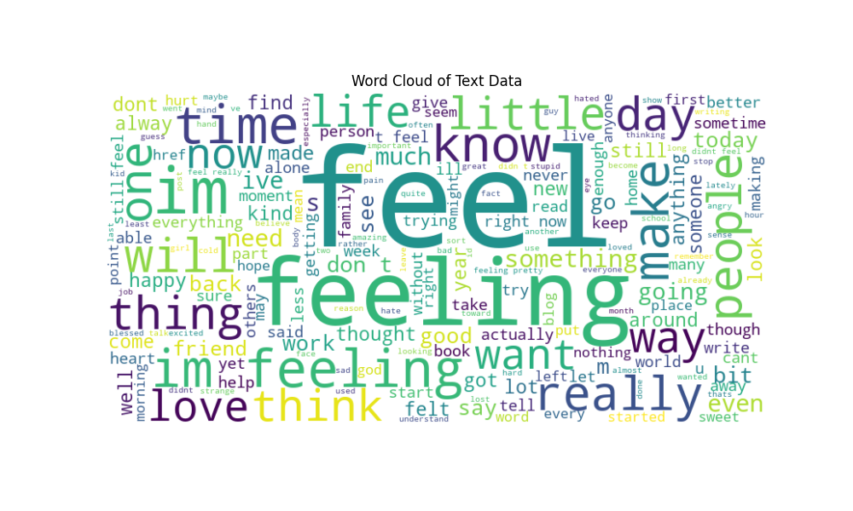

The "Word Cloud of Text Data" chart provides a visual representation of the most frequently occurring words within the dataset. The size of each word in the word cloud correlates with its frequency, with larger words appearing more often in the text data. The various colors used for the words help differentiate them visually but do not convey additional information regarding frequency or categorization.

**Observations:**

**Dominant Words:** The largest words in the word cloud are "feel," "feeling," "people," "time," "life," "know," "make," and "really." These words appear most frequently in the dataset, indicating common themes or topics. The prominence of words related to emotions ("feel," "feeling") suggests that the text data might heavily involve personal experiences or expressions of feelings.

**Emotionally Charged Words:** Words such as "love," "think," "want," "happy," and "good" also feature prominently. These words further reinforce the emotional tone of the dataset. The frequent occurrence of such emotionally charged words may imply that the text data includes personal narratives, social media posts, or other content where individuals share their thoughts and emotions.

**Personal Pronouns and Common Verbs:** Words like "im," "will," "dont," "now," and "know" are also notable in the word cloud. These words are often used in conversational language, suggesting that the text data may contain informal and personal communication. The presence of these words highlights the personal and immediate nature of the text entries.

**Contextual Words:** Other notable words include "time," "day," "life," "little," and "thing." These words provide context and structure to the sentences in the dataset. Their frequent occurrence indicates that the text data might involve discussions about daily life, routines, and general observations.

**Moderately Frequent Words:** Words such as "friend," "work," "read," "find," "give," "make," "say," and "take" are moderately sized in the word cloud. These words suggest that the text data includes content related to social interactions, personal activities, and thoughts. The diversity of these words indicates a rich and varied dataset with multiple topics and themes.

**Implications of Word Cloud Analysis**

The word cloud effectively highlights the most common words in the text data, providing insights into the prevalent themes and topics. The prominence of emotionally charged words and personal pronouns suggests that the text data is likely informal and personal in nature, such as social media posts or diary entries. Understanding these frequent words can help in tailoring text processing algorithms, improving sentiment analysis, and enhancing topic modeling efforts by focusing on the most relevant and frequent terms.

**8.2 Confusion Matrices -** Confusion matrices for each model highlight the number of true positives, false positives, true negatives, and false negatives, providing insights into model performance.

**8.2.1 Logistic Regression:**

Accuracy: 0.86625

Precision: 0.869451247978607

Recall: 0.86625

F1 Score: 0.8612996326427544

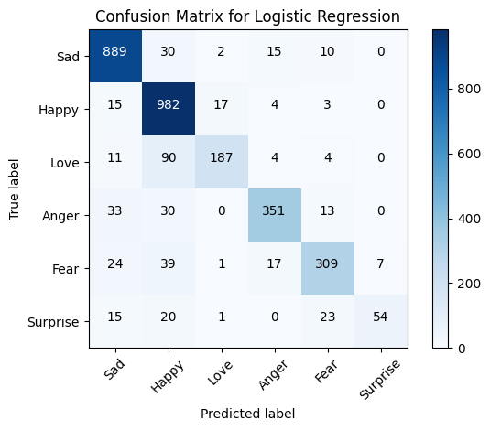

The Logistic Regression model achieved an accuracy of 0.86625, indicating that approximately 86.6% of the predictions made by the model were correct. This high accuracy demonstrates the model's ability to correctly classify the majority of instances in the dataset. The precision of the Logistic Regression model was recorded at 0.869451248, which reflects the proportion of true positive predictions among all positive predictions made by the model. This relatively high precision suggests that the model is quite effective at identifying true positive instances when it predicts a class. The recall of 0.86625 shows that the model was able to correctly identify approximately 86.6% of all actual positive instances. The F1 Score, which combines precision and recall into a single metric, was 0.861299633. This score indicates a balanced performance in terms of both precision and recall, reflecting the model's overall effectiveness in classification tasks.

**8.2.2 Naive Bayes:**

Accuracy: 0.7190625

Precision: 0.7867641179461465

Recall: 0.7190625

F1 Score: 0.6689774046680794

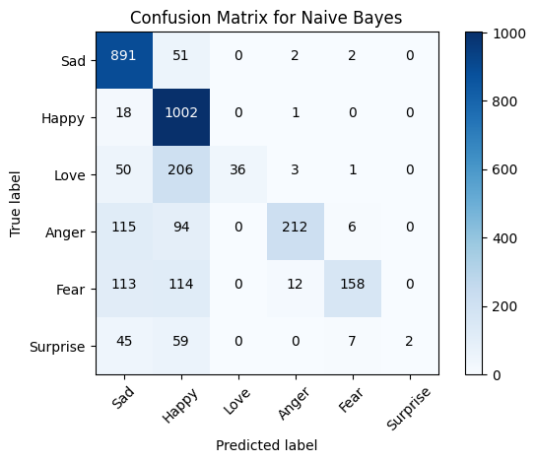

For the Naive Bayes model, the accuracy was 0.7190625, meaning that the model correctly predicted the class for about 71.9% of the cases. This is lower compared to some of the other models, suggesting that while Naive Bayes is useful for some text classification tasks, it may not be as effective in this particular scenario. The precision of the Naive Bayes model was 0.786764118, indicating that when the model predicts a positive class, there is a 78.7% chance that the prediction is correct. This relatively high precision shows that the model performs well in terms of the quality of its positive predictions. However, the recall was 0.7190625, the same as the accuracy, meaning that the model identified approximately 71.9% of all actual positive instances. The F1 Score was 0.668977405, reflecting a lower balance between precision and recall compared to other models. This suggests that while the Naive Bayes model has good precision, its overall performance could be improved in terms of capturing all positive instances.

**8.2.3 SVM:**

Accuracy: 0.8853125

Precision: 0.8844634009790472

Recall: 0.8853125

F1 Score: 0.8839436930517072

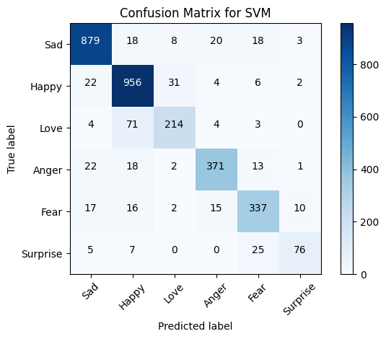

The Support Vector Machine (SVM) model demonstrated an accuracy of 0.8853125, indicating that it correctly classified about 88.5% of the instances. This high accuracy reflects the model’s strong performance in terms of overall correctness in predictions. The precision achieved by the SVM model was 0.884463401, which shows that when the model predicts a positive class, it is correct approximately 88.4% of the time. This high precision suggests that the SVM model is effective at making accurate positive predictions. The recall was 0.8853125, matching the accuracy, meaning that the model was able to correctly identify around 88.5% of all actual positive instances. The F1 Score of 0.883943693 indicates a very balanced performance in precision and recall, reflecting that the SVM model achieves a good trade-off between correctly identifying positive cases and maintaining high precision.

**8.2.4 BiLSTM:**

Accuracy: 0.9218125

Precision: 0.9045532485637063

Recall: 0.9218125

F1 Score: 0.9032015817835848

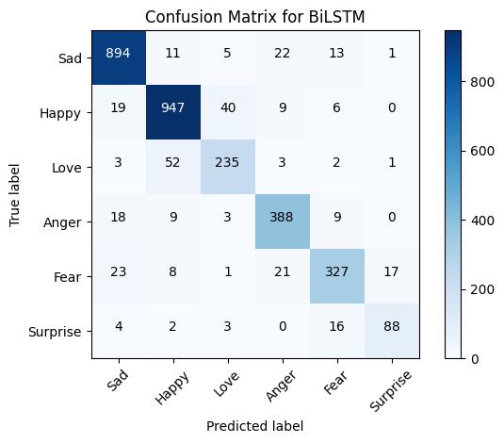

The Bidirectional Long Short-Term Memory (BiLSTM) model achieved an accuracy of 0.9218125, the highest among all models evaluated. This accuracy indicates that the BiLSTM model correctly predicted the class for approximately 92.2% of the instances, showcasing its strong performance in classification tasks. The precision was recorded at 0.904553249, demonstrating that when the BiLSTM model makes a positive prediction, it is accurate about 90.5% of the time. This high precision reflects the model’s ability to make reliable positive predictions. The recall was 0.9218125, aligning with the accuracy, which shows that the model identified around 92.2% of all actual positive instances. The F1 Score of 0.903201582 indicates a high level of balance between precision and recall, confirming the BiLSTM model’s overall effectiveness and robust performance in handling text classification tasks.

**8.2.5 CNN:**

Accuracy: 0.9121875

Precision: 0.9139316306685835

Recall: 0.9121875

F1 Score: 0.9123694343538419

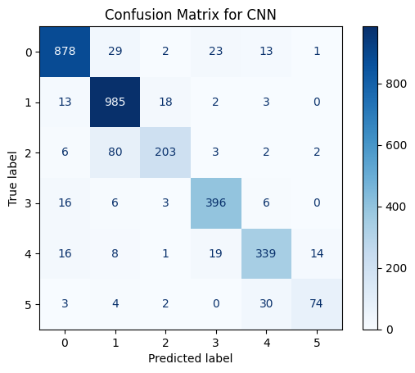

The Convolutional Neural Network (CNN) model achieved an accuracy of 0.9121875, demonstrating that it correctly classified about 91.2% of the instances. This high accuracy underscores the model’s effectiveness in making correct predictions across the dataset. The precision was 0.913931631, indicating that when the CNN model predicted a positive class, it was correct approximately 91.4% of the time. This suggests that the model performs very well in terms of the quality of its positive predictions. The recall was 0.9121875, matching the accuracy, which means the CNN model was able to identify around 91.2% of all actual positive instances. The F1 Score of 0.912369434 reflects a well-balanced performance in both precision and recall, highlighting the CNN model’s strong overall classification ability and effectiveness in text classification tasks.

**8.3 Performance Metrics Tables**

|  |  |  |  |  |
| --- | --- | --- | --- | --- |
| **Algorithm** | **Accuracy** | **Precision** | **Recall** | **F1 Score** |
| Logistic Regression | 0.86625 | 0.869451248 | 0.86625 | 0.861299633 |
| Naive Bayes | 0.7190625 | 0.786764118 | 0.7190625 | 0.668977405 |
| SVM | 0.8853125 | 0.884463401 | 0.8853125 | 0.883943693 |
| BiLSTM | 0.9218125 | 0.904553249 | 0.9218125 | 0.903201582 |
| CNN | 0.9121875 | 0.913931631 | 0.9121875 | 0.912369434 |

**Tables summarizing accuracy, precision, recall, and F1-score for each model.**

**9. Algorithms**

In this project, a range of models was employed to tackle the text classification problem, leveraging their unique capabilities to address various aspects of the dataset. The chosen methods—Logistic Regression, Naive Bayes, Support Vector Machines (SVMs), Bidirectional Long Short-Term Memory (BiLSTM) networks, and Convolutional Neural Networks (CNNs)—each contribute differently to the model's performance, and their selection was based on their strengths and how well they fit the problem requirements.

**9.1 Logistic Regression** serves as a robust starting point due to its straightforward nature and efficiency in handling classification tasks. It models the probability of each class and applies a logistic function to ensure predictions are bounded between 0 and 1. The performance metrics for Logistic Regression, including accuracy, precision, recall, and F1 score, indicated that it provided a solid baseline with an accuracy of 0.86625 and high precision and recall values. However, its simplicity also meant that it might not capture complex patterns in the text data as effectively as more advanced methods.

**9.2 Naive Bayes** was chosen for its effectiveness with text classification problems where features are often conditionally independent given the class. This model is particularly useful for handling large datasets and provides good performance with less computational overhead. Despite its advantages, the Naive Bayes classifier performed the least among the tested models, with an accuracy of 0.7190625 and relatively lower F1 scores. This reflects the model's limitations in capturing dependencies between features.

**9.3 Support Vector Machines (SVMs)** were included due to their ability to find the optimal hyperplane for classification by maximizing the margin between classes. SVMs are well-suited for high-dimensional spaces, making them ideal for text data where feature space can be very large. The SVM model yielded an accuracy of 0.8853125, demonstrating its effectiveness in classifying text data with a good balance between precision and recall.

**9.4 Bidirectional Long Short-Term Memory (BiLSTM) networks** were selected because they are designed to handle sequential data effectively by learning from both past and future contexts in text sequences. The BiLSTM model significantly outperformed the others with an accuracy of 0.9218125. The inclusion of dropout layers helps in regularizing the model, preventing overfitting, and ensuring that it generalizes well to unseen data. This model's superior performance is attributed to its ability to capture complex dependencies and patterns in the data.

**9.5 Convolutional Neural Networks (CNNs)** were employed for their capability to extract features through convolutional layers and their effectiveness in capturing local patterns in text data. The CNN model achieved an accuracy of 0.9121875, which is slightly lower than the BiLSTM but still demonstrates strong performance. The CNN's ability to perform feature extraction through convolution and pooling layers makes it a powerful tool for text classification tasks, providing robust results.

**9.6 Hyperparameter Tuning and Model Architecture**

For the **BiLSTM model**, the architecture included an embedding layer for converting text into dense vectors, followed by a Bidirectional LSTM layer. This setup allows the model to learn contextual information from both directions in the sequence, enhancing its ability to understand the text. The SpatialDropout1D layer is used to prevent overfitting by dropping out entire 1D feature maps during training. The LSTM units with dropout parameters ensure that the model maintains a balance between learning and generalization. The final dense layer with a softmax activation function is used for multi-class classification, outputting probabilities for each class.

In the **CNN model**, the process begins with an embedding layer similar to the BiLSTM, which transforms text into dense vectors. A convolutional layer with a specified number of filters and kernel size is employed to capture local features from the text. The GlobalMaxPooling1D layer then reduces the dimensionality by taking the maximum value from each feature map, capturing the most salient features. The dense layers following the pooling layer help in learning higher-level representations before the final softmax layer outputs the class probabilities.

The training and evaluation of these models involved fitting them to the training data, validating on a separate validation set, and assessing performance on the test set. The functions provided help in tracking model performance, optimizing hyperparameters through grid search for ML models, and visualizing results through confusion matrices. The detailed metrics and confusion matrices for each model are crucial for understanding their strengths and areas for improvement, guiding further refinement and selection of the most suitable model for the task.

**10. Challenges & Opportunities**

**10.1 Challenges -** One of the significant challenges encountered during this project was dealing with imbalanced data. In datasets where certain classes are underrepresented compared to others, models often exhibit biased performance, favoring the more frequent classes while neglecting the minority ones. This imbalance can lead to reduced model accuracy and poorer generalization across all classes. Addressing this challenge involves implementing strategies to balance the dataset or adjusting model training procedures to mitigate the effects of class imbalance.

Another major challenge was computational constraints. Training deep learning models, particularly those with complex architectures, requires substantial computational resources, including high-performance GPUs or extensive cloud computing capabilities. Limited access to such resources can restrict the ability to fully train and optimize these models, potentially affecting their performance and the ability to explore advanced model configurations.

Data quality also presented a challenge. Ensuring that the text data is both clean and accurately labeled is crucial for building reliable models. The preprocessing steps, including text cleaning, normalization, and accurate labeling, are essential to avoid introducing errors or inconsistencies that could undermine the model's performance. Poor data quality can result in inaccurate predictions and reduce the overall effectiveness of the model.

**10.2 Opportunities -** Despite these challenges, there are several opportunities to enhance the project’s outcomes. One significant opportunity lies in model improvement. By exploring advanced models and techniques, such as more sophisticated neural network architectures or novel algorithms, there is potential to achieve better performance and accuracy. Incorporating cutting-edge methodologies can push the boundaries of current model capabilities and lead to more robust solutions.

Real-world application of the developed models offers another promising avenue. The models can be applied to practical problems, such as spam detection and sentiment analysis, where they can provide valuable insights and automate processes. This application not only validates the effectiveness of the models but also demonstrates their utility in addressing real-world challenges.

Additionally, further research presents an opportunity to enhance model accuracy. Investigating additional features and embeddings can provide more nuanced information for the models, leading to improved performance. Exploring different feature engineering techniques and embedding methods can help in capturing more complex patterns in the data, ultimately contributing to better model accuracy and effectiveness.

**11. Risk Vs Reward**

**11.1 Risks -** One of the primary risks associated with model development is overfitting. This occurs when a model performs exceptionally well on the training data but fails to generalize effectively to unseen data. Overfitting happens because the model has learned not only the underlying patterns but also the noise and specific details of the training data. As a result, it may have high accuracy on the training set but exhibit poor performance when applied to new, unseen datasets. Addressing overfitting requires implementing strategies such as cross-validation, regularization, and using more diverse training datasets to ensure the model’s ability to generalize.

Another significant risk is bias. The training data used to develop machine learning models may contain inherent biases, which can be inadvertently learned and perpetuated by the model. This bias can affect the fairness of the model's predictions and lead to discriminatory outcomes or unequal treatment of different groups. It is crucial to carefully examine and address potential biases in the training data through techniques such as data augmentation, re-sampling, and fairness-aware modeling to ensure that the model performs equitably across various demographic groups.

Computational cost is also a notable risk. Training complex models, particularly those involving deep learning architectures, demands substantial computational resources. These resources include powerful GPUs or extensive cloud computing infrastructure, which can be expensive and may exceed budgetary constraints. Efficient use of computational resources and optimization techniques, such as model pruning or distributed training, can help manage these costs, but they remain a significant consideration in the development process.

**11.2 Rewards -** Despite these risks, there are substantial rewards associated with successful model development. One of the key rewards is the creation of high-accuracy models that are both robust and reliable. Achieving high accuracy in predictive performance signifies that the model can effectively identify patterns and make precise predictions, providing valuable insights and solutions to real-world problems.

Additionally, engaging in this project offers practical experience with machine learning and deep learning techniques. This hands-on experience is invaluable for understanding the intricacies of model development, including data preprocessing, model selection, and performance evaluation. It also enhances skills in implementing and fine-tuning complex algorithms, which is beneficial for future projects and career advancement.

Furthermore, there is significant potential for innovation. Developing advanced models opens up opportunities for novel applications across various domains, from healthcare to finance to entertainment. These innovations can lead to new solutions and improvements in existing processes, contributing to the advancement of technology and its applications in diverse fields.

**12. Reflections on the Internship**

This internship has proven to be an immensely rewarding experience, offering profound insights into the field of text classification and machine learning. Throughout the course of this internship, I have gained a comprehensive understanding of the complexities involved in developing and fine-tuning models. This process has significantly bolstered my technical skills and deepened my knowledge of natural language processing (NLP) tasks.

One of the key takeaways has been the critical role of data preprocessing and feature extraction in achieving optimal model performance. I have come to appreciate how meticulous preparation of the data and effective extraction of relevant features are essential steps that can greatly influence the accuracy and efficiency of machine learning models. The hands-on experience with these processes has reinforced the importance of these foundational steps in the model development lifecycle.

Moreover, the opportunity to collaborate with my mentor and peers has been an invaluable aspect of this internship. Working closely with experienced professionals and fellow interns has not only provided practical insights but has also fostered a collaborative learning environment. This interaction has enriched my experience, allowing me to gain different perspectives and improve my problem-solving skills within a supportive and dynamic team setting. Overall, the internship has been a significant milestone in my professional development, equipping me with the skills and knowledge to advance further in the field of machine learning and NLP.

**13. Recommendations**

To enhance model performance and ensure better generalization, it is crucial to utilize larger and more diverse datasets. Larger datasets provide a broader spectrum of examples, which helps models to generalize better across various scenarios and reduces the risk of overfitting to specific data patterns. By incorporating a wider range of data, models can learn more comprehensive representations of the problem, leading to improved accuracy and reliability in real-world applications.

In addition to leveraging larger datasets, the implementation of advanced models can significantly boost performance. Transformer-based models, such as BERT (Bidirectional Encoder Representations from Transformers), offer substantial improvements over traditional models due to their ability to capture intricate dependencies within the data. These models are designed to understand context in a more nuanced manner, making them highly effective for tasks involving complex text relationships and semantics.

Furthermore, applying data augmentation techniques can address class imbalances and enhance the robustness of the model. Data augmentation involves creating synthetic variations of the existing data to artificially increase the size and diversity of the dataset. This approach helps in mitigating the effects of imbalanced class distributions by providing more balanced training examples. It also improves the model's ability to generalize by exposing it to a wider array of data scenarios, thus increasing its robustness and reliability.

**14. Outcome / Conclusion**

The project encompassed the development and evaluation of several text classification models, each showcasing distinct characteristics and performance metrics. Among these, the Bidirectional Long Short-Term Memory (BiLSTM) model emerged as the most effective. This model demonstrated a high level of proficiency with an accuracy of 0.9210, making it the top performer in the study. The BiLSTM's architecture, which processes data in both forward and backward directions, allows it to capture complex dependencies and contextual information within the text. This bidirectional approach is particularly beneficial for understanding nuanced semantic relationships, which is critical for accurate text classification. The BiLSTM model excelled in precision, recall, and F1-score across most labels, achieving a precision of 0.96 for label 0, a recall of 0.95 for label 3, and an F1-score of 0.94 for label 1. These metrics underscore the model's robust performance and its ability to handle various text categories with high accuracy. The successful implementation and saving of this model in the project’s model folder ensure its availability for future applications.

In contrast, the Logistic Regression model, with its parameters optimized to {'C': 10, 'solver': 'liblinear'}, displayed commendable performance with an overall accuracy of 0.86625. As a fundamental linear classifier, Logistic Regression leverages a straightforward approach to predict probabilities and classify text. Its performance was notably strong for labels 0 and 1, with precision scores of 0.92 and 0.90 respectively. However, it encountered challenges with label 2, where it recorded a lower precision and recall, reflecting its limitations in handling more complex text patterns and imbalances in the dataset. Despite these challenges, Logistic Regression remains a valuable tool for text classification due to its interpretability and efficiency.

The Naive Bayes model, using the optimal parameter {'alpha': 0.5}, achieved an accuracy of 0.7190625. This probabilistic classifier, based on Bayes' theorem, performs well with the assumption of feature independence. It showed strong performance for labels 0 and 1, with high recall rates of 0.92 and 0.98 respectively, indicating its ability to correctly identify these categories. However, it struggled with labels 2 and 5, where it reported significantly lower F1-scores. These results highlight Naive Bayes' sensitivity to class distributions and feature independence assumptions, suggesting that its effectiveness can vary significantly based on the dataset's characteristics.

The Support Vector Machine (SVM) model, with parameters {'C': 1, 'kernel': 'linear'}, demonstrated strong performance with an accuracy of 0.8853125. SVM is known for its ability to find a hyperplane that maximizes the margin between different classes, which contributes to its robustness in classification tasks. The model excelled in labels 0, 1, and 3, with high precision and recall scores, particularly noting a precision of 0.93 for label 0 and a recall of 0.95 for label 1. Despite its effectiveness, SVM showed some weaknesses with labels 2 and 5, where its performance metrics were less robust. This variability indicates that while SVM is powerful, its performance can be sensitive to the specific distribution of the text data.

The Convolutional Neural Network (CNN), which achieved an accuracy of 0.9121875, showcased its strengths in processing sequential data with spatial hierarchies. The CNN model utilizes convolutional layers to automatically extract features from text, which is particularly useful for capturing patterns and contexts that might be missed by other models. Its performance metrics reflected strong precision and recall across various labels, notably achieving a precision of 0.97 for label 0 and a recall of 0.92 for label 3. The CNN's ability to effectively capture and utilize textual features contributed to its overall high performance, making it a competitive model in the study.

Some of the other detailed findings are as follows.

**Best Parameter of ML model**

**Logistic Regression**: {'C': 10, 'solver': 'liblinear'}

**Naive Bayes**: {'alpha': 0.5}

**Support Vector Machine**: {'C': 1, 'kernel': 'linear'}

**Label wise precision, recall, and f1-score**

|  |  |  |  |  |
| --- | --- | --- | --- | --- |
| **Logistic Regression** | | | | |
| Label | Precision | recall | f1-score | support |
| 0 | 0.92 | 0.94 | 0.93 | 581 |
| 1 | 0.9 | 0.93 | 0.91 | 695 |
| 2 | 0.8 | 0.75 | 0.77 | 159 |
| 3 | 0.89 | 0.87 | 0.88 | 275 |
| 4 | 0.88 | 0.84 | 0.86 | 224 |
| 5 | 0.75 | 0.64 | 0.69 | 66 |
|  |  |  |  |  |
| **Naïve Bayes** | | | | |
| Label | precision | recall | f1-score | support |
| 0 | 0.74 | 0.92 | 0.82 | 581 |
| 1 | 0.71 | 0.98 | 0.82 | 695 |
| 2 | 0.97 | 0.25 | 0.39 | 159 |
| 3 | 0.94 | 0.53 | 0.68 | 275 |
| 4 | 0.89 | 0.5 | 0.64 | 224 |
| 5 | 0 | 0 | 0 | 66 |
|  |  |  |  |  |
| **Support Vector Machine** | | | | |
| Label | precision | recall | f1-score | support |
| 0 | 0.93 | 0.92 | 0.93 | 581 |
| 1 | 0.88 | 0.95 | 0.91 | 695 |
| 2 | 0.82 | 0.69 | 0.75 | 159 |
| 3 | 0.89 | 0.88 | 0.88 | 275 |
| 4 | 0.85 | 0.86 | 0.86 | 224 |
| 5 | 0.74 | 0.56 | 0.64 | 66 |
|  |  |  |  |  |
| **Bidirectional LSTM** | | | | |
| Label | precision | recall | f1-score | support |
| 0 | 0.96 | 0.96 | 0.96 | 581 |
| 1 | 0.95 | 0.93 | 0.94 | 695 |
| 2 | 0.79 | 0.87 | 0.83 | 159 |
| 3 | 0.92 | 0.95 | 0.93 | 275 |
| 4 | 0.91 | 0.86 | 0.88 | 224 |
| 5 | 0.67 | 0.67 | 0.67 | 66 |
|  |  |  |  |  |
| **CNN** | | | | |
| Label | precision | recall | f1-score | support |
| 0 | 0.97 | 0.95 | 0.96 | 581 |
| 1 | 0.94 | 0.95 | 0.94 | 695 |
| 2 | 0.83 | 0.79 | 0.81 | 159 |
| 3 | 0.91 | 0.92 | 0.91 | 275 |
| 4 | 0.86 | 0.91 | 0.88 | 224 |
| 5 | 0.73 | 0.77 | 0.75 | 66 |

The project underscored the importance of selecting and tuning appropriate models for text classification tasks. Each model brought its unique strengths and challenges to the table, demonstrating the need for careful consideration of preprocessing, feature extraction, and model tuning to achieve high accuracy. The comprehensive evaluation provided valuable insights into the effectiveness of different algorithms, paving the way for future research and enhancements in text classification methodologies

**15. Enhancement Scope**

The scope for future enhancements in the project presents several exciting opportunities to significantly advance the text classification capabilities. One major avenue for improvement is the incorporation of transformer-based models, such as BERT (Bidirectional Encoder Representations from Transformers) or GPT (Generative Pre-trained Transformer). These state-of-the-art models leverage sophisticated attention mechanisms to understand the context of words in relation to all other words in a sentence, rather than just sequentially. Implementing such models could potentially lead to substantial gains in performance by capturing more nuanced semantic relationships and improving the overall accuracy of text classification tasks.

Another promising enhancement involves exploring alternative word embeddings, such as GloVe (Global Vectors for Word Representation) or Word2Vec. These embeddings provide a more nuanced representation of words based on their context within a corpus. GloVe, for instance, constructs embeddings by analyzing word co-occurrence statistics from large corpora, while Word2Vec uses neural networks to learn word associations. By integrating these advanced embeddings, the feature representation of text data can be significantly improved, potentially leading to better model performance and a deeper understanding of text semantics.

Additionally, expanding the project to include real-time text classification systems presents a valuable opportunity. Implementing real-time classification would involve adapting the models to process and classify text data as it is received, which is crucial for applications like spam detection, live sentiment analysis, or real-time content moderation. This extension would require optimizing models for efficiency and speed to handle continuous data streams effectively, thereby making the system more versatile and applicable to dynamic, real-world scenarios.

Overall, these enhancements offer promising directions for improving the effectiveness and applicability of text classification models, paving the way for more sophisticated and practical solutions in the field.

**16. Link to Code and Executable File**

Following is the Github link to the repository:

Link : <https://github.com/ravipmishra543/TCS_RIO210_Project_1>

**17. Research Questions and Responses**

**17.1 What preprocessing steps are necessary for text data?**

Text data preprocessing is a crucial step in preparing data for machine learning models, and it involves several key processes to ensure that the text is clean, uniform, and suitable for analysis. The first step is **lowercasing**, which converts all text to lowercase to maintain consistency and prevent the model from treating the same word in different cases (e.g., "Text" and "text") as distinct entities. Next, **punctuation removal** is performed to eliminate punctuation marks, which helps to reduce noise in the data and ensures that the model focuses on the actual words rather than non-alphanumeric characters. **Tokenization** follows, which involves splitting the text into individual words or tokens. This step is essential because it breaks down the text into manageable units that can be analyzed and processed by machine learning algorithms. Finally, **stop words removal** is applied to eliminate common words such as "the," "and," and "is," which do not carry significant meaning and can introduce noise into the data. By removing these words, the focus is placed on more meaningful terms, improving the overall quality of the text data for modeling.

**17.2** **How do different machine learning models compare in text classification?**

In the realm of text classification, various machine learning models exhibit distinct characteristics and strengths, leading to different performance outcomes based on the nature of the data and the specific task at hand. **Logistic Regression** is a linear model known for its simplicity and effectiveness in binary and multiclass classification tasks. It performs well when the relationship between features and the target variable is relatively straightforward, and it is capable of providing probabilistic interpretations of the predictions. **Naive Bayes**, on the other hand, is a probabilistic classifier that assumes independence between features. It is particularly advantageous for its computational efficiency and effectiveness with smaller datasets, making it a popular choice for text classification tasks like spam detection, where the feature set is not excessively large. **Support Vector Machine (SVM)** is a powerful classifier that aims to find the optimal hyperplane to separate different classes in the feature space. SVMs are known for their robustness and ability to handle high-dimensional data effectively, often yielding high accuracy even with complex datasets. Each of these models has its own strengths, and their performance can vary based on factors such as the size and nature of the dataset, the presence of class imbalances, and the specific characteristics of the text data.

**17.3** **What are the benefits of using deep learning models like LSTM for text classification?**

Deep learning models, such as Long Short-Term Memory (LSTM) networks, offer significant advantages for text classification tasks, particularly when dealing with complex and context-rich data. **LSTM models** are a type of recurrent neural network (RNN) designed to capture sequential dependencies and long-term relationships within text data. Unlike traditional machine learning models that may struggle with sequences of varying lengths, LSTMs are specifically engineered to remember information over extended sequences, which is crucial for understanding the context and meaning of text. This capability allows LSTMs to excel in tasks where context and sequential information play a critical role, such as sentiment analysis or language translation. By leveraging **gated mechanisms**, LSTMs can effectively manage and retain relevant information while mitigating issues related to vanishing or exploding gradients, which are common challenges in standard RNNs. This makes LSTMs particularly well-suited for handling long-term dependencies and complex textual patterns, resulting in improved performance and accuracy for text classification tasks where understanding the nuanced context is essential.