Company
- Login with admin_platform
- Click on Companies from Category menu
- From Action menu click on Company
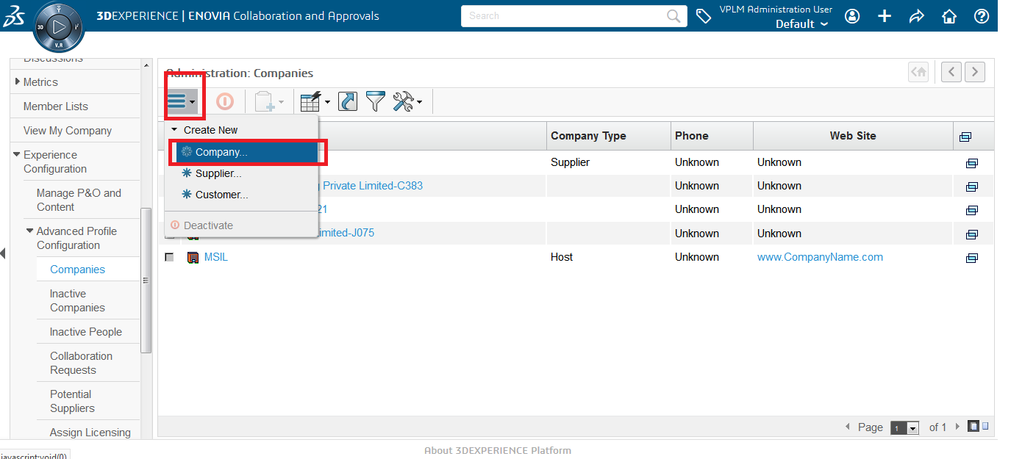
- Create Company
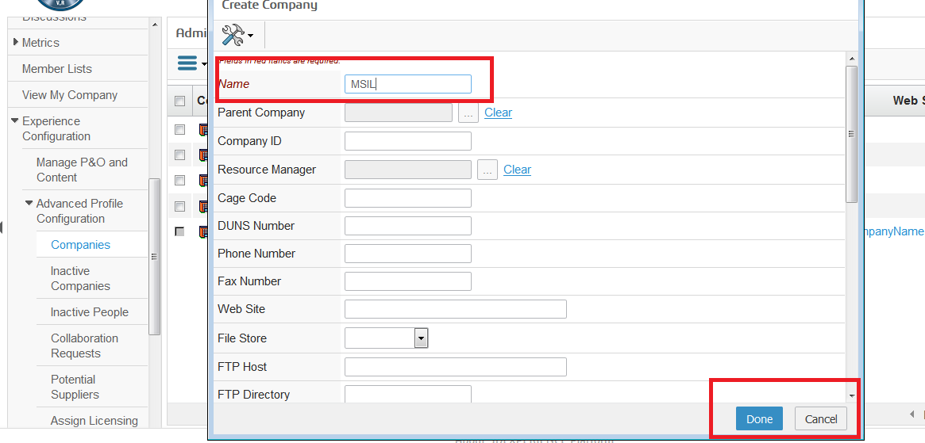
Enter Company Name--> click on Done

- Click on Done
- Company should be created
- From category Menu of Company Page Click on Business Unit
- 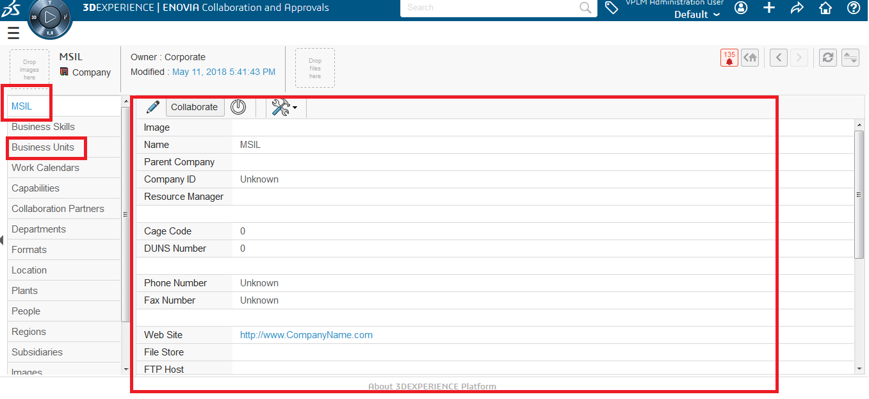
Bussiness Unit
- From Action Menu --> click on create Business Unit
- Enter the Detail for Business unit and click on Submit
- 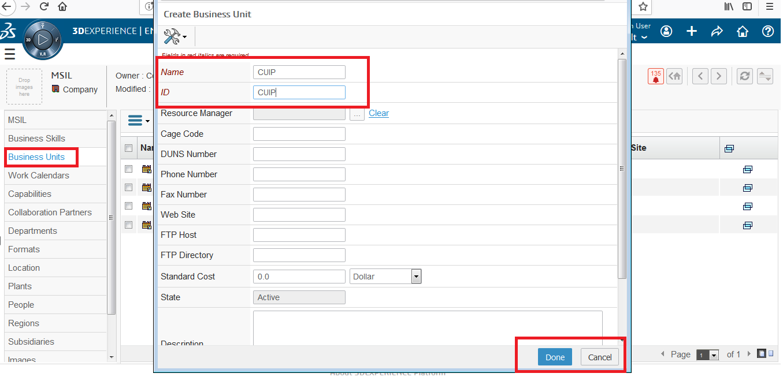
- Business Unit Created for the company
- 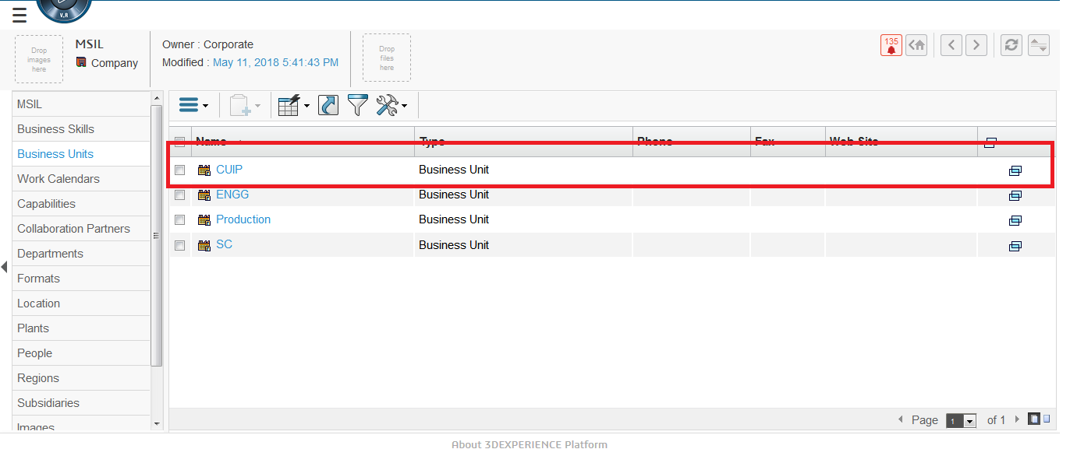

Create Supplier
- Click on Companies from Category menu
- From Action menu click on Supplier

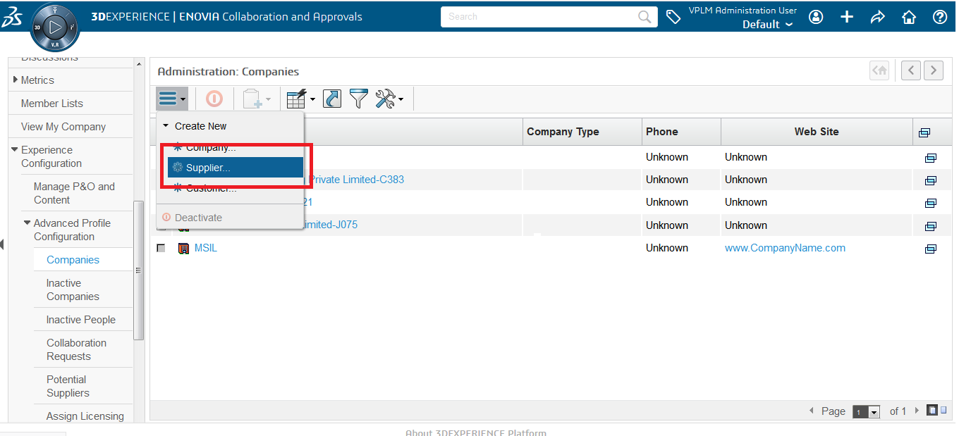
- Enter The name for Supplier and Click on Done

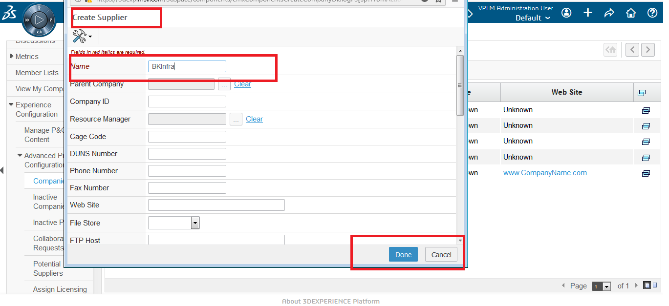
- Supplier should be created
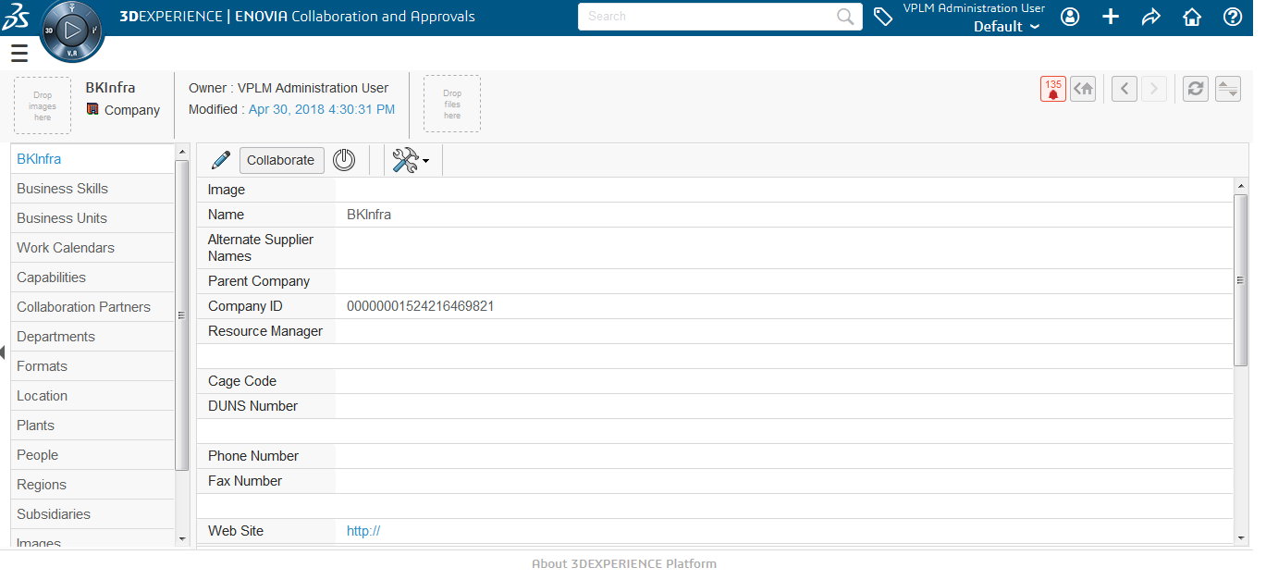

Create Person in 3dspace
- Login with admin_platform
- Click on Companies from Category menu
- From Action menu click on Manage P&O and Content

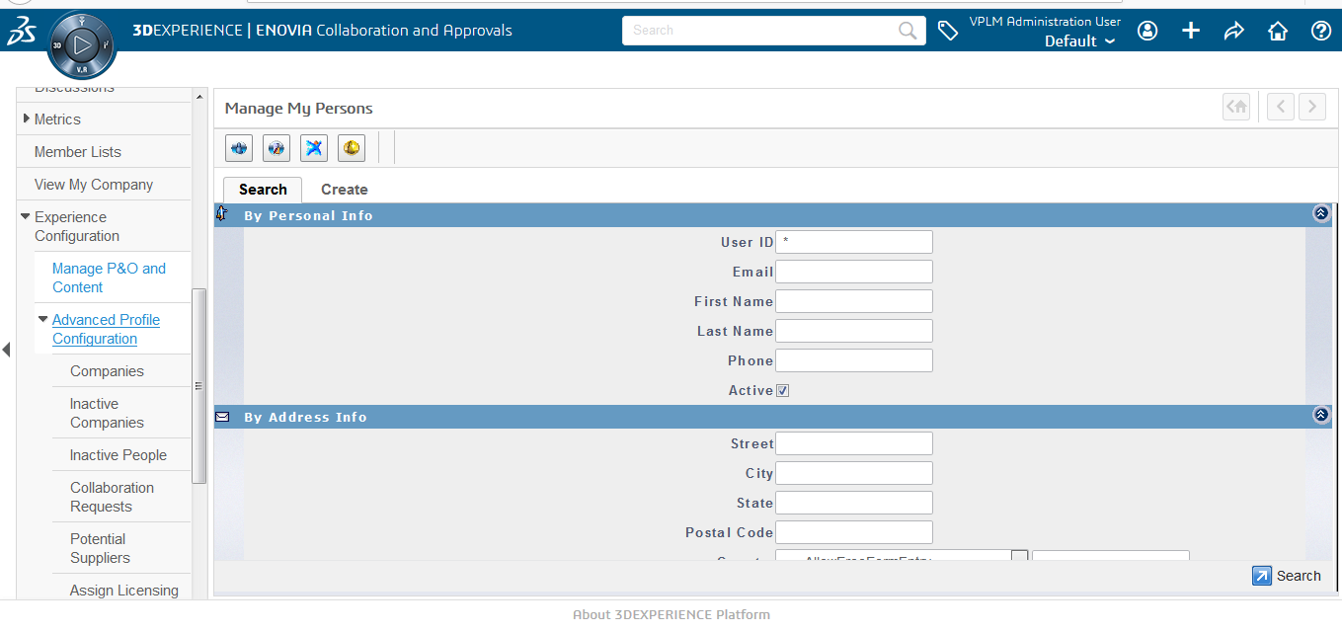
- Click on Create Tab

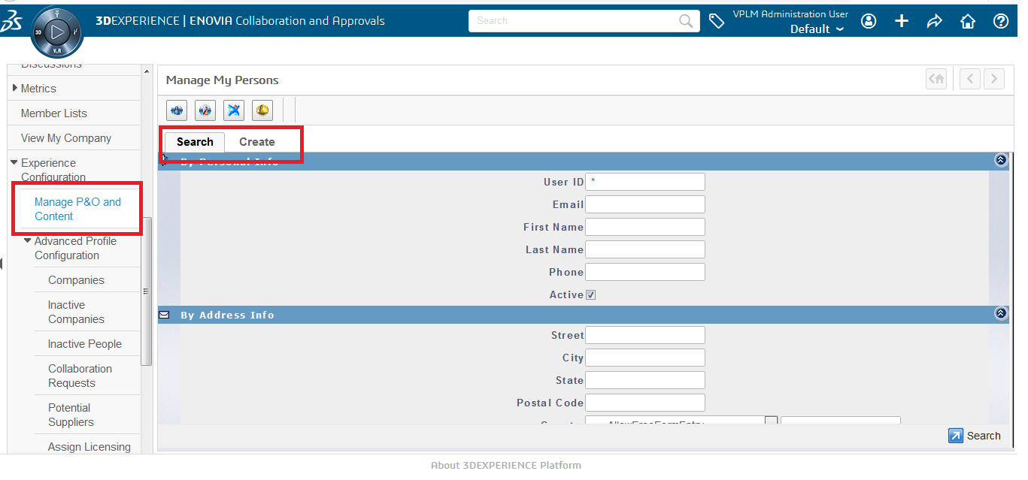
- Enter all the Detail for Person
- Enter UserID / first name / last name / Email
- Select Employee / Members / Current Organization
- Select for license (Example :- CSV,DPG)
- Click on Create
- It will create user .
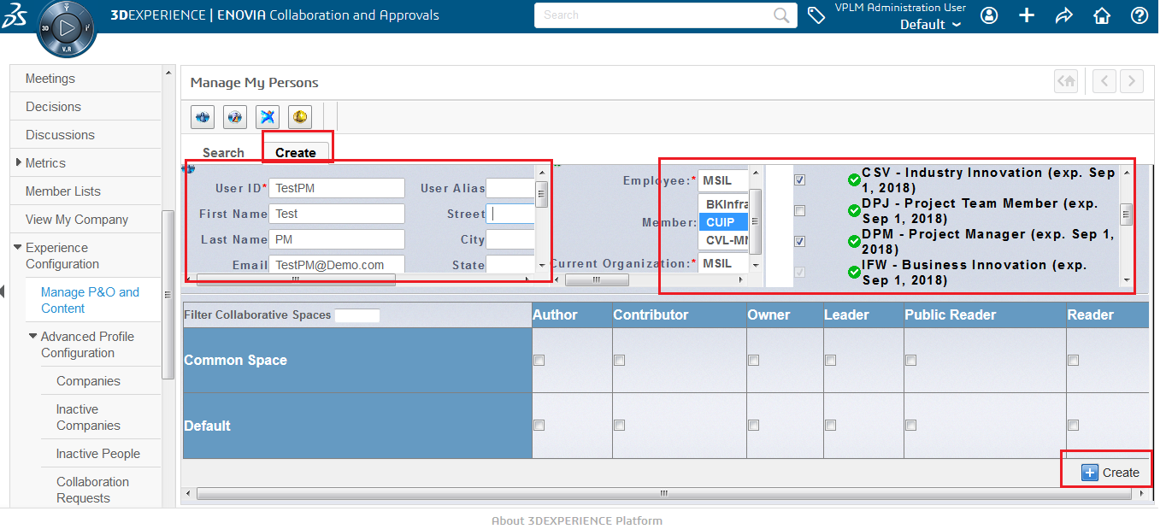

Create Person in 3dpassport

- Enovia Login Page --> Click on Create an Account
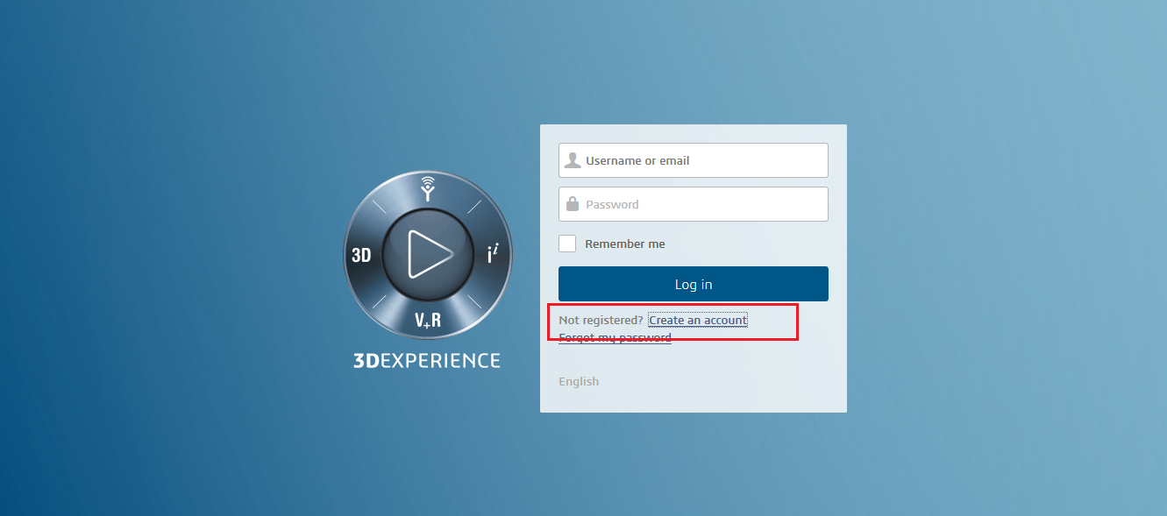
- Enter the same detail which we have given to create a person in 3dspce ,
- Set password
- Click on Register
- User is created .
- Now try to login with userID , it will able to login

