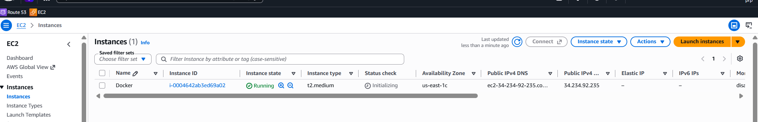
One ec2 instances created for expense -docker project

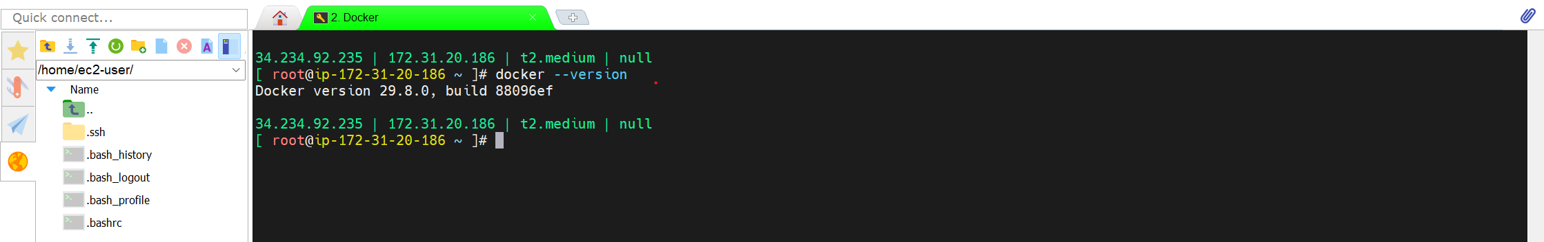
sudo dnf -y install dnf-plugins-core
sudo dnf config-manager --add-repo https://download.docker.com/linux/rhel/docker-ce.repo
sudo dnf install docker-ce docker-ce-cli containerd.io docker-buildx-plugin docker-compose-plugin
sudo systemctl start docker
sudo systemctl enable docker
sudo usermod -aG docker ec2-user

clone the repo in the ec2 instance
https://github.com/raviprakash96520/expense-devops-project.git
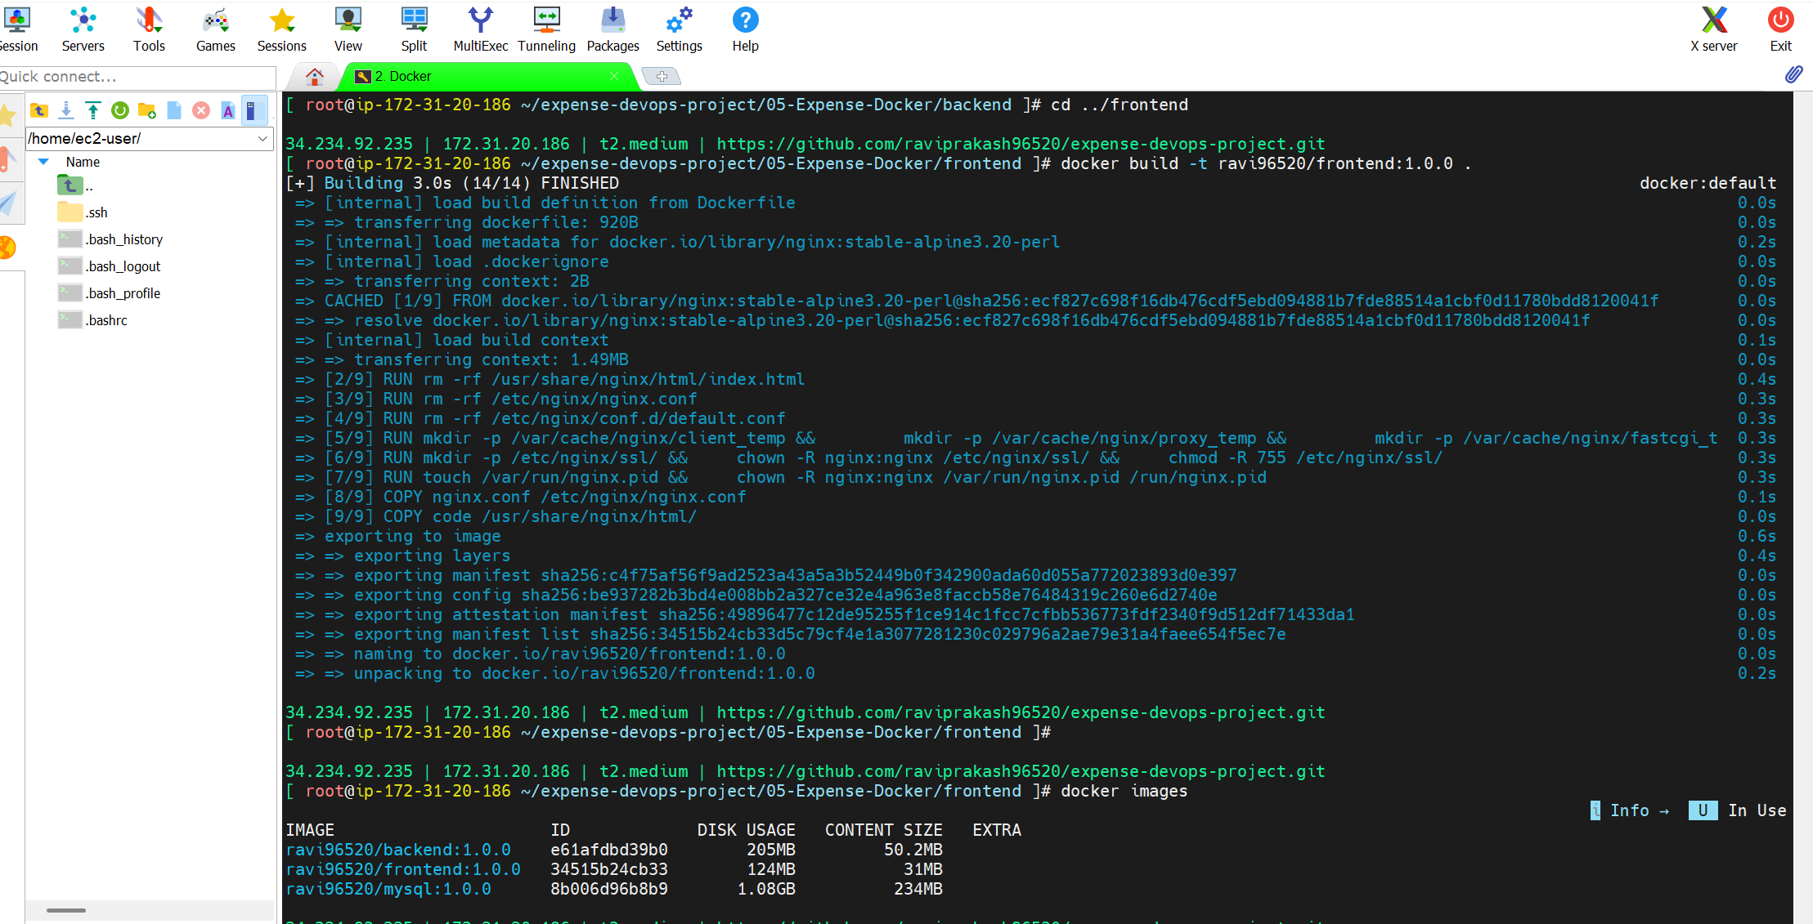
Using docker command like
docker build -t <docker-hub-account>/<component>:1.0
Pushed to docker hub also

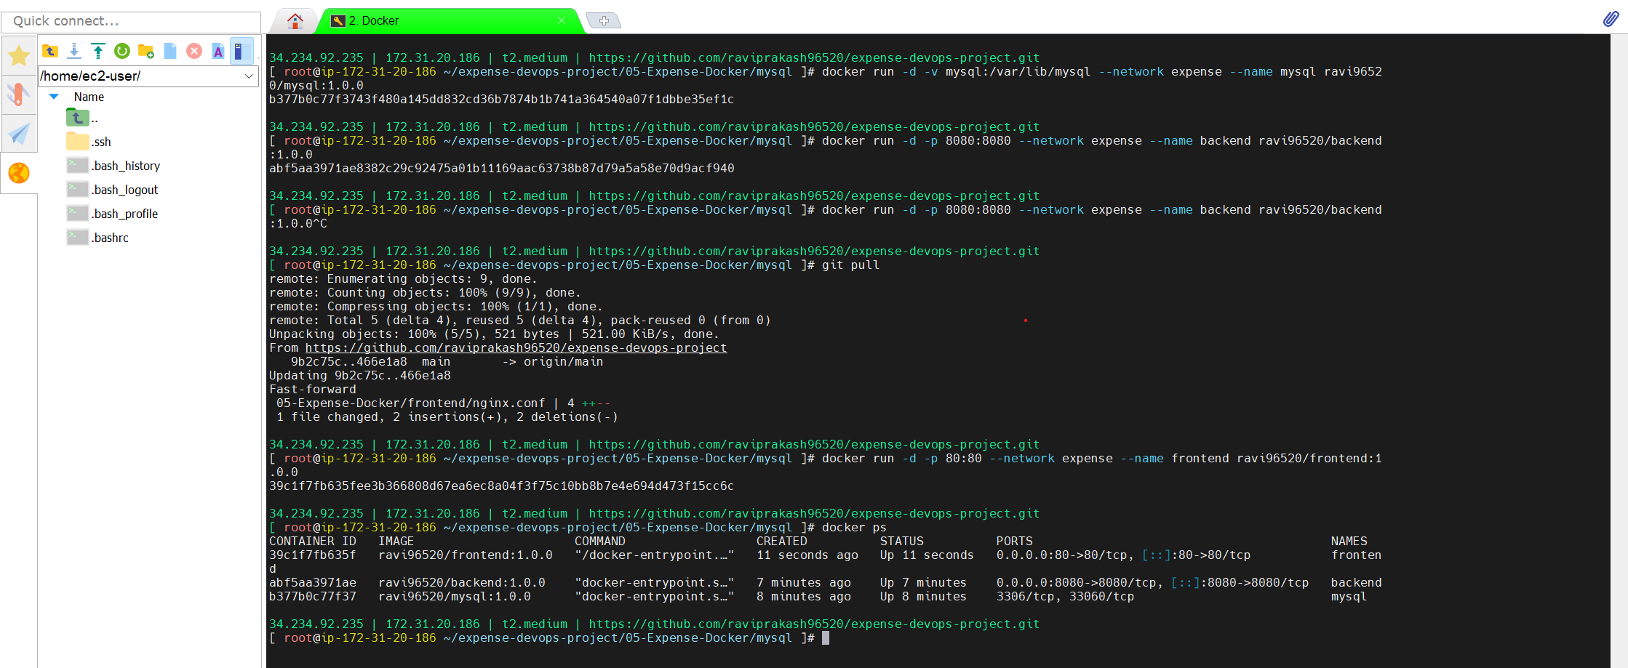
using docker run command

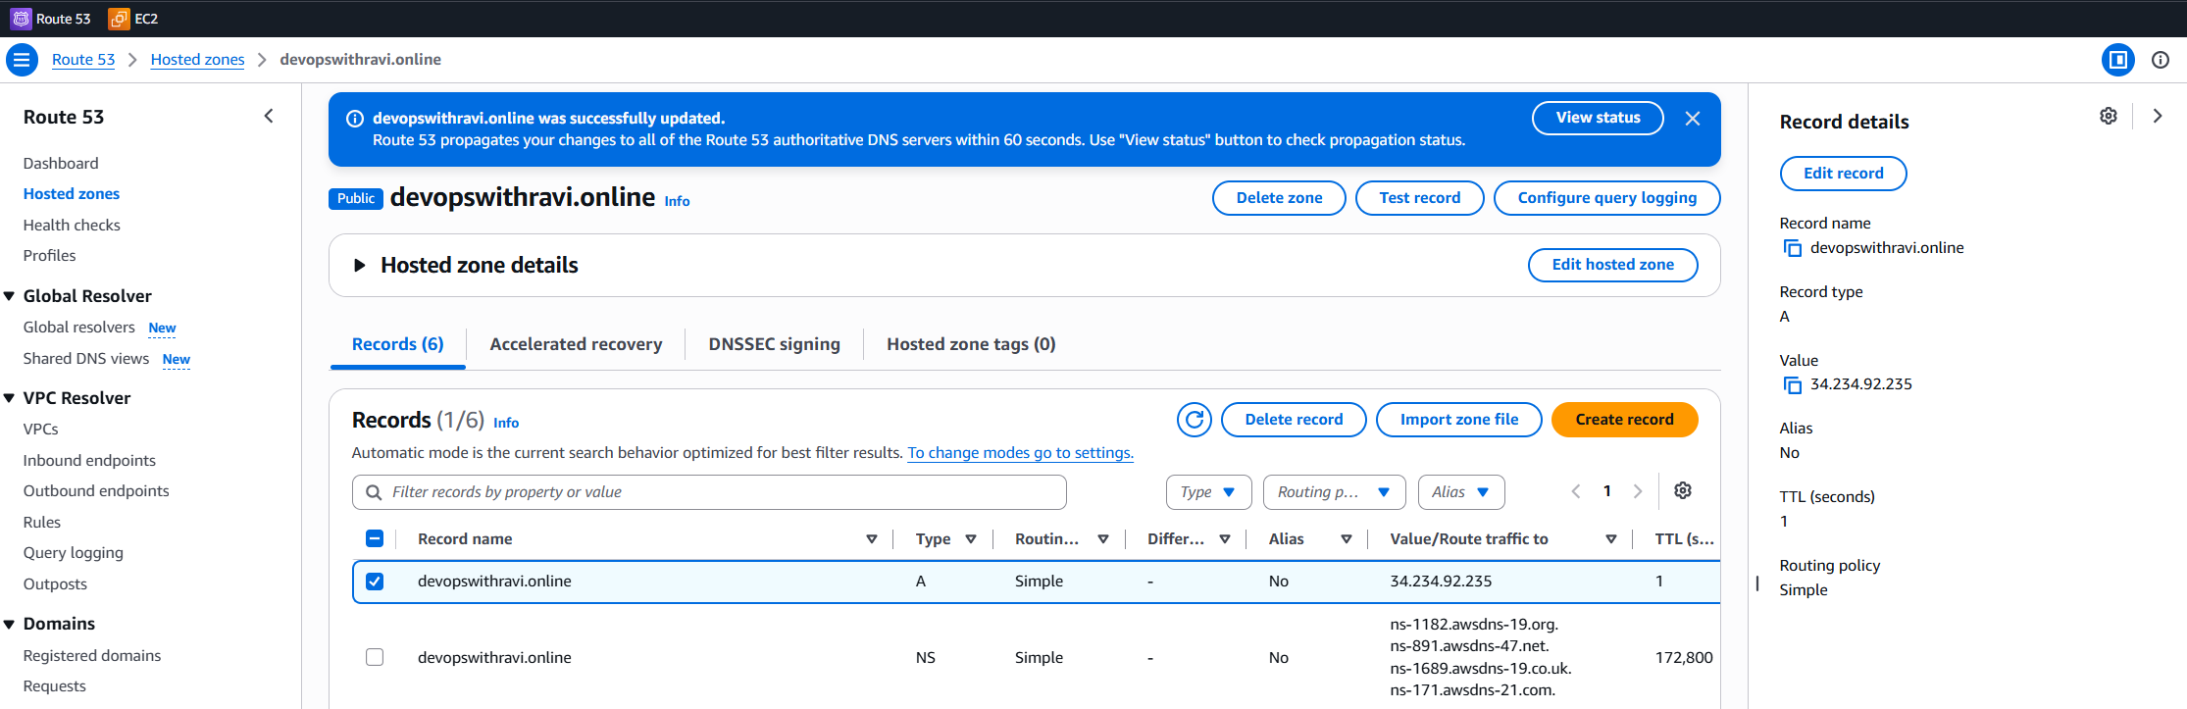
route53 record updated to my domain for frontend
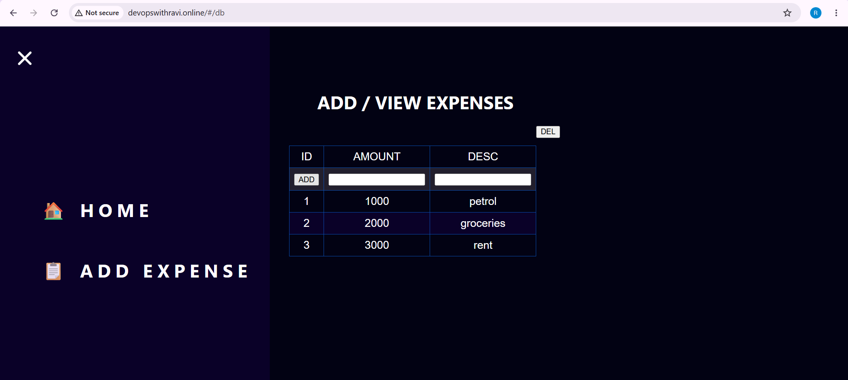
Access the website through my domain

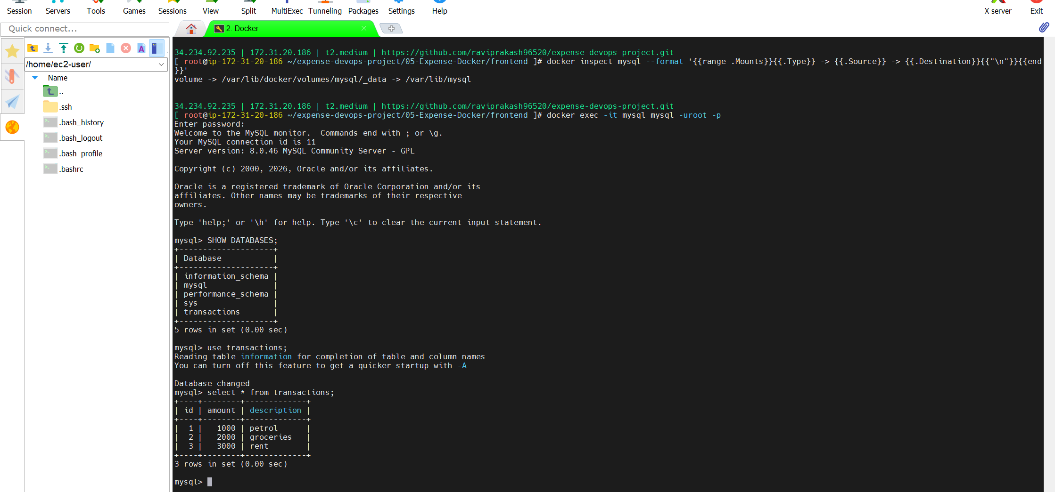
mysql data inside container
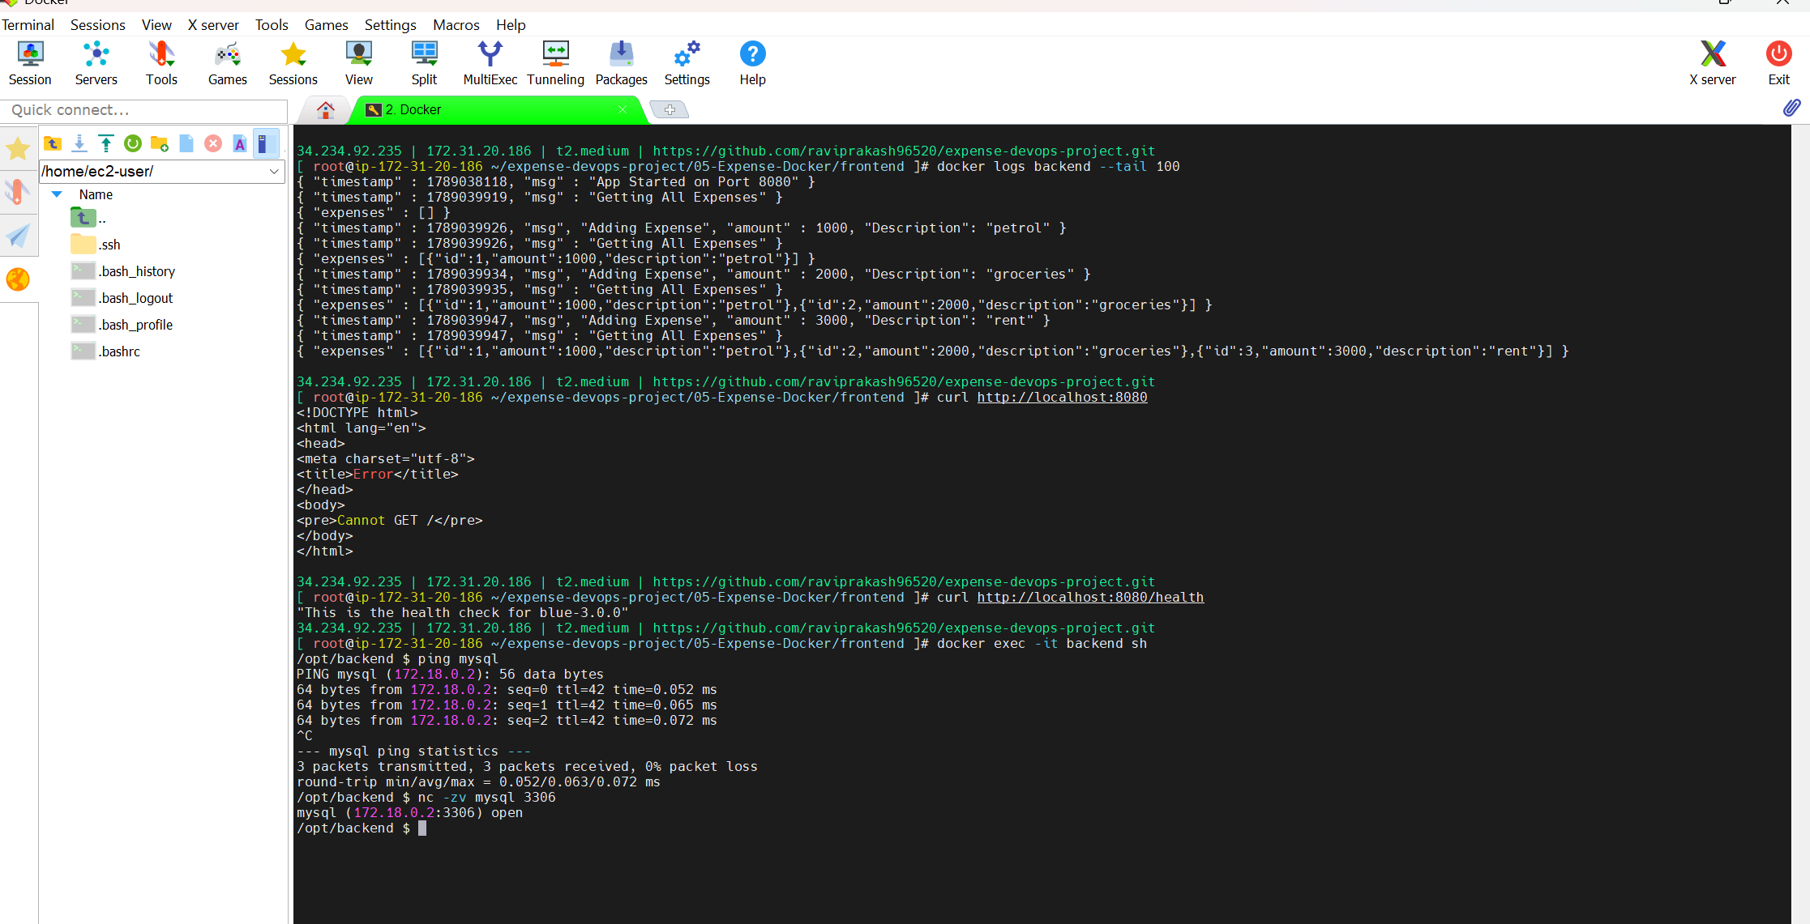
backend troubleshooting

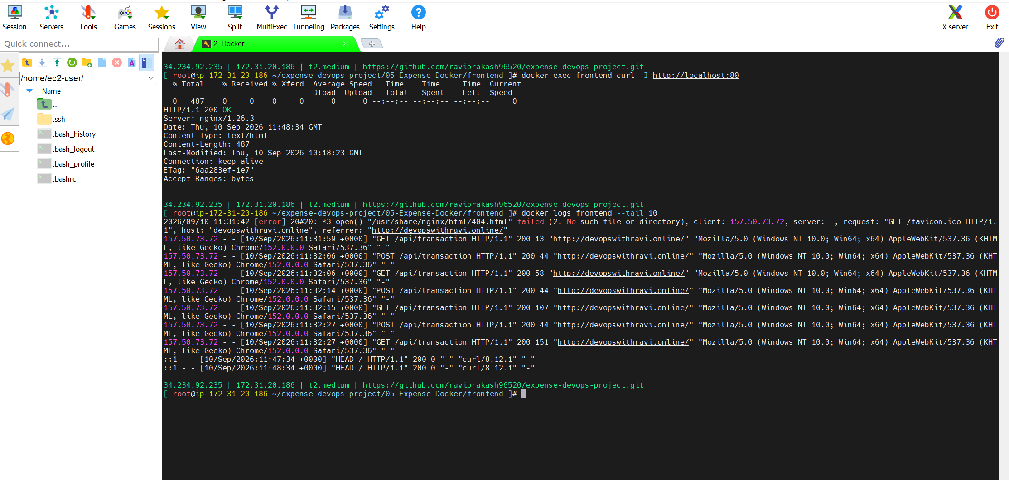
frontend working

network
using docker compose
