Aws configure
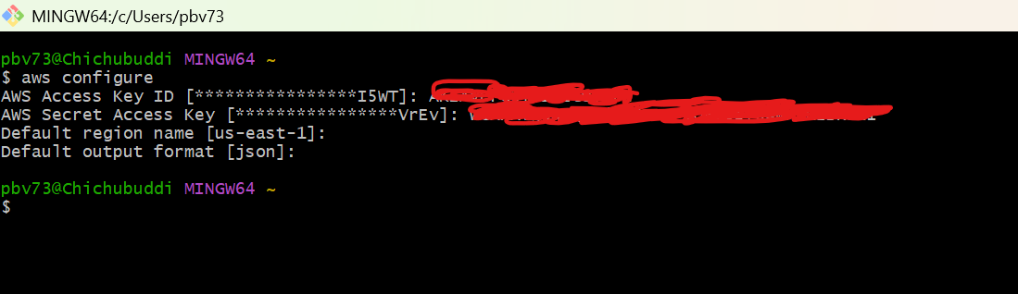

Cluster creation ( takes 15 min)
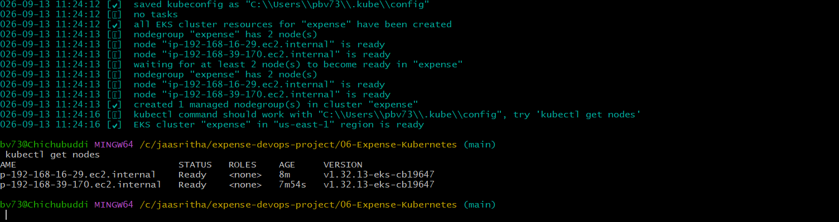

After successful installations of ebscsidriver and aws-load-balancer-controller
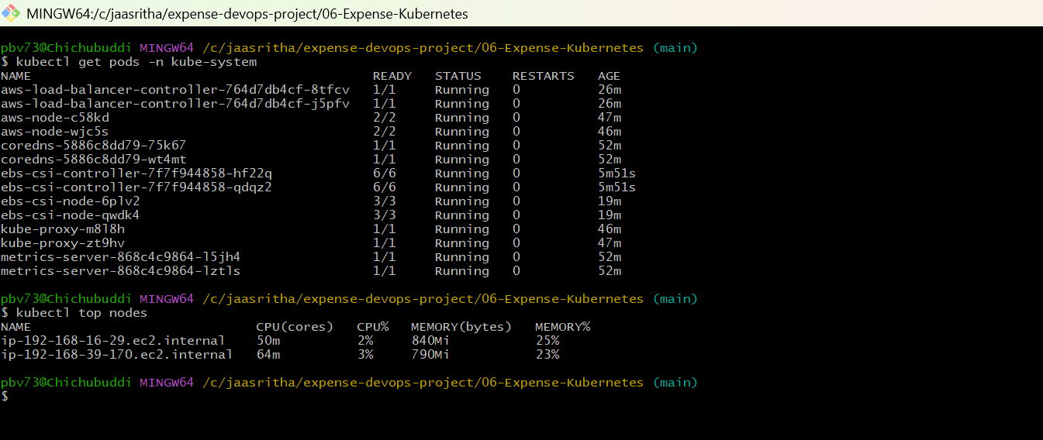

After successful apply we get all pods
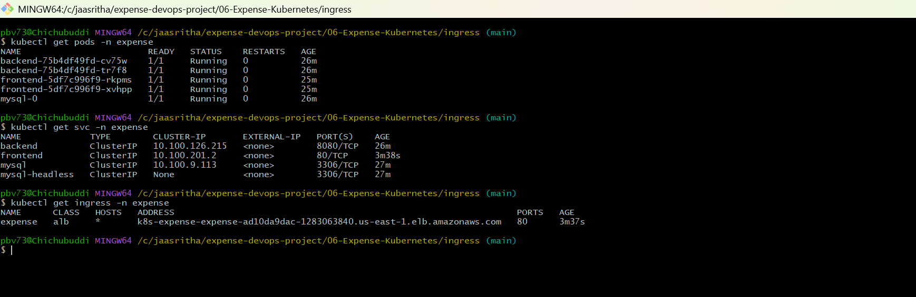

Access the website through browser
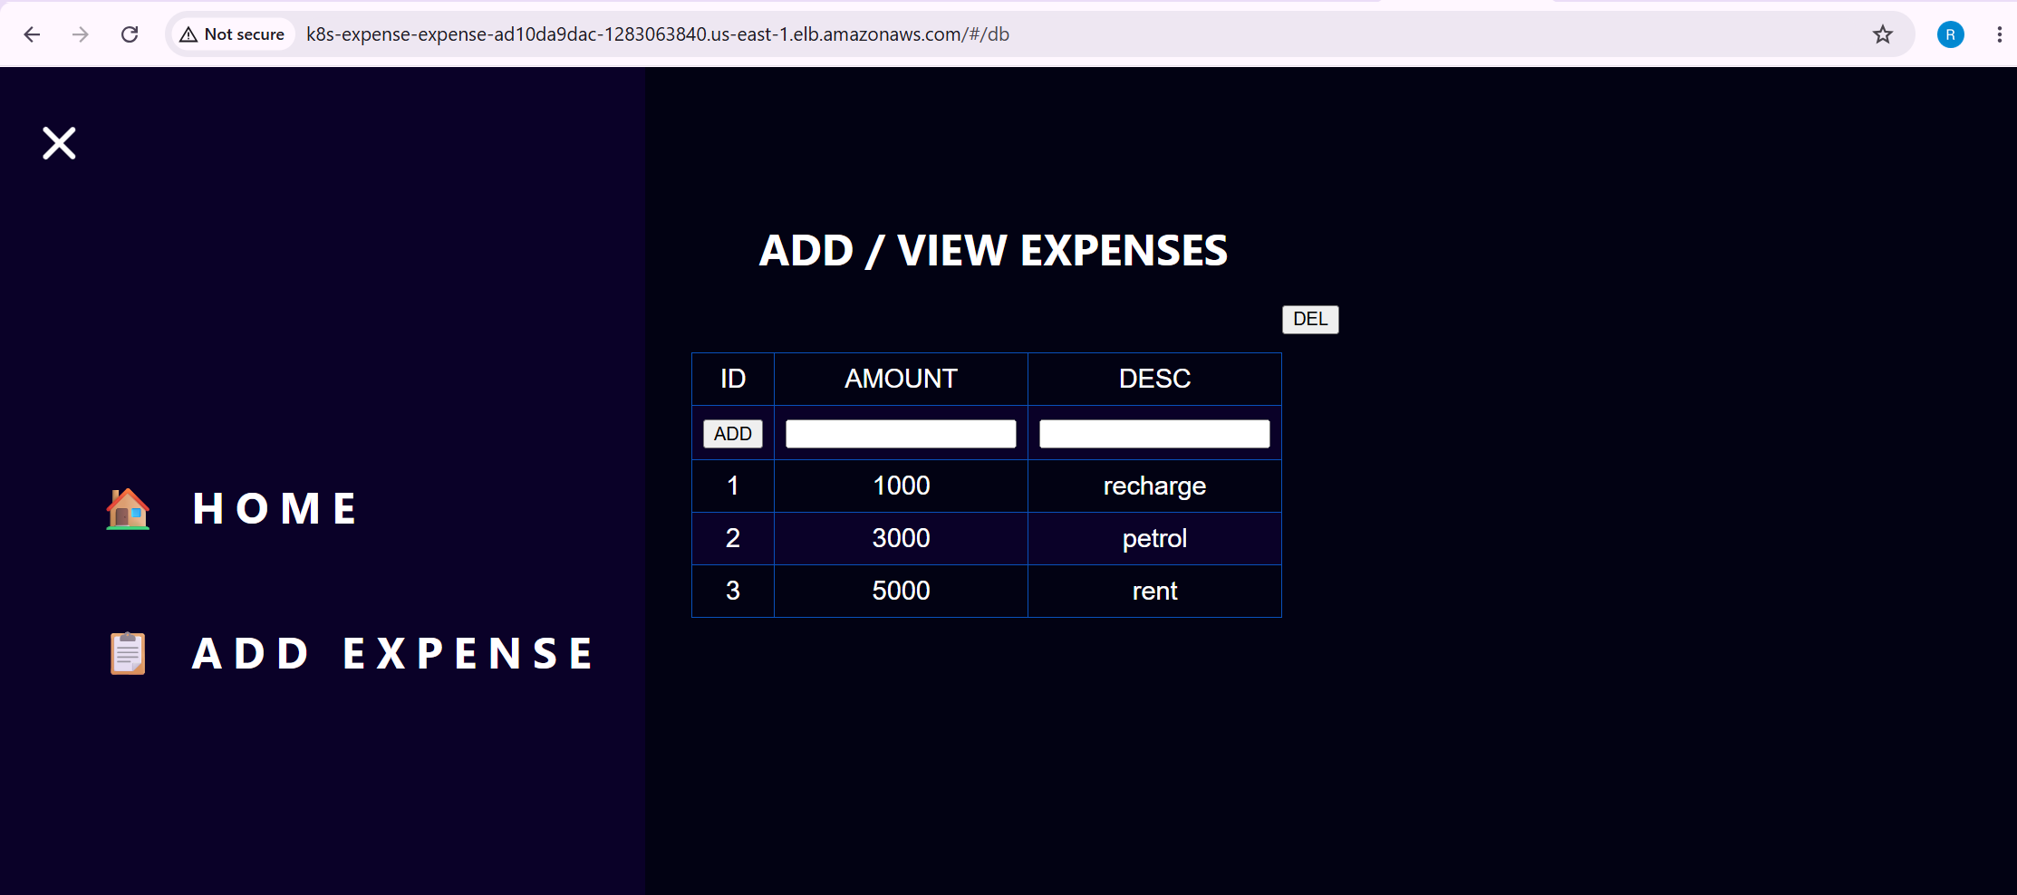

You have to delete the mysql-o pod and after creating again see the saved expenses
