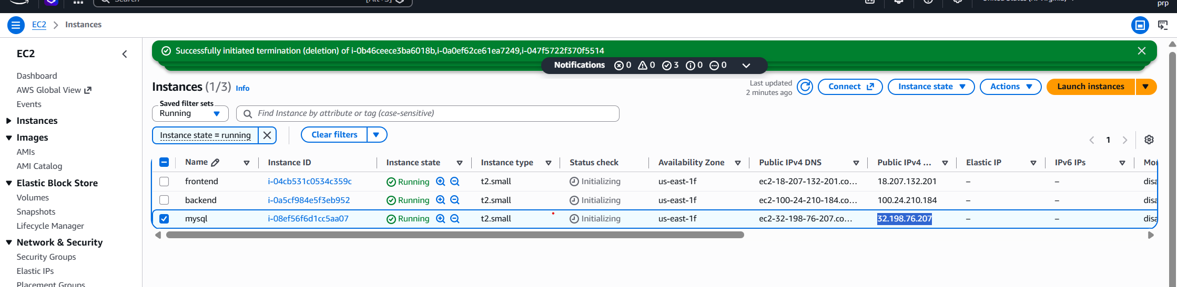
Login through mobaxterm via SSH
Sudo dnf update -y
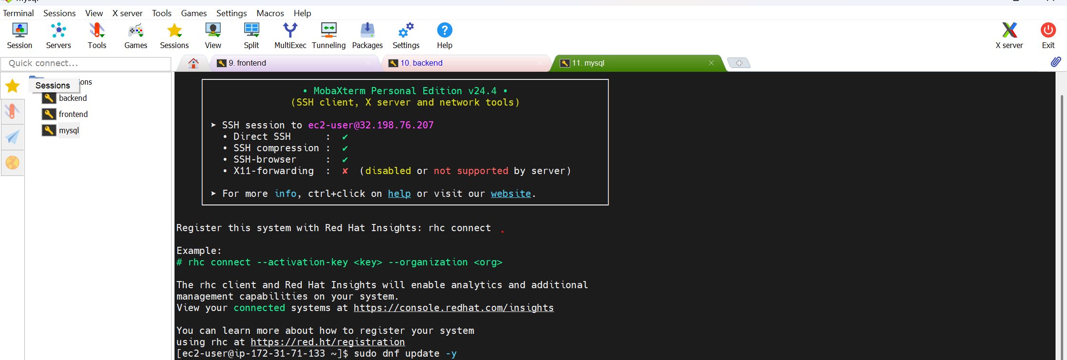

First DB configuration in mysql instance
Follow the steps in documentation
See the confirmation of mysql server running
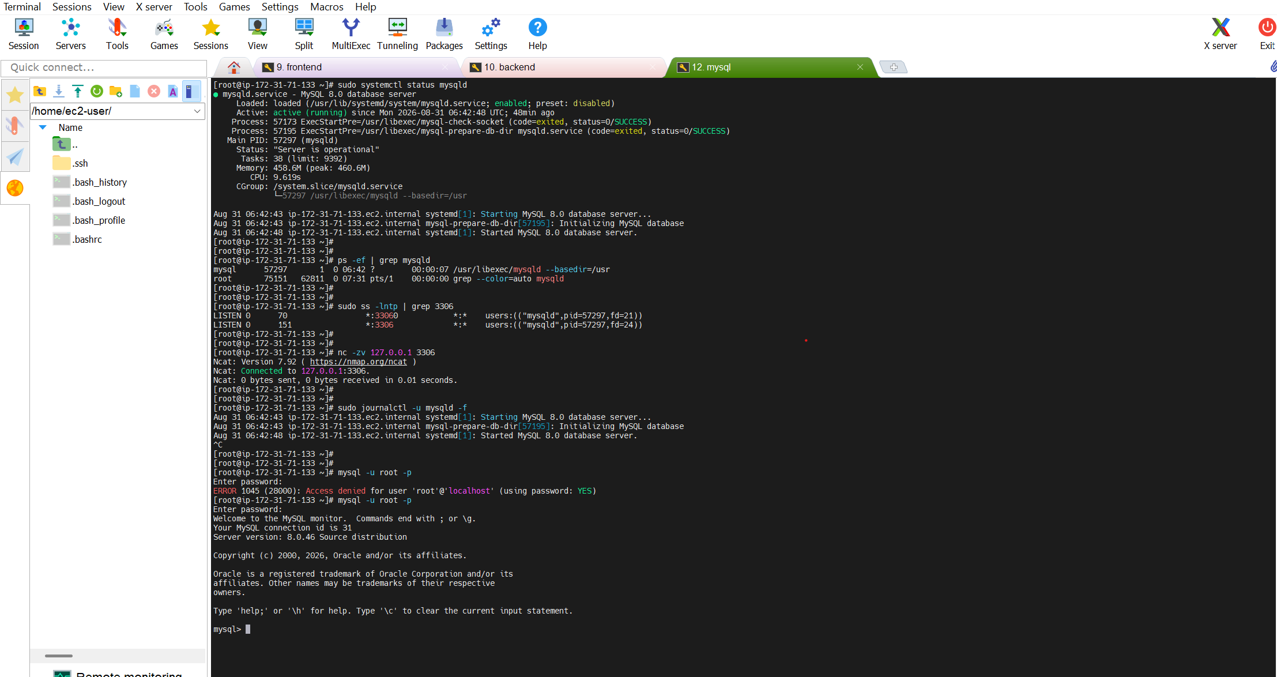

1. MySQL service running unda?
sudo systemctl status mysqld
Active: active (running) vaste ✅
2. MySQL process unda?
ps -ef | grep mysqld
/usr/sbin/mysqld kanipiste ✅
3. MySQL 3306 port listen avutunda?
sudo ss -lntp | grep 3306
Example:
LISTEN 0 70 0.0.0.0:3306
ante ✅ MySQL 3306 port lo listening.

5. MySQL itself port lo listen chestundo test cheyyi
Same EC2 machine nunchi:
nc -zv 127.0.0.1 3306
Expected:
Connection to 127.0.0.1 3306 port [tcp/mysql] succeeded!
Follow logs live:
sudo journalctl -u mysqld -f

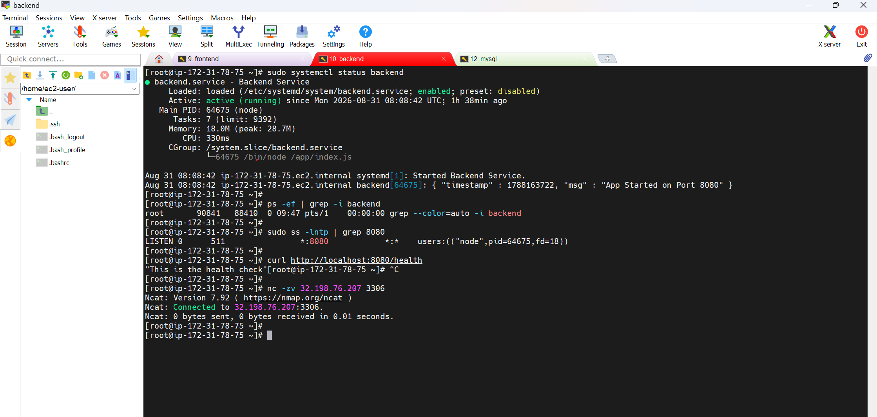

1. Backend process/service running unda?
If backend service ga run chestunte:
sudo systemctl status backend
Service name teliyakapotey:
ps -ef | grep -i backend

2. Backend port listening lo unda?
Suppose backend port 8080:
sudo ss -lntp | grep 8080
Example:
LISTEN 0 128 0.0.0.0:8080
Ante ✅ backend 8080 lo listening.
3. Local ga backend reachable unda?
curl http://localhost:8080
If health endpoint undi ante better:
curl http://localhost:8080/health
Response vaste ✅

4. Backend → MySQL reach avutunda?
Backend EC2 nunchi:
nc -zv 32.198.76.207 3306
Expected:
Connection to 32.198.76.207 3306 port [tcp/mysql] succeeded!
Ante ✅ Backend server MySQL server ni reach cheyyagalutundi.

5. Backend logs
Service use chestunte:
sudo journalctl -u backend -n 50
Live logs:
sudo journalctl -u backend -f

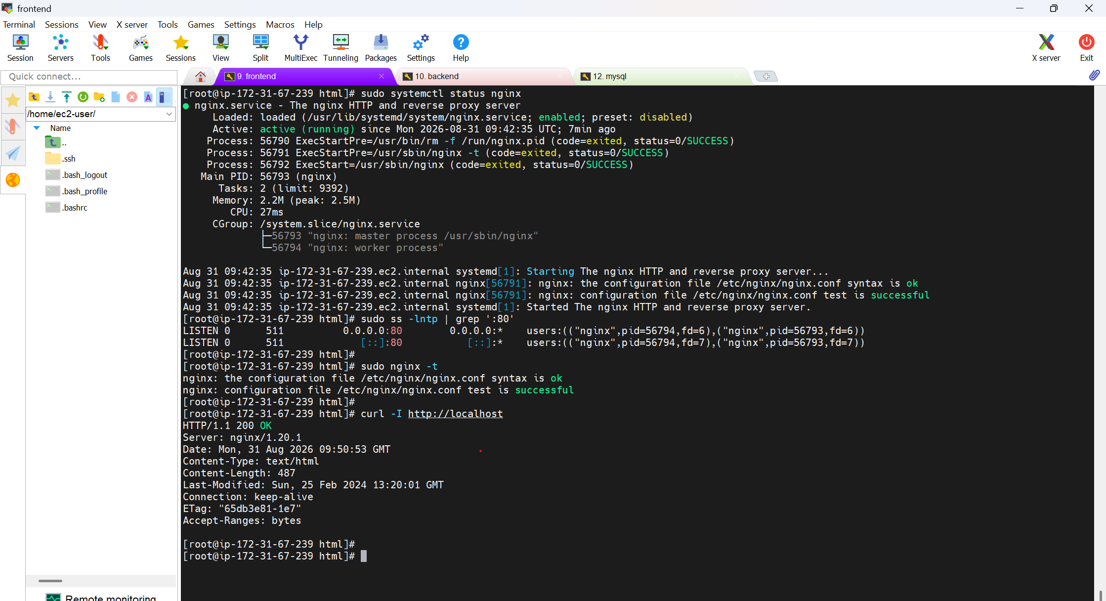

Command | Enduku?
sudo systemctl status nginx | Nginx service running lo unda ani check cheyyadaniki
sudo ss -lntp | grep ':80' | Nginx port 80 lo listening avutunda ani check cheyyadaniki
sudo nginx -t | Nginx configuration correct ga unda ani check cheyyadaniki
curl -I http://localhost | Frontend locally reachable avutunda ani check cheyyadaniki
sudo tail -50 /var/log/nginx/error.log | Nginx lo errors emaina unnaya ani check cheyyadaniki
sudo tail -50 /var/log/nginx/access.log | Browser/client requests Nginx ki reach avutunnaya ani check cheyyadaniki
sudo journalctl -u nginx -n 50
curl http://<BACKEND-IP>:8080 | Frontend server nunchi backend API reachable avutunda check cheyyadaniki
nc -zv <BACKEND-IP> 8080 | Backend 8080 port network level lo reachable avutunda check cheyyadaniki
ping -c 3 <BACKEND-IP> | Frontend server nunchi backend server network reachable aa check cheyyadaniki
curl -I http://<BACKEND-IP>:8080 | Backend HTTP response istunda check cheyyadaniki
Note :

sudo setsebool -P httpd_can_network_connect 1
run above command if frontend not adding the products and getting 404 error from frontend side

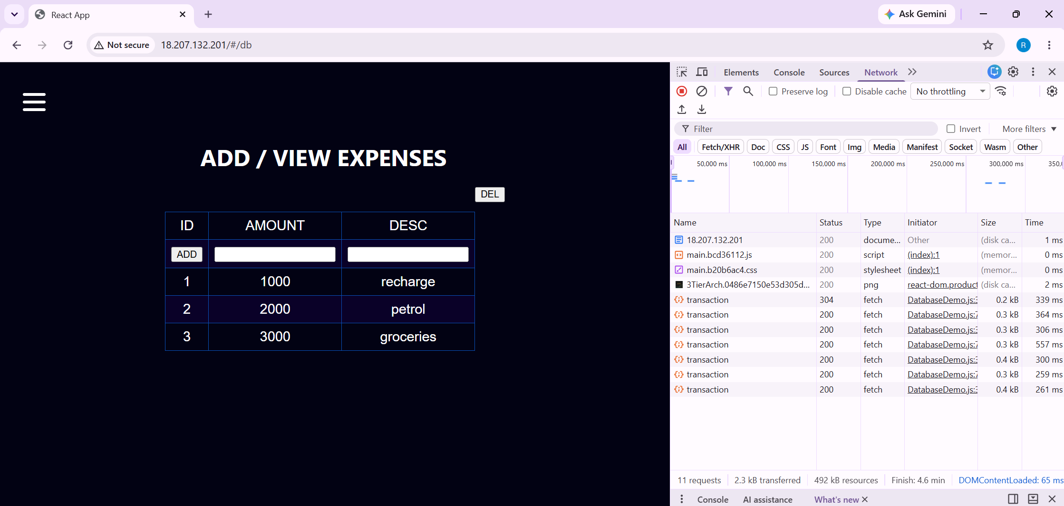

sudo tail -f /var/log/nginx/access.log
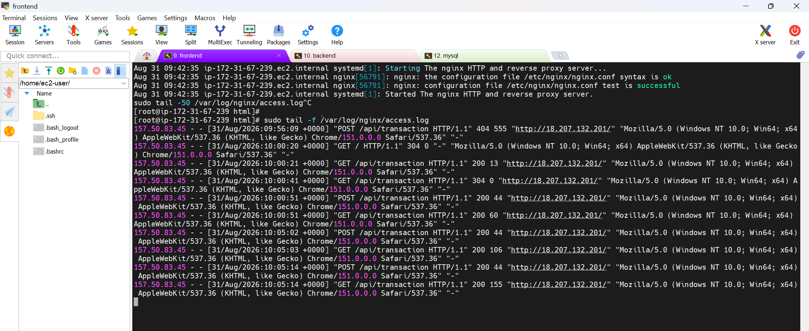

sudo journalctl -u backend -f

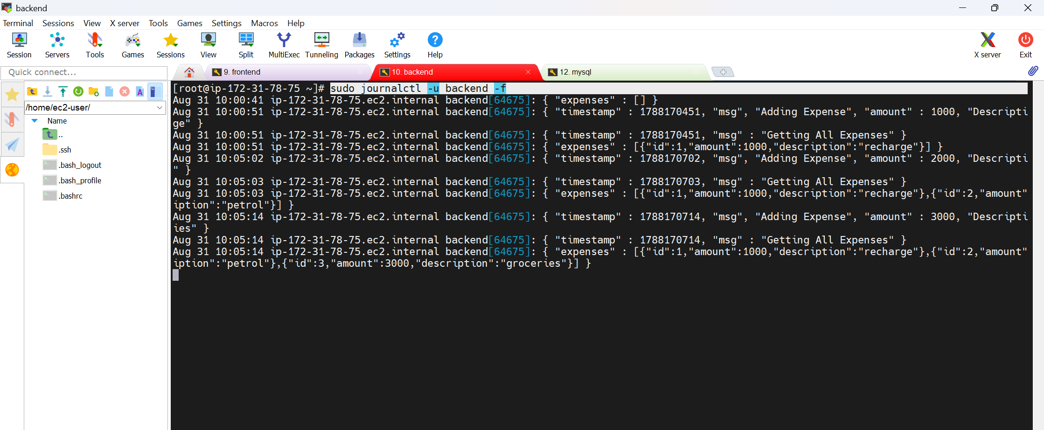

Mysql :
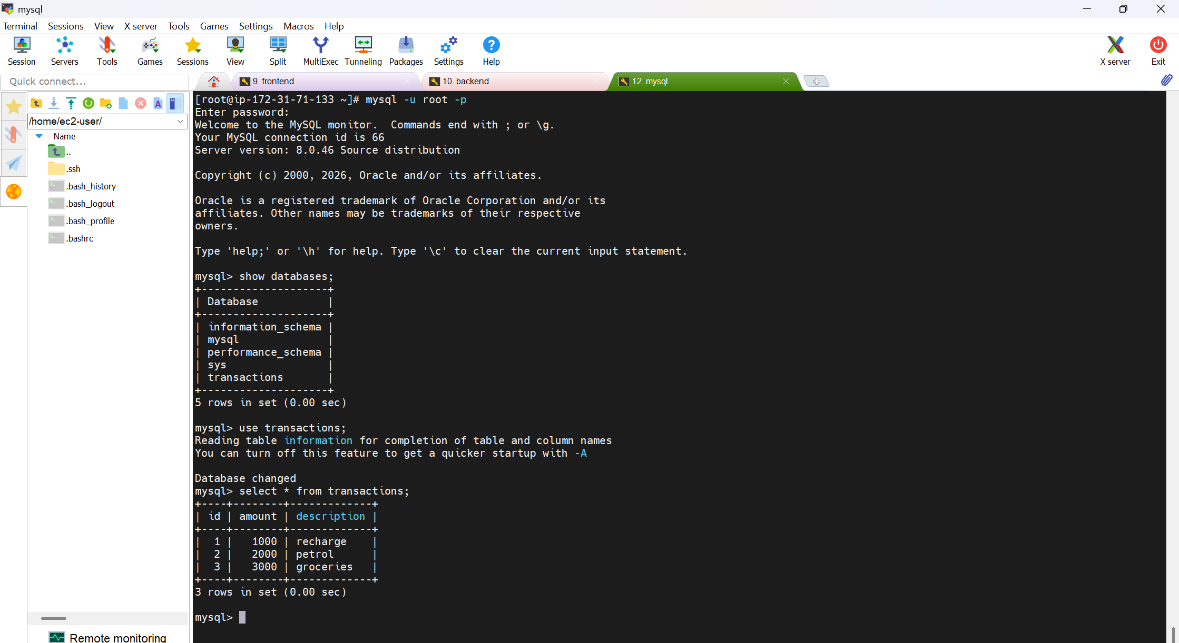

systemd
↓
Service manager

systemctl
↓
systemd ni control cheyyadaniki command

journald
↓
systemd services logs collect chestundi

journalctl
↓
journald logs ni choodataniki command

data stored in mysql location : /var/lib/mysql/transactions/

