**GenAI using LangGraph**

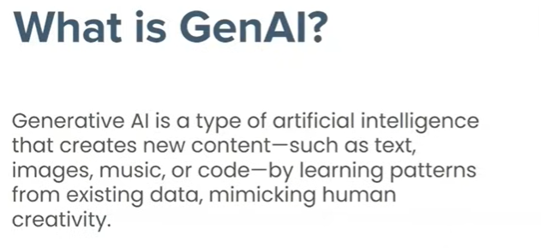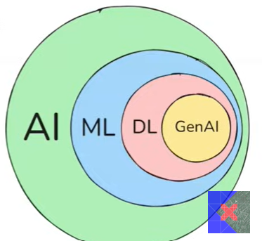

**machine learning created huge impact on generative AI**

**GenAI is replacing human creativity**

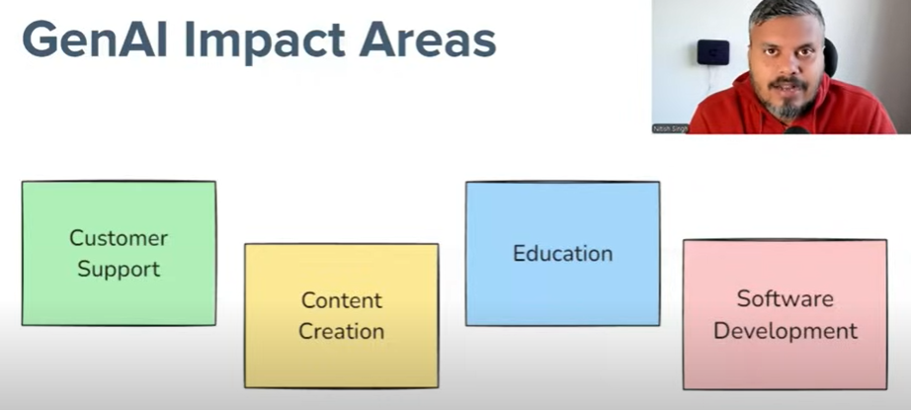

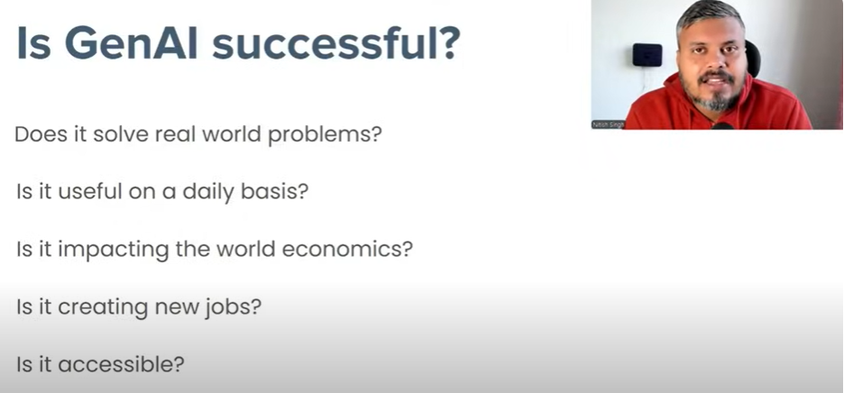

All of above Question have “YES” ANSWERS

**Foundation models is the center of all modes that include LLM, LMM(Large multi model deals with voice image etc)**

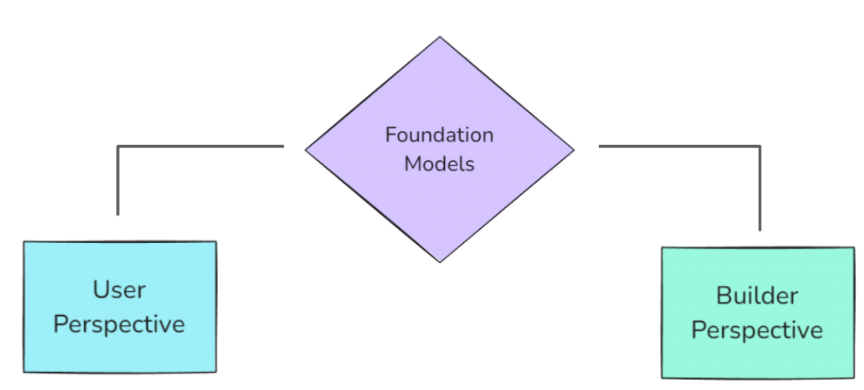

**Users perspective where we use prebuilt model like LLM for your work**

**builders perspective built this foundation model and deploy it like LLM**

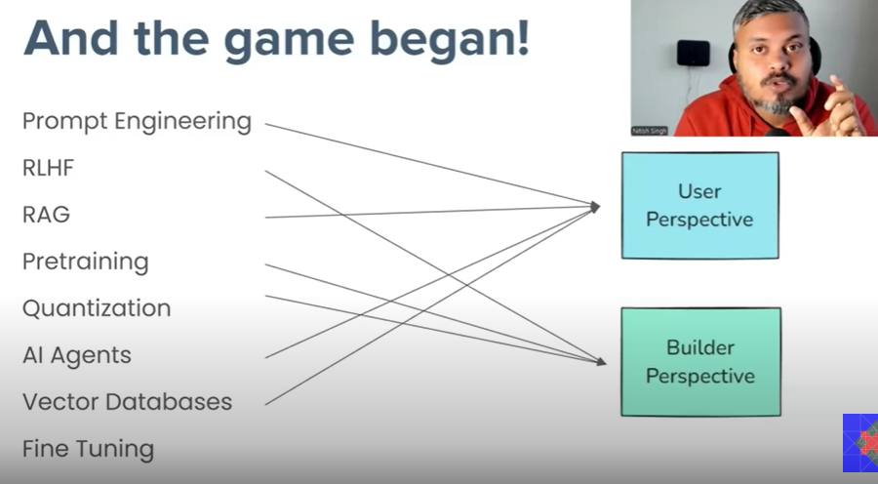

builders perspective should have knowledge of machine learning deep learning and pytorch or tensorflow

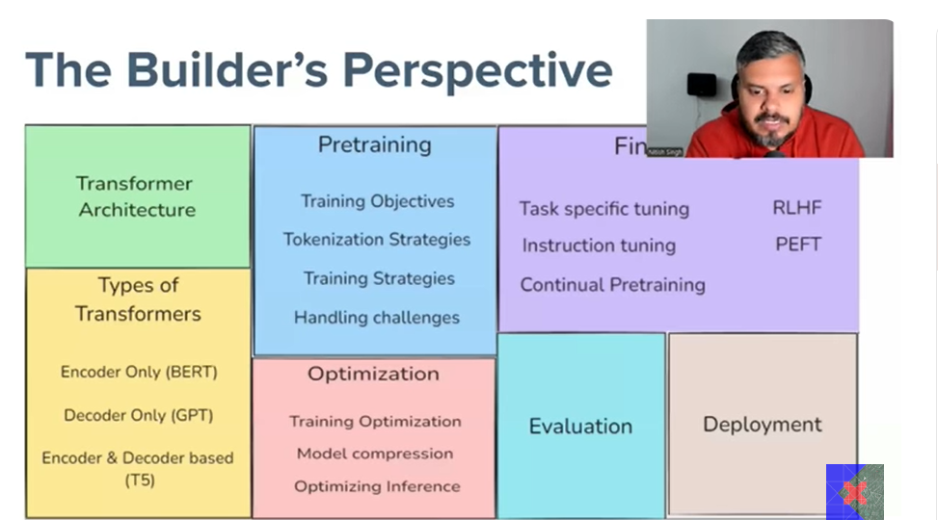

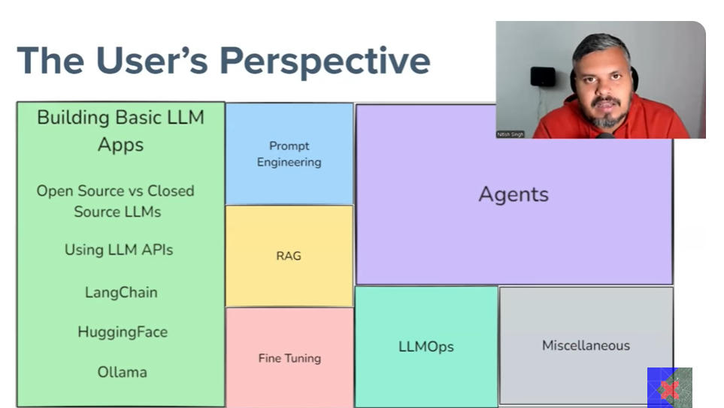

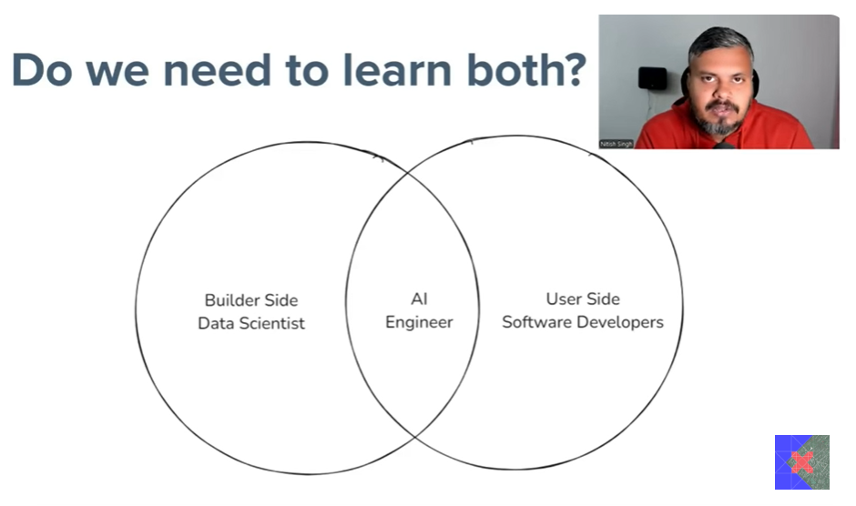

# Expanded Explanation of GenAI using LangGraph

## Introduction to GenAI

Generative AI (GenAI) refers to artificial intelligence systems capable of generating text, images, audio, and other media in response to prompts. These systems are built on foundation models that are trained on vast datasets and can perform a wide range of tasks without task-specific training. GenAI is revolutionizing industries by enabling automation, creativity, and personalized experiences.

## Understanding LangGraph

LangGraph is a framework designed to facilitate the development of applications using language models. It allows developers to define workflows as graphs, where each node represents a step in the process and edges define transitions based on conditions. LangGraph supports asynchronous execution, memory management, and integration with various tools, making it ideal for building complex GenAI applications.

## Foundation Models

Foundation models are large-scale machine learning models trained on diverse datasets. Examples include GPT-4, PaLM, and Claude. These models serve as the backbone of GenAI systems, providing capabilities such as natural language understanding, generation, and reasoning. They are adaptable to various tasks through prompting and fine-tuning.

## User and Builder Perspectives

From a user perspective, GenAI applications offer intuitive interfaces for interacting with AI, such as chatbots, content generators, and assistants. Users benefit from enhanced productivity, creativity, and decision-making support.  
From a builder perspective, LangGraph provides a structured way to design and implement GenAI workflows. Builders can define custom nodes, manage state, and orchestrate interactions between models and tools, enabling the creation of robust and scalable applications.

## Relevant Technologies

Key technologies involved in GenAI and LangGraph include:  
- Language models (e.g., GPT, PaLM, Claude)  
- LangChain for chaining model calls and tools  
- Vector databases for semantic search and memory  
- Prompt engineering for guiding model behavior  
- APIs and SDKs for integration and deployment

## Conclusion

GenAI using LangGraph represents a powerful paradigm for building intelligent applications. By leveraging foundation models and structured workflows, developers can create solutions that are both flexible and effective. As the technology evolves, we can expect even greater capabilities and broader adoption across domains.