**LangChain Components**



Components:

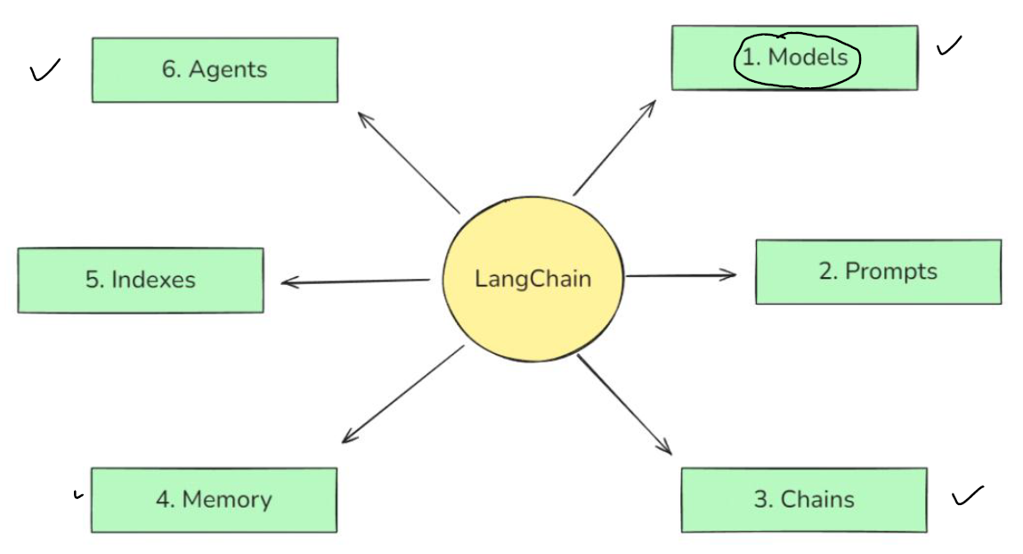

1. Models.



Standardation become challenge because different LLMs have different ways to write APIs. Langchain identified this problem and solve thisv by creating interface that can communicate with any LLMs API with changing code. Just need to change API keys

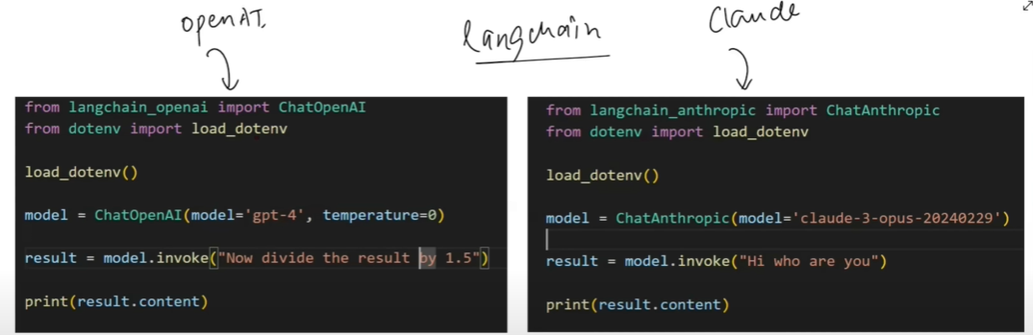

Chat models and embedding models in Langchain

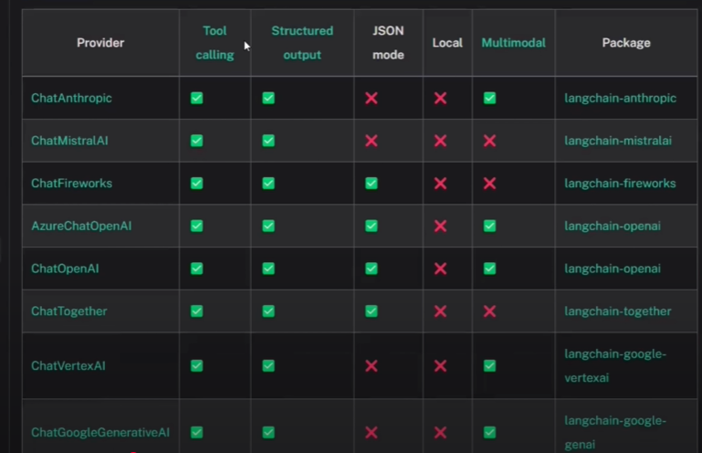 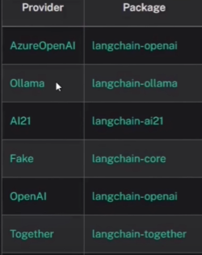

1. Prompts

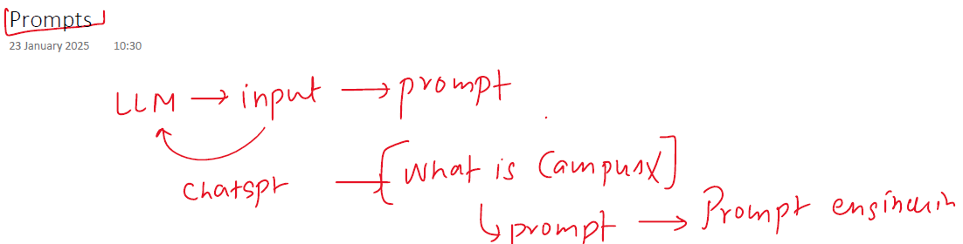

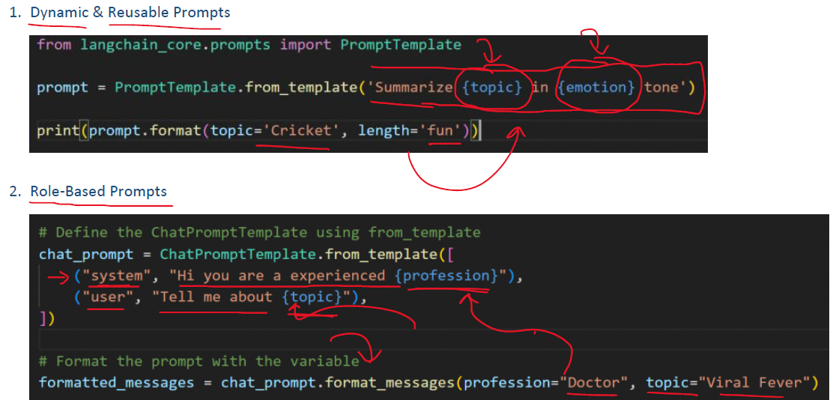

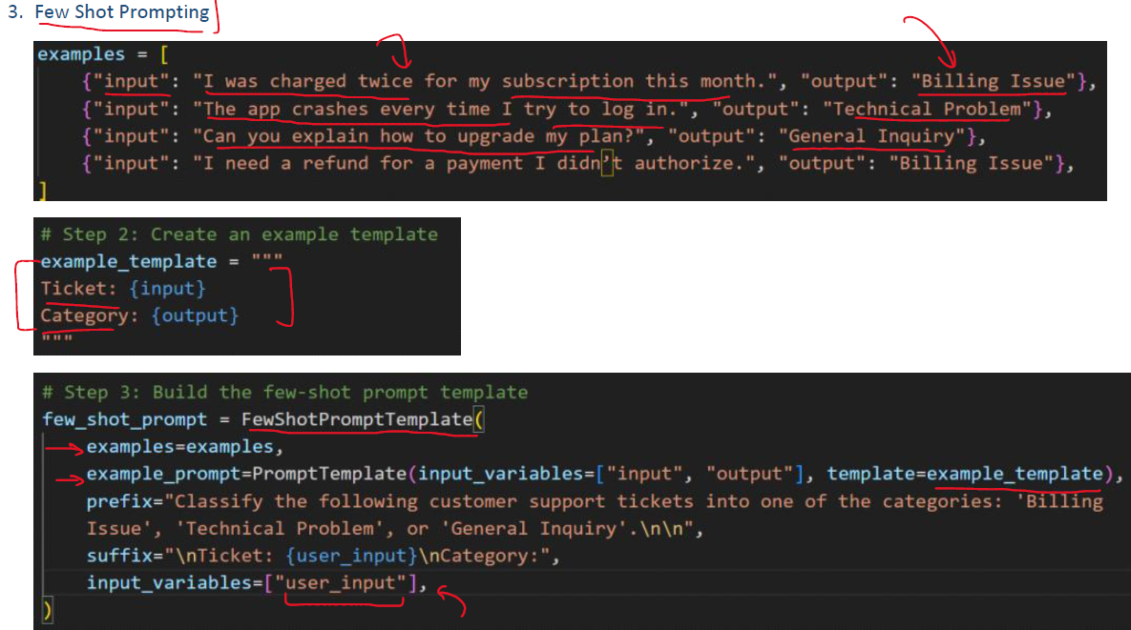

1. Chains

1. Indexes

1. Memory

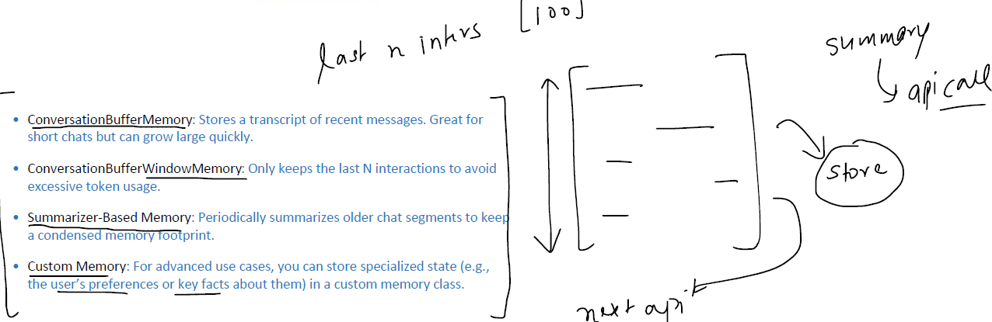

1. Agents

