**GenAI using LangGraph**

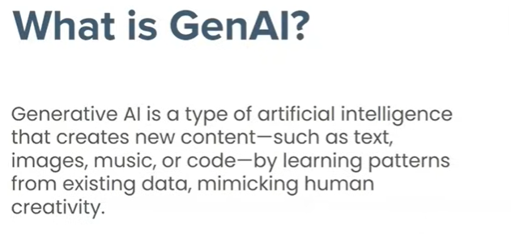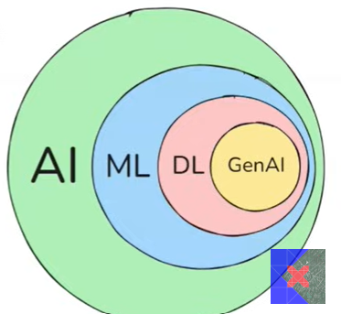

**machine learning created huge impact on generative AI**

**GenAI is replacing human creativity**

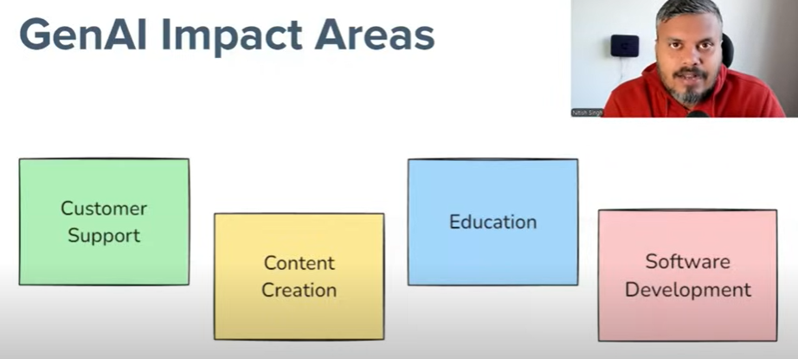

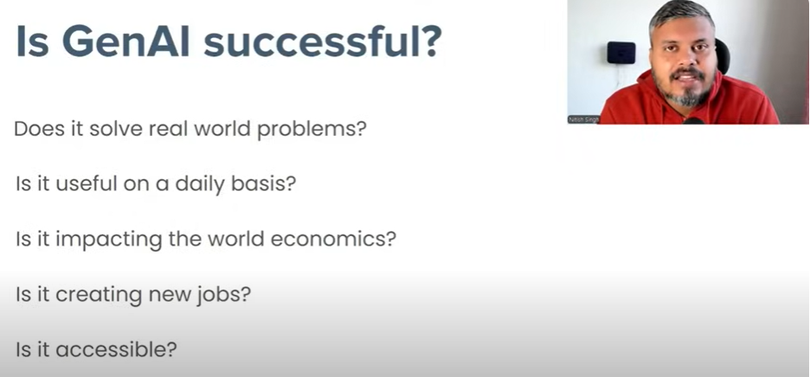

All of above Question have “YES” ANSWERS

**Foundation models is the center of all modes that include LLM, LMM(Large multi model deals with voice image etc)**

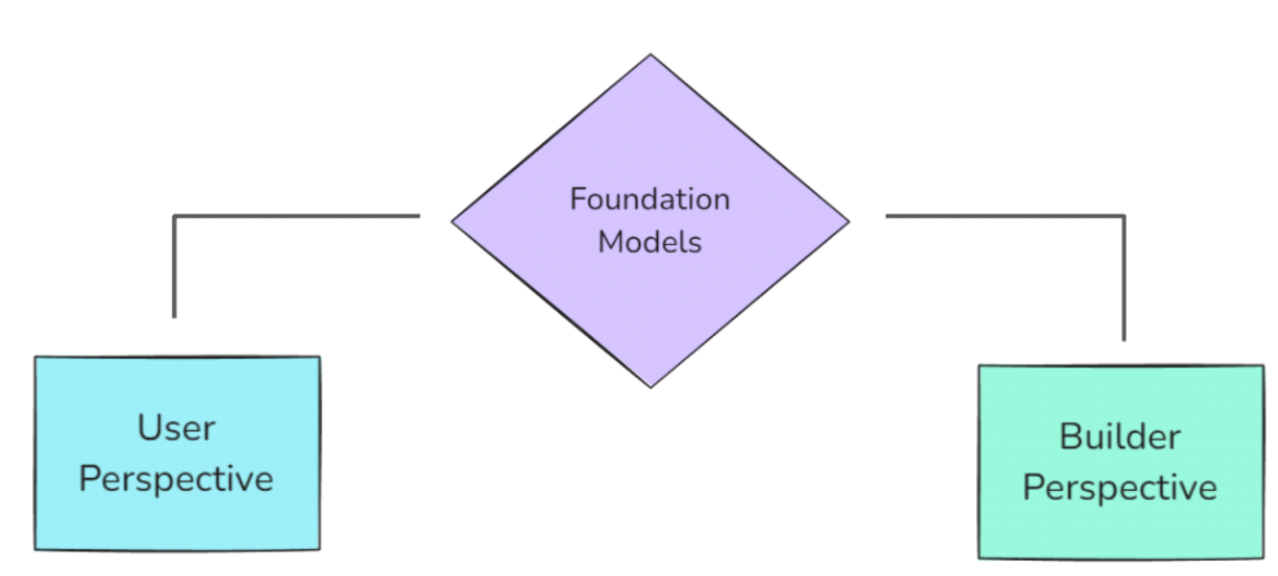

**Users perspective where we use prebuilt model like LLM for your work**

**builders perspective built this foundation model and deploy it like LLM**

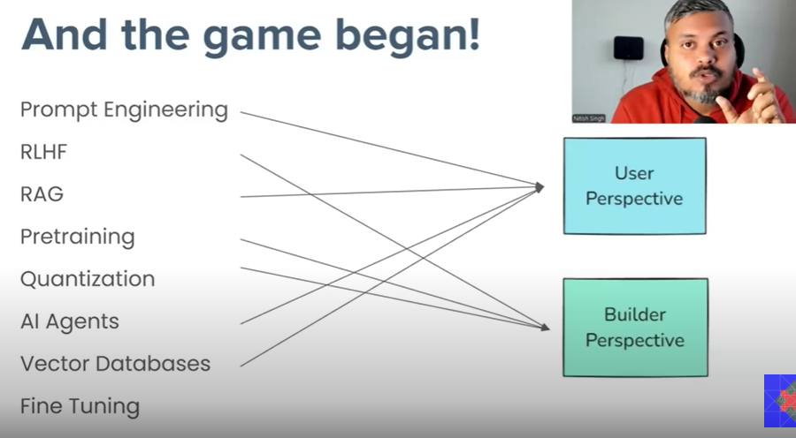

builders perspective should have knowledge of machine learning deep learning and pytorch or tensorflow

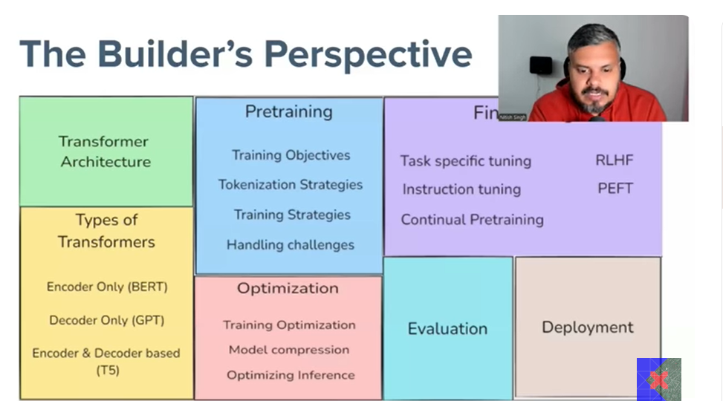

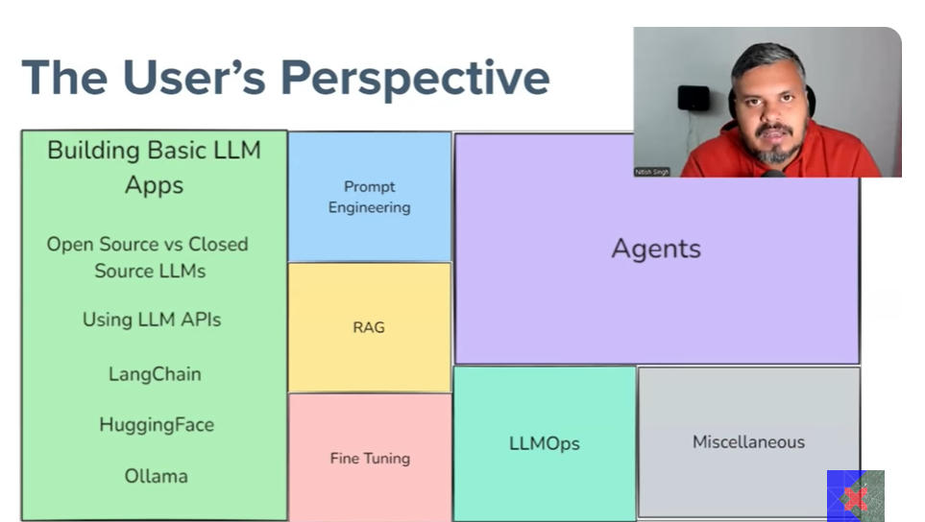

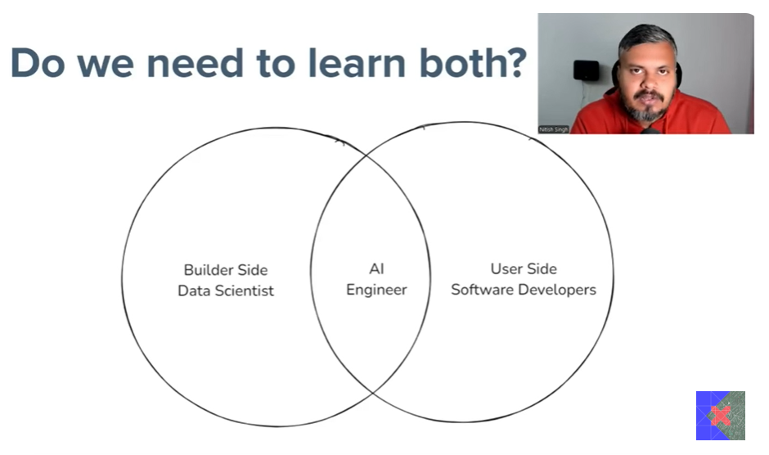

# Diagram Explanations

Each diagram referenced in the original notes illustrates key concepts of GenAI and LangGraph. For example, diagrams showing the flow of data through LangGraph nodes help clarify how GenAI applications are structured and executed. Diagrams of foundation models highlight the scale and complexity of the models used in GenAI systems. User and builder perspectives are often visualized to show the interaction between end-users and developers in the GenAI ecosystem.

# Visual Overview of GenAI and LangGraph

The following diagram provides a visual representation of the relationship between GenAI, LangGraph, foundation models, and the roles of users and builders. It helps to understand how these components interact to create intelligent applications.

