Script Documentation: Execution Script

Content :
- Libraries
- File : execution.py
- Proxy Setup
- Class ExecutionScript
- construter define
- run_command
- dpdk_crafter_downloader
- Calling class for execution

Libraries :
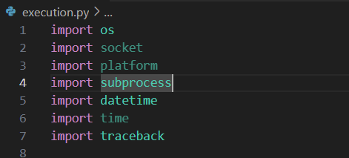

os – Operating System Interface : - Used to interact with the operating system. You can perform tasks like reading environment variables, navigating the file system, and executing system commands.

socket – Network Communication
Provides access to the BSD socket interface. Useful for network communication, creating servers and clients

platform – System Information
Used to access underlying platform’s data like OS name, version, architecture, etc.

subprocess – Running External Commands
Allows you to spawn new processes, connect to their input/output/error pipes, and obtain their return codes.

datetime – Date and Time Handling
Provides classes for manipulating dates and times.

time – Time-related Functions
Used for time-related tasks like delays, timestamps, and performance measurement.

traceback – Error Tracebacks
Helps in printing or retrieving stack traces of errors, useful for debugging.

2.a Proxy Setup :

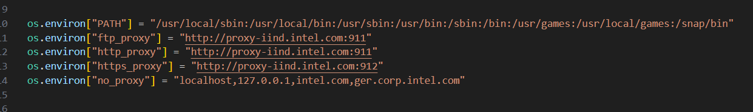

Why Required ?
In Intel, direct internet access from internal systems is often restricted for security, compliance, and monitoring reasons. Instead of allowing every user or machine to connect freely, all traffic is routed through proxy servers.
Proxy:
A proxy acts like a middleman between your computer and the internet. It filters requests, logs activity, and enforces security policies. Without setting up the proxy, your Python scripts (or tools like pip, wget, etc.) may fail to connect to external resources like GitHub, PyPI, or other APIs.
So, when we are working inside Intel's network, you we mustconfigure proxy settings to ensure your scripts can access the internet safely and in compliance with company policies.

We used Libraries for updating varuible “ OS Module “

2.b Execution Script:

The ExecutionScript class is designed to automate the setup of a DPDK development environment. It initializes Git repo details, generates a unique branch name using the current timestamp, and provides methods to run shell commands and clone the repo. The class structure promotes modularity, error handling, and logging, making it ideal for deployment or CI/CD pipelines in controlled environments like Intel’s internal network.

Class method :
- __init__
- run_command
- dpdk_crfter_downoader

2.b.i __init__ Method
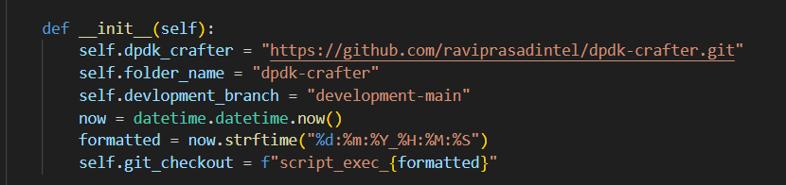
self.dpdk_crafter
This stores the GitHub URL of the DPDK Crafter repository. It’s the source code that your script will clone and work with.
Example: "https://github.com/raviprasadintel/dpdk-crafter.git"
• self.folder_name
This is the name of the folder where the repository will be cloned. It helps in identifying or navigating to the repo directory after cloning.
Example: "dpdk-crafter"
• self.devlopment_branch
This specifies the branch of the Git repository that should be cloned. It’s typically a working or feature branch like "development-main" used for active development.
• now = datetime.datetime.now()
Captures the current date and time. This is used to generate a unique name for the new Git branch to avoid conflicts and track when the script was executed.
• formatted = now.strftime("%d:%m:%Y_%H:%M:%S")
Formats the current timestamp into a readable string like "27:10:2025_14:35:07". This helps in creating a unique identifier.
• self.git_checkout
Combines a prefix ("script_exec_") with the formatted timestamp to create a new branch name. This branch is used to isolate the current execution from others.
Example: "script_exec_27:10:2025_14:35:07"

2.b.ii run_command() Method – Purpose & Functionality
This method executes shell commands from within Python. It accepts a command list, an optional description for logging, and a flag to capture output. If check_output is True, it returns the command’s output; otherwise, it just runs the command. It includes error handling for missing commands or failed executions, making it reliable for automation tasks like Git operations or system setup. 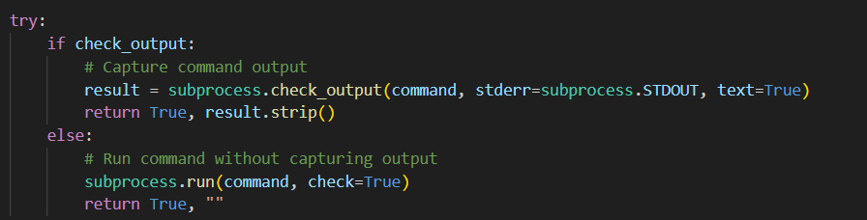

2.b.iii dpdk_crfter_downoader() Method – Purpose & Functionality 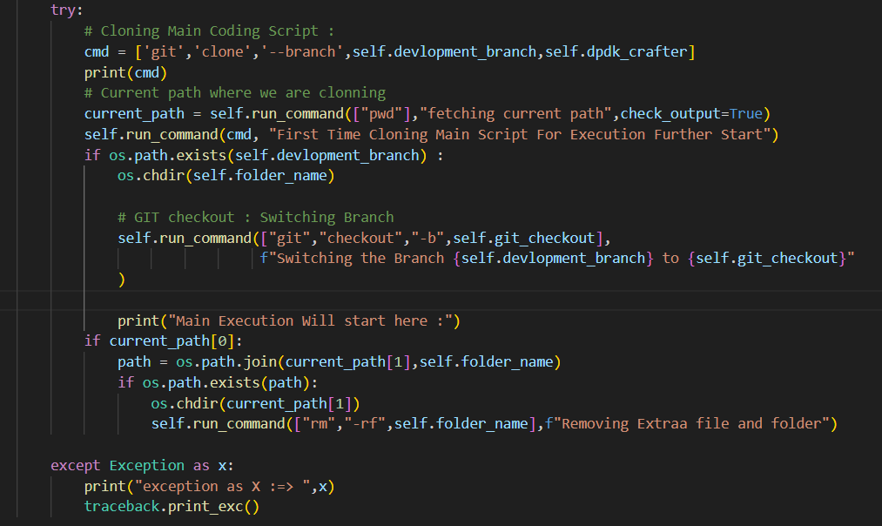
1. Prepare Git Clone Command
- Constructs a command to clone the DPDK Crafter repository from GitHub using the specified development branch.
2. Fetch Current Working Directory
- Uses pwd to get the current path where the script is running. This helps in managing folder paths later.
3. Clone the Repository
- Executes the git clone command to download the repo locally. This is the starting point for further automation.
4. Check if Folder Exists
- Verifies if the cloned folder exists using os.path.exists(). If it does, it navigates into the folder.
5. Create and Switch to a New Branch
- Uses git checkout -b to create a new branch with a timestamped name. This isolates the current execution from others.
6. Log Execution Start
- Prints a message indicating that the main execution will begin from this point.
7. Clean Up If Needed
- If the folder exists in the current path, it removes it using rm -rf to avoid leftover files from previous runs.
8. Error Handling
- Wraps the entire process in a try-except block and prints detailed traceback if any error occurs.

