Script Documentation: MainExecutionScript :
Content :

1Library Overview
This script uses several Python libraries to interact with the system, manage network interfaces, and automate configuration tasks:
- os – Interacts with the operating system for environment variables, file paths, and command execution.
- socket – Enables network communication and IP address retrieval.
- platform – Provides system information like OS name and architecture.
- subprocess – Executes external commands and handles their input/output.
- datetime – Manages date and time operations.
- time – Used for delays and performance timing.
- traceback – Prints stack traces for debugging errors.

2. Main Execution Script
Purpose
Automates the setup of a DPDK DTS testing environment, including firmware updates, driver installation, environment preparation, interface mapping, and configuration of DTS files.
Modules Used
- AutomationScriptForSetupInstallation
- PairingManagerInfo
- DutPortConfig
- DutCrbsConfig
- ExecutionCfgUpdate

Configuration Modules
- AutomationScriptForSetupInstallation – Handles firmware, driver updates, proxy setup, package installation, and repo cloning.
- DutPortConfig – Manages port mapping and updates ports.cfg.
- DitCrbsConfig – Updates crbs.cfg with DUT/tester credentials.
- ExecutionCfgUpdate – Updates execution.cfg with tester IP and test suite filtering.

Environment Variables Required
Before running the script, the following environment variables must be set:
- DPDK_INSTALLTION_PATH
- FIRMWARE_PATH
- DRIVER_PATH
- GIT_USERNAME
- GIT_TOKEN
- DPDK_SETUP_INSTALLATION
- DRIVER_UPDATE
- APT_PACKAGE_UPDATE_REQUIRED
- DPDK_SETUP_RUN

3. Execution Steps
3.1 Environment Validation
Validates required environment variables using os.environ.get(). If any are missing, the script exits early to prevent misconfiguration.
3.2 Proxy Setup
Configures proxy settings using setup_proxy_environment() to ensure connectivity in restricted environments.
3.3 Firmware & Driver Update
- Creates a setup directory.
- Validates firmware and driver paths.
- Extracts and installs firmware using ./nvmupdate64e.
- Installs NIC drivers from extracted files.
3.4 Installing Required Packages
- Uses install_required_packages() to install system and Python packages.
- Syncs system time.
- Installs build tools and DTS dependencies via apt.
- Installs Python modules via pip.
3.5 DPDK DTS Setup
- Creates a setup folder.
- Updates working path.
- Prints Git credentials.
- Clones DTS and DPDK repositories.
- Uses print_separator() for log clarity.
3.6 Fetching Interface and Configuration Details
3.6.1 Initialize Pairing Manager
Creates an instance of PairingManagerInfo.
3.6.2 Fetch Interface Pairing Info
- Uses ip -br a to list interfaces.
- Filters UP/DOWN status using regex.
- Activates DOWN interfaces.
- Stores active interfaces.
3.6.3 Fetch Connection Details
- Resets NIC link using ethtool -r.
- Captures dmesg output.
- Extracts interface names via regex.
- Updates pairing list.
- Adds sleep between checks.
- Stores results.
3.6.4 Map Interface to Bus Info
Maps interface names to PCI bus addresses using mapInterfaceToBus().
3.6.5 Initialize Port Config Object
- Uses DutPortConfig(dpdk_dts_path) to prepare ports.cfg.
- Fetches system IP via socket.
- Gets username via getlogin().
- Sets default password.
- Prints DUT details.
3.6.6 Update ports.cfg
- Generates config lines: pci=<bus_info_0>,peer=<bus_info_1>;
- Formats full config using a template.
- Navigates to DTS config directory.
- Writes config to file.
- Sets file permissions.
- Displays updated config.
3.6.7 Update crbs.cfg
- Loads existing config.
- Extracts first DUT block using regex.
- Updates DUT and tester fields.
- Displays updated block.
- Pauses for review.
- Writes back to file.
3.6.8 Update execution.cfg
- Loads current config.
- Filters out unnecessary test suites.
- Updates tester IP.
- Writes updated config.

3.7 Running DTS (Conditional)
If DPDK_SETUP_RUN is set to "TRUE":
- Navigates to DTS repo.
- Executes ./dts to start automated testing.

GIT REPOSITORY : CLICK_HERE
URL : raviprasadintel/dpdkCrafter at stage-main

  - Libraries :

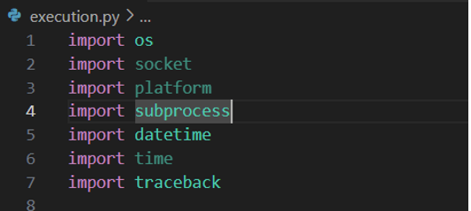

Python Libraries Overview
- os – Operating System Interface
Interacts with the operating system to manage environment variables, navigate file paths, and execute system-level commands.
- socket – Network Communication
Provides access to low-level network communication using the BSD socket interface. Useful for building servers and clients.
- platform – System Information
Retrieves system-level information such as OS name, version, and architecture.
- subprocess – Running External Commands
Facilitates the execution of external commands and scripts, allowing interaction with their input/output and capturing return codes.
- datetime – Date and Time Handling
Offers classes and functions for manipulating and formatting dates and times.
- time – Time-related Functions
Supports time-related operations including delays, timestamps, and performance measurements.
- traceback – Error Tracebacks
Enables printing and retrieving stack traces for error debugging and analysis.

  - MainExecutionScript :

Purpose:
Main automation script for setting up DPDK DTS environment, updating firmware,
installing drivers, configuring ports, and preparing system for testing.

Modules Used:
- execution.setup_installation.AutomationScriptForSetupInstalltion
- execution.bus_info_details.PairingManagerInfo
- execution.dut_ports_config.DutPortConfig

Or
Automates the complete setup of a DPDK DTS testing environment, including firmware updates, driver installation, environment preparation, interface mapping, and configuration of DTS files.

STEPS EXPLANATION :
Imports:

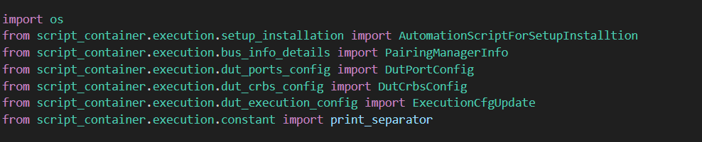
Module Used
- AutomationScriptForSetupInstalltion: Handles firmware, driver updates, package installation, repo cloning.
- PairingManagerInfo: Fetches and maps interface pairing and bus info.
- DutPortConfig: Updates ports.cfg with DUT port details.
- DutCrbsConfig: Updates crbs.cfg with credentials and IPs.
- ExecutionCfgUpdate: Updates execution.cfg with DUT IP.
Before Running this Script have to set default value “OS.ENVIRON”
- DPDK_INSTALLTION_PATH = PATH WHERE WE HAVE TO INSTALL.
- FIRMWARE_PATH = UPDATING FIRMWARE PATH REQ…
- DRIVER_PATH = UPDATING DRIVER PATH REQ…
- GIT_USERNAME = HAVE TO PROVIDE USERNAME
- GIT_TOKEN = HAVE TO PROVIDE TOKEN
- DPDK_SETUP_INSTALLATION = BOOLEAN VALUE
- DRIVER_UPDATE = BOOLEAN VALUE
- APT_PACKAGE_UPDATE_REQUIRED = BOOLEAN VALUE
- DPDK_SETUP_RUN = BOOLEAN VALUE
  - Execution Flow (Point wise)
- Environment Validation: Checks for required environment variables.
- Proxy Setup: Configures proxy settings.
- Firmware & Driver Update (conditional).
- Package Installation (conditional).
- DPDK/DTS Repo Cloning (if enabled).
- Interface Mapping: Uses PairingManagerInfo to fetch and map interfaces.
- Port Configuration: Updates ports.cfg with mapped interface details.
- CRBS Configuration: Updates crbs.cfg with DUT/tester credentials.
- Execution Config Update: Sets DUT IP in execution.cfg.
- Run DTS (optional): Executes DTS if enabled.

3.1. Environment Validation 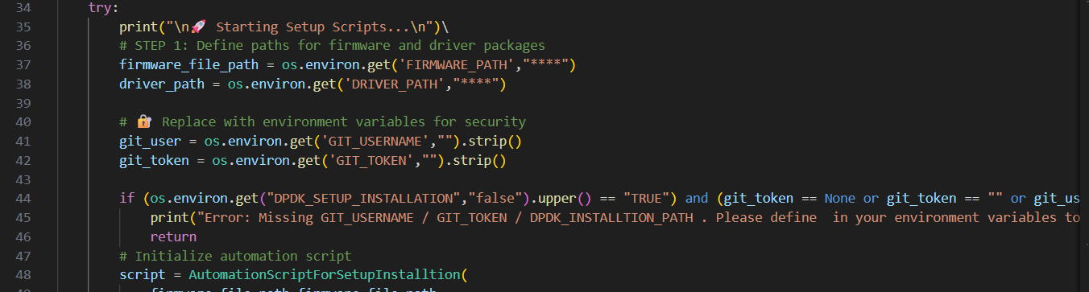

- Purpose
This step ensures that all critical environment variables required for the automation process are correctly defined before proceeding. These include credentials for Git access (GIT_USERNAME, GIT_TOKEN) and the installation path (DPDK_INSTALLTION_PATH). Without these, the script cannot clone repositories or configure the DTS setup, which would lead to failure in subsequent steps.
- Logic Used The script uses os.environ.get() to fetch values from the environment. It checks if DPDK_SETUP_INSTALLATION is set to "TRUE" and validates that git_user, git_token, and dpdk_dts_path are not empty or None. If any are missing, it prints an error and exits early. This prevents partial or broken setups due to missing credentials or paths.
- Conclusion:
This step acts as a gatekeeper, ensuring the system is ready and secure for automation. It prevents wasted execution time and avoids misconfigurations.

3.2. Proxy Setup (UBUNTU 25.04.3)
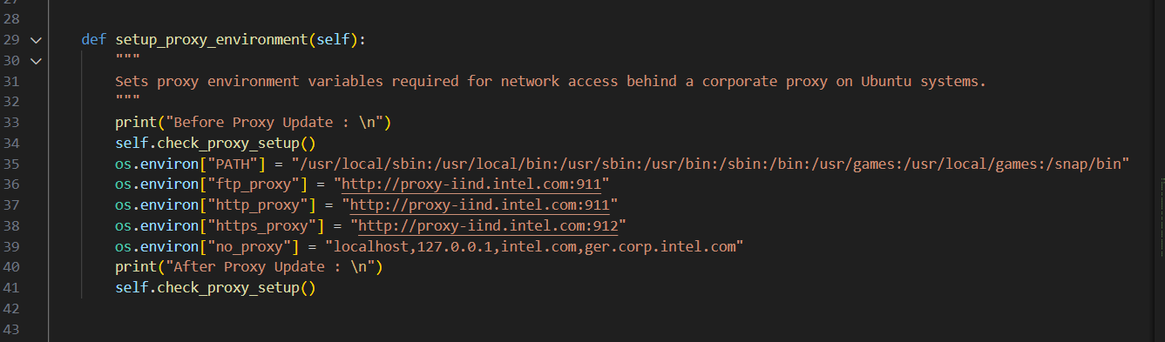
PATH : /script_container.execution/setup_installation : Class Name AutomationScriptForSetupInstalltion

- Purpose:
Configures proxy settings to ensure network operations like package installation and Git cloning work in environments with restricted internet access.

- Logic Used:
Calls setup_proxy_environment() from AutomationScriptForSetupInstalltion, which likely sets environment variables like http_proxy, https_proxy, and configures system-wide proxy settings.

- Conclusion:
This step ensures smooth internet connectivity for all subsequent operations, especially in enterprise or firewall-restricted setups.

3.3. Firmware & Driver Update (Conditional)
Step 1 : We have to Import “AutomationScriptForSetupInstalltion”
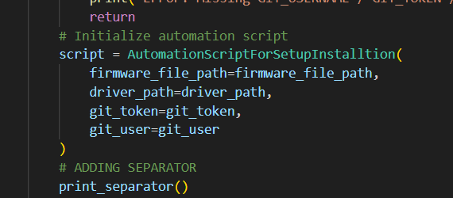
Step 2 : Checking “DRIVER_UPDATE” condition was “TRUE”
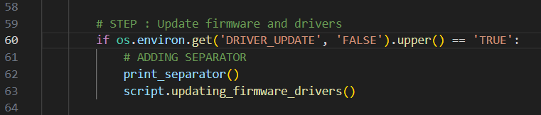
Step 3 : CALLING METHOD “ updating_firmware_drivers()”
Explanations Methods :
Validates paths and extracts firmware and driver tar files.
Navigates into extracted directories and runs firmware installation.
Parameters:
- firmware_file_path (str): Path to the firmware tar.gz file.
- driver_path (str): Path to the driver tar.gz file.

Step 3.1: Creating Setup Directory
The script creates a dedicated folder named setup_frimware_driver inside the working directory. This isolates firmware and driver operations from the rest of the environment, keeping the setup clean and organized.
Step 3.2: Validating File Paths
Before proceeding, the script checks whether the paths provided for the firmware and driver tar files are valid. If either path is missing or incorrect, it raises an exception and halts execution. This prevents errors during extraction or installation.
Step 3.3: Extracting Firmware & Running Update
The firmware tar file is extracted into the setup_frimware_driver folder. The script then navigates into the extracted directory and runs the command ./nvmupdate64e, which is typically Intel’s tool for updating NIC firmware. This command applies the firmware update to the NICs based on the configuration files bundled in the tar archive.
Step 3.4: Returning to Setup Directory
After the firmware update, the script returns to the setup_frimware_driver directory to maintain context and prepare for the next step.
Step 3.5: Installing Driver
The driver tar file is extracted, and the script runs the installation commands (usually make install or a vendor-specific script) to install the NIC driver. This ensures the system kernel can properly interface with the NIC hardware
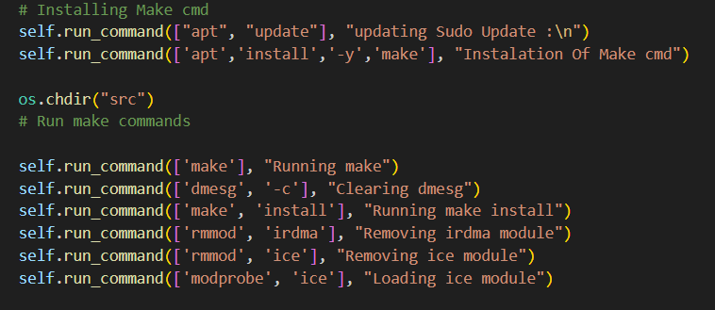

3.4. Installing Required Packages (Conditional) 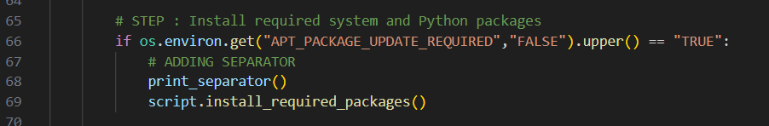
Explantion Method : “install_required_packages()”
PATH : /script_container/execution/setup_installation.py
PURPOSE
This method automates the installation of all necessary system and Python packages required for compiling, running, and testing DPDK and DTS. It ensures the DUT or host system has the correct build tools, libraries, and Python modules to support the full lifecycle of DPDK—from source compilation to test execution. By automating this step, it eliminates manual setup errors, speeds up environment preparation, and ensures consistency across different test systems.
Logic Used:
The method begins by setting the system time using timedatectl to ensure time synchronization, which is often required for secure package installations and logging accuracy. It then performs an apt-get update to refresh the package index.
The script defines two lists:
- apt_packages: Contains commands to install essential build tools (gcc, build-essential, meson, ninja-build), DPDK dependencies (libnuma-dev, libpcap-dev, libboost-all-dev, etc.), and DTS-related utilities (python3-scapy, lldpad, etc.).
- pip_packages: Installs Python modules like xlrd, xlwt, pexpect, and pyelftools, which are used for DTS parsing, automation, and ELF binary analysis.
Each command is executed using self.run_command(), which likely wraps subprocess.run() or similar, providing logging and error handling. The --break-system-packages flag is used with pip3 to bypass restrictions in newer Python environments (like Debian-based systems with strict package boundaries).
This modular approach ensures that each package is installed individually, allowing for granular logging and easier debugging if any package fails.

3.5. DPDK DTS /Setup (Conditional)
Purpose :
This step automates the setup of the DPDK and DTS repositories, which are essential components for running data plane performance tests. DPDK provides the core libraries and drivers for fast packet processing, while DTS (DPDK Test Suite) contains the test framework and scripts to validate DPDK functionality. Automating this setup ensures consistency, reduces manual errors, and speeds up the preparation of the test environment.
Logic :
- Create Setup Folder:
It calls script.creating_folder_setup(dpdk_dts_folder_name) to create a subdirectory (usually named dts_setup) where the cloned repositories will reside. This keeps the environment organized and isolated.
- Update Path:
The script updates dpdk_dts_path to the current working directory using os.getcwdb().decode(), ensuring all subsequent operations use the correct path.
- Print Git Credentials:
For debugging or logging purposes, it prints the Git username and token types to verify that credentials are correctly loaded.
- Clone Repositories:
It calls script.clone_dts_repo() to clone the DTS repository. This method likely uses the Git credentials to authenticate and pull the latest code from a remote source (e.g., GitHub or internal GitLab). A similar method (clone_dpdk_repo()) is called afterward to clone the DPDK source code.
- Visual Separation:
Throughout the process, print_separator() is used to visually separate log sections, improving readability and traceability in console output.
Conclusion
This step is crucial for preparing the test environment. By automating the cloning of DPDK and DTS repositories, it ensures that the latest code is available and correctly placed in the setup directory. It also validates the presence of Git credentials and sets up the folder structure needed for further configuration and testing. This forms the backbone of the DTS automation pipeline and ensures a clean, reproducible setup.

  - Fetching Details For Updating In Ports/CRFS /Execution .cfg
PATH: /script_container/execution/bus_info_details.py import PairingMangerInfo

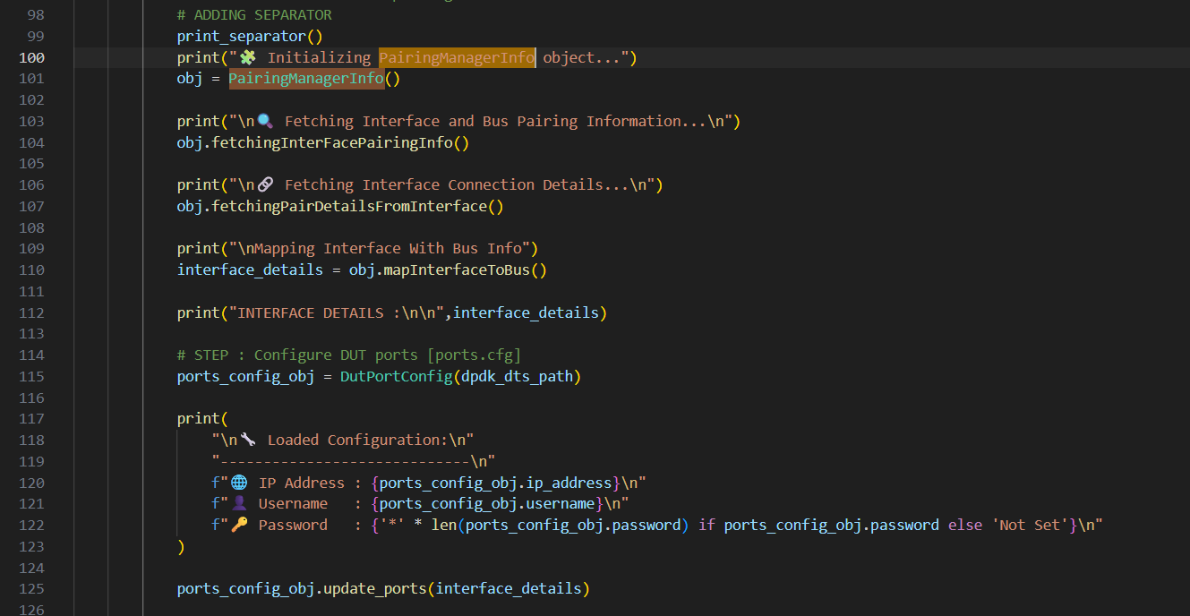
Purpose
This step is designed to dynamically discover and map the system’s network interfaces to their corresponding PCI bus addresses. This mapping is essential for DPDK and DTS to correctly identify and bind NICs for testing. Once the interfaces are mapped, the script configures the ports.cfg file with DUT connection details (IP, username, password) and the mapped interfaces. This ensures DTS knows which ports to test and how to access the DUT.
Logic Used:
STEP 6.1 : Initialize Pairing Manager
The script creates an instance of PairingManagerInfo, which encapsulates logic for discovering and mapping interfaces.
STEP 6.2 : Fetch Interface Pairing Info
fetchingInterFacePairingInfo() collects raw data about available network interfaces, likely using tools like lspci, ip link, or ethtool.
Explantion :
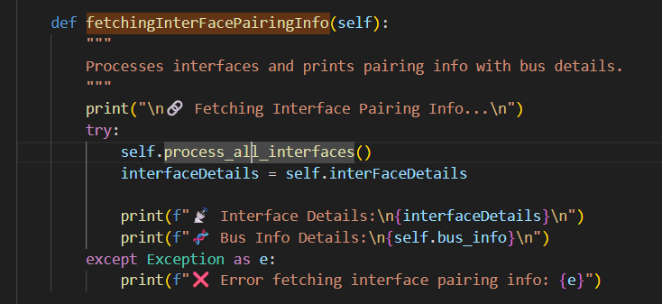
STEP 6.2 a: While Calling this method within Method we are calling “process_all_interface() “
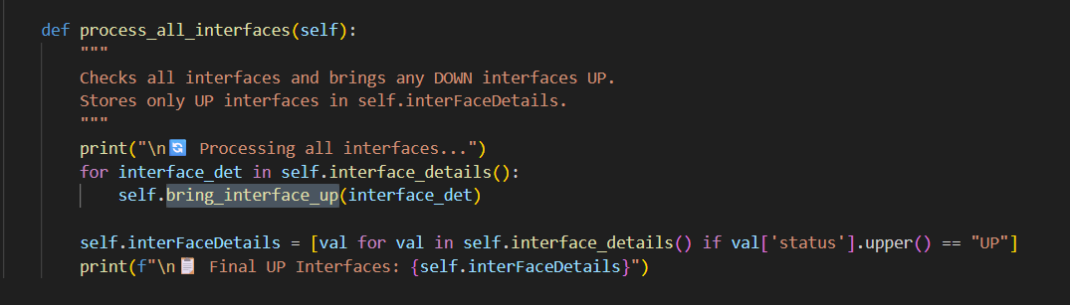
Note: Interface Status Filtering and Activation Logic
- This method begins by fetching all available network interfaces using the command ip -br a , which returns a concise, line-by-line summary of interface names and their statuses in plain text format.
- It then applies a regular expression pattern:
r'^(\S+)\s+(UP|DOWN)(?:\s+(.*))?$'
This pattern is used to extract the interface name and its current status (UP or DOWN) from each line of output.
- The matched results are stored in a list, which contains only the interfaces that are relevant for further processing.
- For each interface that is found to be in the DOWN state, the method calls bring_interface_up() and passes the interface name as a parameter. This function attempts to bring the interface UP by executing the command:
ip link set <interface_name> up

STEP 6.2 b: After fetching all available interfaces, the script filters out only those that are currently active (i.e., in the "UP" state). These filtered interfaces are then stored in interfaceDetails for further processing, such as mapping to PCI bus addresses and configuring DTS port settings.

STEP 6.3 : Fetch Connection Details
fetchingPairDetailsFromInterface() refines the data, possibly identifying which interfaces are physically connected or active
Explation :
Purpose:
This method is responsible for identifying active network interfaces that show link activity, which helps in determining valid NIC pairings for DTS testing. It uses system tools like ethtool and dmesg to detect physical link status changes and extract meaningful interface relationships. The goal is to populate a list of interface pairs that are actively communicating or linked, which is essential for accurate DTS port configuration and test execution.
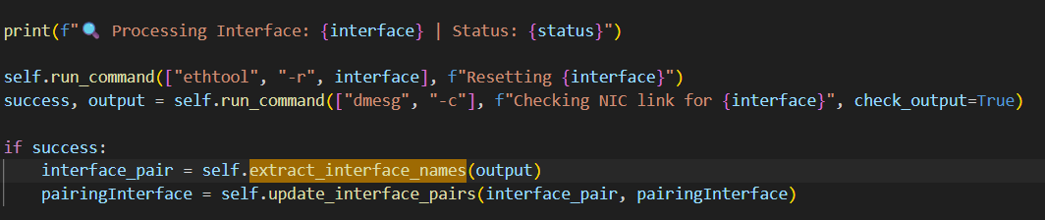
Logic Used :
- Iterate Over Interfaces
It loops through all interfaces stored in self.interFaceDetails, which were previously filtered to include only those in the UP state.
- Reset NIC Link
For each interface, it runs ethtool -r <interface> to reset the NIC link. This action typically triggers link-related messages in the kernel log (dmesg), which can be used to detect pairing behavior.
- Capture Link Messages
Immediately after resetting, it captures the new dmesg output and checks for success. If successful, it parses the output using extract_interface_names() to identify any interface names mentioned in link messages. Using regex fetching pattern.
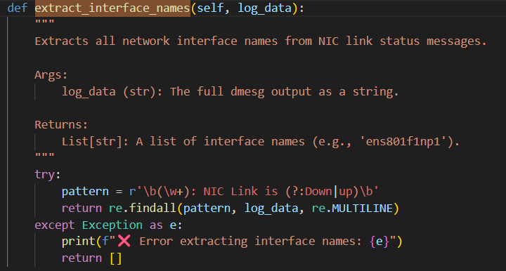
- Update Pairing List
The extracted interface names are passed to update_interface_pairs() to update the pairingInterface list, ensuring no duplicates and maintaining valid pairings. 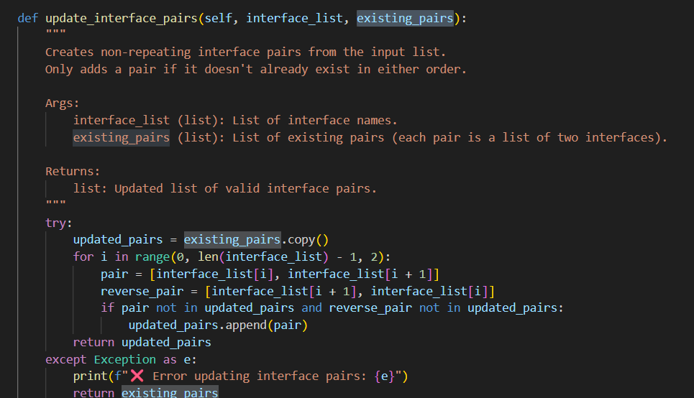
- Sleep Between Interfaces
A short sleep (time.sleep(2)) is added between interface checks to avoid overwhelming the system and to allow link resets to complete.
NOTE : For only checking print .
- Store Results
The final list of interface pairs is stored in self.pairingInterface for use in later configuration steps.

STEP 6.4 : Map Interface to Bus Info
mapInterfaceToBus() creates a structured mapping between interface names (e.g., eth0, ens5f0) and their PCI bus addresses (e.g., 0000:3b:00.0). This mapping is critical for DTS to bind the correct NICs during test execution.
STEP 6.5 : Initialize Port Config Object
DutPortConfig(dpdk_dts_path) loads or prepares the ports.cfg file located in the DTS setup directory.
STEP 6.6 : Print Loaded Configuration
Purpose:
When an object of DutPortConfig is initialized, its constructor automatically gathers essential DUT connection details. These include the current system's IPv4 address, the username of the logged-in user, and a default password (currently set as "tester"). These values are used to populate the ports.cfg file, which DTS uses to connect to and manage the DUT during test execution. Automating this ensures consistency and reduces manual configuration errors.
The script prints the DUT IP, username, and password (masked) for verification.
Constructor Logic:
Fetch IPv4 Address
- Calls self.get_ipv4_address() to determine the current system’s IP address.
- This is typically the IP used to communicate with the DUT or tester node.
- Using Socket to fetch Ip details of current system (import socket)
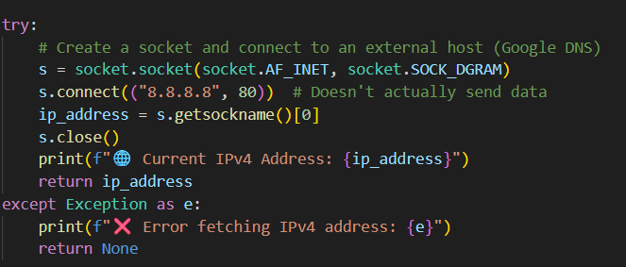
Fetch Username
- Uses self.getlogin() to retrieve the current system user.
- This is used as the SSH login name for DUT access.
Set Password
- Sets a default password ("tester") for the DUT.
- This can be overridden later if needed.
:: Printing the details IPV4 Address, USERNAME, PASSWORD

STEP 6.7 : update_ports(interfaceDetails)
PATH : /script_container/execution/dut_ports_config.py
Purpose :
To update the ports.cfg configuration file with DUT connection details and mapped PCI interface pairs. This file is essential for DTS to know which NICs to test and how to connect to the DUT.
Logic :
Step 6.7 a : Generate Port Configuration Lines
- Iterates over each item in mapped_pair.
- Formats each line as:
pci=<bus_info_0>,peer=<bus_info_1>;
- Joins all lines into a single string pair_text.
Step 6.7 b: Format Full Configuration Text
- Uses a predefined template port_config_prompt_update to insert the DUT IP and the generated pair_text.
- This forms the complete content for the ports.cfg file.
Step 6.7 c: Navigate to Configuration Directory
- Changes the working directory to the DTS configuration folder:
.../conf inside the DTS repo.
Step 6.7 d: Confirm Current Working Directory
- Executes pwd to verify the current path and logs the result.
Step 6.7 e : Write Configuration to File
- Calls self.write_ports_config(updated_text) to write the formatted content to ports.cfg.
Step 6.7 f : Set File Permissions
- Runs chmod 777 on the file to ensure full read/write access.
Step 6.7 g : Get Network Interface Details
- Executes ip -br a to list all network interfaces and their statuses.
Step 6.7 h : Fetch Bus Information
- Uses lshw -c network -businfo to get PCI bus mappings for NICs.
Step 6.7 I : Display Updated Configuration File
- Runs cat ports.cfg to show the final content for verification
STEP 6.8 : Updating CRBS.CFG
PATH: /script_container/execution/dut_crbs_config.py
Purpose :
- The goal is to configure the crbs.cfg file, which defines how DTS connects to the DUT and tester systems.
- An object of DutCrbsConfig(dpdk_dts_path) is created, passing the DTS setup path to access and modify the configuration file.
- The method updating_crbs_file(...) is then called with parameters like dut_ip, dut_user, dut_passwd, tester_ip, and tester_passwd.
- These values are used to update the first DUT block in the crbs.cfg file, ensuring DTS has the correct credentials and IPs for communication.
Method: updating_crbs_file(...)
- Step 6.8 a: Load Existing Configuration
  - Retrieves the current content of crbs.cfg from self.crbs_data.
  - Initializes filter_crbs_data to store the first DUT block.
  - Uses a counter filter_status to track when the first DUT block ends.
- Step 6.8 b: Extract First DUT Block
  - Iterates through each line of the config file.
  - Uses regex to match lines like [DUT IPx] or [IPv4].
  - Collects lines until the first DUT block is fully captured.
  - Stops collecting once a second DUT block is detected.
- Step 6.8 c: Update DUT and Tester Fields
  - If dut_user is provided, replaces the dut_user= line.
  - If dut_ip is provided:
    - Updates the [DUT IP1] header to [<dut_ip>].
    - Updates the dut_ip= line.
  - If dut_passwd is provided, replaces the dut_passwd= line.
  - If tester_ip is provided, replaces the tester_ip= line.
  - If tester_passwd is provided, replaces the tester_passwd= line.
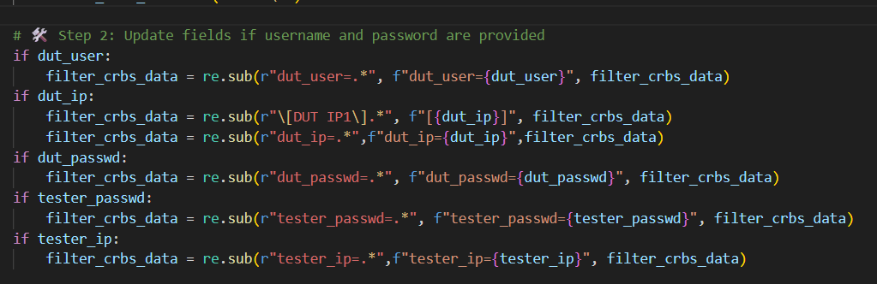
- Step 6.8 d: Display Updated Configuration
  - Prints the updated DUT block line-by-line for verification.
- Step 6.8 e: Pause for Review
  - Sleeps for 3 seconds to allow the user to visually verify the changes.
- Step 6.8 f: Write Back to File
  - Calls self.write_crbs_config(filter_crbs_data) to save the updated block back to crbs.cfg
STEP 6.9 : Updating Execution.CFG
Purpose
- The goal is to configure the execution.cfg file, which defines how DTS connects to and interacts with the DUT and tester systems during test execution.
- An object of the class ExecutionCfgUpdate is created, with the DTS setup path (dpdk_dts_path) passed to its constructor. This allows access to the configuration directory and file.
- The method update_execution_file(...) is then called with parameters such as tester_ip, which is used to update the relevant fields in the configuration.
- Before updating, the method removes any extra or unnecessary test suites from the configuration, ensuring that only the required suite (e.g., HelloWorld) remains.
- Finally, the updated content is written back to the execution.cfg file, completing the configuration process.
Step-by-Step Logic
- Load Existing Configuration
  - Reads the current content of execution.cfg from the DTS configuration directory.
- Filter Test Suites
  - Identifies and removes any test suites that are not required for the current run.
  - Ensures that only the HelloWorld suite (or another specified one) remains.
- Update Tester IP
  - Replaces or inserts the tester_ip field with the provided IP address.
  - Ensures DTS knows where to connect for executing tests.
- Write Updated Configuration
  - Saves the modified content back to execution.cfg.
  - Ensures the file is correctly formatted and accessible for DTS.

  - Running DTS (Conditional)
This step is responsible for initiating the actual DTS (DPDK Test Suite) execution process. It verifies whether the environment variable DPDK_SETUP_RUN is set to "TRUE", which acts as a control flag to determine if the DTS tests should be run.
If enabled, the script navigates to the DTS repository directory (networking.dataplane.dpdk.dts.local.upstream) and executes the DTS test suite using the command ./dts. This triggers the automated testing framework to begin running predefined test cases against the configured DUT and tester setup.
This step marks the final phase of the automation pipeline, where all prior configurations (firmware, drivers, ports, crbs, execution settings) are validated through actual test execution.

