1) Structure of the Framework is,

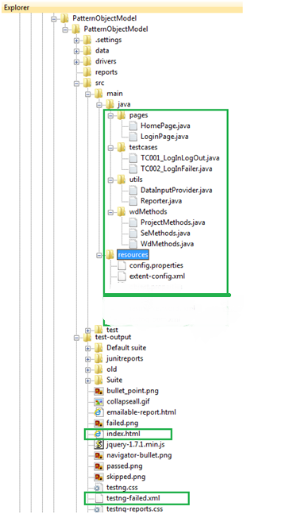

1. Java folder has,
2. pages folder is the Object Repository where in seperateclassfile has been created for each page. Pages are considered as Objects.
3. testcases folder has set of test cases where in page class and methods inside the class have been used as per the execution of testcases. Each testcase is written is seperate class file.
4. utils folder has "DataProvider" and "ExtentReports".

* DataProvider class reads data from excel.
* Reporter class generates ExtentReport such that status & screenshot of each step executed in each testcase will be captured in this report.

1. wdmethods folder is to store wrapper classes. The interface (WdMethods), wrapperclass(SeMethods) and Project specific methods (ProjectMethods) are stored inside this folder.
2. resources folder has,

1) "Config.properties" file to store the configuration data(like URL). This file could be used to maintain project configuration data, database config or project settings etc.,

2) extent-config.xml -> this file has configuration data specific to ExtentReports.

1. test-ouput folder has

a) testng-failed.xml where in failed testcases are captured and we could run only those test cases with this xml.

b) index.html provides the report of Passes methods, Ignored methods, count of tests, groups, etc.,

c) snapshots are stored in this folder by default, if no seperate folder path (to store screenshots) is specified in the written code.

2) We store URL information in config.properties file which is present inside resources(PatternObjectModel\src\main\resources) folder.

Then we access the configurations stored inside .properties file in SeMethods. Respective code is,

Properties prop = new Properties();

try {

prop.load(new FileInputStream(new File("./src/main/resources/config.properties")));

sHubUrl = prop.getProperty("HUB");

sHubPort = prop.getProperty("PORT");

sUrl = prop.getProperty("URL");

}

URL is written in config.properties file since URL could be modified without disturbing the code whenever there is a change in URL.