Android Mockups

This page is for the pharmacist, store manager and executive manager so that they can login and perform the necessary activities.

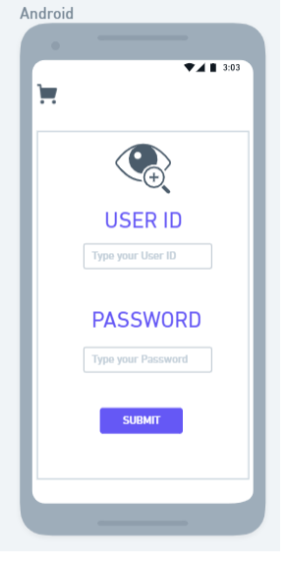

It is used by the store manager and executive manager to check the sales report and to add or remove a pharmacist
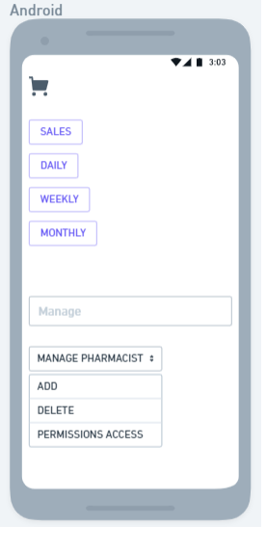

It displays all the details about the product with a brief description of contents of the products, price and the availability of the stock.

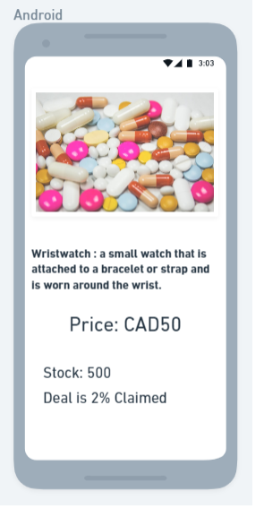
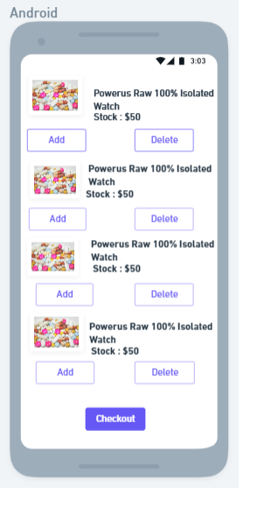
This page displays the list of products that are added to the checkout page.

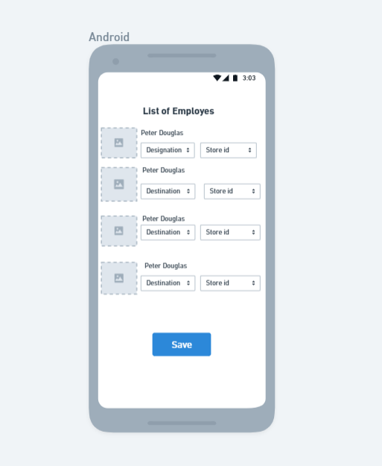
This page is used to display the list of employess who are working in the store which contains their designation and store id.

