1. generate the code base through https://start.spring.io/ web url for spring boot

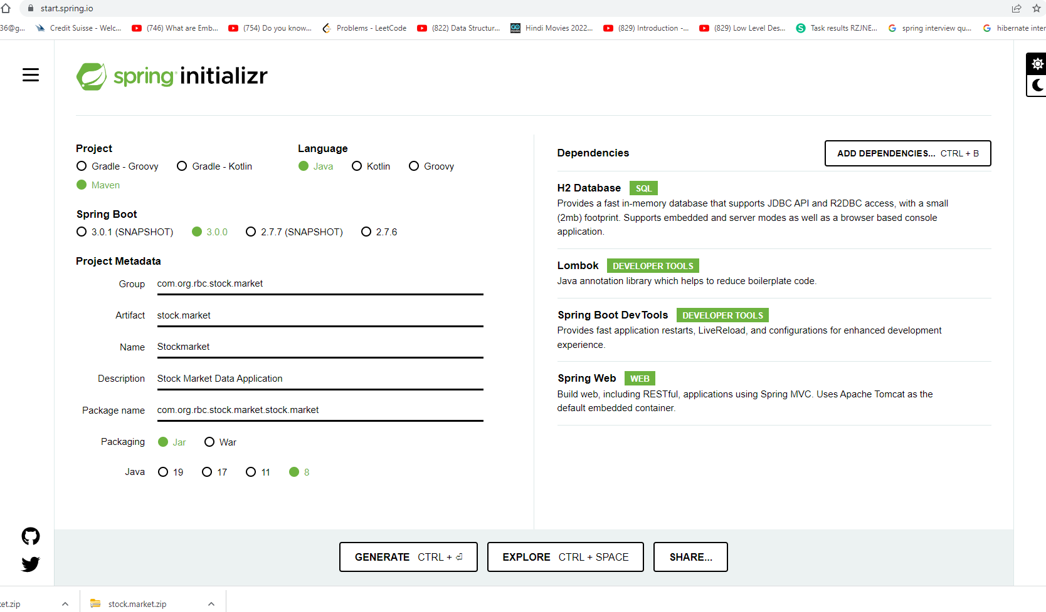

1. After giving artifact name, project details and required jar will generate the zip file
2. unzip the jar file and import it into any IDE i used eclipse(22.06 version) with java 8 version
3. after import it will display in eclipse project section

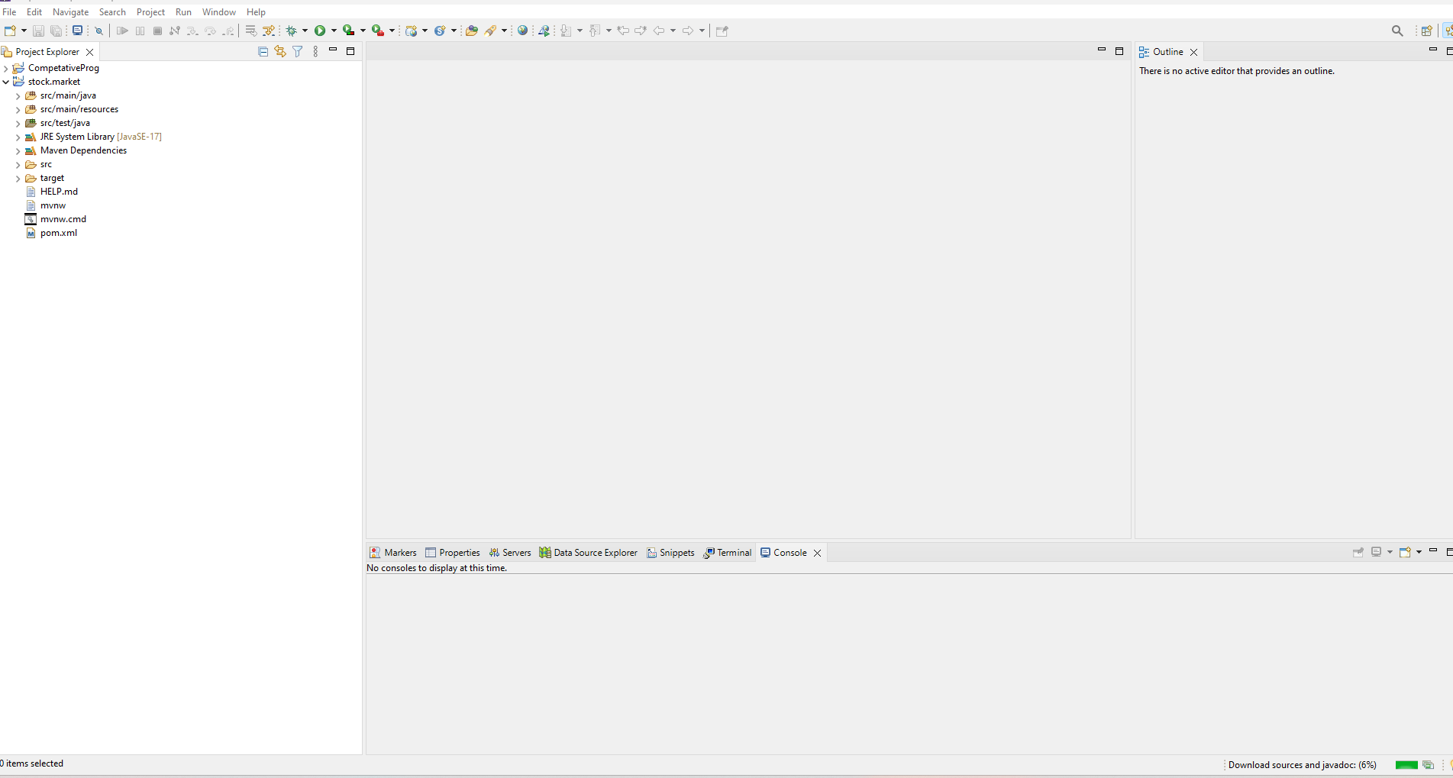

1. after do maven build either through ide or command in terminal

mvn clean install

6 after this all the dependencies will, be download from maven repository in local machine

This is below pom.xml, its part of maven build tool here we have many dependencies which we are using in spring boot application to fulfil the task, we are using spring dependencies for spring application , h2 dependecies for h2 in memory data base(to store file data), we have open csv dependencies to read and parse data file , Lombok dependcies to autogenerate the getter and setter method, it will used to remove boilerplate code. Persistent dependencies for jpa crud operation

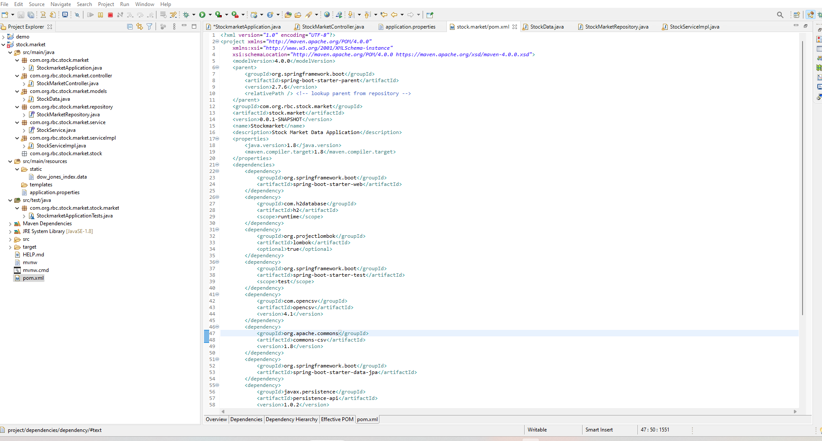

This is application.property files, every application is having the file to store the properties , here we have application server port where the application would be up and running , other is h2 data base properties to create h2 database

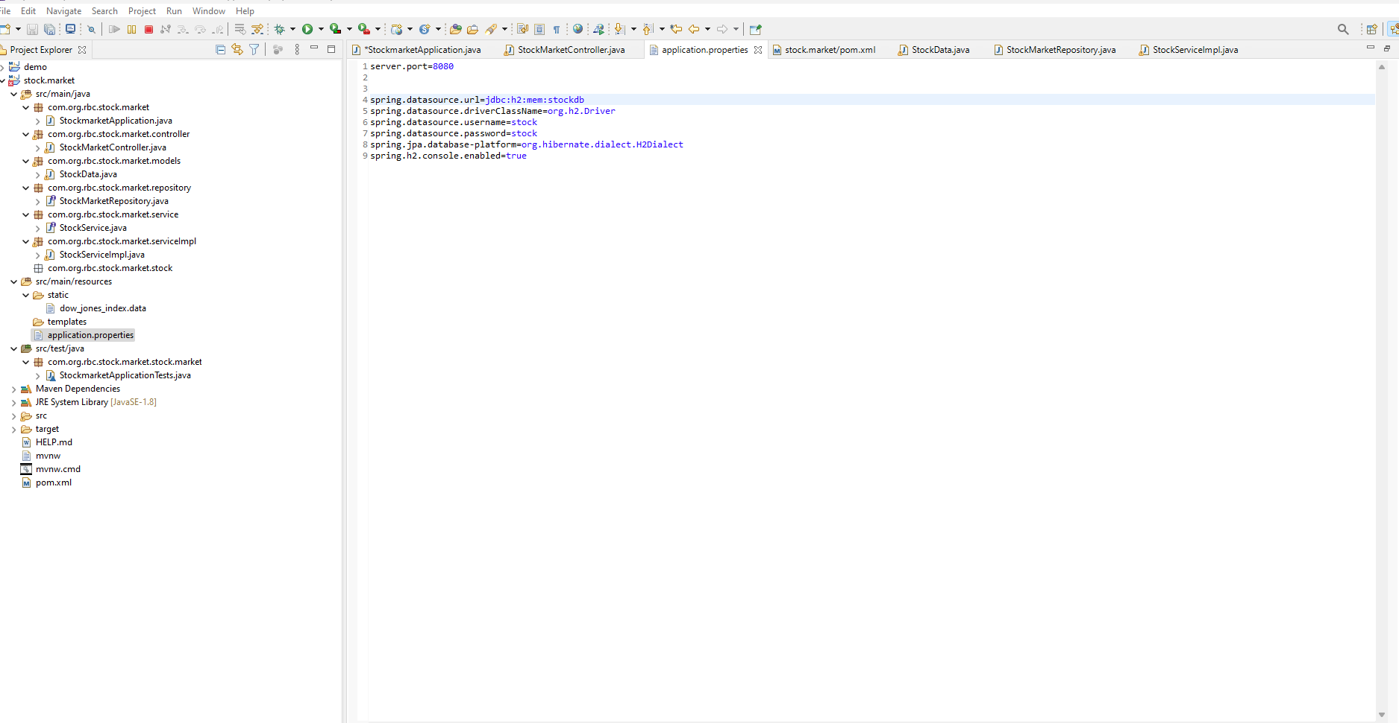

1. This is starting point of application StockmarketApplication @SpringBootApplication annotation is used in springboot application to auto configuration of the components

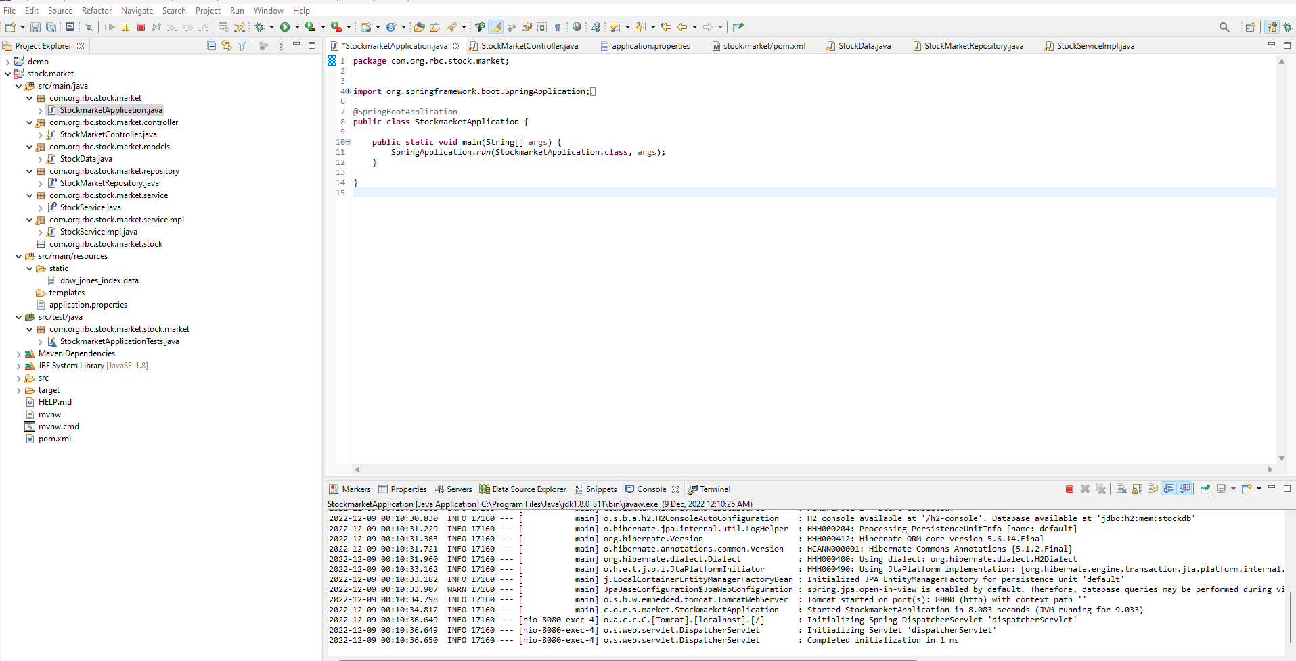

Below is Spring boot controller where we have 3 api

1. First on will be used for upload the file and same we will parse through open csv jar to read data file and same we will store in H2 database through jpa crudrepository.

url for local :- <http://localhost:8080/upload>

if api successful it will display like below in postman(api testing tool)

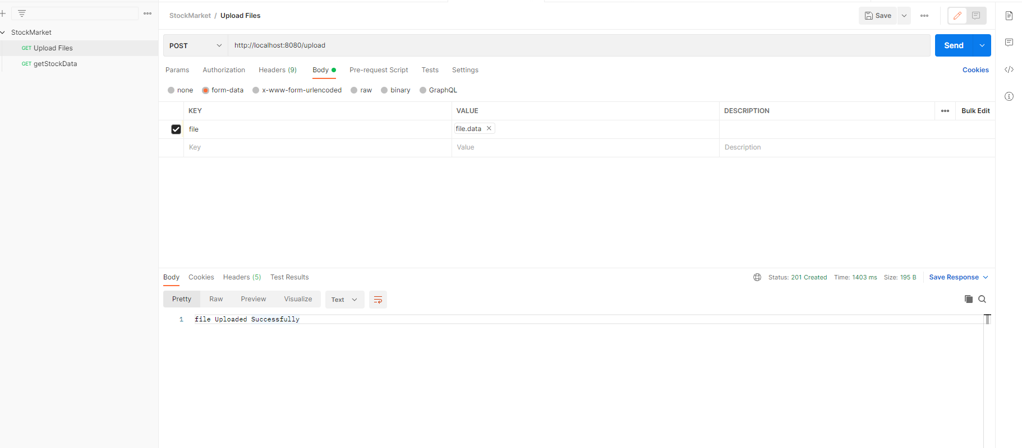

1. 2nd api is used to store the the single data in h2 database

url for local :- <http://localhost:8080/stock/add>

1. 3rd api is used to retrive the stocks through request param as stock name, here we will pass stock name as parameter and get the response from h2 database

Api url :- <http://localhost:8080/stock/get?stockName=AA>

Postman screenshpot how it will look like

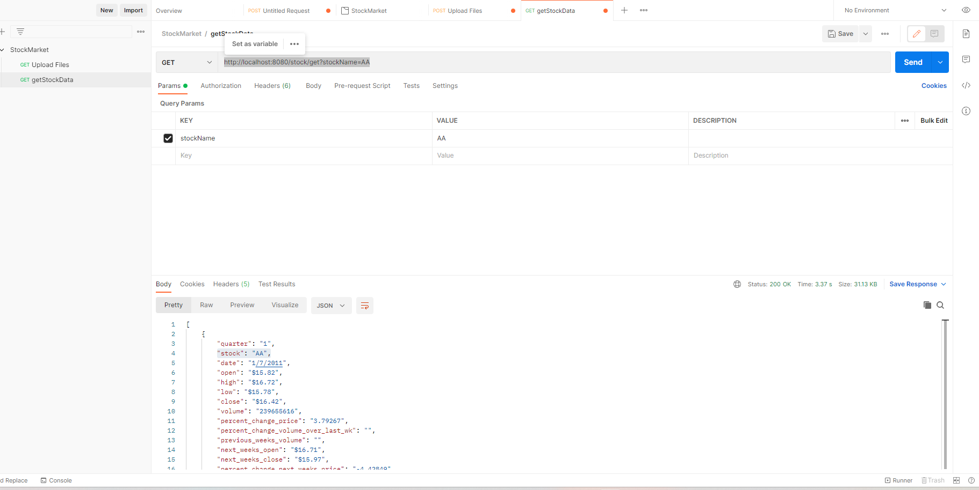

Now we have models (similar to file header to map file data)

Here @Data is Lombok annotation it is used for generate getter setter

@Entity it is jpa annotation it is used to create table name same as class in h2 database

@Id annotation is jpa annotation it is used for primary key in h2 database

@CsvBindByName annotation is open csv annotation which is used for mapping file attribute to class attribute

@JsonProperty attribute is used for serialization (to convert json)

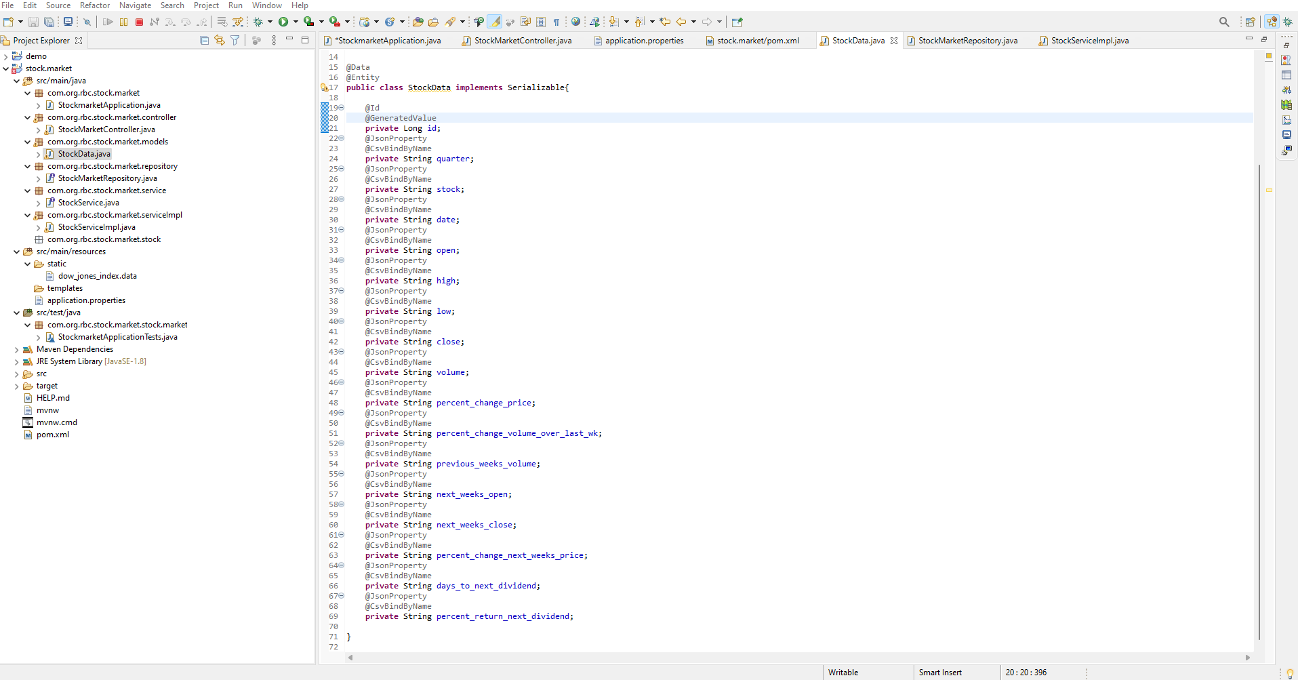

Below is the jpa crudrepository examples here be default methods are there like save, saveall but here we are creating custom method List<StockData> findByStock(String stockName); here it will accept stock name as a parameter and find with stock and return list of stocks from h2 database/

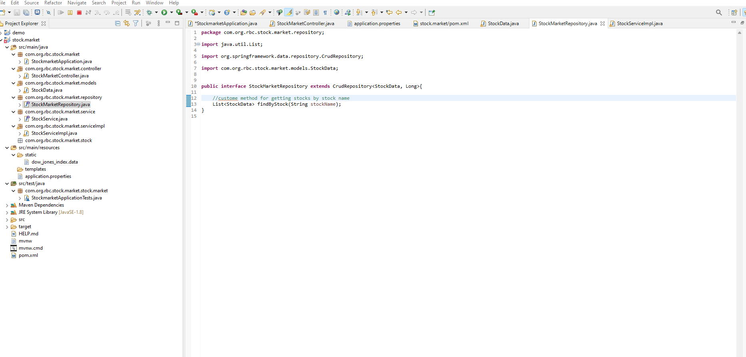

Below is interface is create as a best practices

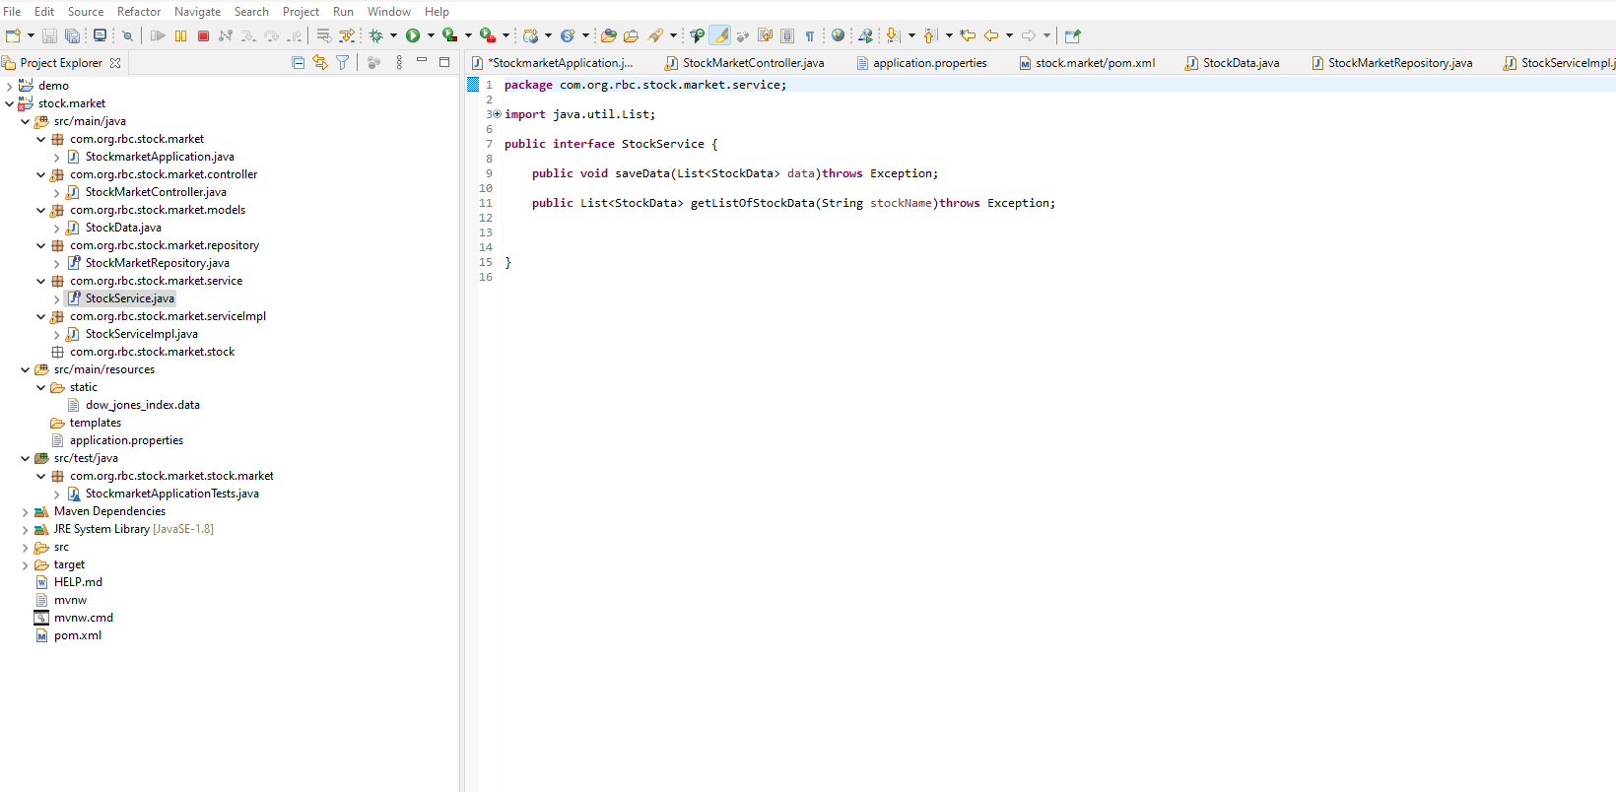

Below is a service layer where actual we will call jpa repository method, here we are injecting(dependency injection) StockMarketRepository so that we can use jpa methods

@Autowired

**private** StockMarketRepository stockMarketRepository;

here there are 2 method

getListOfStockData method is used for retive the data from h2 by passing stock name

saveData is a method is used to story file data as well as singe record data.

