State vs LPG Shortage
This graph represents the total LPG shortage (MMT) in each state. It helps identify the states that experienced higher shortages of LPG.
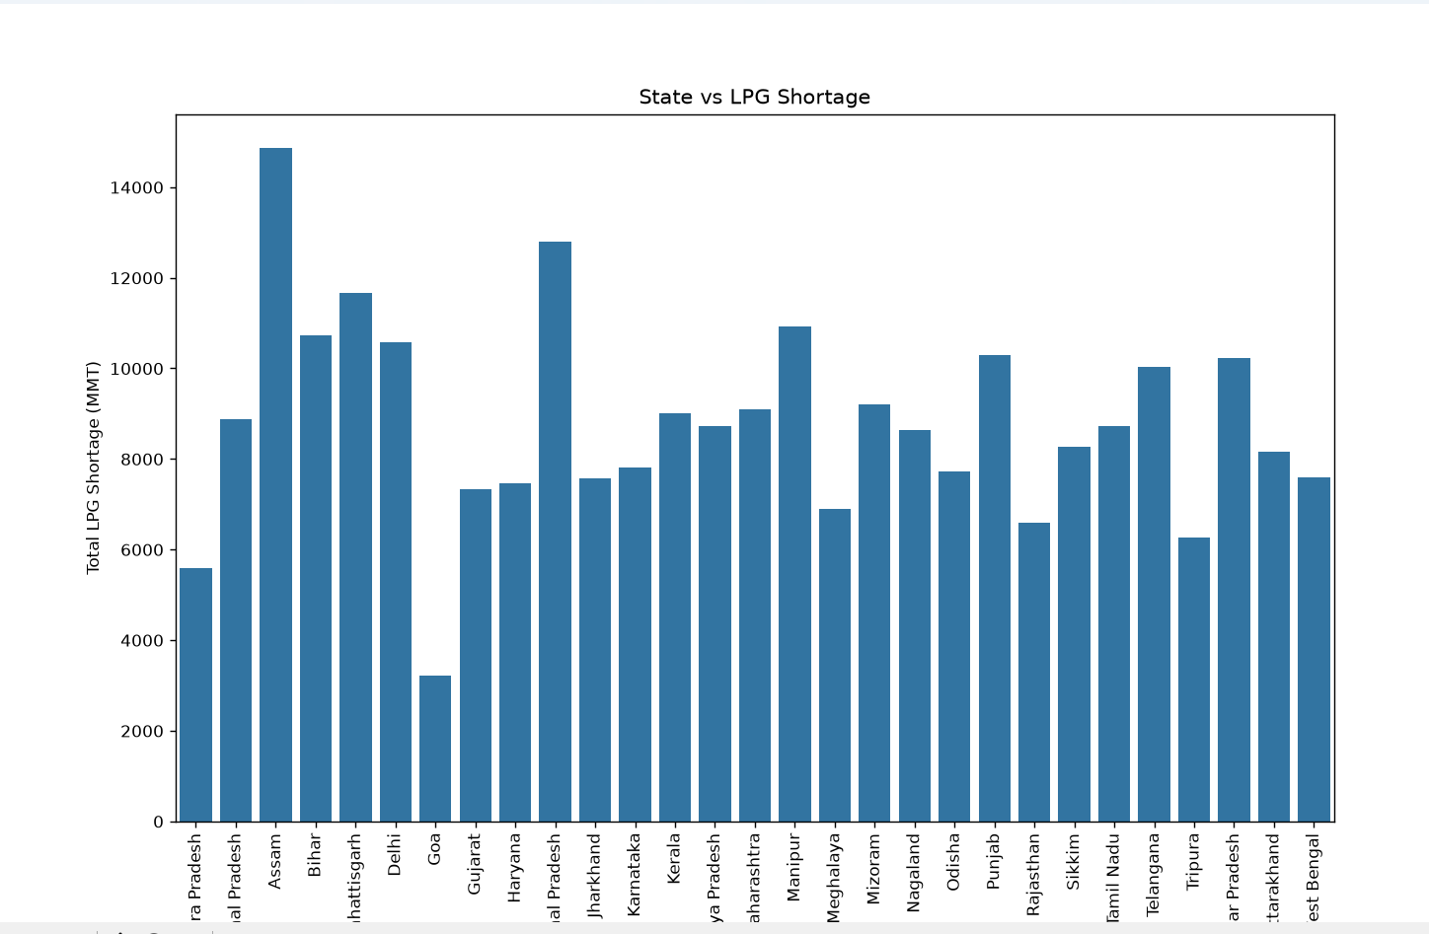

State vs LPG Consumption
This graph represents the total LPG consumption (MMT) in each state. It is used to compare LPG consumption across different states.
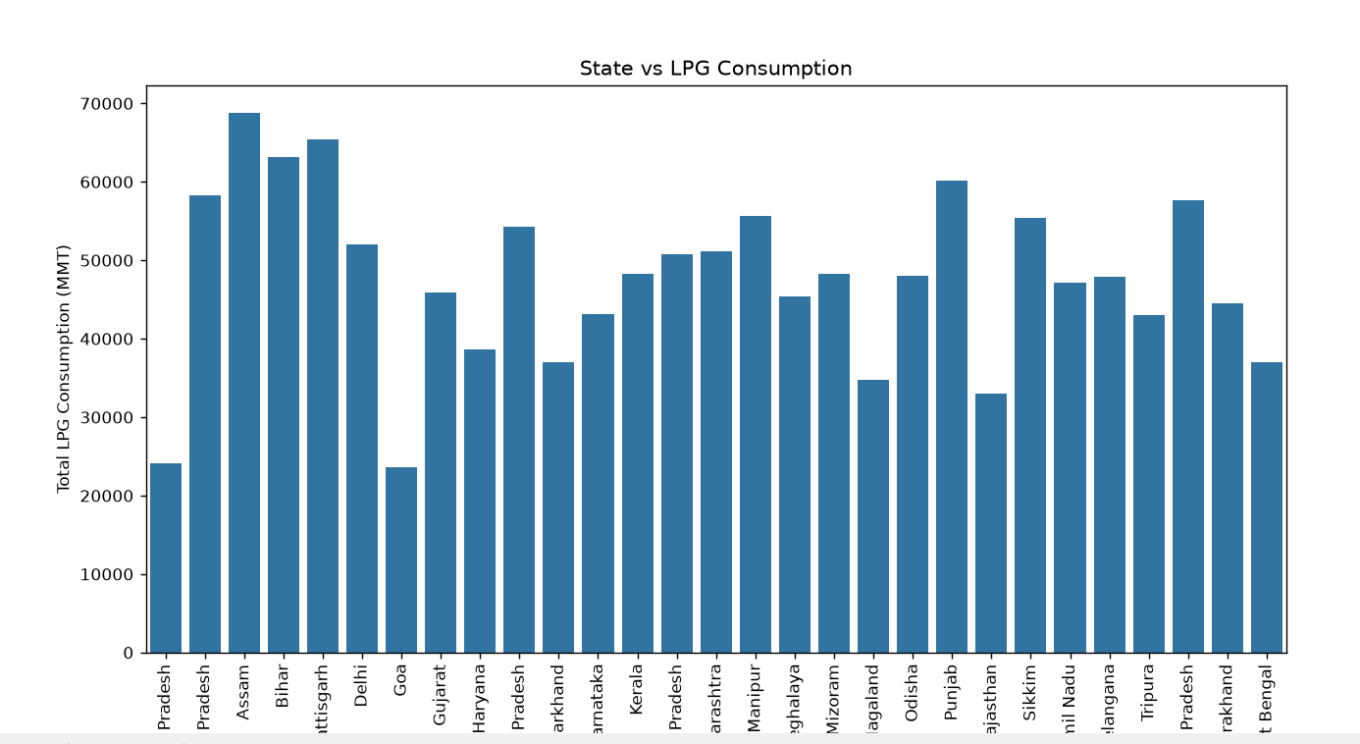

State vs People Migrated
This graph represents the total number of people who migrated from each state. It helps compare migration levels among different states based on the dataset.
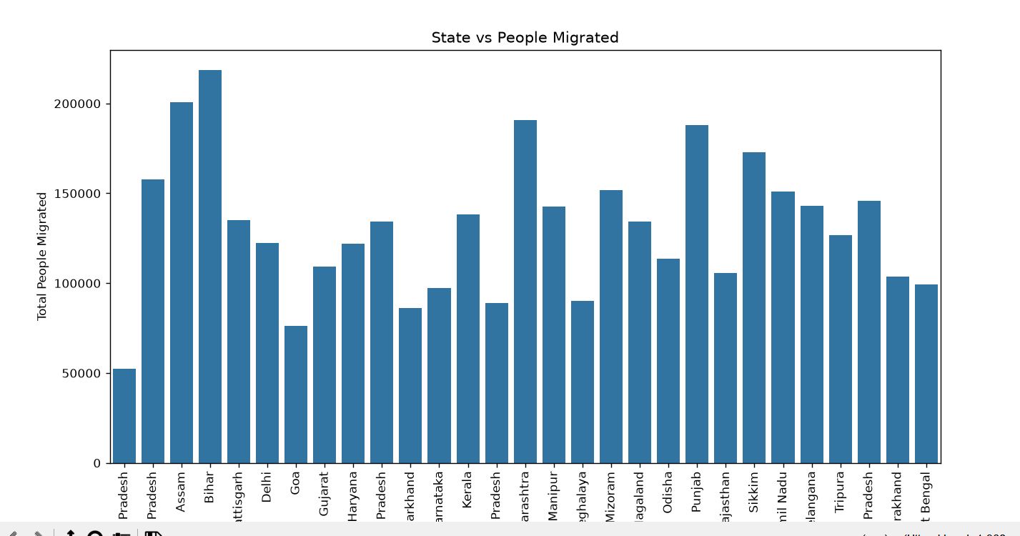

2. State vs Cured Cases and Deaths
This graph compares the total number of cured cases and deaths for each state. It provides a clear comparison of treatment outcomes and mortality across different states.
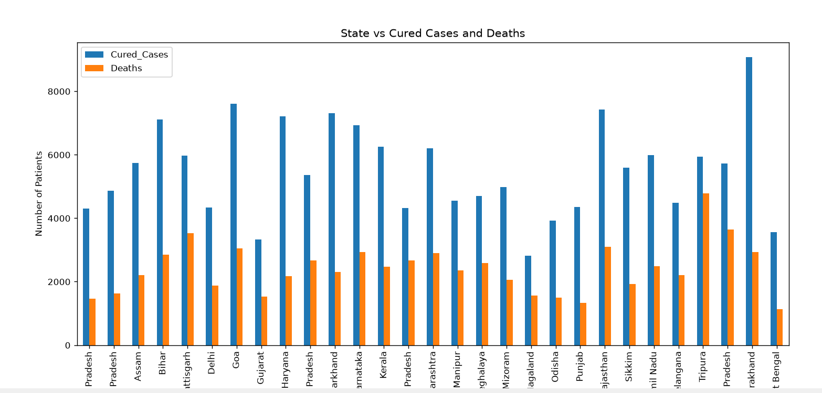

3.State vs Violation Type
This graph shows the distribution of different traffic violation types across various states. It helps analyze which types of traffic violations are more common in each state.

