**Project Title –**

**Airline Reservation System (Online Ticket Booking Application)**

**Description: -**

Airline Reservation System contains the details about flight schedule and its fare tariffs, passenger reservations and ticket records. Airlines operate flights between 10 destinations in India namely Pune, Mumbai, Chennai, Delhi, Kolkata, Jaipur, Dispur, Andaman and Nikobar, Kochi and Srinagar.

Main objective of project is to provide service to passenger for book airline tickets from anytime and providing information about flight schedule online. Users can easily search for the flight and available seats, after login they can book their tickets online. In this application there are 3 types of users: system admin, sub admin and passenger. Airline Reservation System offers show available flights, booking of flight, showing ticket fair, cancelling tickets.

**# Functional requirements**

**For User: -**

**1. user login**

**2. user registration**

**3. edit profile**

**4. reset password**

**For System Admin: -**

**1. add sub admin**

**2. adding flight**

**3. see all flights**

**4. remove flight**

**5. update flight**

**6. generate ticket for booked seat**

**7. list of passengers**

**8.see ticket of passenger**

**For Passenger: -**

**9. search flight based on source, destination and date**

**10. book seat**

**11. see ticket**

**12. cancel booking**

**13. user logout**

**#Nonfunctional requirements -**

**1. logging of all operations (flight add, seat booking)**

**2. exception log**

**3. exception handling**

**4. security**

**5. portability**

**6. availability**

**Use Case Diagram: -**

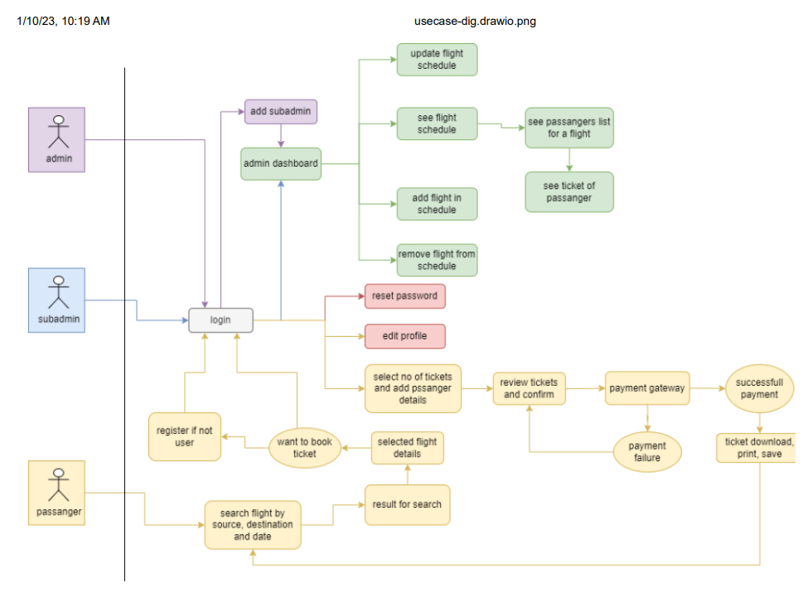

**ER Diagram -**

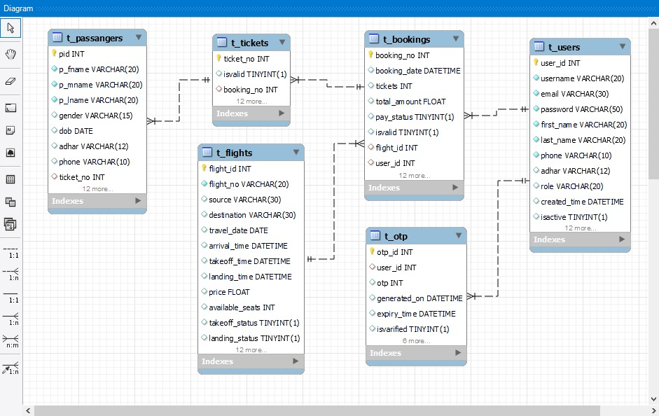

**UI Design –**

