AIMLCZG546 - Software Engineering for Machine Learning
Assignment I: Real-Time Product Recommendation for an E-commerce Platform
Domain: E-commerce / Retail | Patterns: Event-Driven Architecture and API Gateway
This editable report completes Objective 1 and Objective 2: GR4ML requirements formulation, architecture with ML and non-ML components, two architectural patterns, and a working prototype with run evidence.

Field | Value
Group No | G49
Submission file | G49.docx or G49.pdf as required by Taxila
Implementation notebook | final_submission/G49.ipynb
Submission deadline | 30 June 2026, 23:00
Prototype folder | seml-ecommerce-reco/

Sl. | BITS ID | Name | Contribution (qualitative) | %
1 | 2025aa05877 | VIVEK KUMAR AGARWAL | Requirements Lead: problem statement, requirements, measurable goals, quality requirements | 100
2 | [Enter BITS ID] | [Enter Name] | GR4ML Modelling Lead: Business, Analytics Design, and Data Preparation views | 100
3 | [Enter BITS ID] | [Enter Name] | Architecture Lead: architecture diagram and pattern selection / justification | 100
4 | [Enter BITS ID] | [Enter Name] | Implementation Lead: code, run evidence, screenshots, and code explanation | 100

Assignment Coverage Matrix
Official requirement | Where covered
Select a domain and define an ML-based problem statement | Section 1.1
Formulate requirement specifications and measurable goals using GR4ML concepts | Sections 1.2 and 1.3
Develop GR4ML Business View, Analytics Design View, and Data Preparation View | Section 1.3 and Figures 1-3
Identify the top three quality requirements with justification | Section 1.4
Draw architecture diagram showing ML and non-ML components | Section 2.1 and Figure 4
Select and apply any two relevant architectural patterns | Sections 2.2 and 2.3
Implement selected patterns using appropriate technologies | Section 2.3, Appendix A, prototype folder, and GXXX.ipynb
Include screenshots / outputs of the application with explanation | Section 2.4 and Figures 5-9
Mention group details and contribution | Cover page and Task Distribution section

Objective 1 - Requirements Formulation

1.1 Domain and Problem Statement
Domain: E-commerce and Online Retail.
Objective: To enhance user engagement and drive incremental revenue by transitioning from static product listings to dynamic, real-time personalized recommendations.
Problem Statement: In an e-commerce environment, users' preferences are dynamic and influenced by their immediate interactions (e.g., clicks, views, cart additions). The challenge is to build a real-time recommendation system that leverages these implicit feedback signals to rank relevant catalogue items for individual users. The system must process event streams to provide a personalized Top-N recommendation list, mitigating the limitations of static "best-seller" blocks which fail to account for individual intent.
Assumptions:
- The e-commerce platform stores user activity events such as views, clicks, cart additions, and purchases.
- Every user and product has a unique identifier.
- Historical interaction data is available for training and evaluation.
- The recommendation service is accessed through REST APIs.
Motivation for Machine Learning: Traditional rule-based heuristics fail to capture the high-dimensional, sparse, and non-linear relationships inherent in user-item interaction data. Furthermore, user preferences evolve rapidly due to seasonal trends and changing product catalogs. A machine learning approach is appropriate here as it enables the system to learn item affinities and adapt recommendations dynamically based on real-time behavioral data. User preferences keep changing over time and there are many products and users, making it difficult to create recommendation rules manually. Rule-based recommendations become difficult to maintain when the number of products increases.

1.2 Requirement Specifications and Measurable Goals
ID | Requirement | GR4ML role | Verification
FR1 | Capture user activity events: view, click, cart, purchase, with user and item identifiers. | Operational capability | POST sample events and check they enter the queue.
FR2 | Continuously update user-item interaction features from the event stream. | Analytics capability | Consumer log shows processed events and feature count changes.
FR3 | Serve personalised top-N recommendations for any valid user, excluding already-seen items. | ML output / insight | GET /recommend returns ranked unseen items.
FR4 | Expose client traffic through one authenticated gateway. | Software interface requirement | External calls use gateway port 8000, not internal port 8001.

Quality / measurable goal | Metric | Target | Reason
Relevant top-N | Offline Precision@5 | >= 0.30 | Measures whether top returned products include held-out relevant items.
Business uplift | CTR uplift vs non-personalised block | >= 8% | Represents expected production A/B test improvement.
Real-time serving | Recommendation API p95 latency | < 150 ms | Recommendations appear on the page-render path.
Freshness | Event-to-feature lag | < 60 s | Recent behaviour should affect recommendations quickly.
Catalogue reach | Catalogue coverage | >= 60% | Avoids showing only a narrow set of popular products.

Executed prototype note: the local implementation reports offline Precision@5 = 0.323 on deterministic synthetic interaction data, clearing the >= 0.30 target.

1.3 GR4ML Views
GR4ML links business intent, analytics design, and data preparation. In this solution the traceable chain is: revenue and engagement goal -> product-display decision -> question about user intent -> top-N recommendation insight -> prediction/ranking analytics goal -> prepared interaction matrix and item-similarity table.
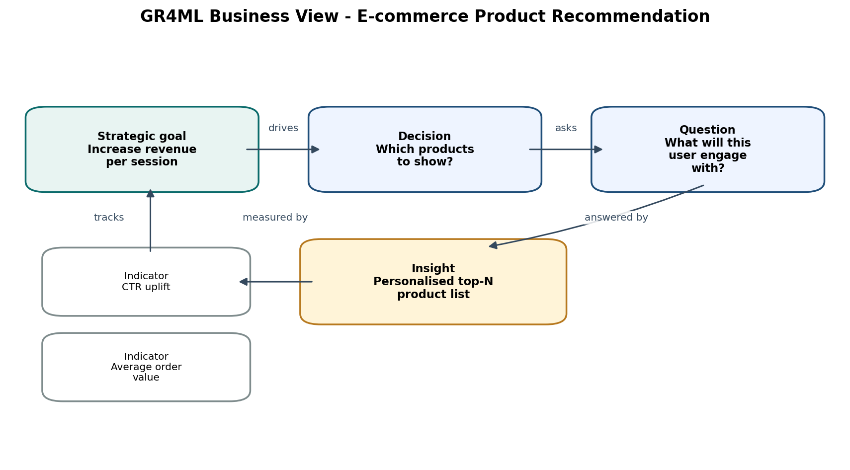
Figure 1: Business View showing the strategic goal, decision, question, indicators, and insight.
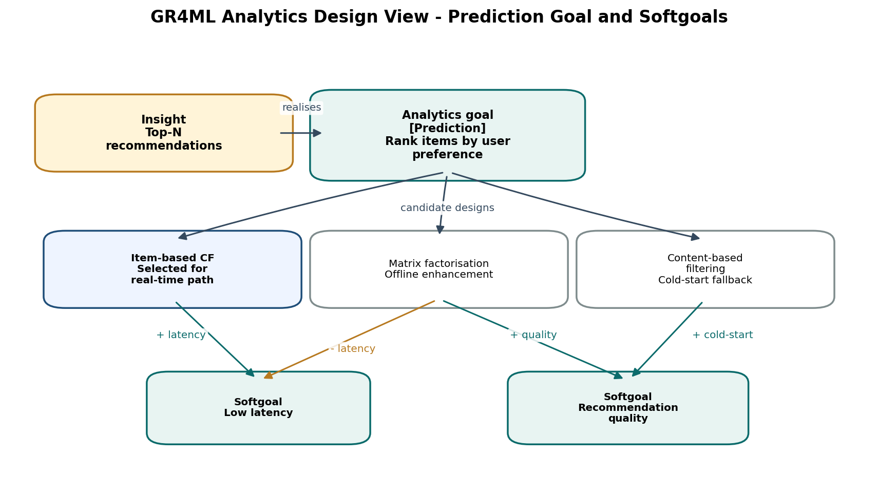
Figure 2: Analytics Design View showing the prediction goal, candidate algorithms, and softgoal trade-offs.
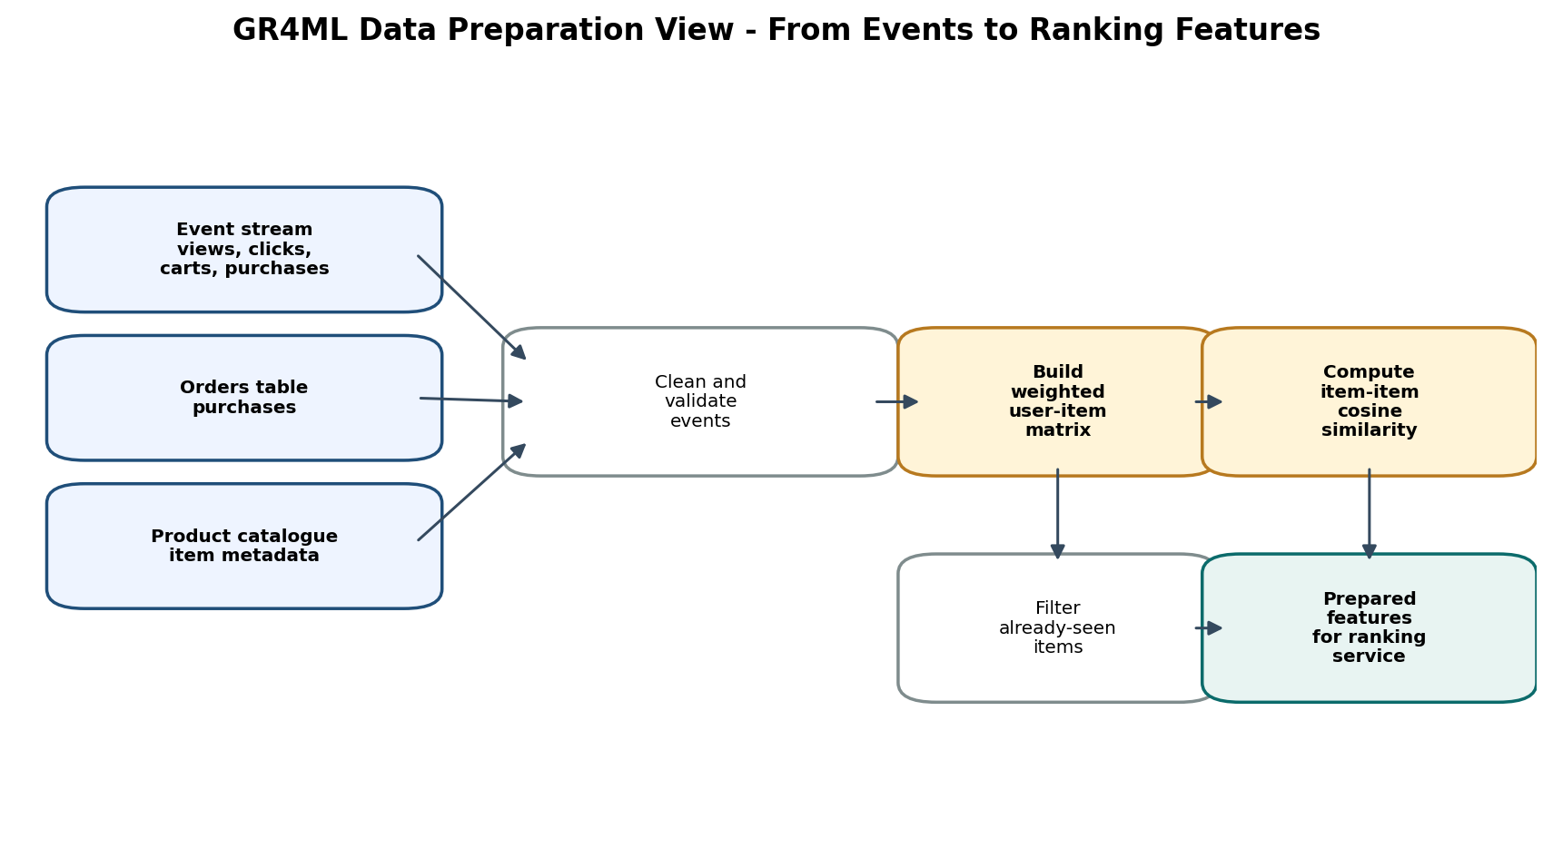
Figure 3: Data Preparation View showing how raw events become prepared ranking features.
Business View: Our project aims to increase revenue per session by improving cross-selling. We want to move away from static product lists to something more dynamic. The main decision here is: which products should we show a user to keep them engaged? We’re answering this by providing a personalized 'Top-N' list of recommendations. We’ll measure our success primarily through CTR (Click-Through Rate) and Average Order Value (AOV).
Analytics Design View: We translated the business goal into a concrete prediction task: ranking items based on predicted user preference. We chose 'item-based collaborative filtering' for our real-time path because it’s fast and allows us to pre-calculate similarity scores efficiently. We are keeping 'matrix factorization' on our roadmap as an offline enhancement, and we've added content-based filtering to help us handle the 'cold-start' problem for new items.
Data Preparation View: Our data pipeline processes raw event streams like clicks, views, and purchases. After we clean and validate these logs, we transform them into a weighted user-item interaction matrix. From this, we compute the cosine similarity between items to map out product relationships. Finally, we filter out items the user has already seen, which keeps our recommendations relevant and fresh.

1.4 Top Three Quality Requirements
Quality requirement | Justification | Design decision influenced
Low latency | Recommendations render inline while the shopper browses; slow serving damages the shopping experience. | Precompute item similarity, cache top-N, keep the serving path simple.
Scalability / elasticity | Traffic is bursty during campaigns and sales; ingestion should not block recommendation serving. | Use an event-driven broker/queue and independently scalable consumers.
Recommendation relevance | Poor suggestions waste screen space and erode user trust. | Use interaction weights, item similarity, seen-item filtering, Precision@5, and coverage monitoring.

Objective 2 - System Architecture

2.1 Architecture Diagram and Component Responsibilities
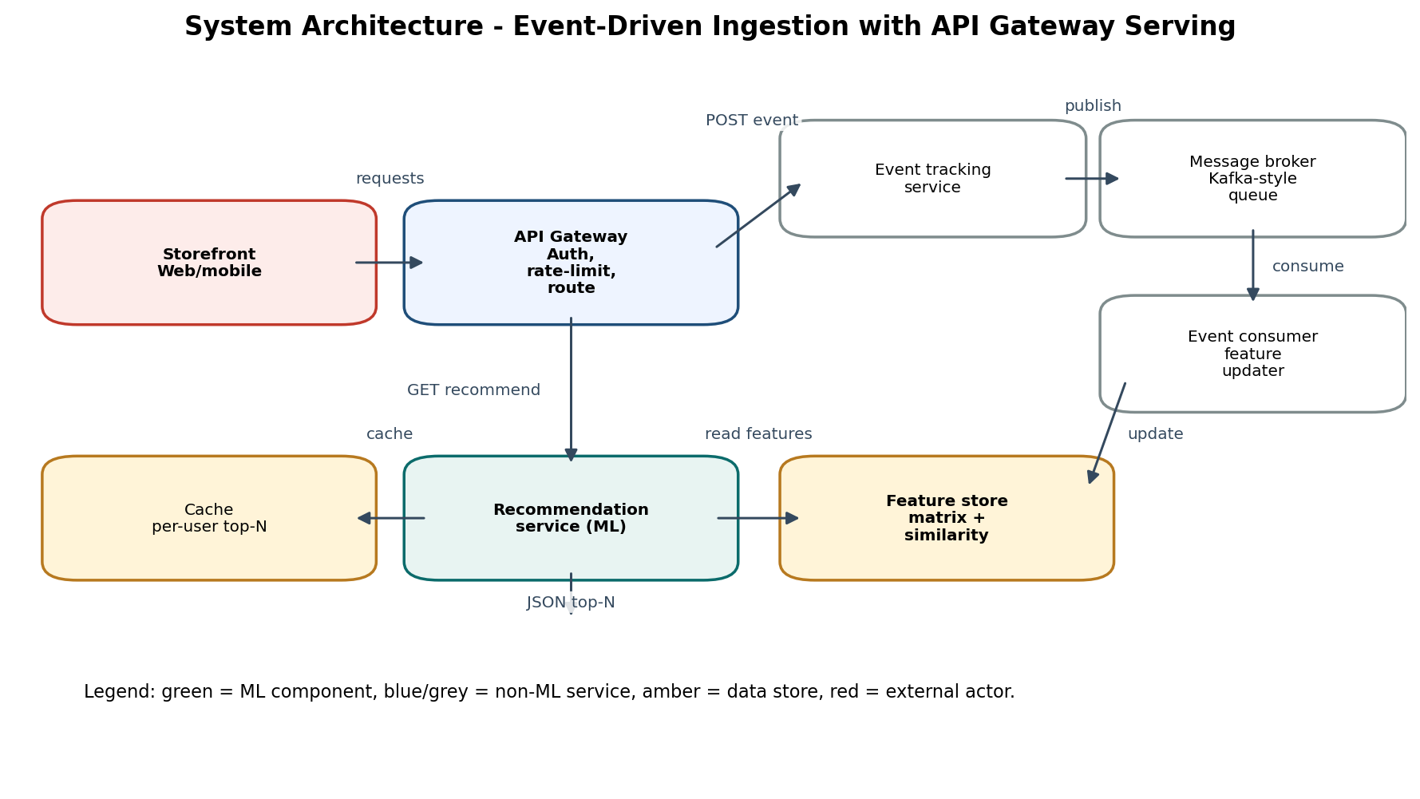
Figure 4: System architecture with ML and non-ML components clearly separated.
Component | Type | Responsibility
Storefront | External | Emits activity events and renders returned product recommendations.
API Gateway | Non-ML | Single entry point for routing, authentication, and rate limiting.
Event Tracking Service | Non-ML | Validates user activity and publishes events.
Message Broker / Queue | Non-ML | Buffers events and decouples producers from consumers.
Event Consumer / Updater | Non-ML | Processes queued events and updates feature data asynchronously.
Feature Store | Data store | Stores the user-item matrix and item-similarity table.
Recommendation Service | ML component | Ranks candidate products using item-based collaborative filtering.
Cache | Data store | Stores repeated per-user top-N results for fast reads.

2.2 Architectural Patterns Selected
Pattern 1 - Event-Driven Architecture: We chose this approach because our e-commerce platform needs to handle constant user clicks and views that can spike during campaigns. By using an event queue, we decouple the incoming activity from the recommendation processing. This way, our recommendation engine isn't bogged down by write traffic, and we can update features in the background.
Pattern 2 - API Gateway: We set up an API Gateway to serve as the single, stable entry point for all our storefront traffic. This centralizes our authentication and rate-limiting logic, allowing our internal recommendation service to stay focused on ranking products rather than handling external traffic. Together, these patterns make our system both scalable and clean, ensuring that we keep the storefront fast while keeping the backend logic organized.

Together, the two patterns implement the desired shape of the system: asynchronous writes for freshness and elasticity, plus fast controlled reads for the storefront experience.

2.3 Implementation Summary
File | Purpose | Pattern / concern demonstrated
recommender_engine.py | Maintains the user-item matrix, computes item similarity, ranks unseen products, reports offline Precision@5. | ML feature management and recommendation logic
recommendation_api.py | Internal FastAPI app with POST /track, GET /rank, event queue, and background consumer. | Event-Driven Architecture
api_gateway.py | External FastAPI app with GET /recommend and POST /activity; validates token and routes requests. | API Gateway
demo_requests.py | Sends events through the gateway and captures the recommendation response. | Application evidence
report_evidence.py | Generates metric JSON, console output text, and recommendation plot. | Evaluation and screenshots / figures
final_submission/GXXX.ipynb | Notebook version of the implementation and evidence cells for assignment submission. | Implementation notebook

Run commands used for the local prototype:
python -m pip install -r requirements.txt
python -m uvicorn recommendation_api:app --host 127.0.0.1 --port 8001
python -m uvicorn api_gateway:app --host 127.0.0.1 --port 8000
python demo_requests.py
python report_evidence.py

2.4 Application Evidence and Screenshots
The following figures come from the live local run. They include real browser-rendered Swagger UI screenshots plus request/response and console evidence. The gateway accepted activity events, routed them to the internal service, and returned recommendations through the single public API.
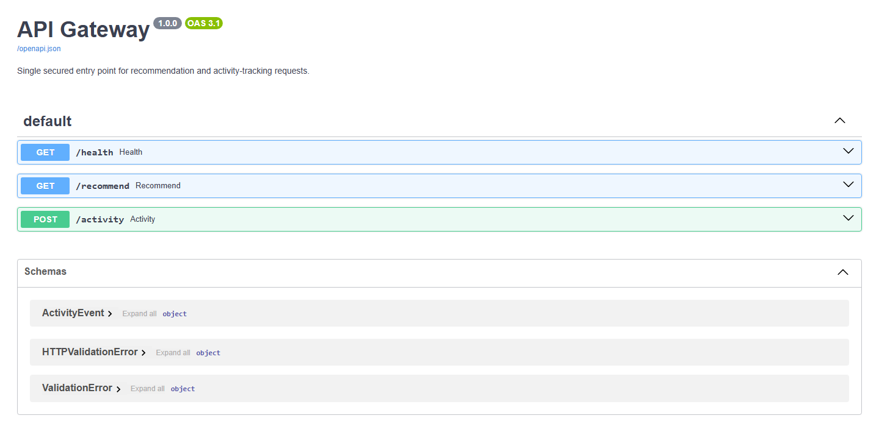
Figure 5: API Gateway Swagger UI showing the public /health, /recommend, and /activity endpoints.
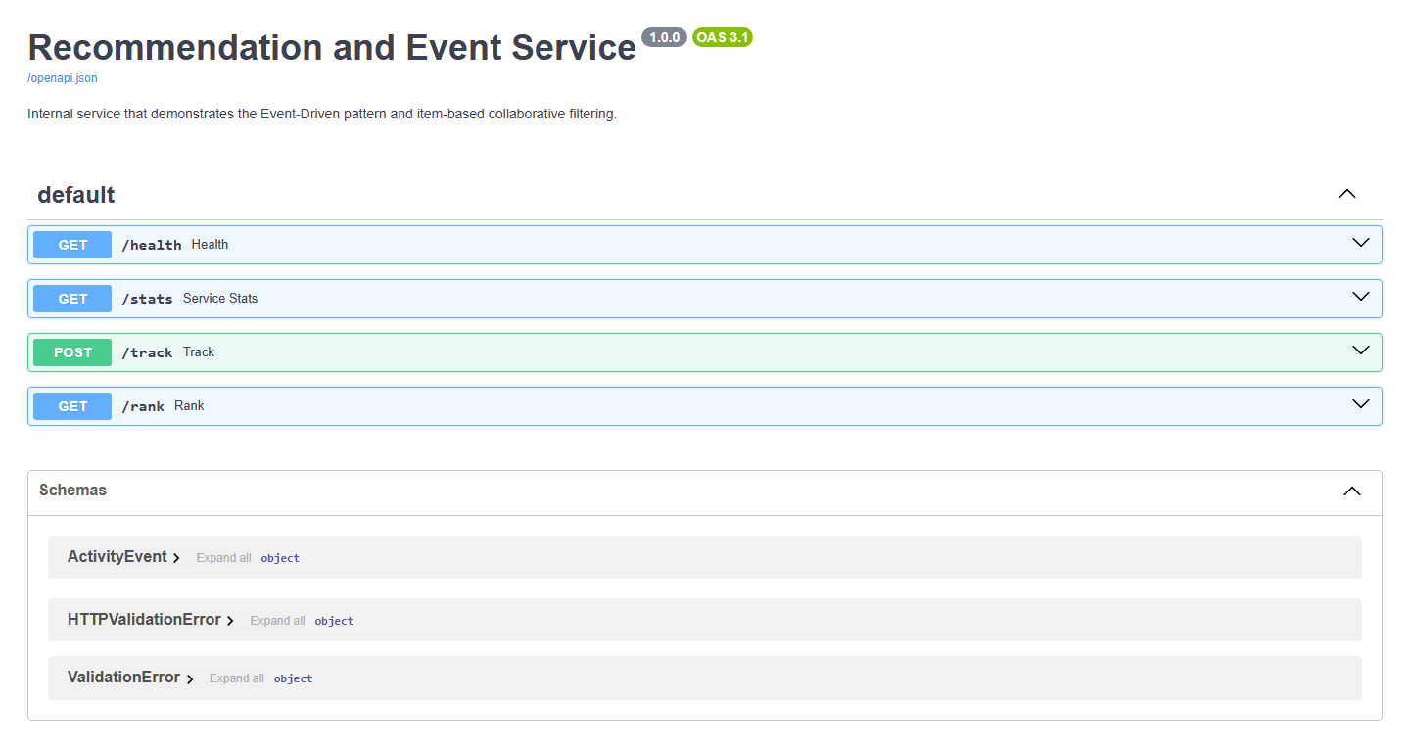
Figure 6: Internal recommendation/event service Swagger UI showing /track, /rank, /stats, and /health.
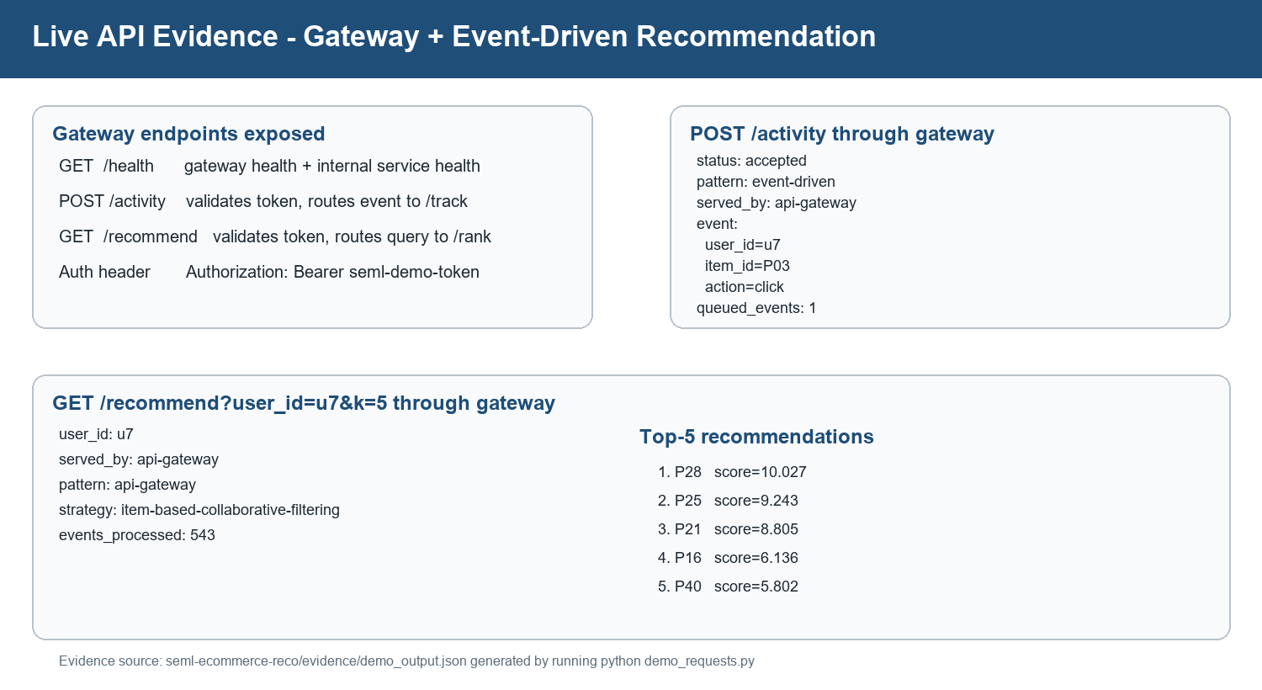
Figure 7: Live API evidence from gateway request/response output.
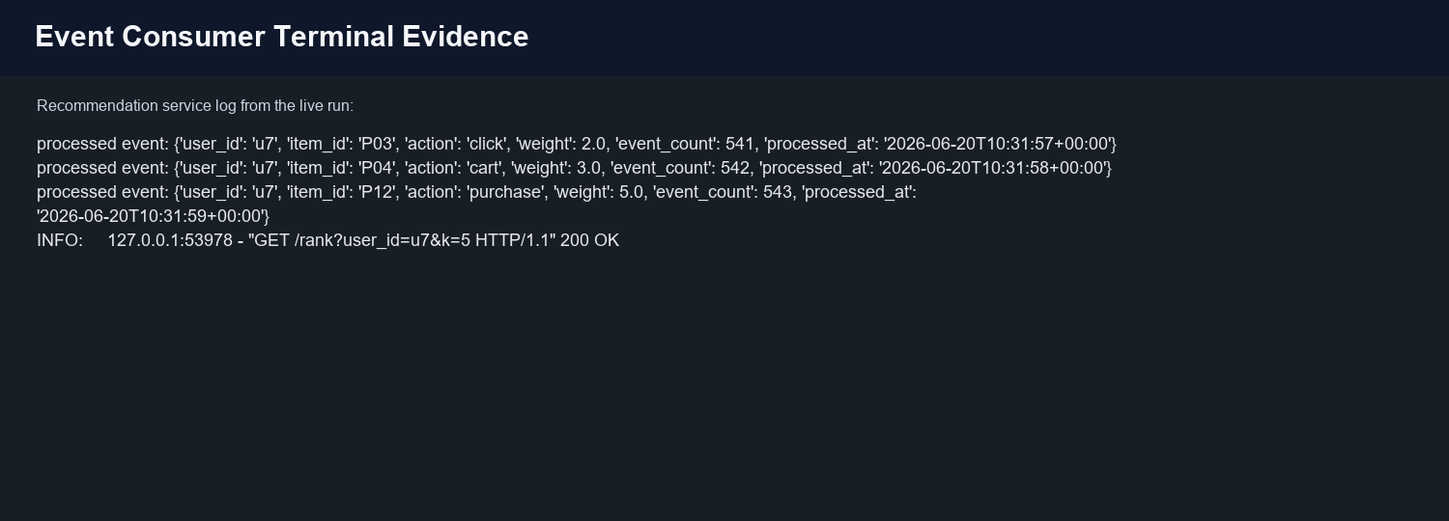
Figure 8: Event consumer log showing asynchronous event processing.
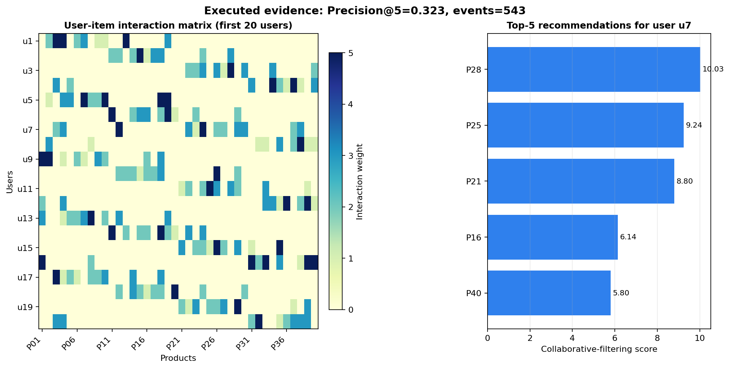
Figure 9: Executed recommendation evidence: matrix view and top-5 products for user u7.
Captured console output from the executed run:
=== Recommendation service - sample run ===
Dataset: 60 users x 40 items, overall matrix density 22.63%
Offline Precision@5 (leave-three-out, synthetic interactions): 0.323
Sample GET /recommend?user_id=u7&k=5 response:
{
"user_id": "u7",
"strategy": "item-based-collaborative-filtering",
"recommendations": [
{
"item_id": "P28",
"score": 10.027
},
{
"item_id": "P25",
"score": 9.243
},
{
"item_id": "P21",
"score": 8.805
},
{
"item_id": "P16",
"score": 6.136
},
{
"item_id": "P40",
"score": 5.802
}
]
}

2.5 Reading the Result
The demonstration sends three fresh actions for user u7 through the gateway. The response marks the activity calls as event-driven and served by the API gateway. After the consumer processes the events, GET /recommend?user_id=u7&k=5 returns items P28, P25, P21, P16, and P40, ranked by collaborative-filtering score. Already-seen items are filtered out, so the output is a true recommendation list rather than an echo of prior interactions.

2.6 Limitations and Future Improvements
This is an academic prototype, so it uses a small deterministic dataset and an in-memory queue to keep the run simple. In production, the event queue should be replaced with Kafka, Redis Streams, or a managed broker; feature data should be stored in a persistent feature store; and monitoring should track latency, event lag, Precision@5, catalogue coverage, drift, and online CTR uplift through A/B testing.

Appendix A - Key Code Excerpts
The full runnable code is in the seml-ecommerce-reco folder and the notebook deliverable is final_submission/GXXX.ipynb. The excerpts below show where the selected patterns and recommendation logic are implemented.

A.1 Event-Driven queue and consumer
EVENT_QUEUE: Queue[dict[str, str]] = Queue()
def consumer_loop() -> None:
while not STOP_WORKER.is_set():
event = EVENT_QUEUE.get(timeout=0.2)
result = recommender_engine.track_event(
event["user_id"], event["item_id"], event["action"]
)
print("processed event:", result, flush=True)
EVENT_QUEUE.task_done()
@app.post("/track", status_code=202)
def track(event: ActivityEvent) -> dict[str, Any]:
recommender_engine.validate_event(event.user_id, event.item_id, event.action)
EVENT_QUEUE.put(event.model_dump())
return {"status": "accepted", "pattern": "event-driven"}

A.2 API Gateway route
@app.get("/recommend")
async def recommend(user_id: str, k: int = 5,
authorization: str | None = Header(default=None)) -> Any:
require_token(authorization)
enforce_rate_limit(f"recommend:{user_id}")
async with httpx.AsyncClient(timeout=5.0) as client:
response = await client.get(
f"{RECO_SERVICE}/rank",
params={"user_id": user_id, "k": k},
)
payload = await forward_response(response)
payload["served_by"] = "api-gateway"
payload["pattern"] = "api-gateway"
return payload

A.3 Collaborative-filtering ranking
def rank_items(user_id: str, k: int = 5) -> list[dict[str, Any]]:
user_row = _MATRIX[USER_INDEX[user_id]].copy()
scores = user_row @ _ITEM_SIMILARITY
scores = scores.astype(float, copy=True)
scores[user_row > 0] = -np.inf
ordered = np.argsort(np.nan_to_num(scores, neginf=-1e12))[::-1]
return [
{"item_id": ITEMS[i], "score": round(float(scores[i]), 3)}
for i in ordered
if user_row[i] == 0
][:k]

Task Distribution and References
Member / role | Tasks owned | Deliverable | %
Member 1 - Requirements Lead | Domain, problem statement, requirements, measurable goals, and top quality requirements. | Sections 1.1, 1.2, 1.4 | 25
Member 2 - GR4ML Modelling Lead | Business, Analytics Design and Data Preparation views; diagram validation. | Section 1.3 + diagrams | 25
Member 3 - Architecture Lead | Architecture diagram, ML/non-ML component split, and pattern justification. | Sections 2.1, 2.2 | 25
Member 4 - Implementation Lead | FastAPI services, event queue, gateway routing, evidence generation, screenshots, and code explanation. | Sections 2.3, 2.4 | 25

Submission Readiness Checklist
Item | Status
PDF final report | Generated in final_submission/
Editable DOCX report | Generated in final_submission/
Implementation notebook | Generated as final_submission/GXXX.ipynb; rename to actual group number
Runnable source code | Available in seml-ecommerce-reco/
Application screenshots | Gateway Swagger, internal service Swagger, API evidence, terminal log, output plot
Group number, names, BITS IDs | Must be filled by the group before upload

References
- Nalchigar, S., and Yu, E. (2020). Designing Business Analytics Solutions: A Model-Driven Approach. Business & Information Systems Engineering, 62(1), 61-75.
- Nalchigar, S., and Yu, E. (2018). Business-driven data analytics: A conceptual modeling framework. Data & Knowledge Engineering.
- Nalchigar, S., Yu, E., Obeidi, Y. et al. (2019). Solution Patterns for Machine Learning. CAiSE 2019.
- Sarwar, B., Karypis, G., Konstan, J., and Riedl, J. (2001). Item-based collaborative filtering recommendation algorithms. WWW 2001.
- FastAPI documentation and scikit-learn cosine_similarity documentation used for the local prototype implementation.
Final submission checklist: fill group details, verify the file name matches the group ID, and upload this DOCX or the exported PDF to Taxila before 30 June 2026, 23:00.

