AIMLCZG546
Software Engineering for Machine Learning
Assignment I - E-commerce Product Recommendation
GR4ML requirements | Item-based collaborative filtering | Microservices + CQRS
Group: G049
Submission deadline: 7 July 2026 (per final faculty clarification)

Group Details and Submission Note
Sl. | BITS ID | Name | Contribution | %
1 | TO_FILL | TO_FILL | Problem statement, requirements, measurable goals, and quality requirements | 25
2 | TO_FILL | TO_FILL | GR4ML Business, Analytics Design, and Data Preparation views | 25
3 | TO_FILL | TO_FILL | Microservices and CQRS architecture design and justification | 25
4 | TO_FILL | TO_FILL | ML implementation, tests, execution evidence, and report integration | 25

Required before upload: Replace all TO_FILL values with the actual BITS IDs and member names before submission.
Submission format. We have included the implementation notebook together with this Word report. The report contains the answers, code excerpts, GR4ML diagrams, architecture diagram, and screenshots of executed output.

How This Report Answers the Seven Questions
Question | Requirement | Evidence in this submission
1 | Domain and ML problem statement | Section 1
2 | Requirements and measurable goals using GR4ML | Section 2
3 | Business, Analytics Design, Data Preparation views | Section 3; Figures 1-3
4 | Top three quality requirements with justification | Section 4
5 | Architecture with ML and non-ML components | Section 5; Figure 4
6 | Select and apply two relevant patterns | Section 6
7 | Implement patterns with code and screenshots | Sections 7-9; Appendix A

Objective 1 - Requirements Formulation

Question 1 - Domain and Problem Statement
Chosen domain. We selected e-commerce and online retail. A storefront must decide which small set of products to show each shopper while catalogue size, user intent, and inventory change continuously.
Problem statement. We use timestamped implicit feedback - view, click, cart, and purchase events - to build an ML system that learns product affinity and returns a personalized top-5 list of unseen products for a known user. We use item-based collaborative filtering because it is explainable, inexpensive to train at assignment scale, and fast at query time.
ML formulation. We map each action to preference strength (1, 2, 3, or 5), aggregate it into a user-item matrix, and transform it into an item-item cosine-similarity model. A user vector multiplied by this similarity matrix produces scores; previously seen products are masked before ranking.
Why ML is appropriate. User preference is not governed by a stable set of deterministic rules. It depends on sparse historical behavior and changes over time. The requirement therefore covers data quality, uncertainty in model output, repeatable retraining, and continuous evaluation - not only an API response.
Following the lecture, we aligned goals at four levels so that model performance is traceable to user and business value.
Goal level | Goal for this application | Measure
Organizational | Increase revenue per shopping session. | CTR uplift and average order value
Product | Show a useful personalized product block. | Recommendation usage and response latency
User | Find interesting products quickly. | Top-5 hit rate and user feedback
Model | Rank relevant unseen products. | Precision@5, Recall@5, Coverage@5

Question 2 - Requirement Specifications and Measurable Goals
Unlike a deterministic application, an ML system depends on both software behavior and the training data. We therefore specify functional, data, model, and quality requirements.
ID | Requirement specification | Verification
FR1 | Load a schema-valid interaction dataset. | CSV loader rejects missing columns.
FR2 | Deduplicate events and apply action weights. | Unit tests inspect event counts and matrix.
FR3 | Train and persist an item-based CF model. | NPZ artifact and metadata are version matched.
FR4 | Evaluate without train-test leakage. | Leave-2-out Precision/Recall/Hit Rate@5.
FR5 | Accept interactions and training as commands. | Command Service returns 202/200.
FR6 | Serve top-k unseen products as queries. | Query Service returns five ranked products.
DR1 | Accept only complete IDs, valid actions, and ISO timestamps; ignore duplicate event IDs. | Validation and deduplication unit tests.
MR1 | Make training reproducible and version every persisted model. | Fixed seeds and model/metadata version check.
NFR1 | Keep training writes separate from low-latency reads. | Independent Command and Query services.

Each measure below is directly related to a goal, quantifiable, objective, and practical to collect. We distinguish executed offline evidence from production goals that require traffic, load testing, or an A/B experiment.
Goal | Target | Executed result | Status
Recommendation relevance | Precision@5 >= 0.30 | 0.330 | Passed
Held-out recovery | Recall@5 >= 0.70 | 0.825 | Passed
Catalogue reach | Coverage@5 >= 0.80 | 1.000 | Passed
Serving latency | p95 < 200 ms | Requires load test | Production validation
Business impact | CTR uplift >= 8% | Requires A/B test | Production validation

Question 3 - GR4ML Views
We prepared the three complementary GR4ML views described in Session 3. The notation now matches the lecture examples: actors are stick figures; goals are ovals; decision and question goals carry D and Q markers; algorithms are hexagons; softgoals are clouds; indicators use a traffic-light symbol; entities use structured boxes; operators use rectangles; and notes have a folded corner. Each figure contains its own view-specific legend.
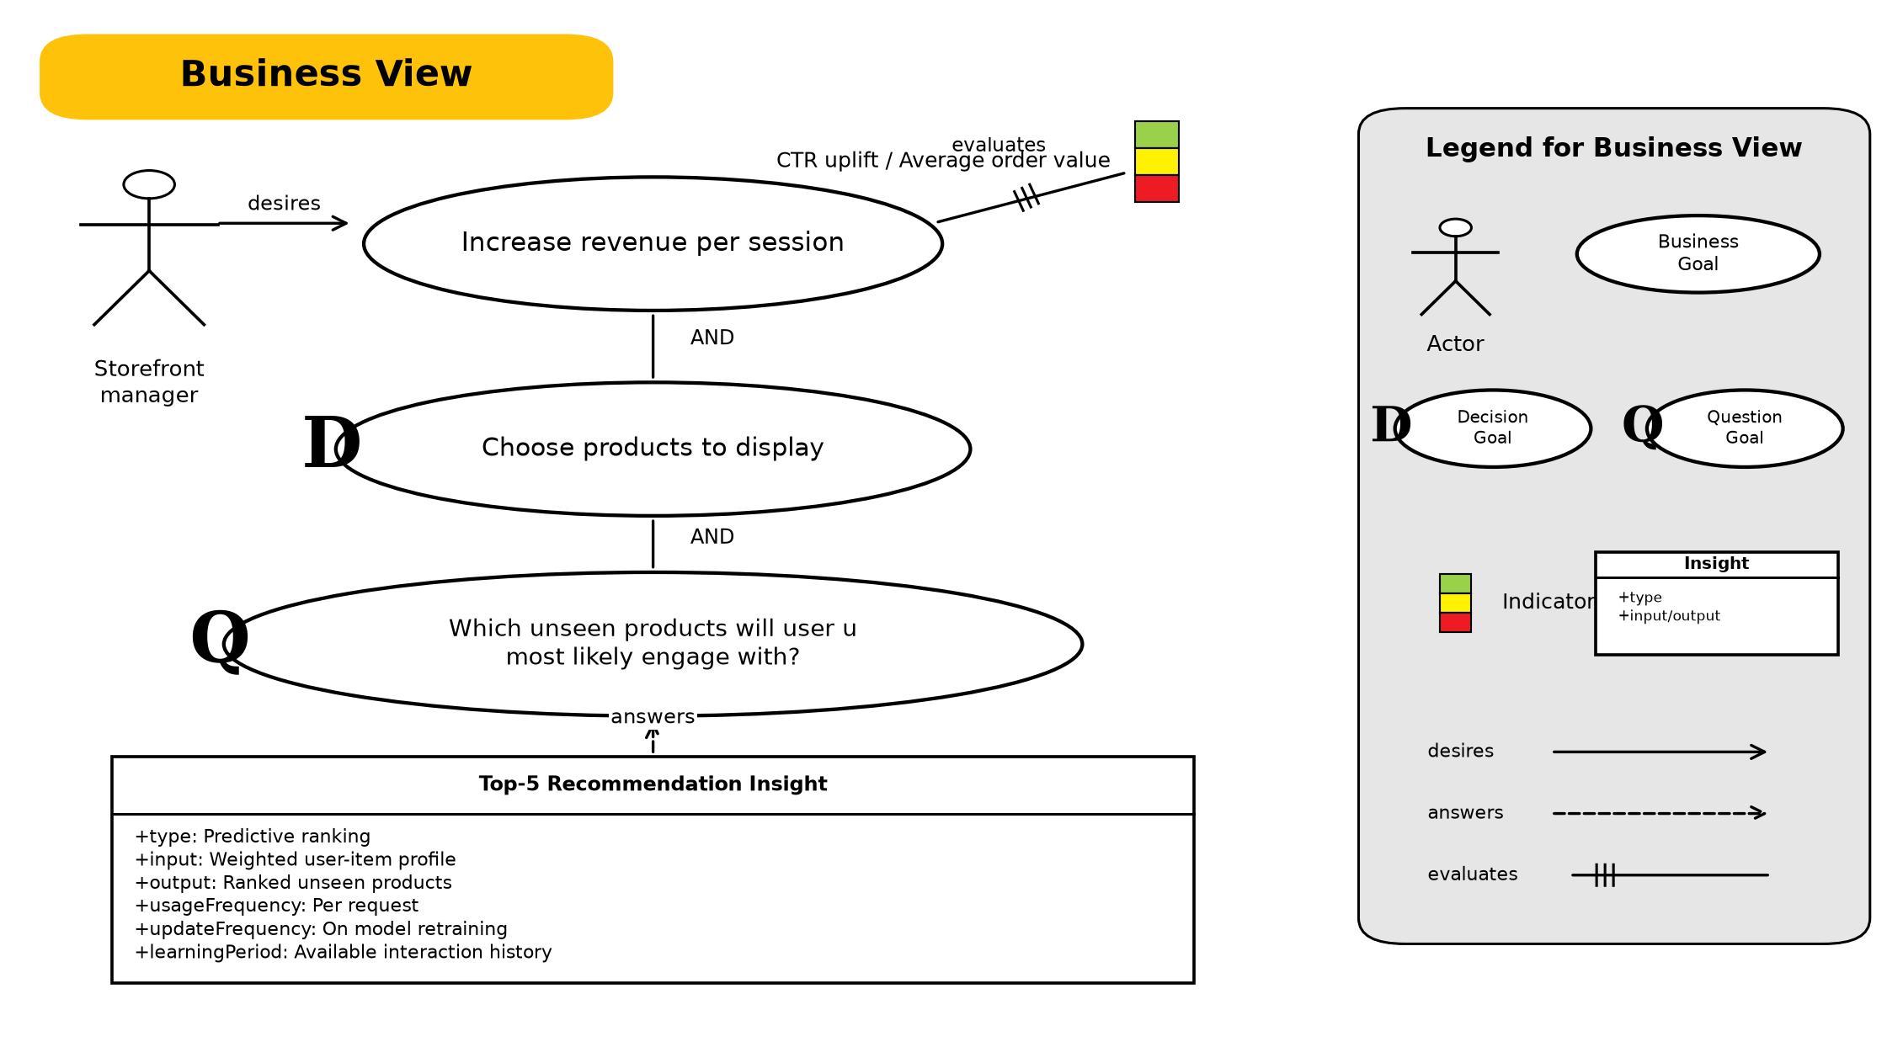
Figure 1. GR4ML Business View using Actor, Business Goal, Decision Goal, Question Goal, Indicator, and Insight notation.
Business interpretation. The Storefront Manager desires the business goal of increasing revenue per session. This goal is refined into the decision of which products to display. The decision requires an answer to which unseen products a user will engage with. The structured Top-5 Recommendation Insight answers that question, while CTR and average order value evaluate the business goal.
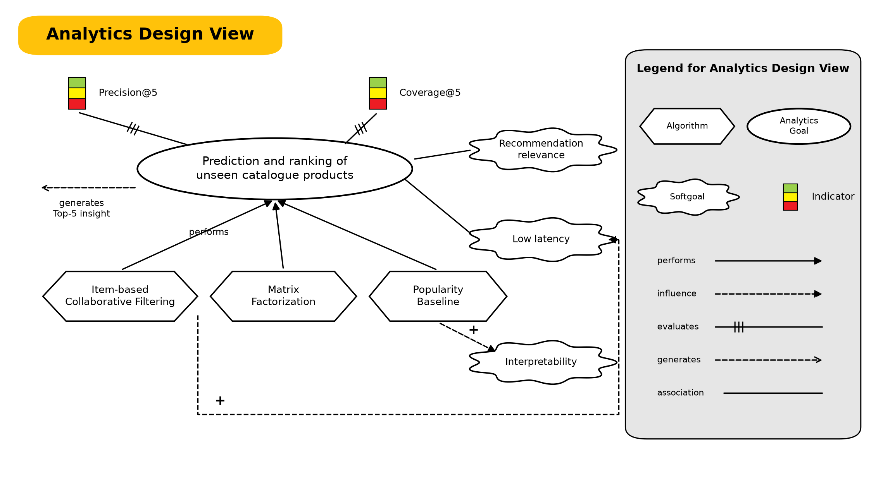
Figure 2. GR4ML Analytics Design View using Analytics Goal, Algorithm, Softgoal, Indicator, Performs, Influence, Evaluates, and Generates notation.
Analytics interpretation. This is a Prediction Goal because the system estimates unknown future preference scores. Item-based collaborative filtering, matrix factorization, and a popularity baseline are alternative algorithms that perform the goal. Item-based CF is selected for the prototype because it positively supports low latency and interpretability while still meeting the relevance threshold. Precision@5 and Coverage@5 evaluate the goal.
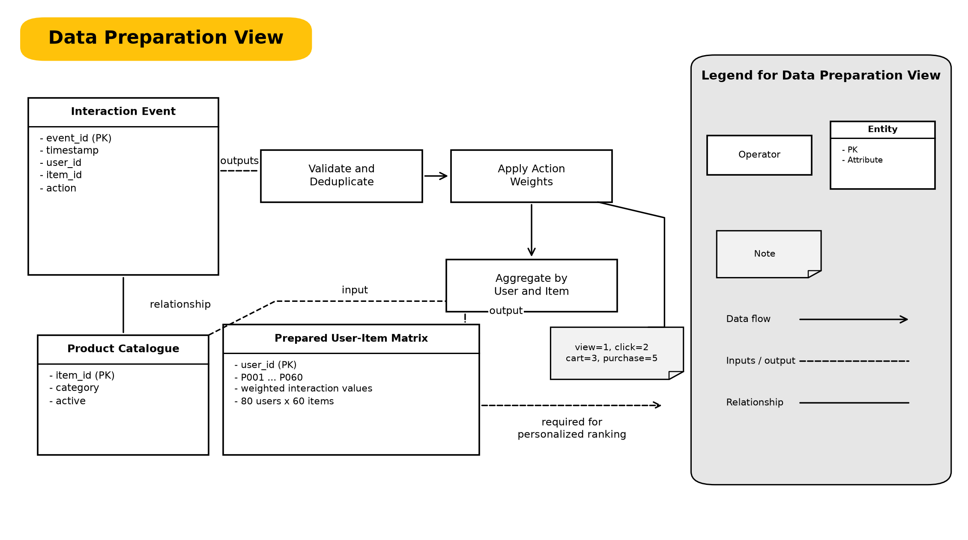
Figure 3. GR4ML Data Preparation View using Entities, Operators, Note, Data Flow, Input/Output, and Relationship notation.
Data interpretation. Interaction Event and Product Catalogue are entities. Validate and Deduplicate, Apply Action Weights, and Aggregate by User and Item are operators connected by data flows. Dashed links identify inputs and outputs. The Prepared User-Item Matrix is the resulting entity required by the analytics goal; the folded note records the action weights.
Cross-view traceability: Prepared User-Item Matrix is required for the Prediction and Ranking Analytics Goal; that goal generates the Top-5 Recommendation Insight; the insight answers the Question Goal; the answer supports the product-display Decision Goal; and the decision contributes to the revenue-per-session Business Goal.

Question 4 - Top Three Quality Requirements
Quality requirement | Why it is critical | Design response
Recommendation relevance | Irrelevant products waste scarce storefront space and reduce user trust. | Weighted feedback, unseen-item masking, Precision/Recall/Hit Rate@5 gates.
Low query latency | Recommendations are requested on the page-render path. | Precomputed similarity and a read-only Query Service; p95 target < 200 ms.
Scalability and change isolation | Training is compute-heavy while reads are frequent and latency-sensitive. | Command and Query microservices can deploy and scale independently.

In the Analytics Design View, these quality requirements are modeled as Softgoals. Influence links make the trade-offs visible instead of treating algorithm selection as an accuracy-only decision.

Objective 2 - System Architecture

Question 5 - Architecture and Responsibilities
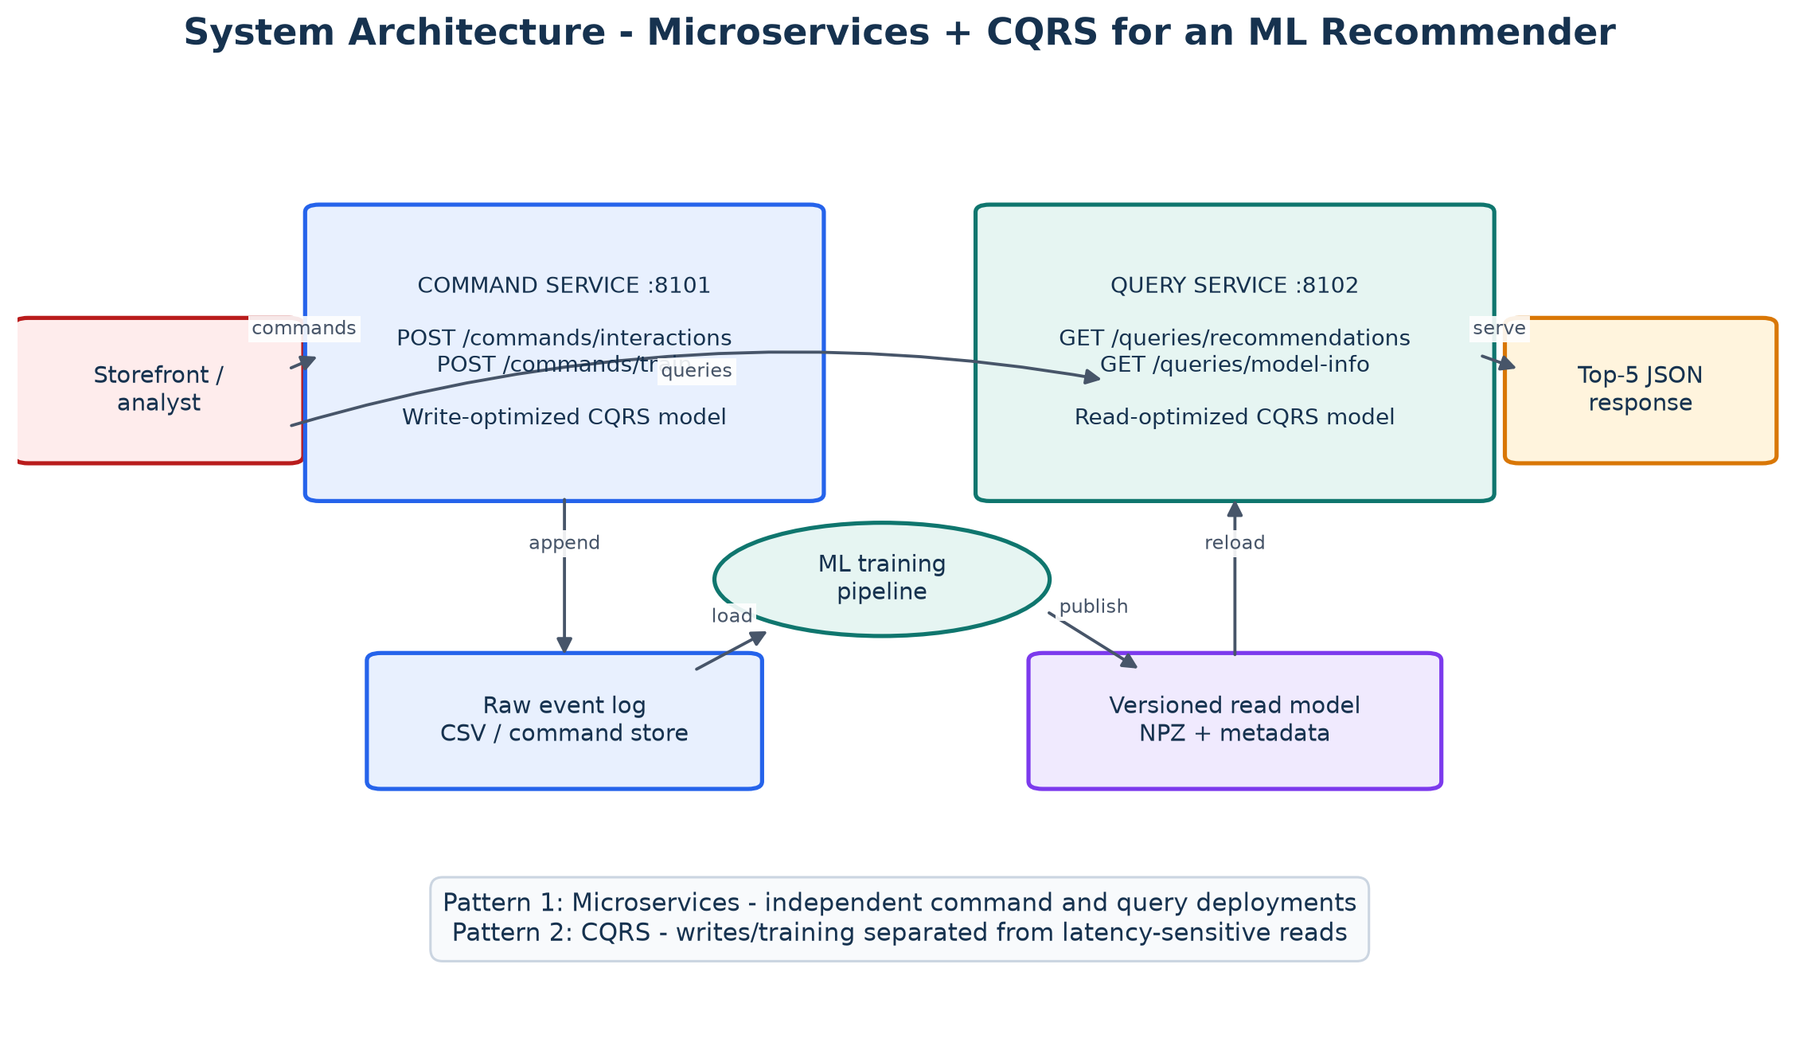
Figure 4. System architecture separating ML, data, command/write, and query/read concerns.
Component | Type | Responsibility
Storefront / analyst | External | Issues commands and recommendation queries.
Command Service :8101 | Non-ML service | Owns writes and invokes training.
Training pipeline | ML component | Loads, prepares, evaluates, fits, and persists.
Raw event log | Data store | Authoritative command-side interaction history.
Versioned read model | ML artifact | Similarity matrix, user features, metadata.
Query Service :8102 | ML serving | Reloads versions and ranks unseen products.

Question 6 - Two Selected Architectural Patterns

Pattern 1 - Microservices
Application. Command and Query responsibilities are separate FastAPI applications on ports 8101 and 8102. They have independent entry points, API contracts, health endpoints, tests, and Docker Compose processes. Training failures therefore do not require the read service to expose write behavior, and read replicas can scale independently.
Trade-off. Distributed deployment increases operational complexity. The local demonstration uses a shared artifact directory for reproducibility; a production design would publish to a model registry or object store and add authentication, tracing, retries, and rollback.

Pattern 2 - CQRS
Application. POST /commands/interactions appends to the write model and POST /commands/train builds an immutable read model. GET /queries/recommendations and GET /queries/model-info are read-only. The query process checks artifact modification time and atomically reloads a new model version.
Trade-off. CQRS introduces eventual consistency: an accepted interaction affects queries only after training and publication. For recommendations this is acceptable when freshness is monitored and the previous valid model remains available during retraining.

Question 7 - Implementation, Code, and Output

7.1 ML Training and Evaluation
The runnable pipeline has five visible stages: LOAD, PREPARE, EVALUATE, TRAIN, and PERSIST. The dataset contains 80 users, 60 items, and 960 deterministic events before the live command. The final artifact contains no executable pickle payload.
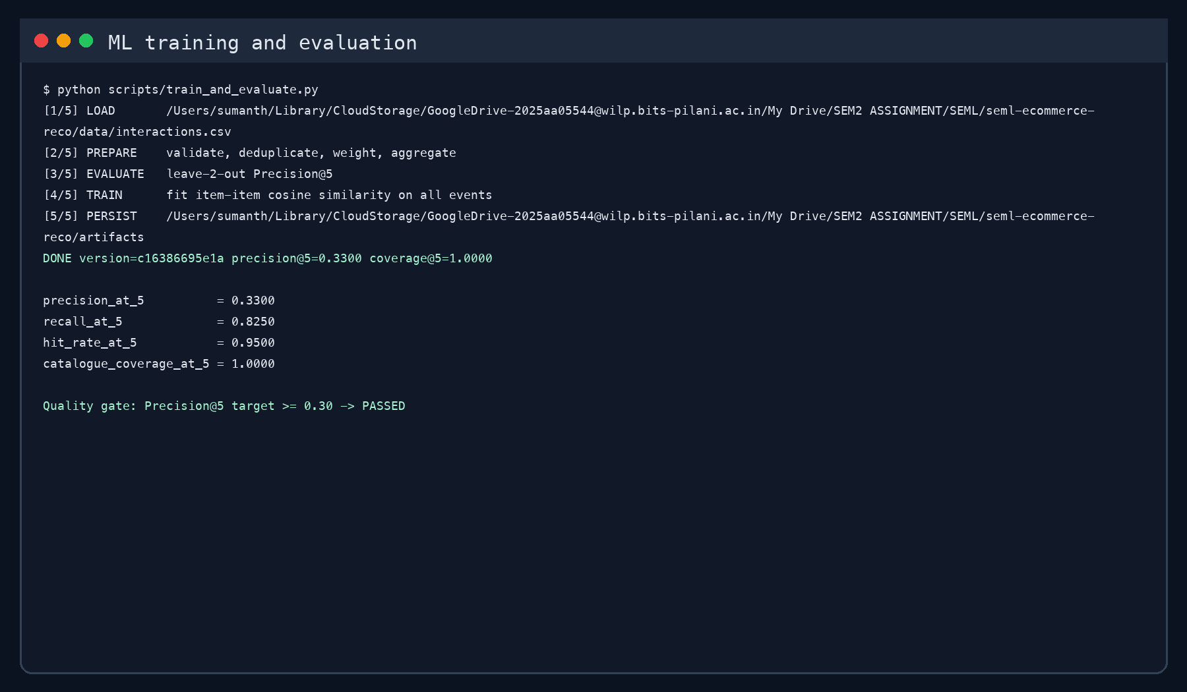
Figure 5. Actual training console output and passed offline quality gate.
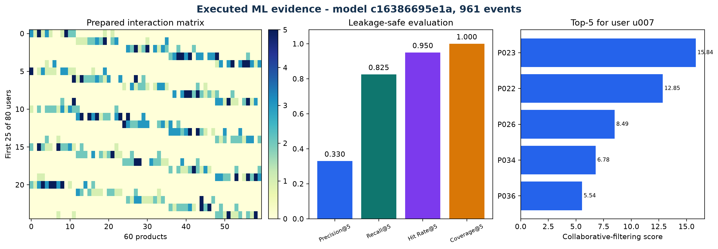
Figure 6. Prepared matrix, offline metrics, and top-5 recommendation scores.
Executed result: Precision@5=0.330, Recall@5=0.825, Hit Rate@5=0.950, and Coverage@5=1.000 across 80 users.

7.2 Pattern Implementation and API Evidence
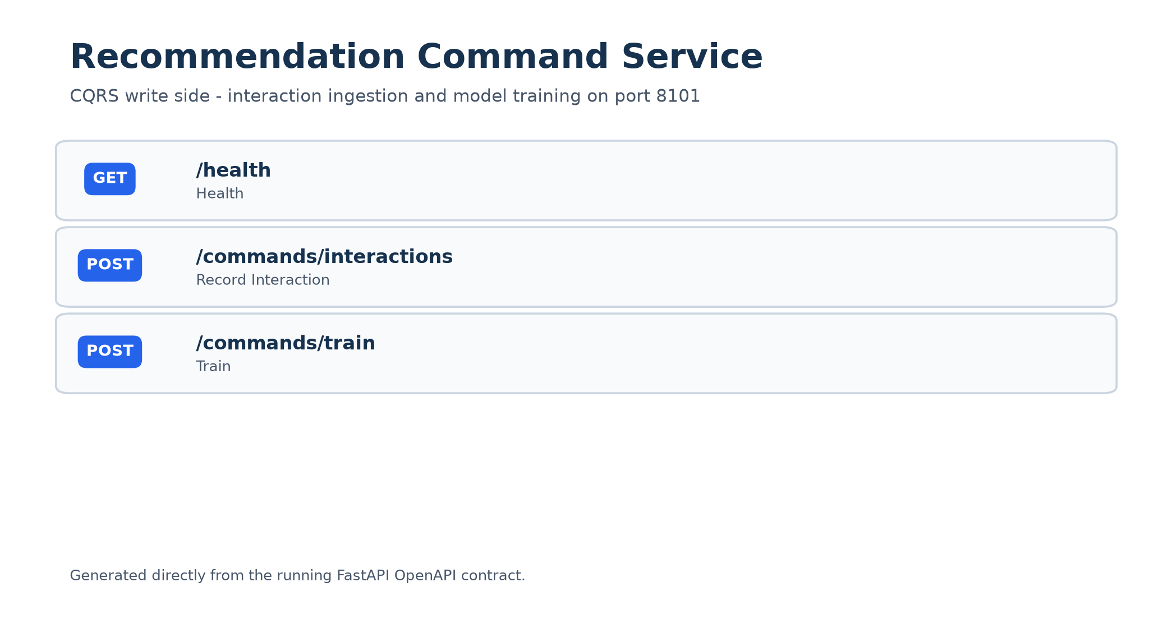
Figure 7. Command Service endpoints generated from its actual OpenAPI contract.
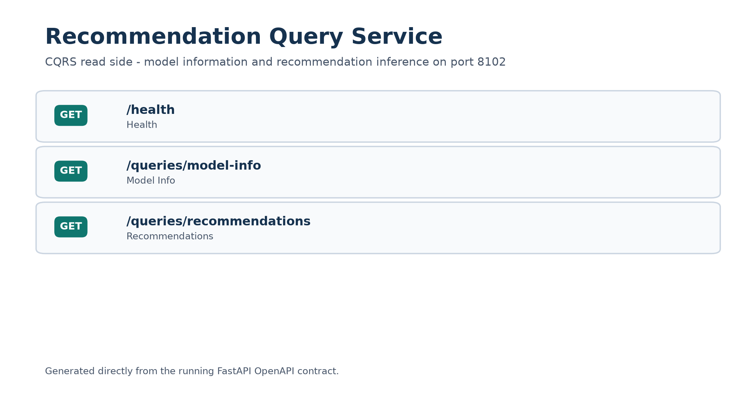
Figure 8. Query Service endpoints generated from its actual OpenAPI contract.
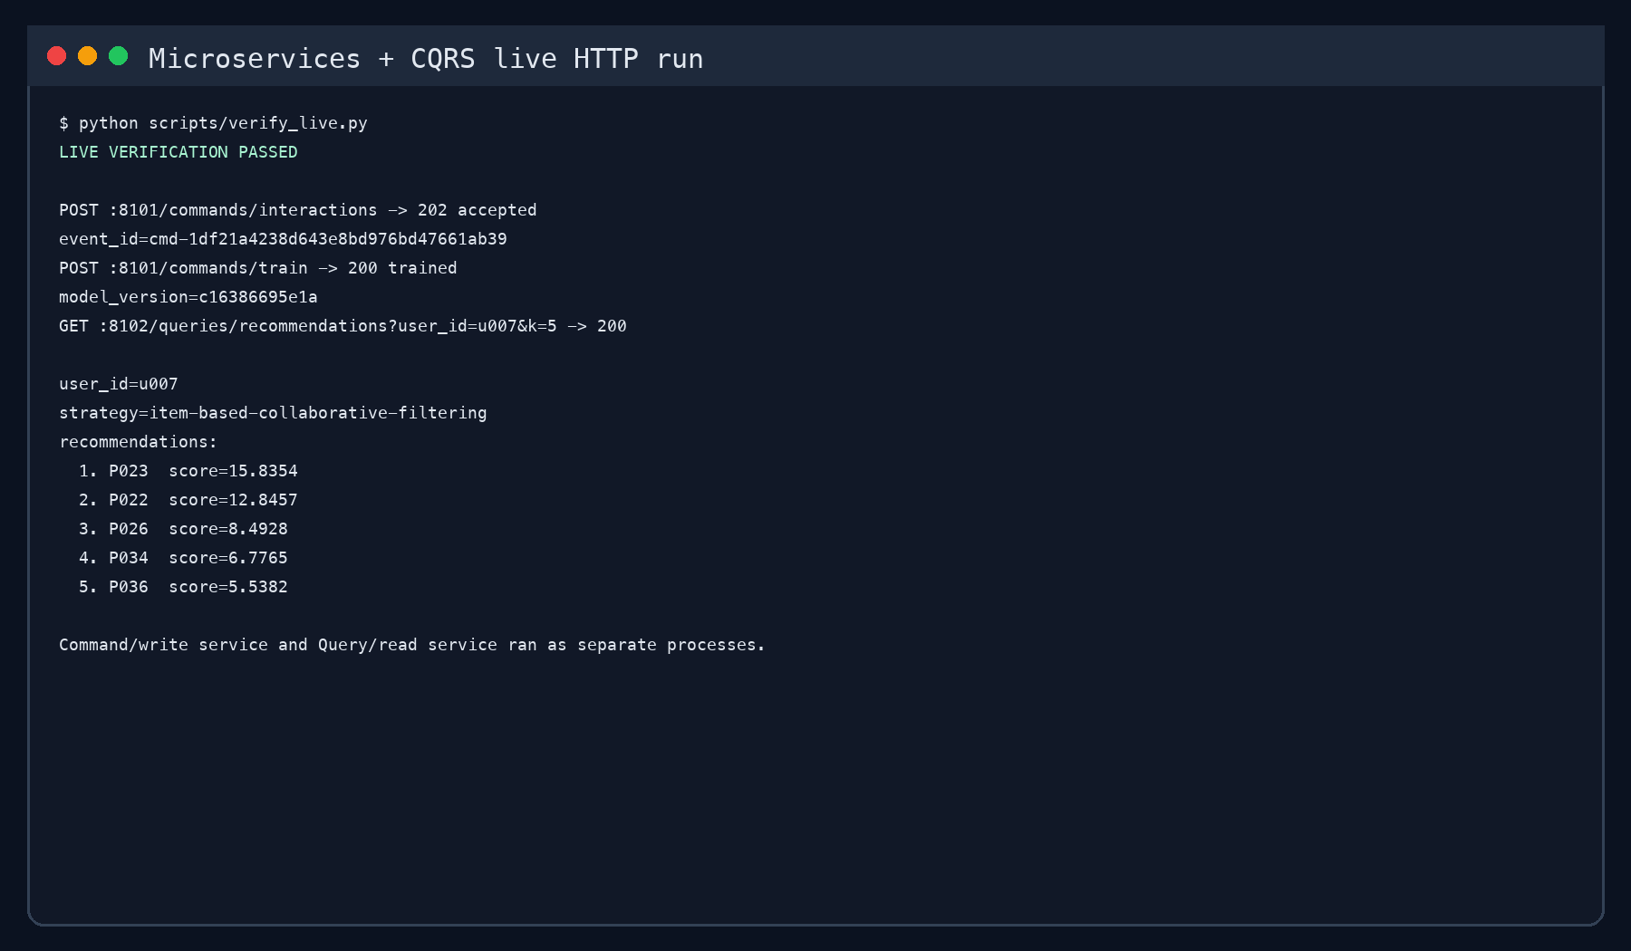
Figure 9. Actual live run across two service processes: command, train, then query.
Result interpretation. After the command service accepted a purchase and trained model c16386695e1a, the query service returned five unseen products for u007: P023 (15.8354), P022 (12.8457), P026 (8.4928), P034 (6.7765), P036 (5.5382). The test suite also proves that the Query Service exposes no command route and rejects unknown users.

7.3 Verification and Reproducibility
Check | Result
Ruff lint | Passed
Ruff formatting | Passed
Mypy static typing | 17 source files passed
Pytest | 8 tests passed
Coverage | 89% total
Live HTTP scenario | Passed with five recommendations
Notebook | All code cells executed; outputs and diagrams saved

Reproduction commands
uv venv --python 3.12 .venv
source .venv/bin/activate
uv pip install -r requirements.txt -e ".[dev,report]"
python scripts/seed_data.py
python scripts/train_and_evaluate.py
# Run in separate terminals
uvicorn ecom_ml.command_service.main:app --port 8101
uvicorn ecom_ml.query_service.main:app --port 8102
python scripts/run_demo.py
# Quality gates
make check
python scripts/verify_live.py

7.4 Limitations and Future Improvements
This is an executed academic prototype, not a production claim. It uses deterministic synthetic behavior, a CSV command store, and a shared local artifact directory. It has no cold-start strategy for unknown users, online experiment data, privacy controls, or model drift alarms.
As future work, we would use an event broker and durable warehouse, a feature store, a model registry with approval and rollback, content/popularity fallbacks, distributed tracing, load tests, drift and bias monitoring, and an A/B experiment measuring CTR and revenue per session.

Appendix A - Key Executed Code
The executed notebook contains the complete ML and service code. The main ML code excerpts are also included below for easy evaluation.
A.1 Data validation, deduplication, weighting, and matrix construction
def prepare_interactions(rows: list[Interaction]) -> PreparedInteractions:
"""Deduplicate, validate, weight, and aggregate raw events into a matrix."""
unique: dict[str, Interaction] = {}
for row in rows:
validate_interaction(row)
unique.setdefault(row.event_id, row)
users = tuple(sorted({row.user_id for row in unique.values()}))
items = tuple(sorted({row.item_id for row in unique.values()}))
if not users or not items:
raise ValueError("at least one user and item are required")
user_index = {user_id: index for index, user_id in enumerate(users)}
item_index = {item_id: index for index, item_id in enumerate(items)}
matrix = np.zeros((len(users), len(items)), dtype=np.float64)
for row in unique.values():
matrix[user_index[row.user_id], item_index[row.item_id]] += ACTION_WEIGHTS[row.action]
return PreparedInteractions(
users=users,
items=items,
matrix=matrix,
raw_event_count=len(rows),
unique_event_count=len(unique),
)
A.2 Model training
@classmethod
def fit(cls, prepared: PreparedInteractions) -> CollaborativeFilteringModel:
"""Fit item-item cosine similarity from a prepared interaction matrix."""
matrix = prepared.matrix.astype(np.float64, copy=True)
similarity = cosine_similarity(matrix.T).astype(np.float64, copy=False)
np.fill_diagonal(similarity, 0.0)
version_input = (
matrix.tobytes() + "|".join(prepared.users).encode() + "|".join(prepared.items).encode()
)
version = hashlib.sha256(version_input).hexdigest()[:12]
return cls(
users=prepared.users,
items=prepared.items,
interaction_matrix=matrix,
item_similarity=similarity,
version=version,
)
A.3 Recommendation inference
def recommend(self, user_id: str, k: int = 5) -> list[Recommendation]:
"""Score and rank unseen items for a known user."""
if k < 1 or k > 20:
raise ValueError("k must be between 1 and 20")
try:
user_index = self.users.index(user_id)
except ValueError as exc:
raise KeyError(f"unknown user_id: {user_id}") from exc
user_vector = self.interaction_matrix[user_index]
scores = (user_vector @ self.item_similarity).astype(np.float64, copy=True)
seen = user_vector > 0
scores[seen] = -np.inf
ordered = np.argsort(np.nan_to_num(scores, neginf=_NEGATIVE_FILL))[::-1]
recommendations: list[Recommendation] = []
for item_index in ordered:
if len(recommendations) == k:
break
if seen[item_index]:
continue
score = scores[item_index]
recommendations.append(
Recommendation(
item_id=self.items[int(item_index)],
score=round(float(score if np.isfinite(score) else 0.0), 4),
)
)
return recommendations
A.4 Leakage-safe evaluation
def evaluate_leave_n_out(
prepared: PreparedInteractions,
*,
k: int = 5,
holdout_per_user: int = 2,
seed: int = 1546,
) -> EvaluationMetrics:
"""Hide interactions, fit on the remainder, and evaluate top-k recovery."""
if k < 1:
raise ValueError("k must be positive")
if holdout_per_user < 1:
raise ValueError("holdout_per_user must be positive")
rng = np.random.default_rng(seed)
train_matrix = prepared.matrix.copy()
held_out: dict[int, set[int]] = {}
for user_index in range(train_matrix.shape[0]):
positives = np.flatnonzero(train_matrix[user_index] > 0)
if len(positives) <= holdout_per_user:
continue
selected = rng.choice(positives, size=holdout_per_user, replace=False)
train_matrix[user_index, selected] = 0.0
held_out[user_index] = {int(index) for index in selected}
train_data = PreparedInteractions(
users=prepared.users,
items=prepared.items,
matrix=train_matrix,
raw_event_count=prepared.raw_event_count,
unique_event_count=prepared.unique_event_count,
)
model = CollaborativeFilteringModel.fit(train_data)
precisions: list[float] = []
recalls: list[float] = []
hit_users = 0
recommended_items: set[str] = set()
for user_index, relevant in held_out.items():
recommendations = model.recommend(prepared.users[user_index], k=k)
predicted_ids = {recommendation.item_id for recommendation in recommendations}
predicted_indices = {prepared.items.index(item_id) for item_id in predicted_ids}
hits = len(predicted_indices & relevant)
precisions.append(hits / k)
recalls.append(hits / len(relevant))
hit_users += int(hits > 0)
recommended_items.update(predicted_ids)
user_count = len(precisions)
return EvaluationMetrics(
precision_at_k=round(float(np.mean(precisions)) if precisions else 0.0, 4),
recall_at_k=round(float(np.mean(recalls)) if recalls else 0.0, 4),
hit_rate_at_k=round(hit_users / user_count if user_count else 0.0, 4),
catalogue_coverage_at_k=round(
len(recommended_items) / len(prepared.items) if prepared.items else 0.0,
4,
),
evaluated_users=user_count,
k=k,
holdout_per_user=holdout_per_user,
)
A.5 End-to-end ML pipeline
def train_pipeline(
data_path: Path,
artifact_dir: Path,
*,
k: int = 5,
holdout_per_user: int = 2,
) -> TrainingSummary:
"""Execute and log every stage of the ML lifecycle."""
print(f"[1/5] LOAD {data_path}", flush=True)
rows = load_interactions(data_path)
print("[2/5] PREPARE validate, deduplicate, weight, aggregate", flush=True)
prepared = prepare_interactions(rows)
print(f"[3/5] EVALUATE leave-{holdout_per_user}-out Precision@{k}", flush=True)
evaluation = evaluate_leave_n_out(
prepared,
k=k,
holdout_per_user=holdout_per_user,
)
print("[4/5] TRAIN fit item-item cosine similarity on all events", flush=True)
model = CollaborativeFilteringModel.fit(prepared)
print(f"[5/5] PERSIST {artifact_dir}", flush=True)
saved = save_artifact(
model,
artifact_dir,
metrics=evaluation.as_dict(),
training_event_count=prepared.unique_event_count,
)
density = float((prepared.matrix > 0).sum() / prepared.matrix.size)
summary = TrainingSummary(
model_type="item-based-collaborative-filtering",
version=model.version,
users=len(prepared.users),
items=len(prepared.items),
raw_events=prepared.raw_event_count,
unique_events=prepared.unique_event_count,
matrix_density=round(density, 4),
metrics=evaluation.as_dict(),
model_path=str(saved.model_path),
)
print(
f"DONE version={summary.version} "
f"precision@{k}={evaluation.precision_at_k:.4f} "
f"coverage@{k}={evaluation.catalogue_coverage_at_k:.4f}",
flush=True,
)
return summary

References
R1. Rao, S. (2026). AIMLCZG546 Session 3 lecture slides: Requirements Engineering and GR4ML Modeling Notation. BITS Pilani WILP.
R2. Nalchigar, S. and Yu, E. (2020). Designing Business Analytics Solutions: A Model-Driven Approach. Business & Information Systems Engineering, 62, 61-75. https://doi.org/10.1007/s12599-018-0555-z
R3. Sarwar, B., Karypis, G., Konstan, J., and Riedl, J. (2001). Item-based collaborative filtering recommendation algorithms. WWW '01, 285-295. https://doi.org/10.1145/371920.372071
R4. Microsoft Azure Architecture Center. CQRS pattern. https://learn.microsoft.com/en-us/azure/architecture/patterns/cqrs
R5. Microsoft Azure Architecture Center. Architecture styles - Microservices. https://learn.microsoft.com/en-us/azure/architecture/guide/architecture-styles/
R6. scikit-learn documentation. sklearn.metrics.pairwise.cosine_similarity. https://scikit-learn.org/stable/modules/generated/sklearn.metrics.pairwise.cosine_similarity.html
R7. FastAPI documentation. Automatic interactive API documentation. https://fastapi.tiangolo.com/features/#automatic-docs
Final submission check: Fill group metadata, confirm the portal naming convention, open the executed notebook to verify saved outputs, and submit the requested IPYNB plus one report format.

