Field Returns Failure Mode Mining
Analysis Report • Source: service_notes_sample.xlsx • Generated: 09 Aug 2026

Summary
Total Notes | Themes Discovered | Top Failure Mode | Product Models
450 | 8 | Does / Battery / Power / Charge | 3

Failure Themes (Overall)
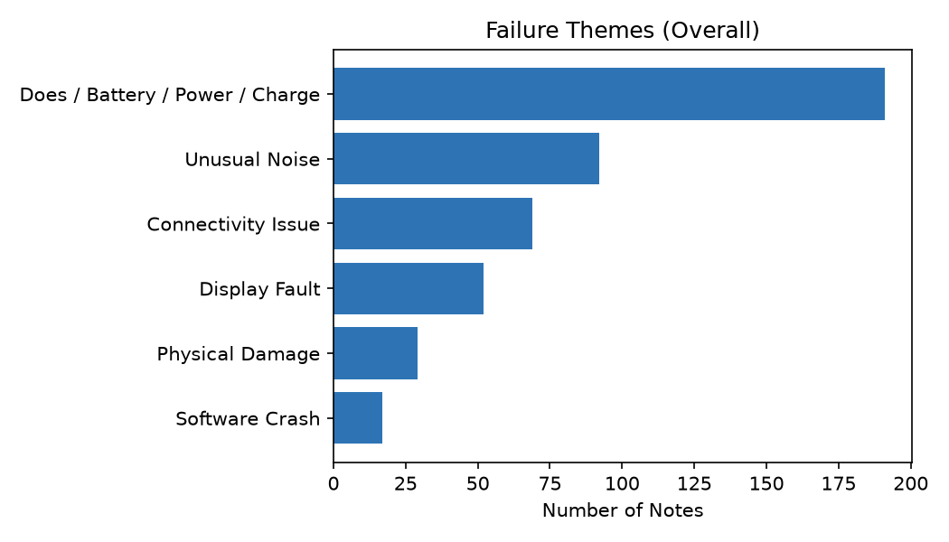

Trend Over Time by Theme
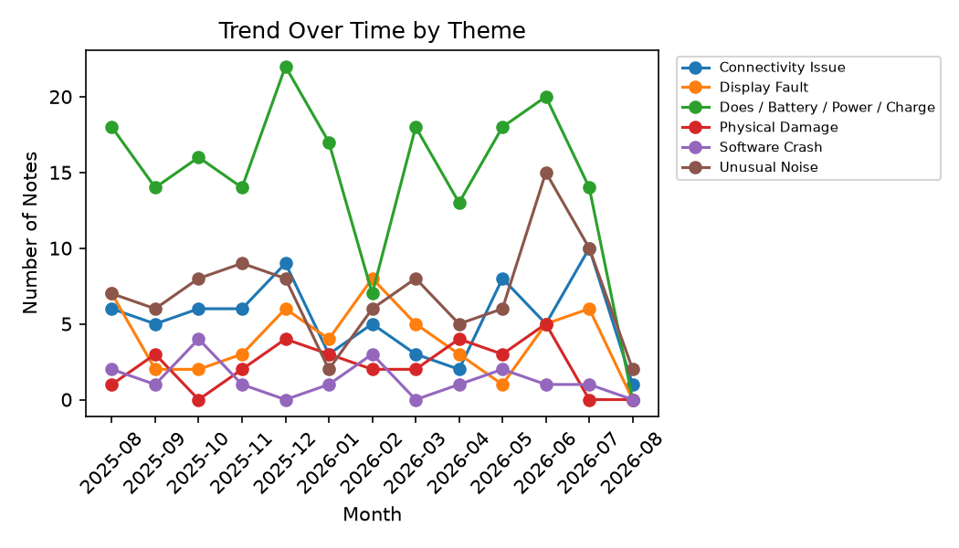

Failure Counts by Product Model
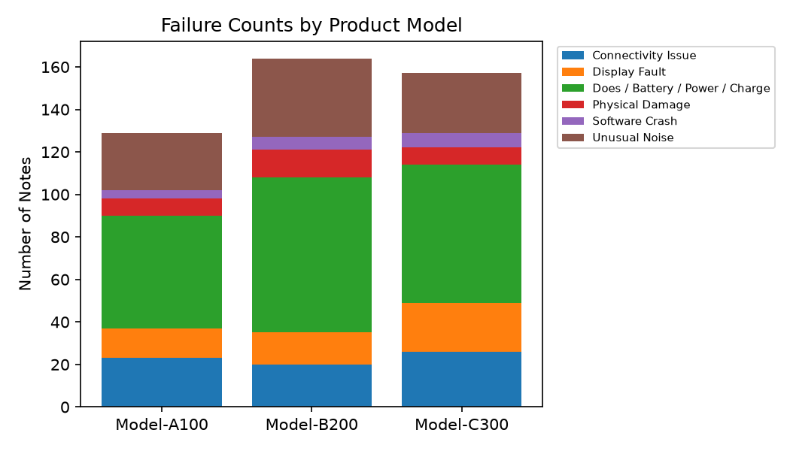

Actionable Insights Summary

Does / Battery / Power / Charge — 191 notes (42.4% of total)
Most affected model: Model-B200
Most common serial range: SN-C30-00001
Structured-tag agreement: 29.8% (how often the technician's own tag matched this auto-discovered theme)
Example notes:
- Customer reports burning smell and excessive heat near vents.
- Customer reports battery does not hold charge overnight.
- Battery drains fully within 2 hours of light use.

Unusual Noise — 92 notes (20.4% of total)
Most affected model: Model-B200
Most common serial range: SN-C30-00006
Structured-tag agreement: 84.4% (how often the technician's own tag matched this auto-discovered theme)
Example notes:
- Loud grinding noise coming from internal fan. Contact: [REDACTED_PHONE].
- Loud grinding noise coming from internal fan.
- High pitched whining noise during operation.

Connectivity Issue — 69 notes (15.3% of total)
Most affected model: Model-C300
Most common serial range: SN-C30-00002
Structured-tag agreement: 79.2% (how often the technician's own tag matched this auto-discovered theme)
Example notes:
- Customer [REDACTED_NAME] reported: Thermal shutdown triggered repeatedly under light load.
- Bluetooth pairing fails every time.
- Unit repeatedly disconnects from WiFi network.

Display Fault — 52 notes (11.6% of total)
Most affected model: Model-C300
Most common serial range: SN-A10-00004
Structured-tag agreement: 81.5% (how often the technician's own tag matched this auto-discovered theme)
Example notes:
- Flickering screen, gets worse when device is warm.
- Screen shows vertical lines across display.
- Cracked display panel, screen partially visible.

Physical Damage — 29 notes (6.4% of total)
Most affected model: Model-B200
Most common serial range: SN-A10-00009
Structured-tag agreement: 100.0% (how often the technician's own tag matched this auto-discovered theme)
Example notes:
- Outer casing has visible dents and scratches.
- Customer reports unit was dropped, casing damaged.
- Outer casing has visible dents and scratches. Reach out at [REDACTED_EMAIL] for follow-up.

Software Crash — 17 notes (3.8% of total)
Most affected model: Model-C300
Most common serial range: SN-C30-00015
Structured-tag agreement: 100.0% (how often the technician's own tag matched this auto-discovered theme)
Example notes:
- Customer reports random restarts several times a day.
- Customer reports random restarts several times a day. Reach out at [REDACTED_EMAIL] for follow-up.
- Customer reports random restarts several times a day. Contact: [REDACTED_PHONE].

MVP scope only — production hardening (robust PII detection, human-in-the-loop labeling, live data ingestion) not included.

