Field Returns Failure Mode Mining
Analysis Report • Source: sample_raw_reviews_large.csv • Generated: 09 Aug 2026

Summary
Total Notes | Themes Discovered | Top Failure Mode | Product Models
50 | 8 | Battery / Car / Properly / Keeps | 5

Failure Themes (Overall)
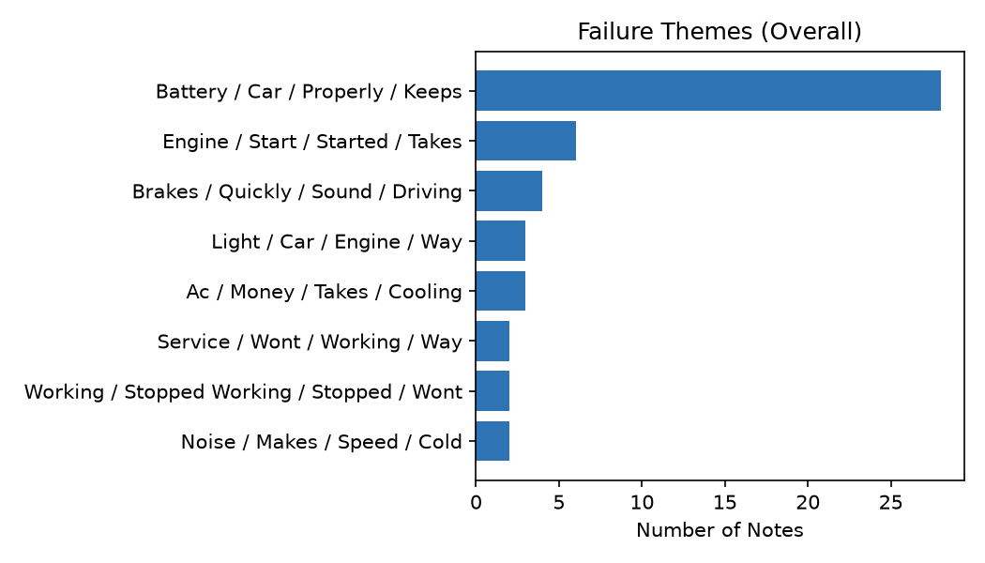

Trend Over Time by Theme
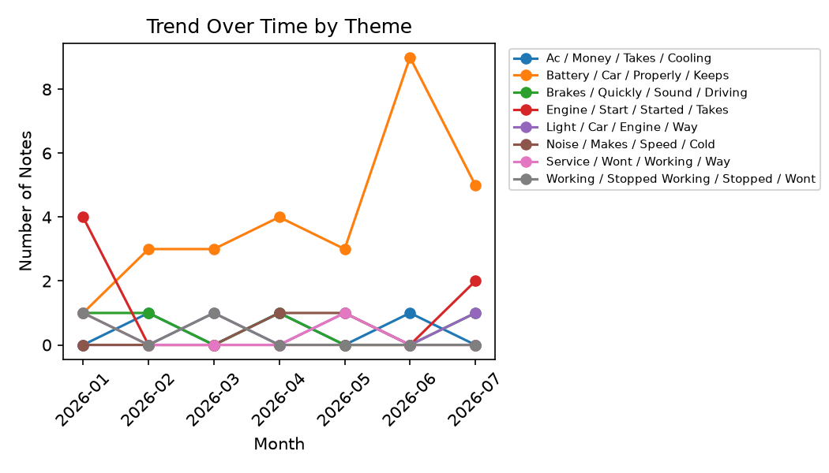

Failure Counts by Product Model
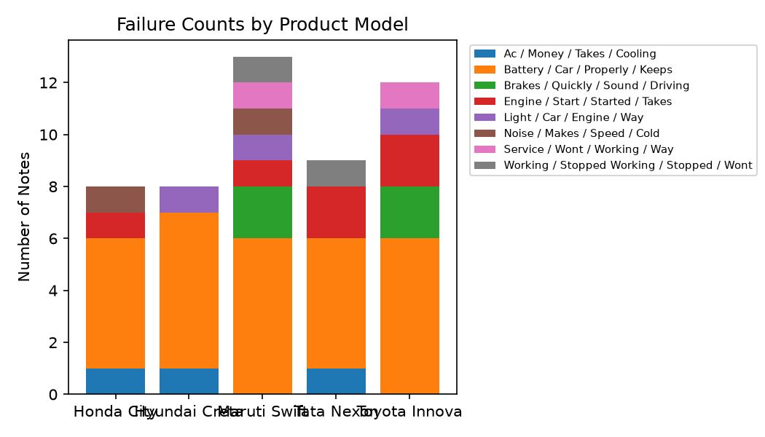

Actionable Insights Summary

Battery / Car / Properly / Keeps — 28 notes (56.0% of total)
Most affected model: Maruti Swift
Most common serial range: Unknown
Example notes:
- Great car for city driving, easy to park and maneuver.
- Boot lid doesnt close properly, has to be slammed shut.
- Navigation app crashes constantly mid-route.

Engine / Start / Started / Takes — 6 notes (12.0% of total)
Most affected model: Toyota Innova
Most common serial range: Unknown
Example notes:
- Engine takes multiple attempts to start on cold mornings.
- Car doesn't start sometimes, engine just cranks and dies.
- White smoke coming from exhaust when engine is started.

Brakes / Quickly / Sound / Driving — 4 notes (8.0% of total)
Most affected model: Toyota Innova
Most common serial range: Unknown
Example notes:
- Brakes feel loose and delayed, not confident stopping quickly.
- Grinding sound from front brakes when slowing down.
- Brakes suddenly stopped responding while driving. Extremely dangerous!!

Ac / Money / Takes / Cooling — 3 notes (6.0% of total)
Most affected model: Honda City
Most common serial range: Unknown
Example notes:
- AC leaks water inside the cabin on the passenger side.
- Ac is not cold at all in summer, waste of money.
- Cooling takes forever even on max AC setting.

Light / Car / Engine / Way — 3 notes (6.0% of total)
Most affected model: Toyota Innova
Most common serial range: Unknown
Example notes:
- Door handle broke off after light use, cheap plastic.
- Engine light came on and car went into limp mode on the highway.
- ABS light stays on and braking feels spongy.

Service / Wont / Working / Way — 2 notes (4.0% of total)
Most affected model: Maruti Swift
Most common serial range: Unknown
Example notes:
- Excellent service from the dealership, very happy with the purchase.
- Very satisfied with after-sales support and service.

Noise / Makes / Speed / Cold — 2 notes (4.0% of total)
Most affected model: Honda City
Most common serial range: Unknown
Example notes:
- A/C blower makes a loud whining noise on high speed.
- Engine makes a strange rattling noise on cold start.

Working / Stopped Working / Stopped / Wont — 2 notes (4.0% of total)
Most affected model: Maruti Swift
Most common serial range: Unknown
Example notes:
- AC compressor stopped working completely, no cold air at all.
- Window regulator stopped working, glass wont go up.

MVP scope only — production hardening (robust PII detection, human-in-the-loop labeling, live data ingestion) not included.

