**Fun-times review document**

1. Formula to calculate non-promotion product price is as follows

**Product Price * Product Quantity**

**Code snippet:**

p.getPrice() * content.get(p)

1. Formula for **X%** promotion on a product calculation is as follows

**(Product Price * Product Quantity) - (promotion % price * Product Quantity)**

**Code snippet:**

((p.getPrice() * content.get(p) ) - (pr.getPrice() * content.get(p) ));

1. Formula to buy N amount of product A and get half price of discount on product B

* Find out the discounted product ID by checking this if condition, p1.getId() == pr.getDiscountId(), once we have the ID
* Find out the quantity for that product
* qty / pr.getEligibleCount() this division result determines, number of product line items to apply discount on product B.
* Check product B quantity less than or equal to division result (content.get(p) <= result)
* Get the total price of the product B (content.get(p) * (pr.getPrice() * p.getPrice()))
* Else quantity of product B is greater than result, calculating as follows

totalPrice = result * (pr.getPrice() * p.getPrice());

totalPrice = totalPrice +(content.get(p) - result) * p.getPrice();

1. For calculating promotion start and end date validity, written a utility program, that takes offset value form the 4 test cases

DateUtils.getToday(0) to get today’s date

DateUtils.getToday(5) bought in 5 days’ time

1. All the below Junit test case conditions are passed, and the results are shown in below screenshot.

**test1:-**

Price a basket containing: 3 tins of soup and 2 loaves of bread, bought today,

Expected total cost = 3.15;

**test2: -**

Price a basket containing: 6 apples and a bottle of milk, bought today,

Expected total cost = 1.90;

**test3:-**

Price a basket containing: 6 apples and a bottle of milk, bought in 5 days’ time,

Expected total cost = 1.84;

**test4: -**

Price a basket containing: 3 apples, 2 tins of soup and a loaf of bread, bought in 5 days’ time,

Expected total cost = 1.97.

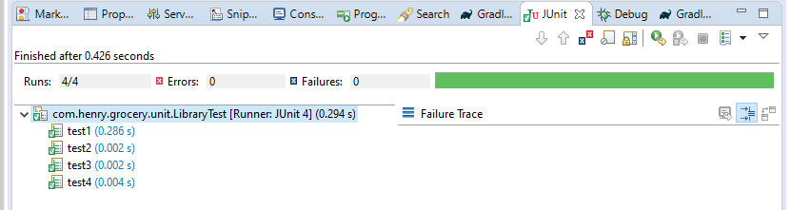

1. Maintained product data and promotion data in .csv file and loaded execution of main program runs.

Product Data:

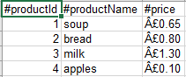

Promotion data:

