Loan Approval Prediction based on Machine Learning Approach

Name
Ravi Rawat
Registration
11918684
number section
KM016

Introduction

A loan is the core business part of banks. The main portion the bank’s profit is directly come from the profit earned from the loans. Though bank approves loan after a regress process of verification and testimonial but still there's no surety whether the chosen hopeful is the right hopeful or not. This process takes fresh time while doing it manually. We can prophesy whether that particular hopeful is safe or not and the whole process of testimonial is automated by machine literacy style. Loan Prognostic is helpful for retainer of banks as well as for the hopeful also.
The main objective of the Project is to compare the Loan Prediction Models made implemented using various algorithms and choose the best one out of them that can shorten the loan approval time and decrease the risk associated with it. It is done by predicting if the loan can be given to that person based on various parameters like credit score, income, age, marital status, gender, etc. The prediction model not only helps the applicant but also helps the bank by minimizing the risk and reducing the number of defaulters. In the present scenario, a loan needs to be approved manually by a representative of the bank which means that person will be responsible for whether the person is eligible for the loan or not and calculating the risk associated with it. As it is done by a human it is a time-consuming process and is susceptible to errors. If the loan is not repaid, then it accounts as a loss to the bank and banks earn most of their profits by the interest paid to them. If the banks lose too much money, then it will result in a banking crisis. These banking crisis affects the economy of the country. So, it is very important that the loan should be approved with the least amount of error in risk calculation while taking up as the least time possible. So, a loan prediction model is required that can predict quickly whether the loan can be passed or not with the least amount of risk possible.

Literature Review

- The author, Vaidya, Ashlesha [1] uses logistic regression as a machine learning tool in paper and shows how predictive approaches can be used in real world loan approval problems. His paper uses a statistical model (Logistic Regression) to predict whether the loan should be approved or not for a set of records of an applicant. Logistic regression can even work with power terms and nonlinear effect. Some limitations of this model are that it requires independent variables for estimation and a large sample is required for parameter estimation.
- The research and work done by Arora, Nisha and Pankaj Deep Kaur [3] aimed at forecasting whether an applicant can be a loan defaulter or not. It uses Bolasso to select most relevant attributes based on their robustness and then applied to classification algorithms like Random Forest, SVM, Naive Bayes and KNearest Neighbours (KNN) to test how accurately they can predict the results. It is concluded that Bolasso enabled Random Forest algorithm (BS-RF) provides the best results in credit risk evaluation and gives better accuracy by using optimised feature selection methods.
- Martin Leo, Suneel Sharma and k. Maddulety's [1] extensive report has explored where Machine Learning is being used in the fields of credit risk, market risk, operational risk, and liquidity risk only to conclude that the research falls short of extensive research is required in the field.
- M. Bayraktar et al. proposed a method for credit risk analysis using machine learning. Boltzman machine was used to make the analysis for risk calculation of loan” [7]
- “V. C. T. Chan et al. proposed a credit approval system using web-services. For clients loan as approved by the system. The consumer provides extra relevant information with the credit application. This information’s are processed by Credit Approval System which finally give credit score to the applicant. The paper developed a web services based solution of this problem” [9]

Proposed Methodology

Preparing the tools

Data Collection and understanding

Exploratory Data Analysis

Data Preprocessing

Model Building

Evaluating Performance Metrics of Models

Preparing the tools
We're going to use pandas, matplotlib, Sklearn and NumPy for data analysis and manipulation.
Pandas:
Pandas is a Python package to work with structured and time series data. The data from various file formats such as csv, json, sql etc can be imported using Pandas. It is a powerful open-source tool used for data analysis and data manipulation operations such as data cleaning, merging, selecting wrangling as well.
Seaborn:
Seaborn is a python library for building graphs to visualize data. It provides integration with pandas. This open-source tool helps in defining the data by mapping the data on the informative and interactive plots. Each element of the plots gives meaningful information about the data.
NumPy:
n NumPy, the basic type is a multidimensional array. Array assignments in NumPy are usually stored a nd array with the minimum type required to hold the objects in sequence, unless you specify the number of dimensions and type.
Matplotlib:
Matplotlib is a comprehensive library for creating static, animated, and interactive visualizations in Python. Matplotlib makes easy things easy and hard things possible.
Sklearn:
This python library is helpful for building machine learning and statistical models such as clustering, classification, regression etc. Though it can be used for reading, manipulating and summarizing the data as well, better libraries are there to perform these functions.

Data Collection and understanding

The machine learning model is trained using the training data set. Every new applicant detail filled at the time of application form acts as a test data set. Based on the training data sets, the model will predict whether a loan would be approved or not. We have 13 features in total out of which we have 12 independent variables and 1 dependent variable i.e. Loan Status in train dataset and 12 independent variables in test dataset. The Loan_ID, Gender, Married, Dependents, Education, Self_Employed, Property_Area, Loan_Status are all categorical

Loan_id | Uniques values
Gender | Male or female
Married | True or False
Dependents | Number of dependents
Education | Graduate/Under Graduate
Self_Employed | Self-employed (y/n)
Applicant Income | Applicant income
CoapplicantIncome | Coapplicant income
LoanAmount | Loan amount
Loan_Amount_term | Term of loan in months
Credit_History | Credit history meets guidelines
property_Area | Urban/Semi Urban/Rural
Loan_status | (Target) Loan approved (y/n)

Exploratory Data Analysis
The goal here is to find out more about the data and become a subject matter expert on the dataset we working with.
- What questions are you trying to solve ?
- What kind of data do we have and how do we treat different types?
- What's missing from the data and how do you deal with it?
- How can you add, change or remove features to get more out of your data?
First look at the data set:
Categorical Columns:
Gender (Male/Female), Married (Yes/No), Number of dependents (Possible values:0,1,2,3+), Education (Graduate / Not Graduate), Self-Employed (No/Yes), credit history (Yes/No), Property Area (Rural/Semi-Urban/Urban) and Loan Status (Y/N),(i. e. Target variable).
Numerical Columns:
Loan ID, Applicant Income, Co-applicant Income, Loan Amount, and Loan amount term.

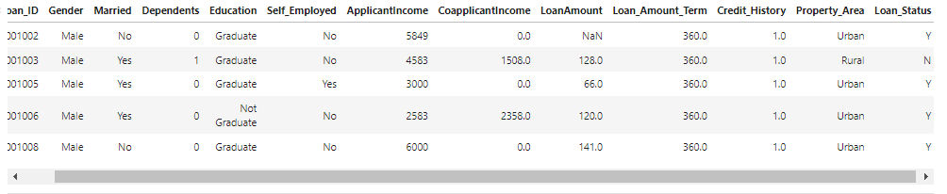

Target Variable – Loan Status:
We will start first with an independent variable which is our target variable as well. We will analyze this categorical variable using a bar chart as shown below. The bar chart shows that loan of 422 (around 69 %) people out of 614 was approved.

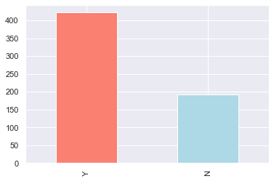

Loan_status according to Gender:
The bar chart shows that loan approved (Female 75 , Male 339 ) and loan not approved ( Female 37 , Male 150 ).
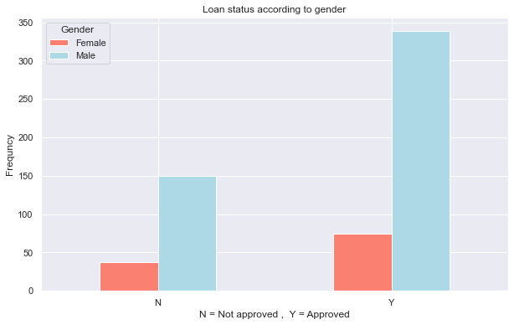

Loan Status according to marital status:
The bar chart shows that loan approved (Married 285, Not Married 134 ) and loan not approved (Married 113 , Not Married 79 )
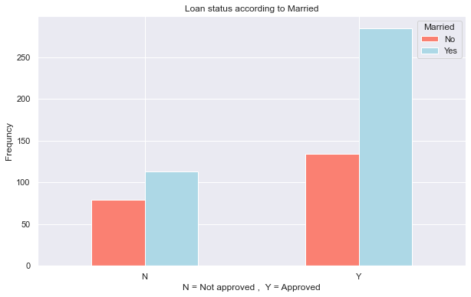

Loan Status according to Dependents:
The bar chart shows that loan approved (0 - 238, 1 – 66, 2 – 76 , 3+ -- 33) and loan not approved (0 - 107 , 1 – 36 , 2 – 25 , 3+ - 18)
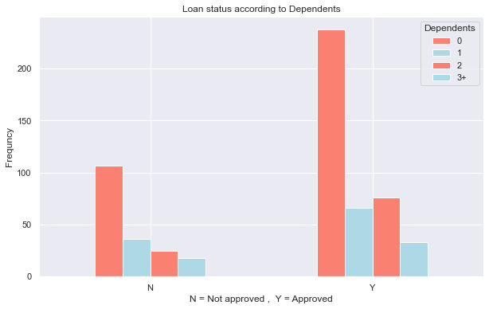
Loan Status according to Education:
The bar chart shows that loan approved (Graduate – 340 , Not Graduate – 82 ) and loan not approved (Graduate – 340 , Not Graduate – 82 ).

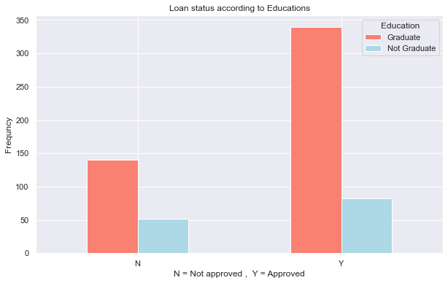

Loan Status according to Self-employed or not:
The bar chart shows that loan approved (Self-employed – 56 , Not Self-employed – 343 ) and loan not approved (Self-employed – 26 , Not Self-employed – 157 )
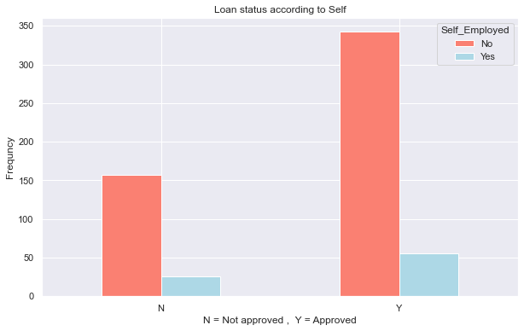
Loan Status according to Credit_History:
The bar chart shows that loan approved (0.0 – 7 , 1.0 - 378 ) and loan not approved ( 0.0 – 82 , 1.0 - 97).
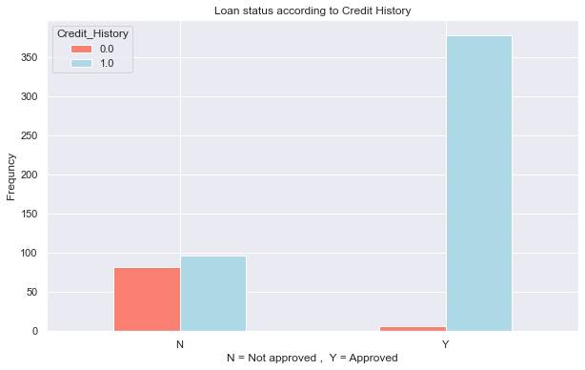

Applicant income:
In this box plot we seen that there is lot of outliers. Which we managed in data preprocessing process.
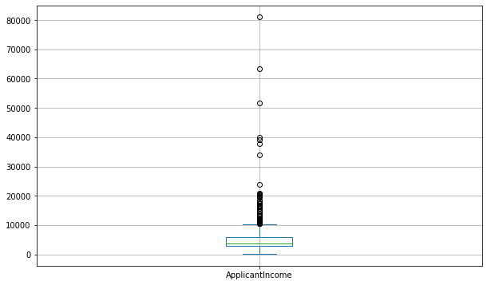
Applicant income and coapplicant income:
In this histogram plot we seen that both Applicant Income and Coapplicant income is right skewed
So, we normalized them in data preprocessing process.
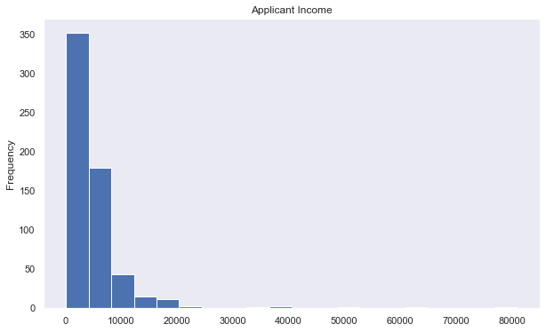
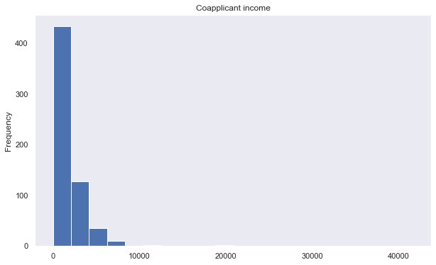

Visualizing correlation via heatmap:

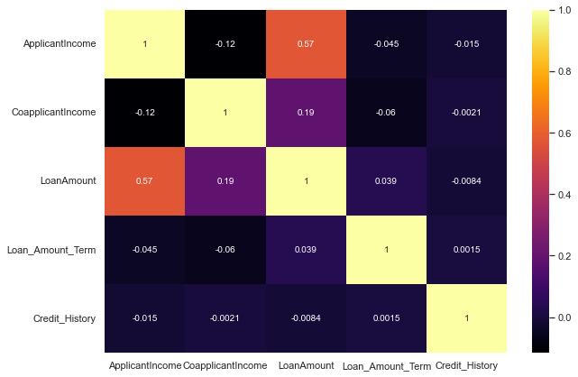

Data Preprocessing
Data Preprocessing
Unnecessary variables will be dropped in this section. Like loan id
Data imputation
Imputation is a technique for substituting an estimated value for missing values in a
dataset. In this section, the imputation will be performed for variables that have missing
values.
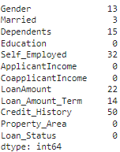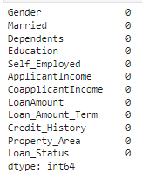
Before After
One- hot encoding
I will transform categorical variables into a form that could be provided by ML
algorithms to do a better prediction.

Skewed Distribution Treatment
In previous section, it already shown that distribution for applicant Income, CoapplicantIncome, and LoanAmount is positively skewed.
I will use square root transformation to normalized the distribution.
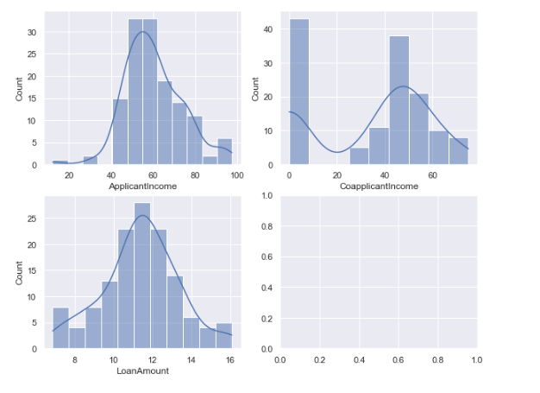
As can be seen, the distribution after using log transformation is much better compared to
Original distribution.
Data Normalization
In this section, data normalization will be performed to normalize the range of independent
Variables or features of data. using MinMaxScaler.
Splitting the data
The data set will be split into 80% train and 20% test.

Models
Logistic Regression
This is a classification algorithm which uses a logistic function to predict binary outcome (True/False, 0/1, Yes/No) given an independent variable. The aim of this model is to find a relationship between features and probability of particular outcome. The logistic function used is a logit function which is a log of odds in the favor of the event. Logit function develops a s-shaped curve with the probability estimate similar to a step function.
Random Forest Classifier
This is a tree-based ensemble model which helps in improving the accuracy of the model . It combines many Decision trees to build a powerful predicting model. It takes a random sample of rows and features of each individual tree to prepare a decision tree model. Final prediction class is either the mode of all the predictors or the mean of all the predictors
SVC:
The goal of the SVM algorithm is to create the best line or decision boundary that can segregate n-dimensional space into classes so that we can easily put the new data point in the correct category in the future. This best decision boundary is called a hyperplane
Gradient Boosting Classifier
GBC are a group of machine learning algorithms that combine many weak learning models together to create a strong predictive model. Decision trees are usually used when doing gradient boosting

Testing models
Putted model into dictionary, Create a function to fit and score models .

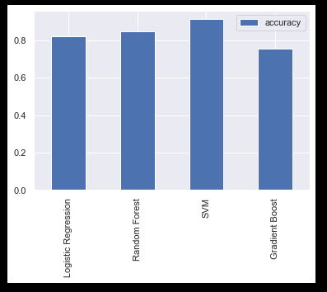

Logistic Regression give accuracy – 0.82
Random Forest give accuracy – 0.84
SVM give accuracy – 0.91
Gradient Boost give accuracy – 0.75

Improving a model

First predictions = baseline predictions.
First model = baseline model.

From a data perspective:
* Could we collect more data? (Generally, the more data, the better)
* Could we improve our data?
From a model perspective:
* Is there a better model we could use?
* Could we improve the current model?

Hyperparameters vs. Parameters
* Parameters = model find these patterns in data
* Hyperparameters = settings on a model you can adjust to (potentially) improve its ability to find patterns

After Tunning using GridSearchCV or by hand comparing model
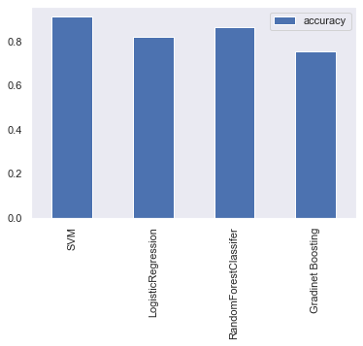
Evaluating performance metrics of models

- Accuracy is a good measure to start with if all classes are balanced (e.g., same amount of samples which are labelled with 0 or 1).
- Precision and recall become more important when classes are imbalanced.
- If false positive predictions are worse than false negatives, aim for higher precision.
- If false negative predictions are worse than false positives, aim for higher recall.
- F1-score is a combination of precision and recall.

Evaluation metric of SVC
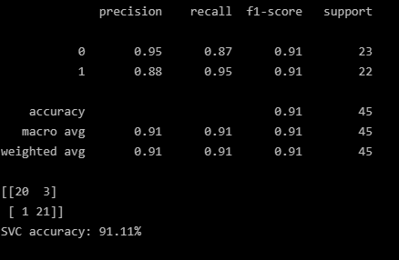
Evaluation metric of LogesticRegression
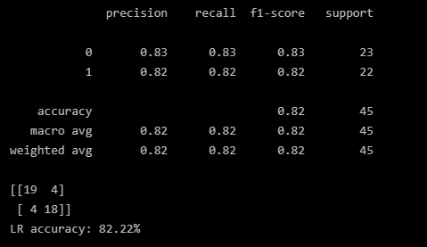
Evaluation metric of GradientBoostingClassifier
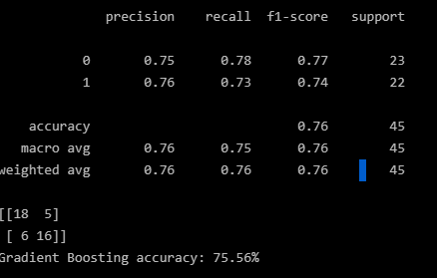

Conclusion:
We did Exploratory data Analysis on the features of this dataset and saw how each feature is distributed.
We analyzed each variable to check if data is cleaned and normally distributed.
We cleaned the data and removed NA values
We also generated hypothesis to prove an association among the independent variables and the Target variable. And based on the results, we assumed whether there is an association.
We calculated correlation between independent variables and found that applicant income and loan amount have significant relation.
We created dummy variables for constructing the model
We tested the data and got the accuracy of 91 % with SV

https://github.com/ravirawat0-cyber/Loan-Approval-Predicition.git

References

- https://deepnote.com/@rhishab-mukherjee/Loan-Prediction-Project-TermPaper-VPSOpiywSu6FZeN2fK8fug
- https://www.sciencedirect.com/science/article/pii/S1877050919320277
- https://medium.com/@rahulshuklawork/prediction-of-loan-approval-with-machine-learning-539cbd2aad31
- https://www.ijert.org/predict-loan-approval-in-banking-system-machine-learning-approach-for-cooperative-banks-loan-approval
- https://iopscience.iop.org/article/10.1088/1757-899X/1022/1/012042/pdf

