RESUME

Name :- PRAJAPATI GAURANGKUMAR LALJI BHAI
 | 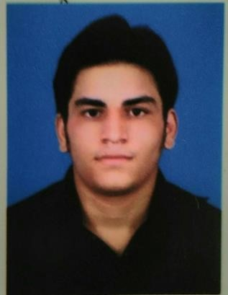
  Permanent Address:  Prajapati Street Near mahadev dhobikui Borsad  Pincode:388560  Gujarat | Email:  Gaurangprajapati71@gmail.com  rp.103.rp@gmail.com  Contact No:  Mobile: +917698103133

Career Objective
I want to do my integrated growth by combining my moral and technical Knowledge with enthusiasm and continuous educate myself by educating others.

Educational Qualification

Degree &  Passing  Year | School/College | Board/Universit y | Percent | CGPIA
10th | Kendriya vidyalaya v.v. nagar | C.B.S.E | 55
12th | C.E.M.S Anand | G.S.E.B | 50
B.E IN INFORMATION TECHNOLOGY | Sardar Patel college of engineering bakrol | GTU | Spi- 9.00 | 7.37

Computer Proficiency
Languages: C, C++, Basic Knowledge of PHP, Prolog Programming Language
Operating System: Windows XP/VISTA/7/8,10, LINUX
Database: MS ACCESS,MY SQL,Oracle
Office Automation: MS Office
Tools: Matlab, Net Beans, MS Visual Studio, PHP

Area of Interest
- Cloud Computing
- Advanced Internet Technology
- Semantic Web
- Computer Network
- VFX effect

Project Work
[1] Title: online complain box
B.E(I.T)
I had successfully make complain box through which one can easily make online complain in the web site which is made in PHP
[2] Title: robot controlling car using network. B.E. (I.T)
We had build car using Arduino board and Bluetooth device to make it moveable any Where
Experience
fresher

Personal Profile
Full Name: PRAJAPATI GAURANGKUMAR LALJI BHAI
Date of Birth:01-March -1995
Languages Known: English, Hindi and Gujarati
Nationality: Indian
Gender: Male
Marital Status: Unmarried
Hobbies: Teaching, Reading, Gym, Singing and Listening Song, Photography, Cricket
Strengths:
- Ability to Work in Team
- An enthusiastic individual with positive attitude
- Good listener and Observer

Declaration
I hereby declare that all the statements made above are true, complete and authentic to the best of my knowledge and belief.
 Your faithfully
Gaurang Prajapati

