* Show order se aap set kar sakte hai

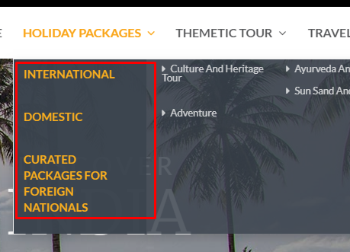

* Added Features for SEO

<https://phoenixdepo.com/lemontree1/admin/index.php/holiday_package_menu/package/add/>

* Name remove kar diya hai

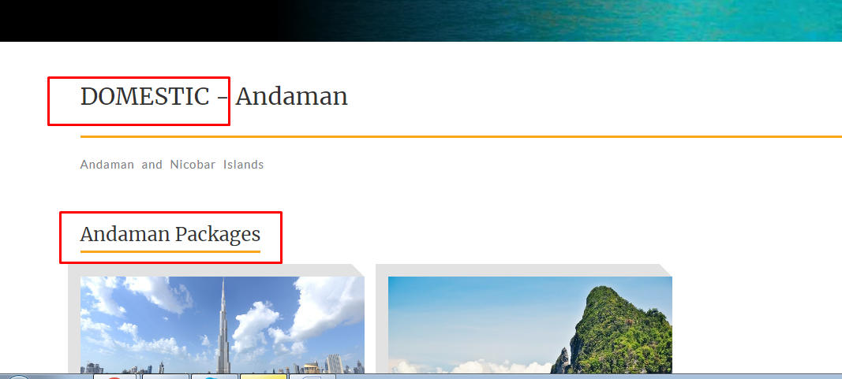

* Image dynamic ho gai hai

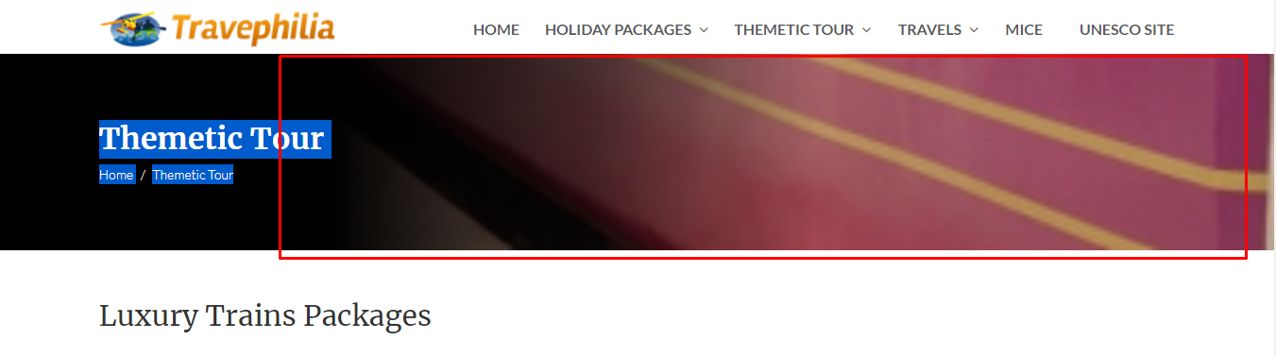

* Design.. 3 REPLACE TO 4

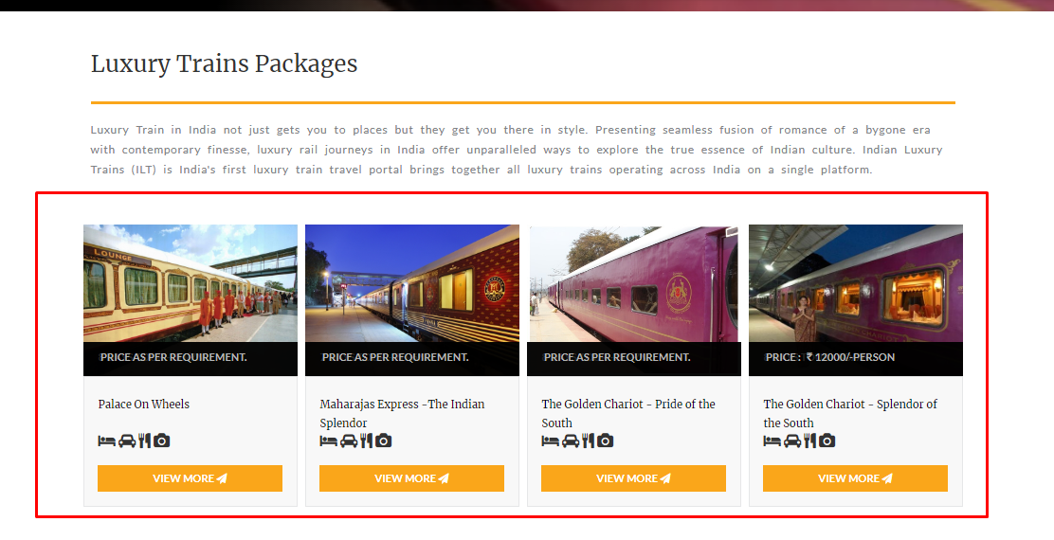

* Check below page for Design and sidebar and “inquiry” form

<https://phoenixdepo.com/lemontree1/index.php/page/themetic_tour_detail/7/7>

* Fonts same like yatra.com