Phoenix Site

* <https://phoenixbinarysystem.com/portfolio>

Portfolio na page ma haju add karvana che like  
Web nu hoy to website, Mobile nu hoy to Mob ma (je rite OLD site ma hatu te rite)

<https://phoenixbinarysystem.com/portfolio>

Badha ma link aapvani baki che

* Career na page ma “Form” Rakhvanu che jemathi badha CV upload kare ane Email ma aapne mali jai

<https://phoenixbinarysystem.com/career>

* Homepage ma niche no part seno che?

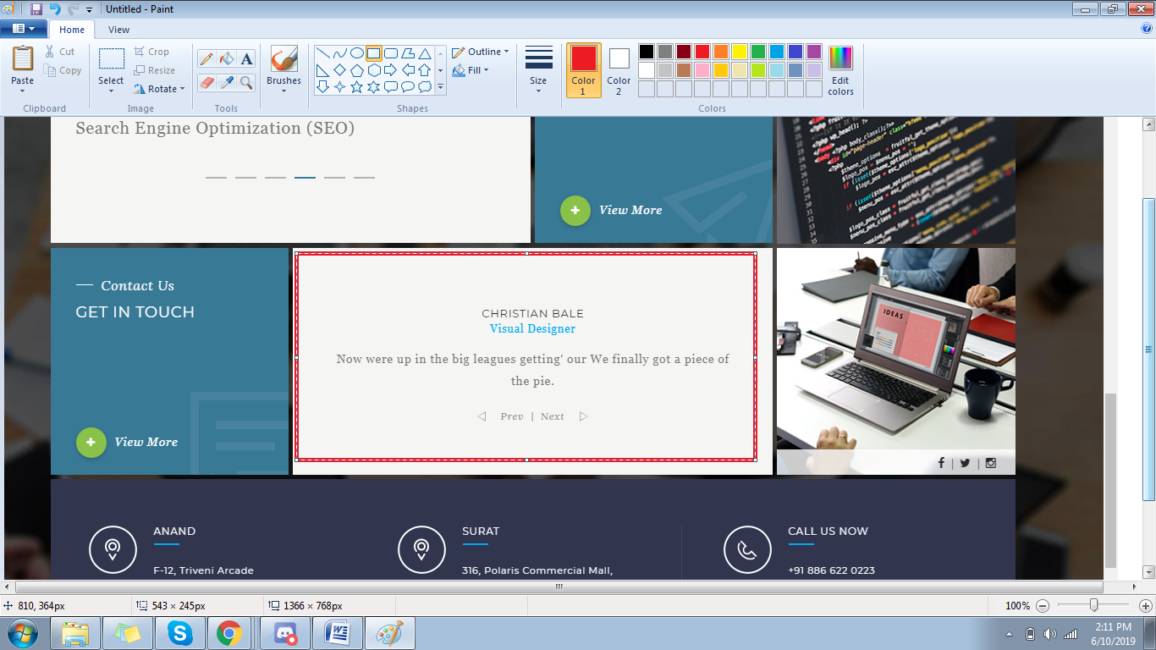

* About us na page ma niche no part seno che?

<https://phoenixbinarysystem.com/about>

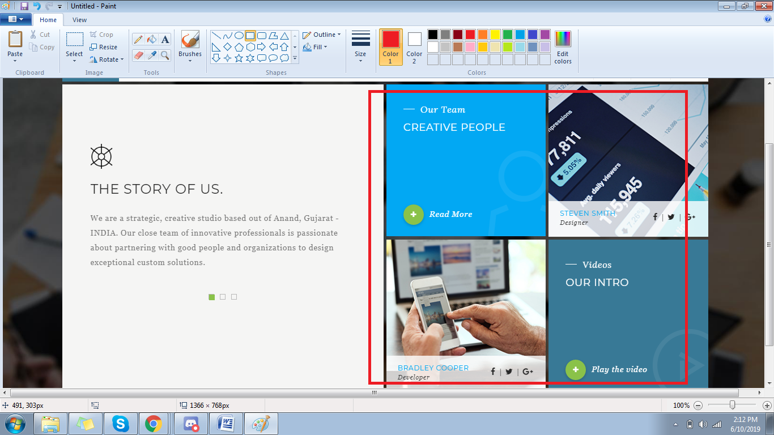

* OLD site ma je pan content hatu te rite aapne aapma karvanu che

Ghanu badhu missing che