* Niche na page mathi remove karvanu che

<https://phoenixbinarysystem.com/services>

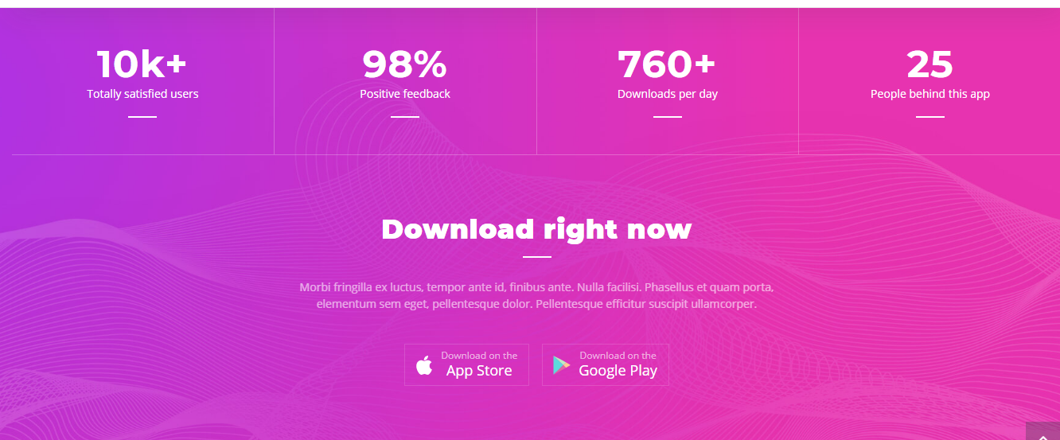

* Niche ni image ma “Website Design and Development” Titel aapvu and baju ma Teni ek image Sagarbhai jodethi lai ne rakhvi

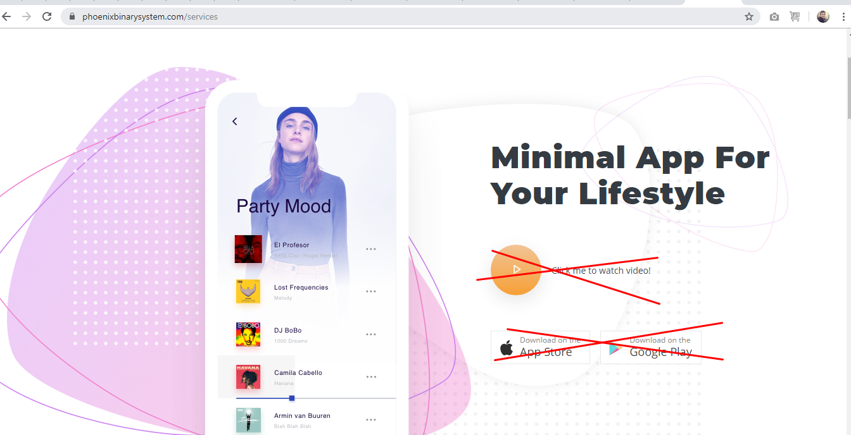

* Niche ni Space ma “Mobile App Development” Title rakhvu and mobile apps ni images niche che teni jaggaye rakhvi, sagarbhai ne keje

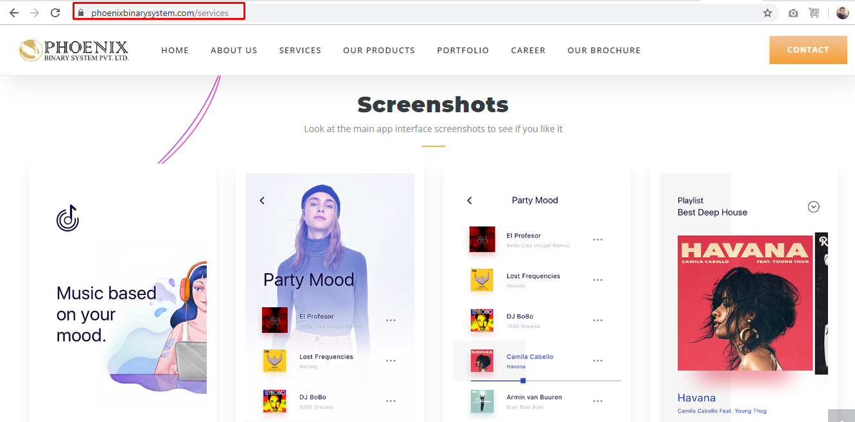

* Niche na space ma “Search Engine Optimization” Title rakhvu and Content rakhvu and Sagarbhai ne keje ek SEO ni image tya rakhva mate aape

**“Phoenix Binary System has always been customer centric, hence we have designed an SEO Project Time Line, which will help both the client and the company to be on the same page, as far as the achieving the results is concerned.”**

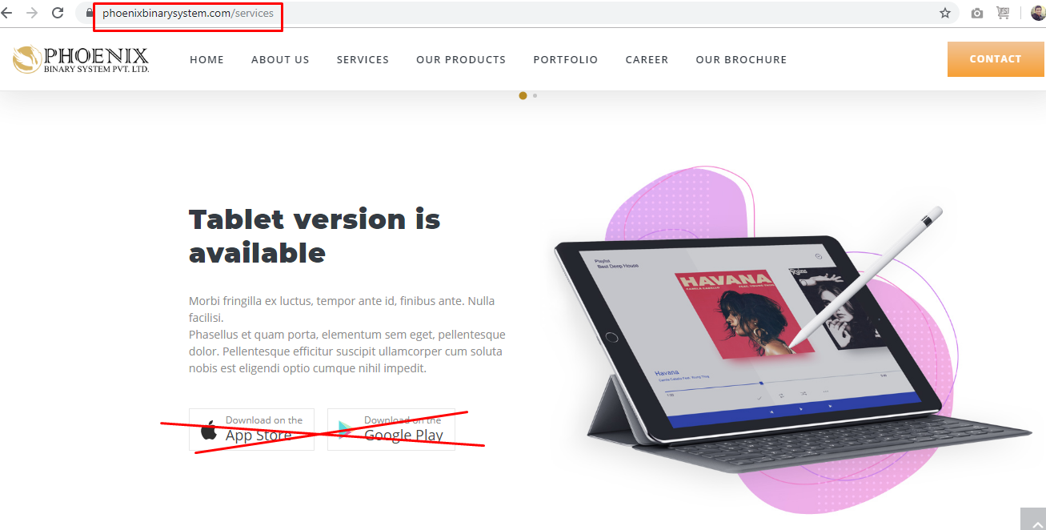

* Niche nu che tene Name change karvu > “ Graphics Design Services”

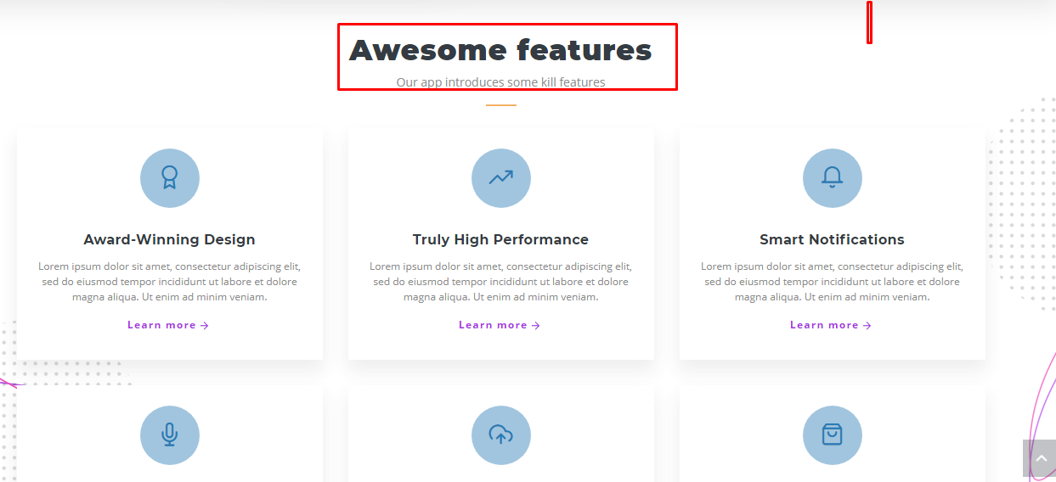

**Teni niche je box aapela che tema niche na Name aapva, under nu content rakhi deje and “Learn more” nu button remove kari deje**

1. Branding

Phoenix binary System is reputed branding service provider, India providing custom corporate branding services at affordable rates. Branding tools include corporate logo, business card , letter pad, envelope design as part of branding services.

1. UI / UX Design

Creative, attractive, engaging and usable interfaces are the soul of any designs. Technically perfect UI/UX Designs for your websites and apps give users a pleasurable experience. An overall great user experience has a great recall value.

1. Logo design

Phoenix Binary System, India designs and provides professional Logo Design services to our esteemed clients. We offer a fast and simple logo design solution with customized color, shape and fonts.

1. Brochure Design

Phoenix Binary System, India is the best creative designing agency providing attractive and eye catching brochure designing services across the globe. Our designers understand the need of your business and then design fully informative, attractive brochure design to meet client requirements.

1. Print Design

We provides complete range of graphic and print design services that are both creative and eye-catching. We print all that is printable including business card, brochure, banner, fliers and other print collateral that is necessary in promoting your company’s products or services

1. Letterheads

Phoenix Binary System, India is business stationery design Specialist Company offering offer a wide gamut of stationery design and printing services at highly affordable rates. Our designer are well versed with the technology and they use the latest graphic design software.

1. Packing design

Phoenix Binary System, India offers packaging solutions that help you revive, re-imagine and create a strong position of your products and services in the market. Creating an eye-catching packaging design that can be reproduced for years is a real challenge.

1. Stationary Design

We designs innovative and eye catching stationery that uphold your brand value and communicate good brand ethics. Stationary design includes business card design, letterhead design, envelope design that gives an idea of who you are and what business you are involved with.

1. Business Card

We at Phoenix Binary System, India are leading name in providing business cards design and printing services as per customer’s business requirements.

1. Enevelop

Phoenix Binary System offer designing and printing services with excellent designs and affordable price. Out team of designers will design the best and creative envelopes for your business plans.

* Niche na page ma Web developer ni img rakhvi, img sagarbhai pasethi levi and content mayur pasethi levu

<https://phoenixbinarysystem.com/services/website_development>

Color combination site no jevo che tem karvu

* Niche na page ma App ne lagti badhi images rakhvi. Sagarbhai pasethi levi

<https://phoenixbinarysystem.com/services/mobile_app_development>

* Niche na page ma images SEO ne lagti levi

<https://phoenixbinarysystem.com/services/mobile_app_development>

* About us na page mathi aa logo ne delete karvo and bijo rakhvo

Bijo logo sagarbhai pasethi levo

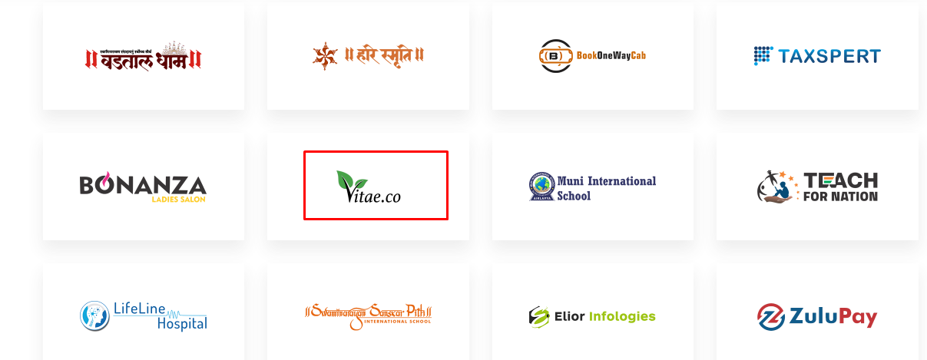

* Niche na koi pan par click kare to redirect niche ni URL ma thay tem karvu

<https://phoenixbinarysystem.com/services>

