Pnx site changes

* Sagarbhai ne puchi ne Color combination nu karvu
* Slide mukvanu che

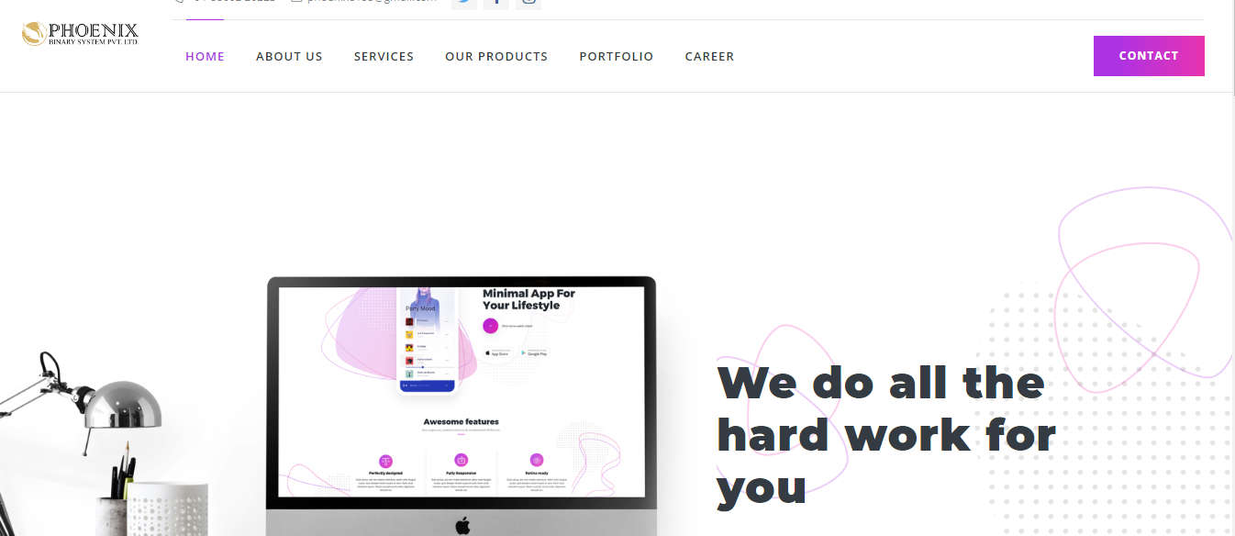

* Homepage mathi button comment ma rakhvu



* Footer ma usefuls links rakhvi
* Product Development
* Website development
* Mobile App development
* SEO
* Mobility services
* CA products
* Schooling system portal
* Portfolio
* Job seeker
* Training program
* Behance <https://www.behance.net/phoenixbinarysystem>
* IOS link

<https://itunes.apple.com/us/developer/phoenix-binary-system-private-limited/id990939824?mt=8>

* Android link

<https://play.google.com/store/apps/developer?id=Phoenix+Binary+System+Pvt.+Ltd.>

* Contact na badle “Statrt up” lakhvu



* About us na page ma “Mission” “vision” thodu company information lakhvanu che

<http://phoenixbinarysystem.com/pnx/index.php/about_us>

Sagarbhai pasethi content lai leje

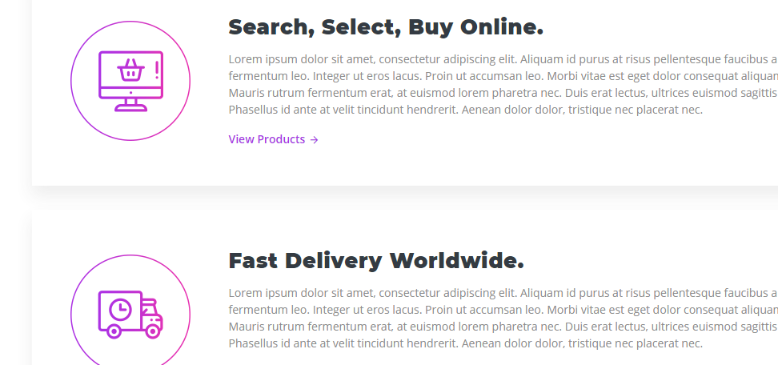

* Niche ma change karvu

Web Development : 99

Mobile app development: 95

UX/UI Design : 99

SEO : 88

Start up: 95%

Blockchain: 90

IT Training: 100%

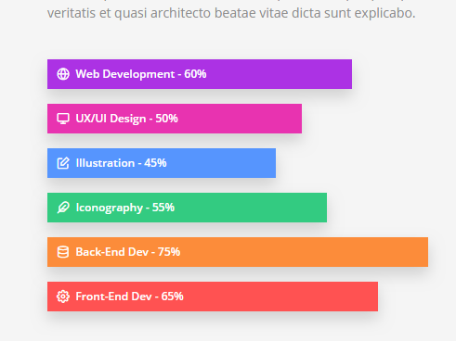

* “Our client” lakhvu and badha clients na Logo Sagarbhai pasethi lai ne static rakhva



* Niche na name rakhva.. under ni details pachi aapish

<http://phoenixbinarysystem.com/pnx/index.php/portfolio>

Web

Mobile App

Logo design

SEO



* Niche na page ma a rakhvu

<http://phoenixbinarysystem.com/pnx/index.php/jobseeker>

SELECT TECHNOLOGIES

* PHP Developer
* Web design
* Codeigniter Developer
* Laravel developer
* Wordpress developer
* SEO
* Android developer
* IOS developer
* Full stack developer
* Joomla developer
* Magento Developer
* Blockchain Developer
* business development executive

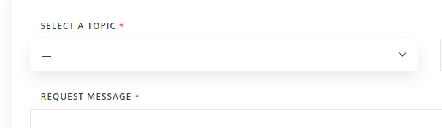

* Niche nu remove karvu



* Niche na mathi aatlu remove karvu

<http://phoenixbinarysystem.com/pnx/index.php/training_program>





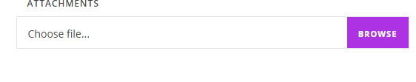

* “Training Program” rakhvu



* Niche na page ma Sagarbhai ne keje k Web admin, website, apps na screenshot proper rakhi de

<http://phoenixbinarysystem.com/pnx/index.php/schooling_services>

Brochure rakhvu

* Niche na page website and Admin panel na screenshor rakhvani che

<http://phoenixbinarysystem.com/pnx/index.php/mobility_services>

Brochure rakhvu

* Main menu ma “Our brochure” name rakhi ne aapnu brochure thathi download kari sake tem karvu

