Quick Corporation

09/01/2026

Task Completed:
- Created an account and used the app as a normal user.
- Explored the features of the app.
- Tested using different inputs

Problems Faced/Noticed:
- Getting an OPT took a long time so I clicked resend multiple times and 4 opts came together.
- Discount not shown in receipt
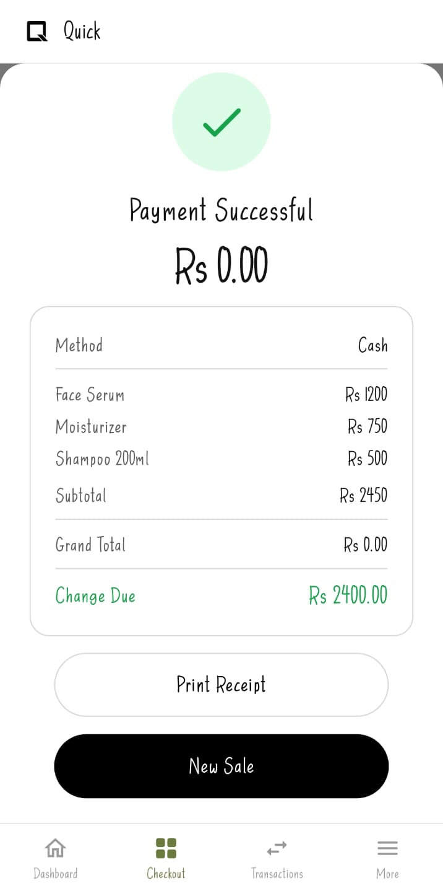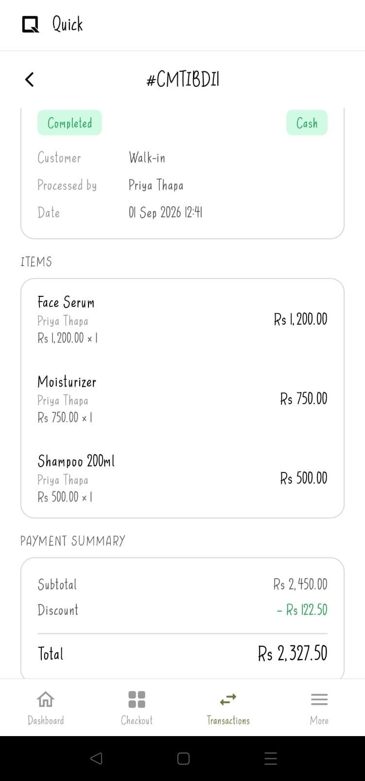

Here, I applied 5% discount so the discounted price became Rs.2327.50 but the receipt is not showing that. As shown in the first picture only the amount before applying the discount is there. When I go to transactions and click that transaction the discount is shown there but since it is not shown when printing the receipt it can be confusing to customers
- Invalid numbers are also being saved
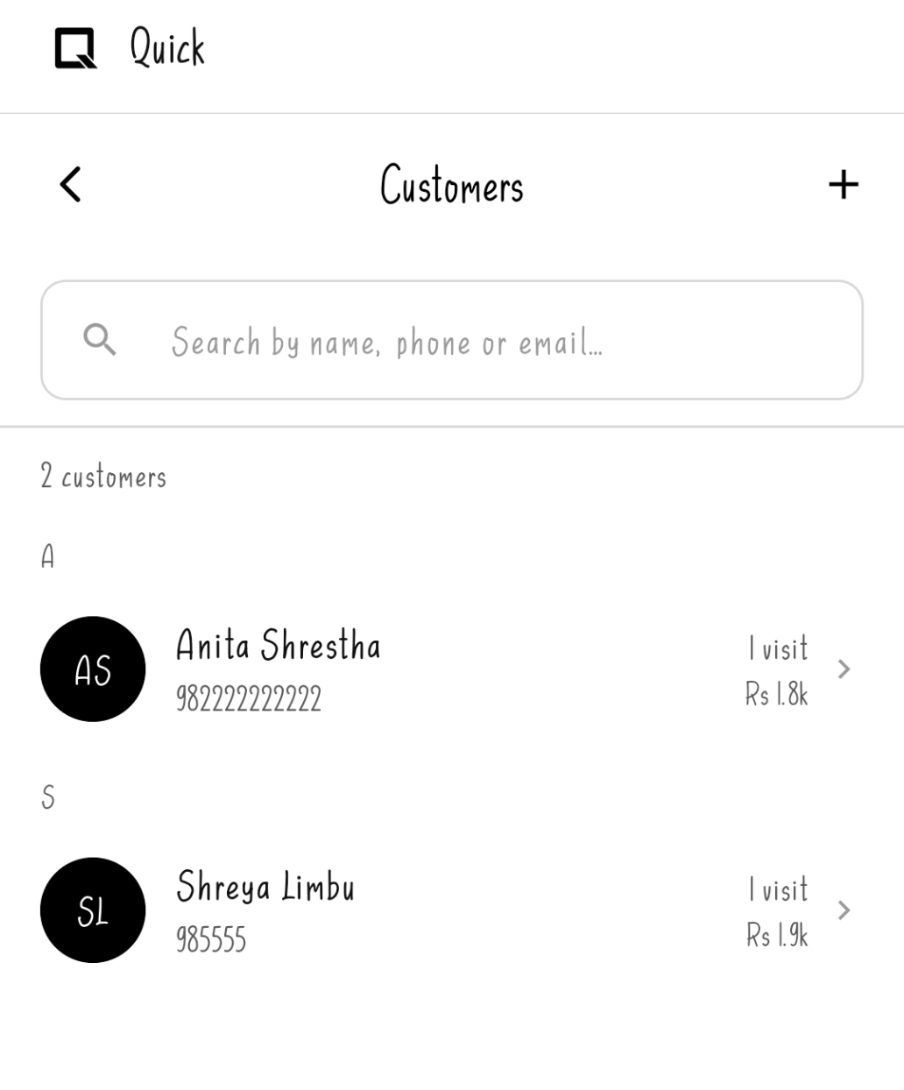
The system allows even invalid phone numbers such as 6-digit or 12–13-digit numbers to be saved.
- The app logs the user out when the mobile device’s back button is pressed instead of the in-app back arrow.

