ER Diagram.

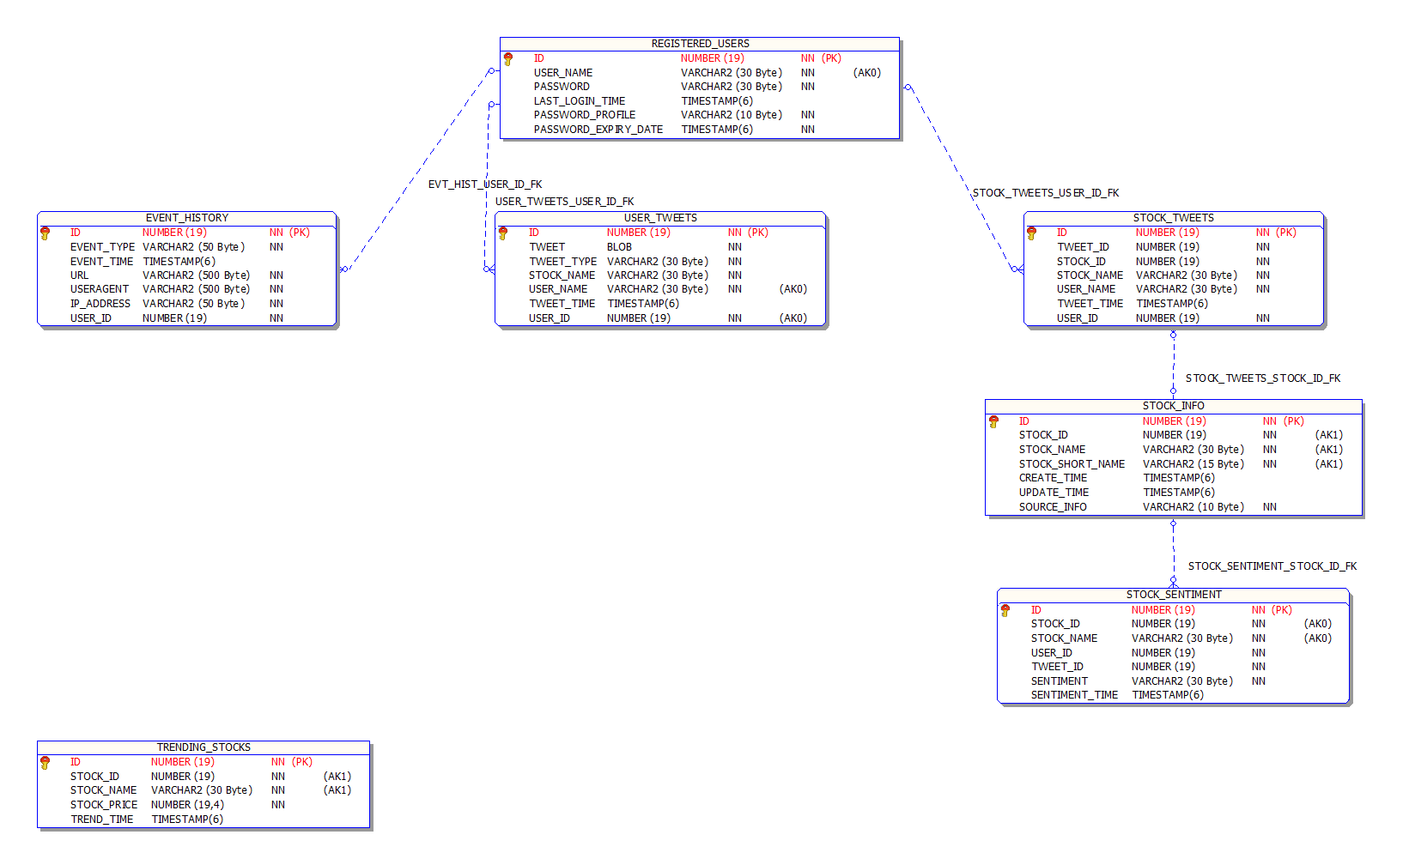

Scripts.

CREATE TABLE tsocial.registered_users

(

ID NUMBER (19) NOT NULL,

USER_NAME VARCHAR2 (30) NOT NULL,

PASSWORD VARCHAR2 (30) NOT NULL,

LAST_LOGIN_TIME TIMESTAMP (6) DEFAULT SYSTIMESTAMP,

PASSWORD_PROFILE VARCHAR2 (10) NOT NULL,

PASSWORD_EXPIRY_DATE TIMESTAMP (6) NOT NULL,

CONSTRAINT reg_users_pk PRIMARY KEY (ID),

CONSTRAINT reg_users_user_name_uk UNIQUE (USER_NAME)

);

COMMENT ON TABLE tsocial.registered_users IS

'Table holds the information of all users.';

COMMENT ON COLUMN tsocial.registered_users.id IS 'Primary Key of the table.';

COMMENT ON COLUMN tsocial.registered_users.user_name IS

'User name of the trading social account. It is a unique identifier.';

COMMENT ON COLUMN tsocial.registered_users.password IS

'Encrypted form of the password.';

COMMENT ON COLUMN tsocial.registered_users.last_login_time IS

'Timestamp of login with a precision of microseconds.';

COMMENT ON COLUMN tsocial.registered_users.password_profile IS

'Depending on the values here, a user''s password expiry is controlled. Eg. A value of ''FOREVER'' means a user''s password cannot expire.';

COMMENT ON COLUMN tsocial.registered_users.password_expiry_date IS

'Date of expiry of the password.';

-- USER_NAME needs a unique key, ID needs to be a PK.

CREATE SEQUENCE tsocial.registered_users_seq;

CREATE TABLE tsocial.event_history

(

ID NUMBER (19) NOT NULL,

EVENT_TYPE VARCHAR2 (50) NOT NULL,

EVENT_TIME TIMESTAMP (6) DEFAULT SYSTIMESTAMP,

URL VARCHAR2 (500) NOT NULL,

USERAGENT VARCHAR2 (500) NOT NULL,

IP_ADDRESS VARCHAR2 (50) NOT NULL,

USER_ID NUMBER (19) NOT NULL,

CONSTRAINT event_history_pk PRIMARY KEY (ID),

CONSTRAINT evt_hist_user_id_fk FOREIGN KEY

(user_id)

REFERENCES tsocial.registered_users (ID)

)

PARTITION BY RANGE (EVENT_TIME)

INTERVAL ( NUMTOYMINTERVAL (1, 'MONTH') )

(PARTITION P1

VALUES LESS THAN (TO_DATE ('2000-01-01', 'YYYY-MM-DD')));

COMMENT ON TABLE tsocial.event_history IS

'Table holds the history of event information of all users.';

COMMENT ON COLUMN tsocial.event_history.id IS 'Primary Key of the table.';

COMMENT ON COLUMN tsocial.event_history.event_time IS 'Timestamp of event.';

COMMENT ON COLUMN tsocial.event_history.url IS '';

COMMENT ON COLUMN tsocial.event_history.useragent IS

'Captures the useragent from which end user login is attempted.';

COMMENT ON COLUMN tsocial.event_history.user_id IS

'User identifier. Foreign Key to tsocial.registered_users.id.';

CREATE SEQUENCE tsocial.event_history_seq;

CREATE TABLE tsocial.user_tweets

(

ID NUMBER (19) NOT NULL,

TWEET BLOB NOT NULL,

TWEET_TYPE VARCHAR2 (30) NOT NULL,

STOCK_NAME VARCHAR2 (30) NOT NULL,

USER_NAME VARCHAR2 (30) NOT NULL,

TWEET_TIME TIMESTAMP (6) DEFAULT SYSTIMESTAMP,

USER_ID NUMBER (19) NOT NULL,

CONSTRAINT user_tweets_pk PRIMARY KEY (ID),

CONSTRAINT user_tweets_user_uk UNIQUE (USER_ID, USER_NAME),

CONSTRAINT user_tweets_user_id_fk FOREIGN KEY

(user_id)

REFERENCES tsocial.registered_users (ID)

)

PARTITION BY RANGE (TWEET_TIME)

INTERVAL ( NUMTOYMINTERVAL (1, 'MONTH') )

(PARTITION P1

VALUES LESS THAN (TO_DATE ('2000-01-01', 'YYYY-MM-DD')));

COMMENT ON TABLE tsocial.user_tweets IS

'Table to hold all the tweets of a user.';

COMMENT ON COLUMN tsocial.user_tweets.id IS 'Primary Key of the table.';

COMMENT ON COLUMN tsocial.user_tweets.tweet IS

'The content tweeted by the user.';

COMMENT ON COLUMN tsocial.user_tweets.tweet_type IS

'The type of tweet of the user.';

COMMENT ON COLUMN tsocial.user_tweets.stock_name IS

'The name of the stock tweeted by the user.';

COMMENT ON COLUMN tsocial.user_tweets.user_name IS

'User name of the tweeter. Same as tsocial.registered_users.user_name.';

COMMENT ON COLUMN tsocial.user_tweets.tweet_time IS 'Timestamp of the tweet.';

COMMENT ON COLUMN tsocial.user_tweets.user_id IS

'User identifier. Foreign Key to tsocial.registered_users.id.';

CREATE SEQUENCE tsocial.user_tweets_seq;

-- unique key on user_id and user_name

CREATE TABLE tsocial.stock_info

(

ID NUMBER (19) NOT NULL,

STOCK_ID NUMBER (19) NOT NULL,

STOCK_NAME VARCHAR2 (30) NOT NULL,

STOCK_SHORT_NAME VARCHAR2 (15) NOT NULL,

CREATE_TIME TIMESTAMP (6) DEFAULT SYSTIMESTAMP,

UPDATE_TIME TIMESTAMP (6),

SOURCE_INFO VARCHAR2 (10) NOT NULL,

CONSTRAINT stock_info_pk PRIMARY KEY (ID),

CONSTRAINT stock_info_uk UNIQUE (stock_id, stock_name, stock_short_name),

CONSTRAINT stock_info_ck CHECK (source_info IN ('USER', 'SYSTEM'))

);

COMMENT ON TABLE tsocial.stock_info IS

'Table to hold information about the publicly traded stocks in the market.';

COMMENT ON COLUMN tsocial.stock_info.id IS 'Primary Key of the table.';

COMMENT ON COLUMN tsocial.stock_info.stock_id IS

'The identifier of the stock.';

COMMENT ON COLUMN tsocial.stock_info.stock_name IS

'The name of the stock in the market.';

COMMENT ON COLUMN tsocial.stock_info.stock_short_name IS

'The short name of the stock in the market.';

COMMENT ON COLUMN tsocial.stock_info.create_time IS

'The timestamp of creation of a new stock entry.';

COMMENT ON COLUMN tsocial.stock_info.update_time IS

'The timestamp of the updation of a stock entry.';

COMMENT ON COLUMN tsocial.stock_info.source_info IS

'The source of the stock data, i.e, whether USER or SYSTEM generated.';

CREATE SEQUENCE tsocial.stock_info_seq;

-- unique constraint on stock_id, stock_name, stock_short_name

-- check constraint on source_info.

CREATE TABLE tsocial.stock_tweets

(

ID NUMBER (19),

TWEET_ID NUMBER (19) NOT NULL,

STOCK_ID NUMBER (19) NOT NULL,

STOCK_NAME VARCHAR2 (30) NOT NULL,

USER_NAME VARCHAR2 (30) NOT NULL,

TWEET_TIME TIMESTAMP (6) DEFAULT SYSTIMESTAMP,

USER_ID NUMBER (19) NOT NULL,

CONSTRAINT stock_tweets_pk PRIMARY KEY (ID),

CONSTRAINT stock_tweets_stock_id_fk FOREIGN KEY

(stock_id)

REFERENCES tsocial.stock_info (ID),

CONSTRAINT stock_tweets_user_id_fk FOREIGN KEY

(user_id)

REFERENCES tsocial.registered_users (ID)

)

PARTITION BY RANGE (TWEET_TIME)

INTERVAL ( NUMTOYMINTERVAL (1, 'MONTH') )

(PARTITION P1

VALUES LESS THAN (TO_DATE ('2000-01-01', 'YYYY-MM-DD')));

COMMENT ON TABLE tsocial.stock_tweets IS

'Table to hold all the tweets of a stock.';

COMMENT ON COLUMN tsocial.stock_tweets.id IS 'Primary Key of the table.';

COMMENT ON COLUMN tsocial.stock_tweets.tweet_id IS

'The identifier of the stock tweet.';

COMMENT ON COLUMN tsocial.stock_tweets.stock_id IS

'The identifier of the stock. Foreign key to tsocial.stock_info.id.';

COMMENT ON COLUMN tsocial.stock_tweets.stock_name IS 'The name of the stock.';

COMMENT ON COLUMN tsocial.stock_tweets.user_name IS

'User name of the tweeter.';

COMMENT ON COLUMN tsocial.stock_tweets.tweet_time IS

'Timestamp of the tweet.';

COMMENT ON COLUMN tsocial.stock_tweets.user_id IS

'User identifier. Foreign Key to tsocial.registered_users.id.';

CREATE TABLE tsocial.stock_sentiment

(

ID NUMBER (19) NOT NULL,

STOCK_ID NUMBER (19) NOT NULL,

STOCK_NAME VARCHAR2 (30) NOT NULL,

USER_ID NUMBER (19) NOT NULL,

TWEET_ID NUMBER (19) NOT NULL,

SENTIMENT VARCHAR2 (30) NOT NULL,

SENTIMENT_TIME TIMESTAMP (6) DEFAULT SYSTIMESTAMP,

CONSTRAINT stock_sentiment_pk PRIMARY KEY (ID),

CONSTRAINT stock_sentiment_stock_uk UNIQUE (stock_id, stock_name),

CONSTRAINT stock_sentiment_stock_id_fk FOREIGN KEY

(stock_id)

REFERENCES tsocial.stock_info (id),

CONSTRAINT stock_sentiment_ck CHECK

(sentiment IN ('BEARISH', 'BULLISH', 'NEUTRAL'))

)

PARTITION BY RANGE (SENTIMENT_TIME)

INTERVAL ( NUMTOYMINTERVAL (1, 'MONTH') )

(PARTITION P1

VALUES LESS THAN (TO_DATE ('2000-01-01', 'YYYY-MM-DD')));

COMMENT ON TABLE tsocial.stock_sentiment IS

'Table to hold the sentiments of a stock mapped to a user.';

COMMENT ON COLUMN tsocial.stock_sentiment.id IS 'Primary Key of the table.';

COMMENT ON COLUMN tsocial.stock_sentiment.stock_id IS

'The identifier of the stock.';

COMMENT ON COLUMN tsocial.stock_sentiment.stock_name IS

'The name of the stock on which the user expresses his sentiments.';

COMMENT ON COLUMN tsocial.stock_sentiment.user_id IS 'User identifier.';

COMMENT ON COLUMN tsocial.stock_sentiment.tweet_id IS 'Tweet identifier.';

COMMENT ON COLUMN tsocial.stock_sentiment.sentiment IS

'Sentiment of the stock, i.e, whether BEARISH, BULLISH or NEUTRAL.';

COMMENT ON COLUMN tsocial.stock_sentiment.sentiment_time IS

'Timestamp of the sentiment.';

CREATE SEQUENCE tsocial.stock_sentiment_seq;

-- check constraint on sentiment.

-- unique key on?

CREATE TABLE tsocial.trending_stocks

(

ID NUMBER (19) NOT NULL,

STOCK_ID NUMBER (19) NOT NULL,

STOCK_NAME VARCHAR2 (30) NOT NULL,

STOCK_PRICE NUMBER (19, 4) NOT NULL,

TREND_TIME TIMESTAMP (6) DEFAULT SYSTIMESTAMP,

CONSTRAINT trending_stocks_pk PRIMARY KEY (ID),

CONSTRAINT trending_stocks_stock_uk UNIQUE (STOCK_ID, STOCK_NAME)

)

PARTITION BY RANGE (TREND_TIME)

INTERVAL ( NUMTODSINTERVAL (1, 'DAY') )

(PARTITION P1

VALUES LESS THAN (TO_DATE ('2000-01-01', 'YYYY-MM-DD')));

COMMENT ON TABLE tsocial.trending_stocks IS

'Table to hold information about the trending stocks in the market.';

COMMENT ON COLUMN tsocial.trending_stocks.id IS 'Primary Key of the table.';

COMMENT ON COLUMN tsocial.trending_stocks.stock_id IS

'The identifier of the stock.';

COMMENT ON COLUMN tsocial.trending_stocks.stock_name IS

'The name of the stock in the market.';

COMMENT ON COLUMN tsocial.trending_stocks.stock_price IS

'The realtime price of the stock in the market.';

COMMENT ON COLUMN tsocial.trending_stocks.trend_time IS

'The timestamp of the realtime price of the stock in the market.';

CREATE SEQUENCE tsocial.trending_stocks_seq;

-- unique constraint on stock_id, stock_name