iPhone Sales Analytics Project Report

Ravi
October 8, 2026

iPhone Sales Analytics Project Report
The completed project turns four CSV files into a small sales warehouse that can be queried in Hive. The supplied data produces four sales records, six units sold and total revenue of 4,400. Product, store, customer and monthly totals agree with that amount. This report explains how the data was processed and presents the actual outputs used to check the result.

Project Purpose and Source Data
The aim was to answer practical questions about sales: which products generated revenue, how the two stores compared, when sales occurred and what each customer purchased. HDFS stores the files, PySpark prepares the data, and Hive provides the reporting tables and SQL queries.
Table 1
Source Files and Record Counts
File | Records | Content
customers.csv | 3 | Customer names and locations
products.csv | 3 | Products categories and prices
stores.csv | 2 | Store names and locations
sales.csv | 4 | Sales dates and quantities

The sample contains iPhone 13, iPhone 14 and AirPods sales. AirPods is retained because it is included in the assignment data. Prices have no stated currency, so the report uses the supplied numeric price units without assigning a currency symbol.

Data Preparation and Warehouse Design
The pipeline follows Bronze, Silver and Gold stages. Bronze preserves the source fields as strings in four Parquet tables. This keeps a copy of the incoming values before cleaning and makes it possible to compare the later results with the original records.
Silver trims text, converts identifiers and quantities to integers, parses sale dates and normalizes state abbreviations. The code removes null or invalid records and exact duplicates. It also rejects conflicting identifiers and unmatched sales references. The supplied records are valid, so all four sales remain. Separate malformed-input tests were not performed for this submission.
Gold contains fact_sales and four dimensions: dim_customer, dim_product, dim_store and dim_date. Each fact row represents one sale record. Product prices join to sales through product_id, and total_amount is quantity multiplied by unit_price. The date dimension contains the four observed sales dates, with year, month and day attributes.
Parquet is a column-oriented format with compression and encoding support (Apache Software Foundation, n.d.). It is suitable for analytical storage, although this project does not include a timed comparison with CSV. Silver sales is partitioned by sale_date, and fact sales is partitioned by date_key. Date filters can limit which partitions a query needs to read.
The project runs in the existing takeo-de-env Docker course container with Hadoop 3.3.3, Hive 3.1.3, Spark 3.3.2 and Java 8. Spark runs locally while using real HDFS storage and the Hive metastore. The existing Linux account is takeo; Ravi is stored separately as the project student name.

Database and Project Identification
The database iphone_analytics contains 13 tables: four Bronze tables, four Silver tables, four dimensions and one fact table. Figure 1 shows the database and complete table listing. Figure 2 confirms that Ravi is saved in the database and table properties.
Figure 1
Database and Warehouse Tables
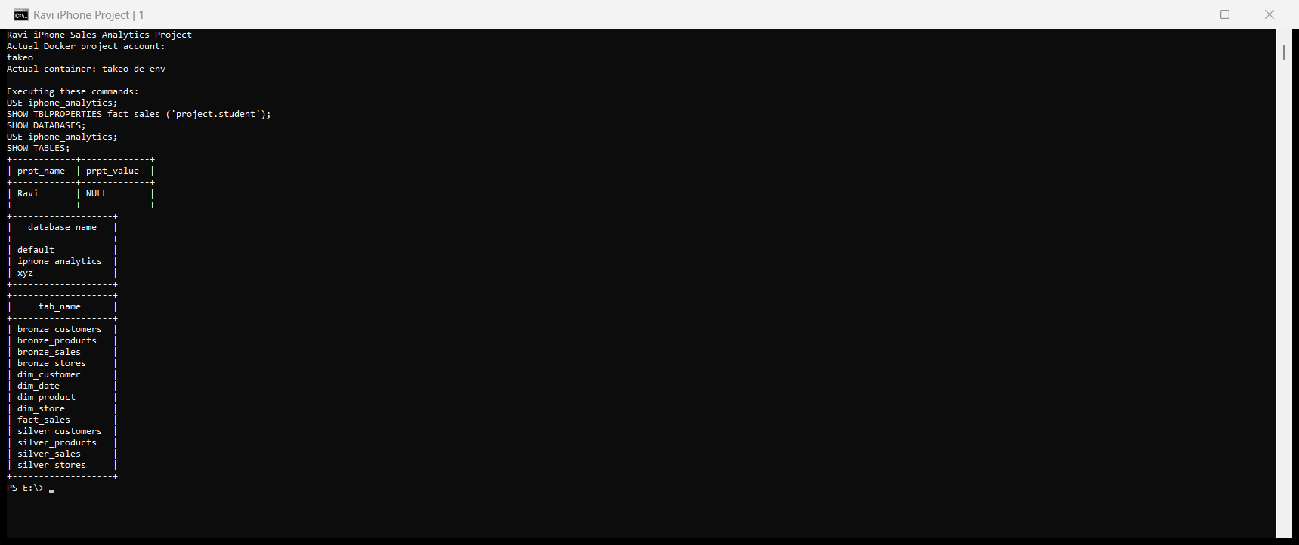
Note. The SHOW DATABASES and SHOW TABLES results identify the completed warehouse.
Figure 2
Project Name Stored in Hive
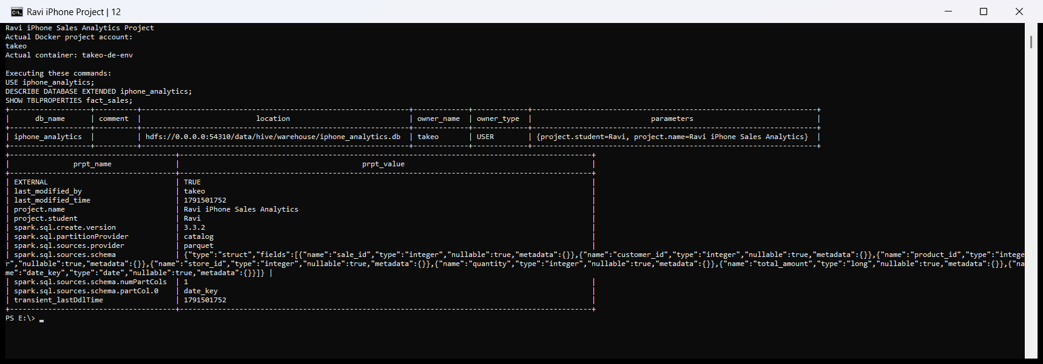
Note. The database properties and fact table properties contain the student name Ravi.

Silver Sales Schema
The Silver sales table contains integer sale, product, customer and store identifiers, an integer quantity, and a DATE partition named sale_date. Figure 3 shows its HDFS location and Parquet storage classes. The table has four partitions.
Figure 3
Silver Sales Table Definition
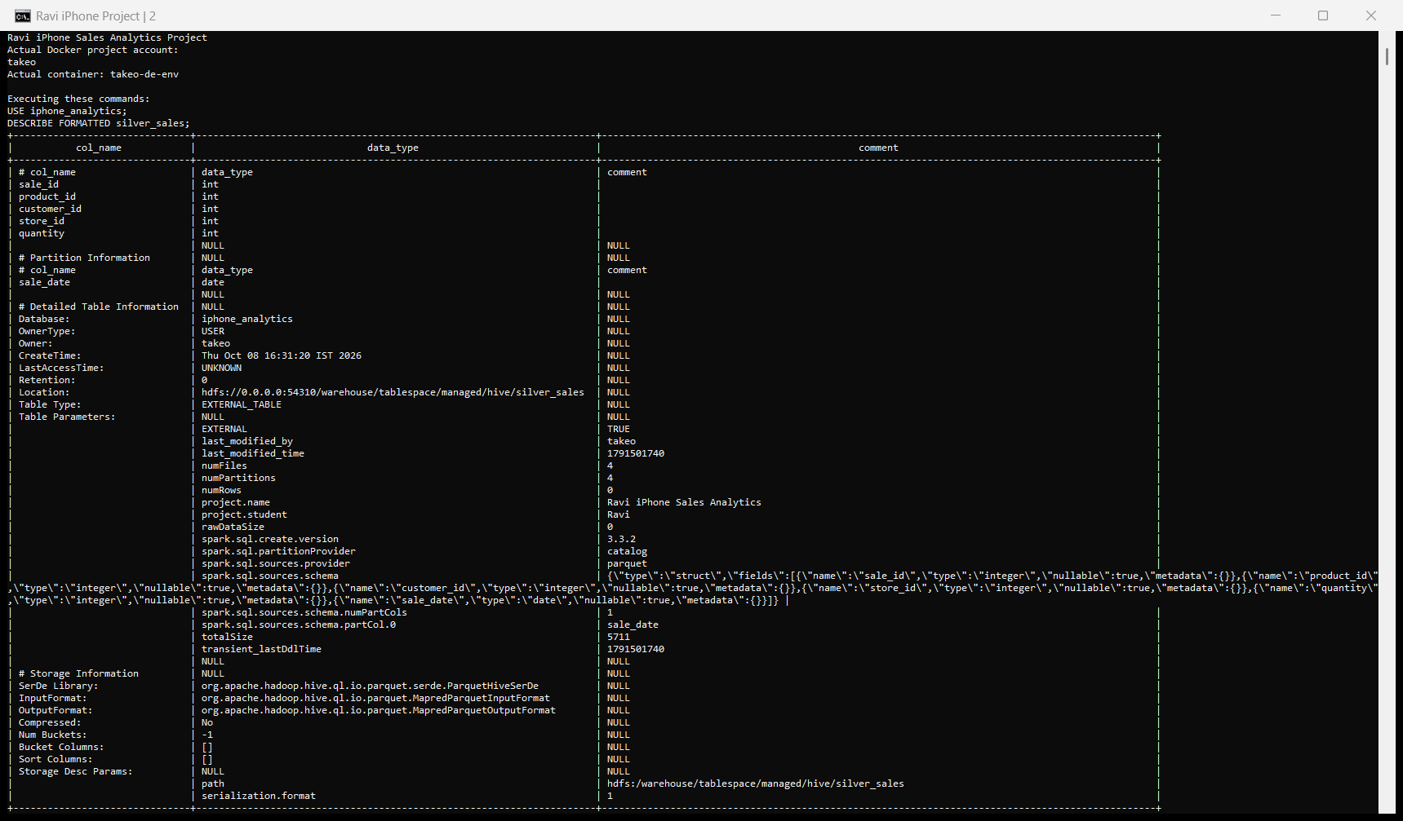
Note. The actual DESCRIBE FORMATTED output shows an external Parquet table and the stored project properties. The numRows statistic is not populated; the COUNT queries later in the report establish the row count.
The tables use explicit external HDFS locations rather than the managed-table default in the reference example. The warehouse directory name includes managed, but Hive correctly reports EXTERNAL_TABLE. The table names, data and required storage locations remain consistent with the project.

Fact Sales Schema
The fact stores sale_id, customer_id, product_id, store_id, quantity and total_amount, and uses date_key as its DATE partition. Figure 4 confirms Parquet storage and the fact table location in HDFS.
Figure 4
Fact Sales Table Definition
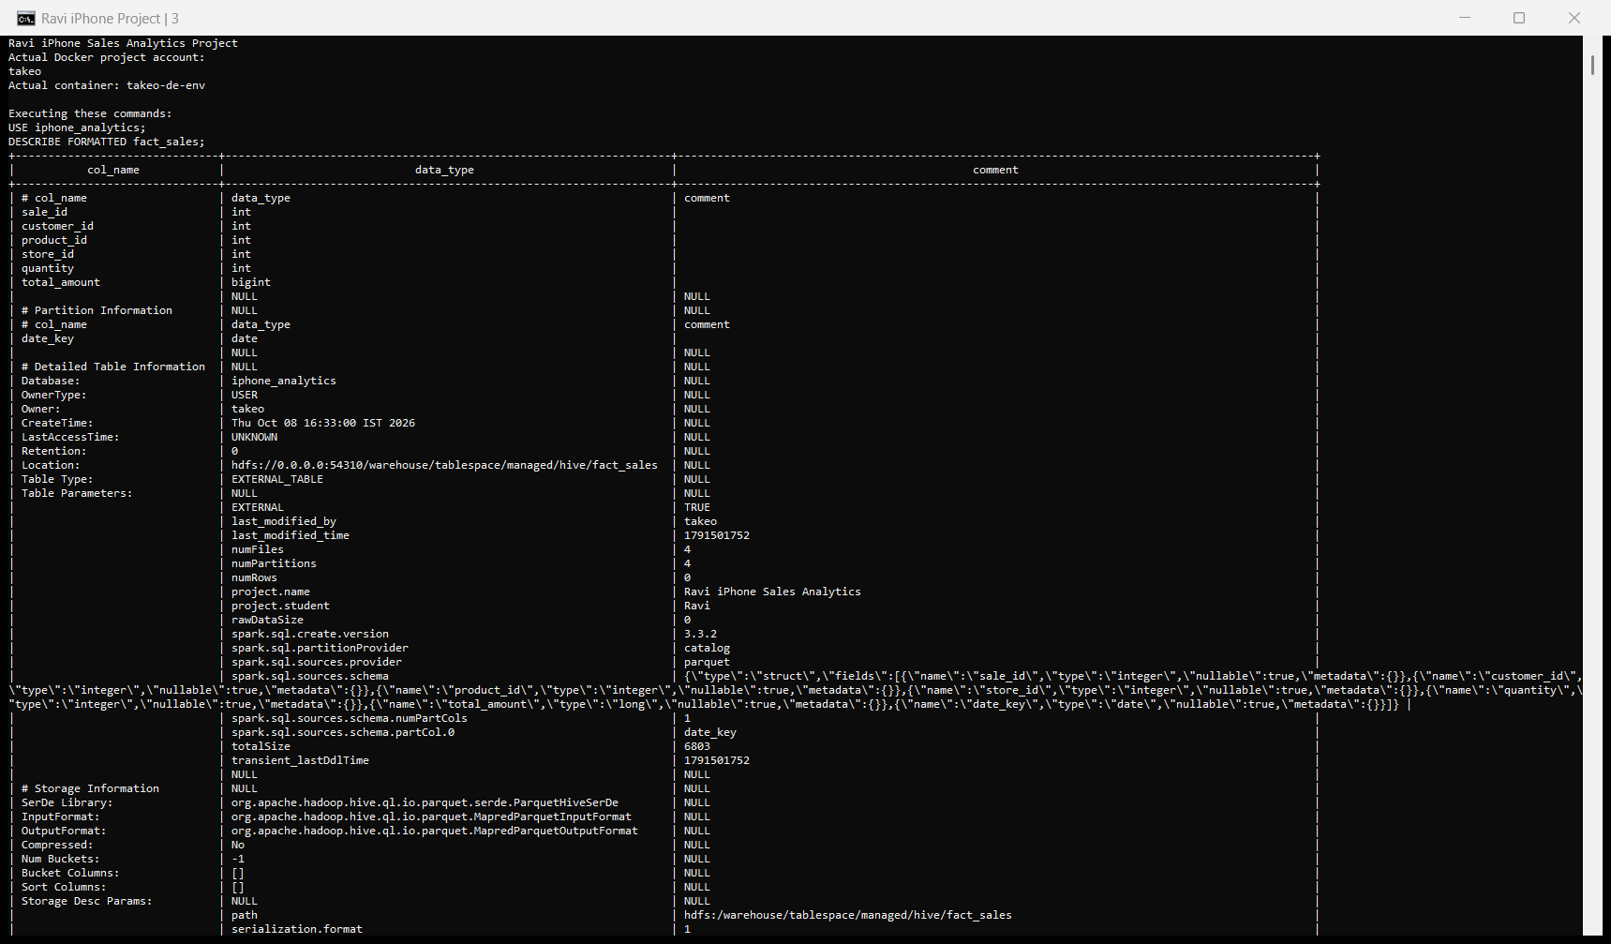
Note. total_amount is BIGINT. date_key is declared once as a typed partition column.
The amount uses BIGINT instead of the reference example's INT. Both quantity and price are cast to long before multiplication to reduce the risk of integer overflow. The reference partition definition was also corrected so date_key is not duplicated and has a DATE type.

HDFS Storage and Date Partitions
Figure 5 shows the warehouse directories, including bronze_sales, silver_sales, fact_sales and dim_product. The HDFS project information file also contains Ravi's name. Figure 6 confirms matching partitions for January 10, 12, 15 and 20, 2023.
Figure 5
HDFS Warehouse Directories
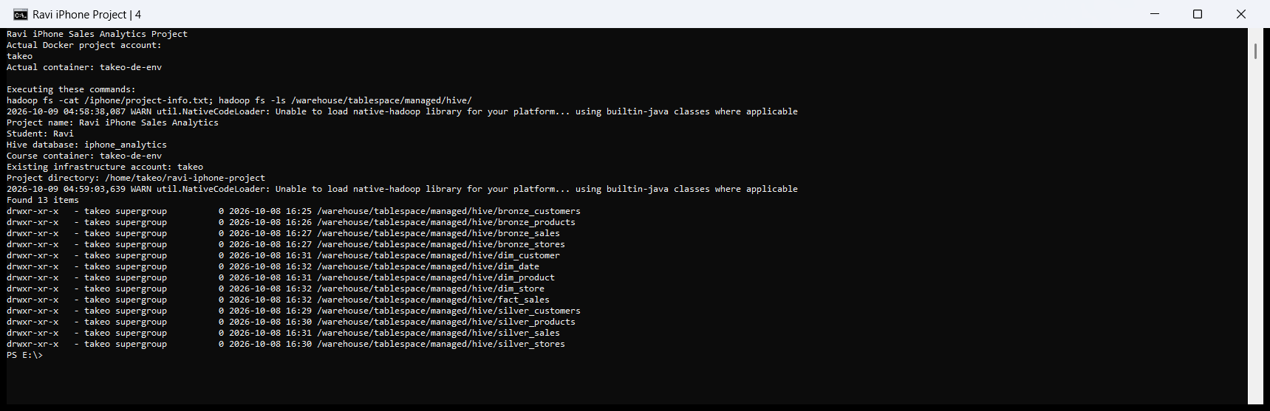
Note. The listing shows the physical directories for all 13 warehouse tables.
Figure 6
Silver and Fact Date Partitions
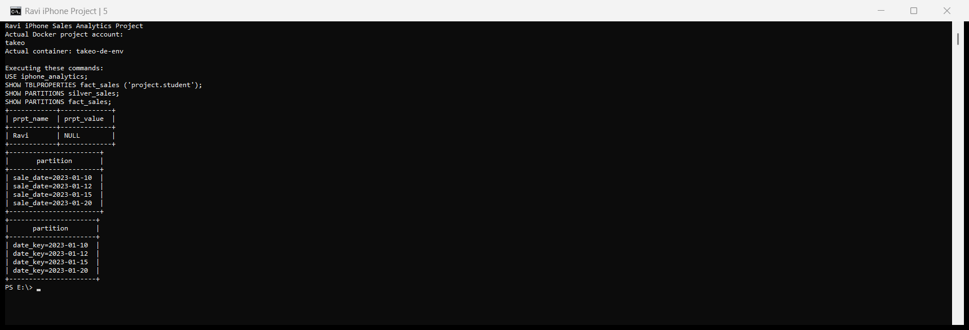
Note. Silver uses sale_date and the fact uses date_key. Both have the same four dates.

Row Counts and Silver Sample
The count check returns four rows in bronze_sales, four in silver_sales and four in fact_sales (Figure 7). This agrees with the four supplied sales records. No valid sale is lost during cleaning or dimension joins.
Figure 7
Sales Record Counts Across the Three Layers
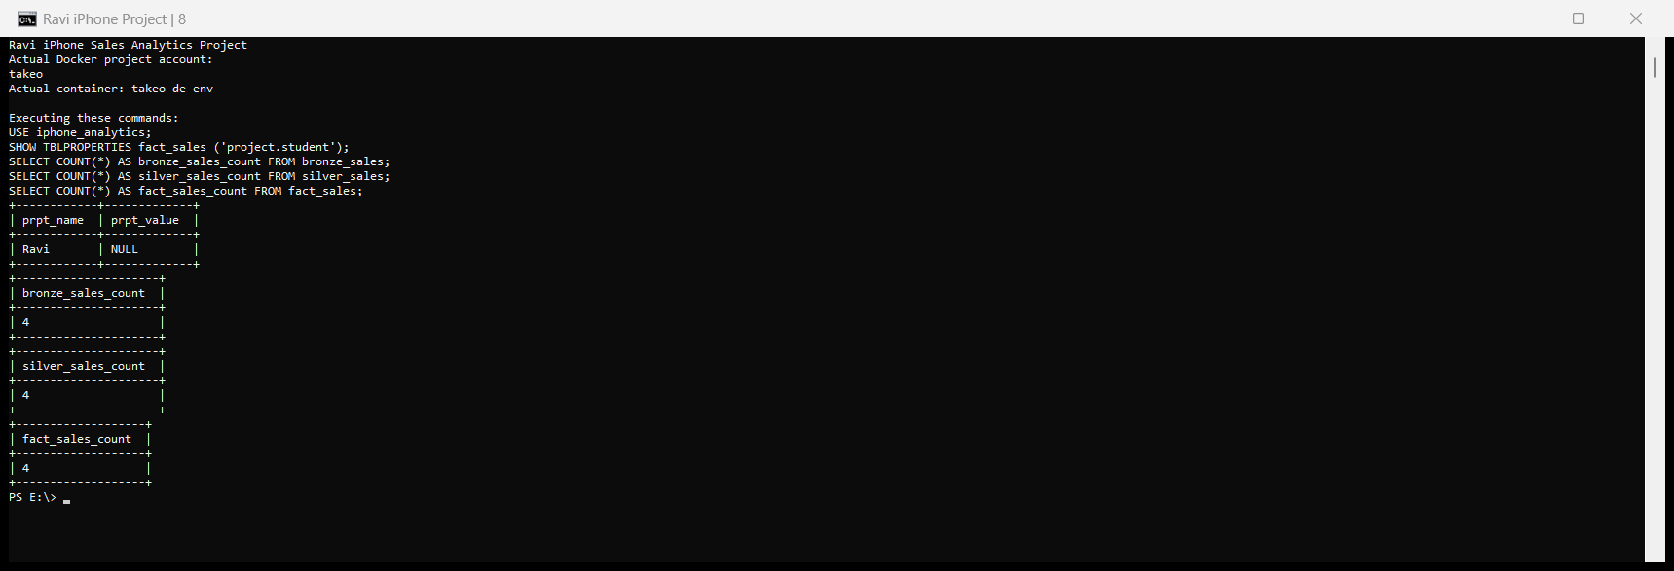
Note. Each COUNT query returns 4.
The Silver sample in Figure 8 preserves the sale identifiers, dimension references, quantities and dates. LIMIT 10 returns only four rows because the table contains four records.
Figure 8
Cleaned Sales Records
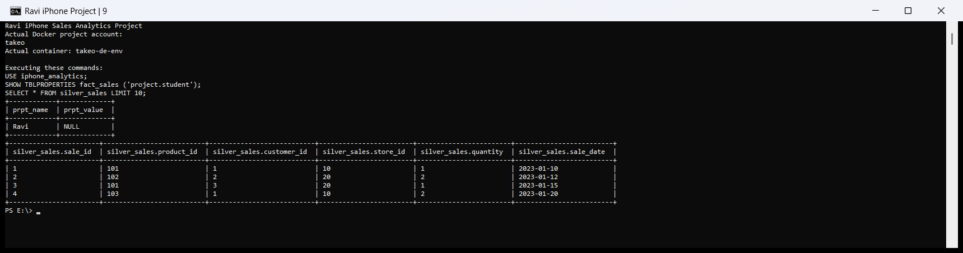
Note. The Silver sample matches the supplied valid sales data.

Fact Records and Revenue Calculation
Table 2 presents the fact values in a readable form. Sale 2 contributes 2,200 because two iPhone 14 units are sold at a unit price of 1,100. Sale 4 contributes 400 from two AirPods units priced at 200 each. Figure 9 shows the corresponding Hive output.
Table 2
Fact Sales Records
Sale | Customer | Product | Store | Units | Amount | Date
1 | 1 | 101 | 10 | 1 | 900 | 2023-01-10
2 | 2 | 102 | 20 | 2 | 2200 | 2023-01-12
3 | 3 | 101 | 20 | 1 | 900 | 2023-01-15
4 | 1 | 103 | 10 | 2 | 400 | 2023-01-20

Figure 9
Fact Sales Query Output
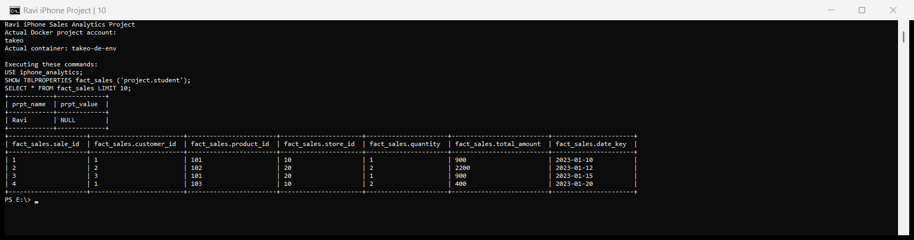
Note. The actual fact sample contains four rows. The amounts sum to 4,400 and the quantities sum to six units.

Revenue by Product
The product query joins fact_sales to dim_product and groups the amounts by product_name. iPhone 14 contributes the highest revenue in this sample at 2,200. The two iPhone 13 sales contribute 1,800, and AirPods contributes 400. Table 3 and Figure 10 show the same results.
Table 3
Product Revenue
Product | Revenue
AirPods | 400
iPhone 13 | 1800
iPhone 14 | 2200

Figure 10
Hive Product Revenue Query
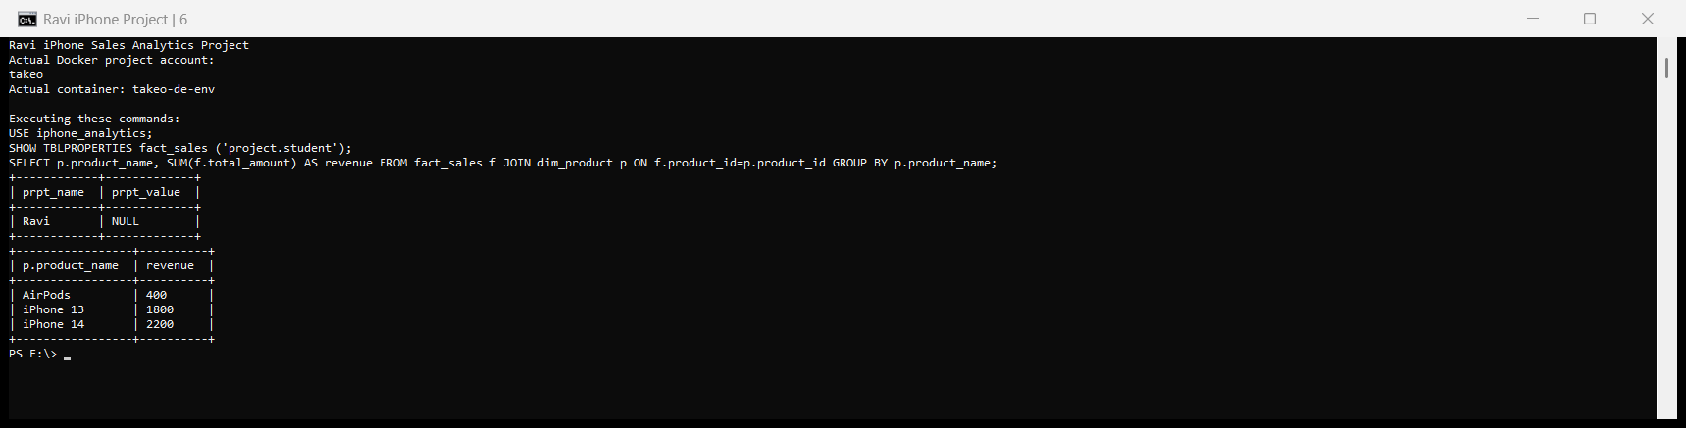
Note. The screenshot includes the executed join and aggregation, output column names and all three product totals.
The totals reconcile to 400 + 1,800 + 2,200 = 4,400. This comparison describes the supplied sample rather than a wider market trend.

Revenue by Store
The store query joins fact_sales to dim_store and groups by store_name. Apple Store NY generates 3,100, while Apple Store SJ generates 1,300. New York's total includes the two-unit iPhone 14 sale and one iPhone 13 sale. San Jose's total includes an iPhone 13 sale and the AirPods sale.
Table 4
Store Revenue
Store | Revenue
Apple Store NY | 3100
Apple Store SJ | 1300

Figure 11
Hive Store Revenue Query
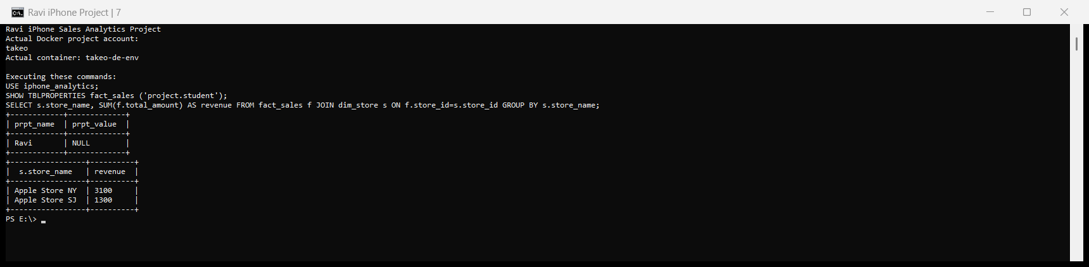
Note. The two store totals add to 4,400, matching the product and fact totals.

Sales by Date and Customer
All four sales occur in January 2023. January 12 has the largest daily amount, 2,200, from Bob's purchase of two iPhone 14 units. Joining the date dimension gives year 2023, month 1 and monthly revenue of 4,400. Table 5 lists each daily result.
Table 5
Daily Sales
Date | Units | Revenue
2023-01-10 | 1 | 900
2023-01-12 | 2 | 2200
2023-01-15 | 1 | 900
2023-01-20 | 2 | 400

Alice has two purchase records and buys three units, contributing 1,300. Bob has one purchase record and buys two units, contributing 2,200. Charlie buys one unit in one record, contributing 900. Purchases in Table 6 means the number of sale records, rather than the number of units.
Table 6
Customer Purchases
Customer | Purchases | Units | Revenue
Alice | 2 | 3 | 1300
Bob | 1 | 2 | 2200
Charlie | 1 | 1 | 900

Figure 12 presents the actual daily, monthly and customer query results. Daily and customer amounts both add to 4,400, and the daily and customer quantities both add to six.

Figure 12
Daily Monthly and Customer Query Results
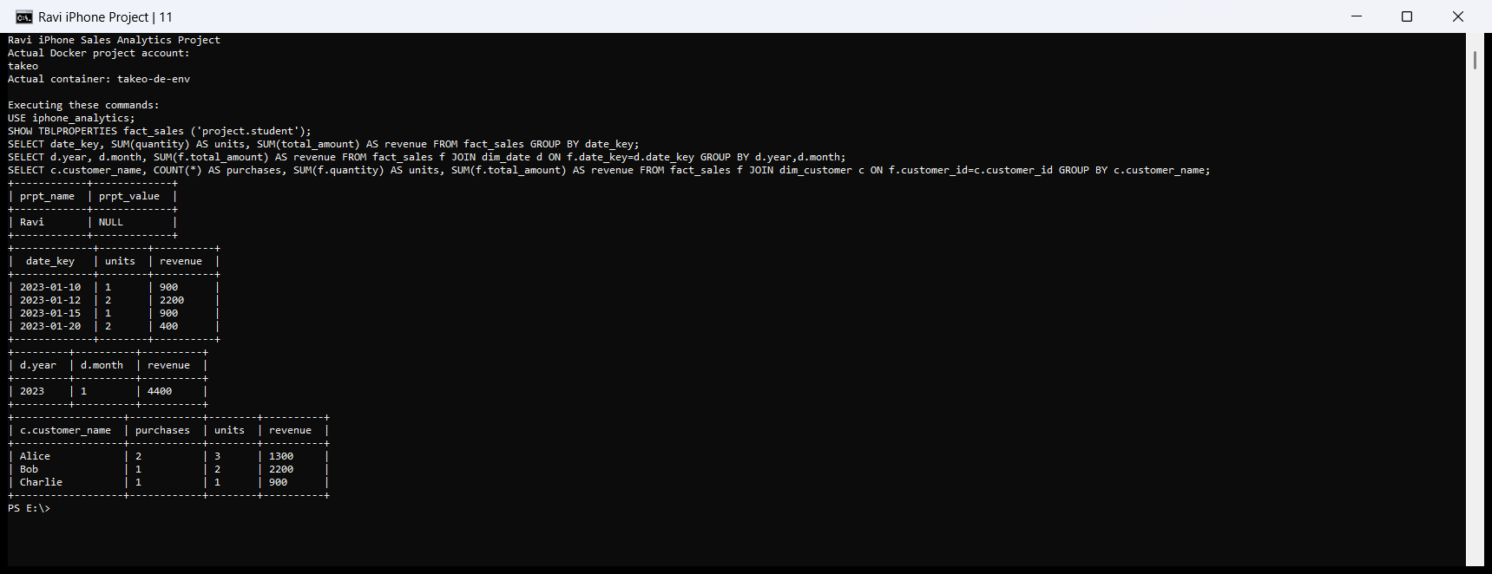
Note. The screenshot shows the SQL statements and complete output tables for the three reports.

Interpreting the Results
The reporting queries agree because they summarize the same four fact records through different dimensions. The sample is useful for demonstrating joins and aggregation, but it is too small to support conclusions about seasonal demand, customer loyalty or long-term store performance.

Discussion and Practical Limits
The Medallion stages make the processing easier to follow. Bronze preserves incoming values, Silver establishes usable records, and Gold presents the business measures. The star schema keeps quantities and amounts in the fact and descriptive information in the dimensions, giving each reporting query a clear join path.
Partitioning by date organizes sales by day and supports pruning for date-filtered queries. Queries covering the whole sample still need all relevant partitions. Hive's SHOW PARTITIONS and DESCRIBE statements provide direct checks of partition definitions and storage metadata (Apache Software Foundation, 2024).
An early parallel query attempt ran out of memory in the course environment. The final Hive service uses a 2 GB heap and a 16 MB sorting buffer, and the captured queries completed successfully. Java subprocesses use FORK, and the optional Spark UI is disabled to avoid issues observed with ARM emulation.
The current pipeline overwrites a complete snapshot. A daily production system would need incremental ingestion, rejected-record reporting, scheduling and historical price handling. Decimal currency types would also be needed if prices include fractions. A complete calendar dimension would allow dates without sales to appear in reports.

Conclusion
The project produces a consistent warehouse from the supplied CSV files. The database, table schemas, HDFS directories, date partitions, record counts and samples are confirmed by the screenshots. Four sales records produce six units and revenue of 4,400, and every product, store, date and customer summary reconciles to that total.

References
Apache Software Foundation. (2024, December 12). LanguageManual DDL. Apache Hive. https://hive.apache.org/docs/latest/language/languagemanual-ddl/
Apache Software Foundation. (n.d.). Overview. Apache Parquet. https://parquet.apache.org/docs/overview/

