Ex1
Aim
To analyze the drawbacks of a basic profile layout and implement modern design principles to create a functional, high-fidelity user interface.
Procedure
Phase A: Analyzing the Old UI Design (Before)
- Placeholder Elements: The design used a generic person icon instead of a real profile photo.
- Simple Layout: The profile featured a basic purple header with a centered name, "Santhosh Priyan" and a small bio.
- Lack of Data: The statistics section only listed "Posts," "Likes," and "Followings" without any specific numerical values.
- Limited Content: The feed section showed only one large image, which did not effectively showcase a full portfolio.
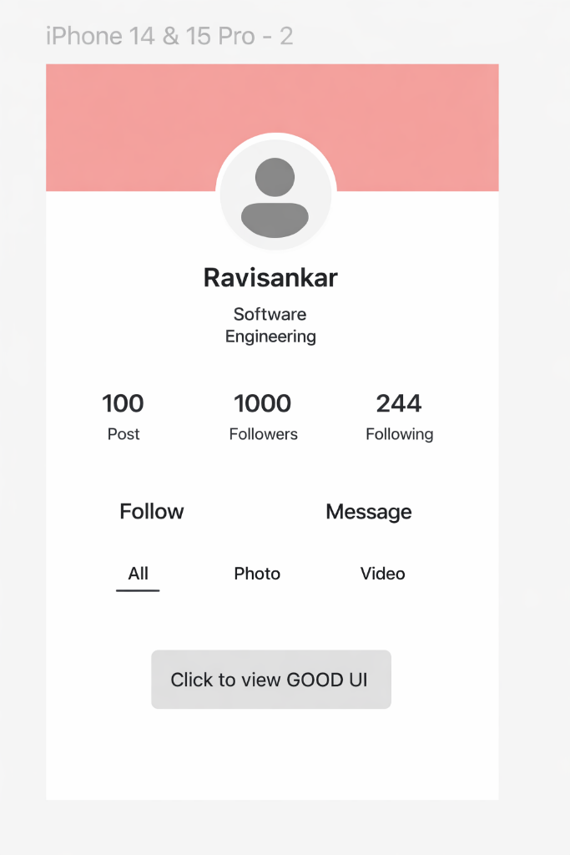

Building the Modified UI Design (After)
- Visual Richness: Replaced the flat color header with a high-resolution city cover photo and added a real profile picture for "Santhosh Priyan".
- Depth Effects: Created a white border around the profile circle and overlapped it with the cover photo to create visual depth.
- Data Accuracy: Added specific, bold numbers for stats: 110 Posts, 600 Followers, and 250 Following.
- Clear Call-to-Action: Designed two distinct buttons: a solid pink "Follow" button and an outlined "Message" button for better hierarchy.
- Grid Layout: Implemented a 4-image portfolio grid with rounded corners to show more content at once.
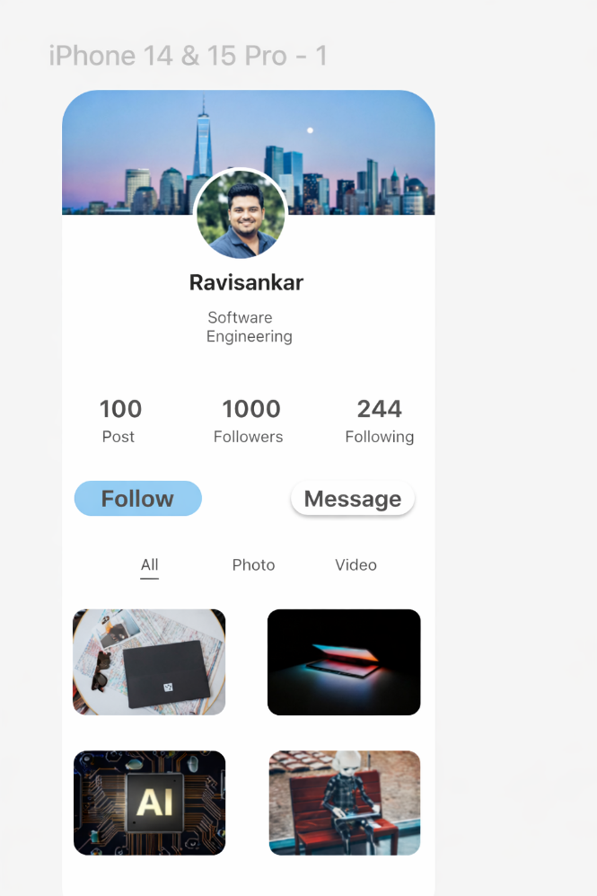

Results
The transition from the "Old UI" to the "Modified UI" resulted in a design that is more professional and engaging.

