SAS 9.4 Installation Guide
DIB Client Environment

End-to-End Installation, Configuration and Validation
Installation and initial configuration of SAS 9.4 at DIB. The SAS/ACCESS Interface to DB2 / DB2 data connector configuration is intentionally left as a later phase.

Contents
1. Document Overview 4
2. SAS Software Order Details 4
3. Environment and Prerequisites 4
3.1 Hardware Specifications 4
3.2 Network and Internet 4
4. Prepare SAS Machine for SAS Installation 5
4.1 Create SAS Machine Users and Directories 5
4.2 Create Application users in Active Directory 5
4.3 Connect the SAS Server to Active Directory 6
4.4 X11 Forwarding and Linux GUI Prerequisites 7
4.5 Third-Party Software 7
4 Download SAS Software Depot 8
4.1 Download SAS Download Manager 8
4.2 Create SAS Software Depot 8
4.3 Validate SAS Software Depot 9
5. Generate the SAS Deployment Plan 10
6. PAM Authentication Configuration 10
7. Port and Firewall Considerations 11
8. SAS 9.4 Installation 11
8.1 Installation Reference Screenshot 11
9. Post-Installation Validation 19
9.1 Check SAS Servers Status 19
9.2 Access SAS Management Console 19
10. SAS Management Console Initial Configuration 21
10.1 Create SAS Application Users in SMC 21
10.2 Create SAS Libraries 21
10.3 Give User access over SAS Data Library 24
10.4 Allow XCMD and modify session timeout in SAS EG 26
11. SASWORK and SASUTILLOC 26
12. SAS Enterprise Guide 27
12.1 SAS Enterprise Guide Installation on Client/Jump Server 27
12.2 Verify SAS Enterprise Guide Installation 27
12.3 SAS Enterprise Guide Connection 28
12.4 Validate SAS License from SAS EG 30
13. Shared Data Directory in SAS EG 30
14. SAS/ACCESS to DB2 31
14.1 Install IBM DB2 Client 31
14.2 Setup ODBC Drivers 32
14.3 Configure DB2 Path in SAS 33
14.4 Create DB2 Libraries in SAS Enterprise Guide 34
15. Home directory for application users 35
16. References 36

1. Document Overview
This document provides the installation procedure used for the DIB SAS 9.4 environment. It covers software-order preparation, SAS Software Depot creation and validation, Linux server preparation, user and Active Directory configuration, X11 prerequisites, SAS deployment, PAM configuration, post-installation validation, SAS Management Console configuration, SAS Enterprise Guide installation, and initial connectivity.
The procedure is based on the supplied DIB installation reference and retains the operational details required to reproduce the setup. Screenshots have been intentionally limited to representative installation/configuration screens to keep the document concise.

2. SAS Software Order Details
Order Number | 9D3QY3
SAS Installation Key | Provided in SAS Software Order email / license
Software Depot Space Required | 33.5 GB
Deployment Type | Planned (Deployment plan needed)
Order Date | January 20, 2026
License Expiration | December 30, 2026
Tech Support Site | 70232039
Site Name | DIB-CORE SVR SITE PROD SUPPLE 4 AND 5
Operating System | Linux for X64
Release Reference | SAS 9.4 64-bits TS1M9, Rev. 940_25w49
License File | SAS94_9D3QY3_70232039_LINUX_X86-64.txt

3. Environment and Prerequisites

3.1 Hardware Specifications
- SAS Linux Server
- SAS Enterprise Guide Client / Jump Server
 | Operating System | CPU (Cores) | RAM (GiB) | Disk Space (GiB)
SAS Linux Server | RHEL 9.4, x86-64 | 16 | 16 | 210
SAS Client | Windows Server 2022 | 8 | 16 | 256

3.2 Network and Internet
Internet access is required to obtain the SAS Download Manager, SAS Software Depot and prerequisite third-party software. The environment must also provide network access between the jump workstation, SAS server, DNS/Active Directory infrastructure and any later database endpoints.
- SAS download Manager: https://www.sas.com/downloadmgr
- SAS plan application: https://support.sas.com/planapp
- SAS third-party software reference: https://support.sas.com/en/documentation/third-party-software-reference/9-4/support-for-other-products.html

4. Prepare SAS Machine for SAS Installation

4.1 Create SAS Machine Users and Directories
- SAS Installer Account: sasins
- SAS Spawned Server Account: sassrv

Create a group “sas” and add “sasins” and “sassrv” users
Set password for both the users: 12345
groupadd sas
useradd -g sas -m -d /home/sasins -s /bin/bash sasins
passwd sasins
useradd -g sas -m -d /home/sassrv -s /bin/bash sassrv
passwd sassrv
Create SAS Installation and Configuration directories
mkdir -p /opt/sas
mkdir -p /opt/sas/config
mkdir -p /opt/sas/depot
Create SAS Installater User owner access over SAS directory
chown -R sasins:sas /opt/sas
chmod -R 775 /opt/sas

4.2 Create Application users in Active Directory
- Create a SAS Application Users group in Active directory: SAS Server Users
- Create SAS Application users in Active directory:
  - test
  - test2
  - test3

- Add Application Users to “SAS Server Users” group
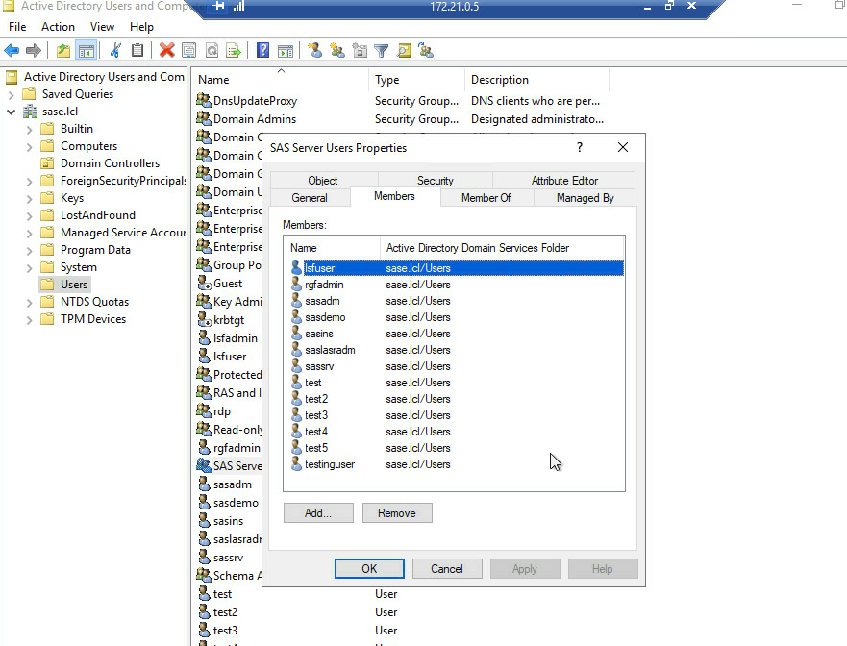

4.3 Connect the SAS Server to Active Directory
- Configure Hostname and DNS
  - Set hostname: Configures the SAS server hostname as saspoc.sase.lcl.
  - Check network connection: nmcli con show displays the available network connections.
  - Configure DNS: Sets the AD/DNS server (172.21.0.5) and DNS search domain (sase.lcl).
  - Apply changes: Restarts the eth0 connection to apply the network configuration.

sudo hostnamectl set-hostname saspoc.sase.lcl
nmcli con show
sudo nmcli con mod "eth0" ipv4.dns "172.21.0.5"
sudo nmcli con mod "eth0" ipv4.dns-search "sase.lcl"
sudo nmcli con down "eth0"
sudo nmcli con up "eth0"

- Install AD Integration Packages
Installs the required packages for Active Directory discovery, domain joining, authentication through SSSD, Kerberos, and automatic home-directory creation.

dnf install -y realmd sssd oddjob oddjob-mkhomedir adcli samba-common-tools krb5-workstation
systemctl enable --now oddjobd

- Discover and Join the AD Domain
  - Discover domain: Verifies that the sase.lcl Active Directory domain can be discovered.
  - Join domain: Joins the SAS server to the AD domain using the specified administrative account.
  - Verify membership: realm list confirms that the server is successfully joined to the domain.

realm discover sase.lcl
realm join --user=Administrator sase.lcl
realm list

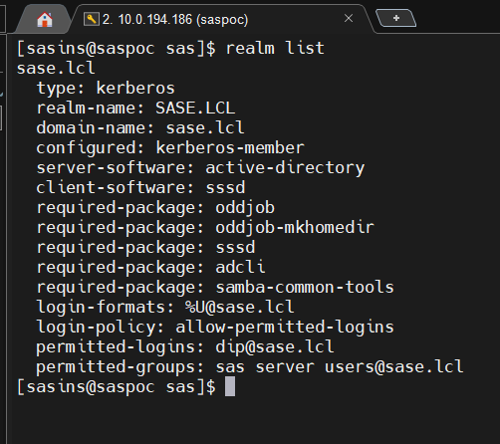

- Configure AD Group Access
After joining the domain, create the required SAS application group in AD, create the application users, and add them to the permitted group. Then permit the group on the SAS server:

realm permit group "sas server users@sase.lcl"
realm list
This allows members of the specified AD group to authenticate and access the SAS server.

Note: The exact AD group and account names must follow the DIB identity-management standard. Do not include passwords in installation documentation or scripts.

4.4 X11 Forwarding and Linux GUI Prerequisites
If the SAS server is administered through a CLI-only Linux host, enable X11 forwarding so graphical SAS deployment/administration tools can be launched through the jump workstation.
grep -E 'X11Forwarding|X11UseLocalhost' /etc/ssh/sshd_config
# /etc/ssh/sshd_config
X11Forwarding yes
X11UseLocalhost yes
systemctl restart sshd
sshd -T | grep x11
rpm -q xorg-x11-xauth
dnf install -y xorg-x11-xauth
dnf install -y \
libXtst libXrender libXi libXext libX11 libXau libxcb \
libXdamage libXfixes libXrandr libXt libXcursor libXinerama \
gtk2 motif xorg-x11-xauth
systemctl restart sshd
On the Windows jump workstation, use an SSH/X11-capable client such as MobaXterm and verify that the SSH session has X11 forwarding enabled before launching GUI-based SAS utilities.

4.5 Third-Party Software
- JUnit 4.13.1 or later; the supplied environment contains JUnit 4.13.2 under /opt/sas/tools.
- For SAS 9.4M9, use a Python version supported by the specific SAS product components being deployed; the supplied reference notes Python 3.9.x–3.11.x.
- zip/unzip utilities.
- X11 runtime libraries, Xauth and Motif/GTK dependencies when GUI deployment is required.

https://support.sas.com/en/documentation/third-party-software-reference/9-4/support-for-other-products.html
mkdir -p /opt/sas/tools
# Place approved third-party JARs/tools under /opt/sas/tools
ls -l /opt/sas/tools

4 Download SAS Software Depot

4.1 Download SAS Download Manager
The SAS Download Manager is used to download the complete SAS Software Depot required for the installation of SAS 9.4.
Perform the following steps to download the SAS Download Manager.
- Open a web browser and navigate to the SAS Downloads portal (https://support.sas.com/downloads).
- Sign in using your SAS Profile credentials when prompted.
- If you do not already have a SAS Profile account, complete the registration process before continuing.
- Download the SAS Download Manager for Linux.
- Save the executable file to a local directory.

4.2 Create SAS Software Depot
The SAS Software Depot is a local repository that stores all installation packages required by the SAS Deployment Wizard.
- Create a directory named SAS Software Depot. Example: /opt/sas/depot
- Launch the downloaded SAS Download Manager as an administrator.
- On the Select Language page, choose the preferred language for the download process and click Next.
- On the Specify Order Information page, provide the following information:
- SAS Order Number
- SAS Installation Key
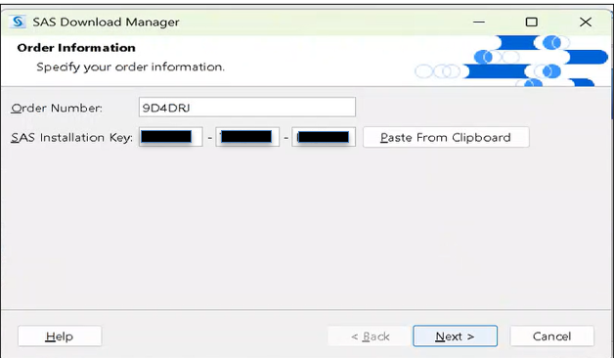
- Verify the provided description for the software order.
- Select Include Complete Order Content to download all software associated with the order.
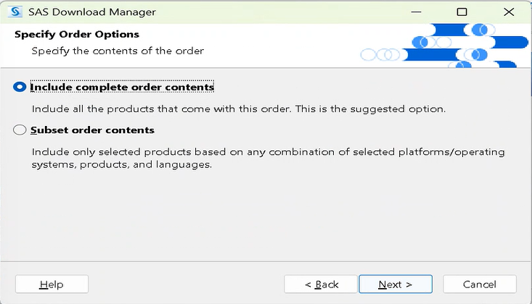
- Specify the location of the SAS Software Depot.
- Review all selections on the Final Review page.
- Click Download to begin downloading the software.
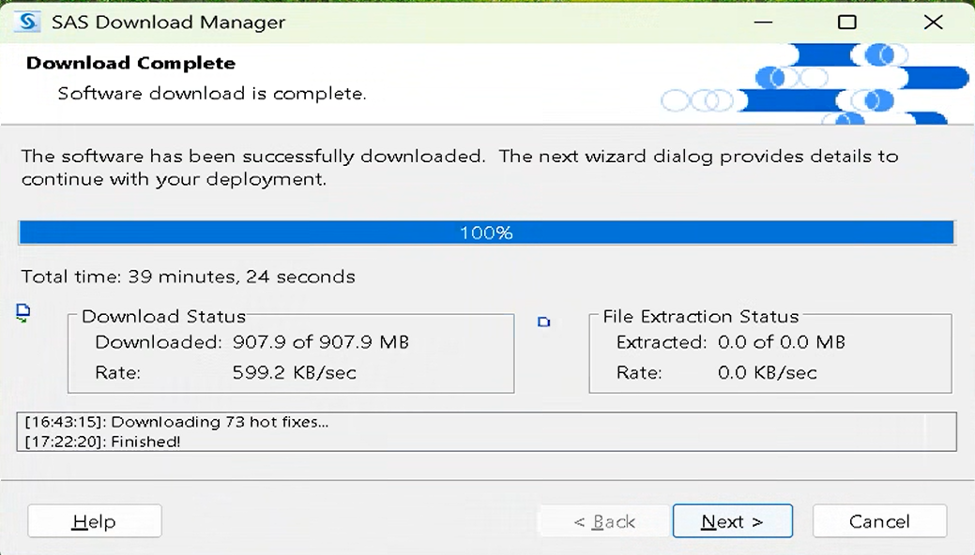
- After the download completes successfully, click Next, followed by Finish to exit the SAS Download Manager.
- Open the following file to verify the download summary.
<SAS Software Depot>\depotsummary.html

4.3 Validate SAS Software Depot
After the download completes, validate the integrity of the SAS Software Depot before starting the installation. Depot validation ensures that all required files have been downloaded correctly and are not corrupted.
- Navigate to the following directory.
<SAS Software Depot>\utilities\depotchecker
- Launch SASDepotCheck.sh.
- Specify the path of the SAS Software Depot.
- Click Start to begin the validation process.
- Review the generated validation report.
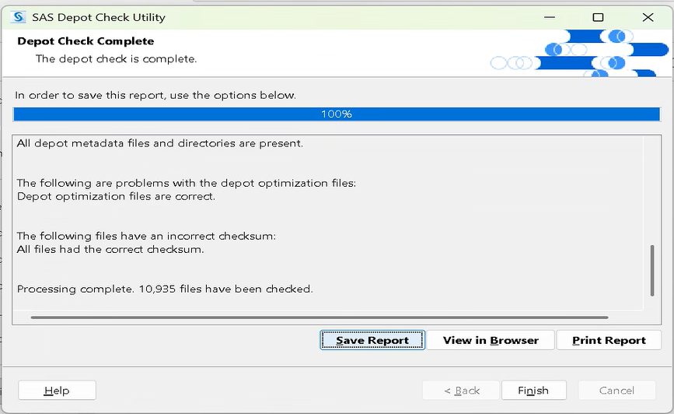
Note: Do not continue with the installation if any checksum validation fails.

5. Generate the SAS Deployment Plan
Because the order is a planned deployment, obtain the deployment plan from the SAS Plan Application.
- Open https://support.sas.com/planapp and sign in with the authorized SAS account.
- Select New Plan.
- Enter the Order Number and Tech Support Site Number.
- Search for the order and retain the default product checklist unless the approved DIB deployment scope requires changes.
- Generate/download the plan XML files.
- Place the required ZQJ plan file(s) in the SAS Software Depot as instructed by the SAS deployment documentation.
Keep the generated plan together with the depot and record the plan version/date for deployment traceability.

6. PAM Authentication Configuration
Create/configure the SAS PAM service file under /etc/pam.d as required by the SAS deployment. The supplied reference uses:
# /etc/pam.d/sasauth
auth include password-auth
account include password-auth
Validate the file permissions and ownership according to the RHEL security policy. Do not expose credentials in configuration files.

7. Port and Firewall Considerations
The following ports appear in the supplied reference environment. Exact ports depend on the deployment plan and should be confirmed against the generated SAS configuration.
Service | Default Port | Direction
SAS Environment Manager Agent | 2144 | Inbound/Outbound
SAS Remote Services | 5091 | Inbound
SAS Web Infrastructure Platform Data Server | 9432 | Inbound/Outbound
SAS Deployment Agent | 5661 | Inbound/Outbound
SAS Environment Manager HTTP | 7080 | Inbound/Outbound
SAS Environment Manager HTTPS | 7443 | Inbound/Outbound
SAS/CONNECT Spawner | 7551 | Inbound
SAS/CONNECT Server | 7541 | Inbound/Outbound
SAS Metadata Server | 8561 | Inbound/Outbound
SAS Workspace Server | 8591 | Inbound
SAS Object Spawner Operator | 8581 | Inbound
Web Application Server | 8080 | Inbound/Outbound
Open only the ports required by the actual deployment. Coordinate firewall changes with the DIB network/security team.

8. SAS 9.4 Installation
Log in to the Linux server using the SAS installer account and start the SAS Deployment Wizard from the SAS Software Depot. Follow the deployment plan and the SAS installation wizard for the ordered products.
- Select the planned deployment and associated plan file.
- Confirm the SAS installation directory, configuration directory and deployment account.
- Provide the license file when requested.
- Confirm product selection against the DIB order.
- Configure the metadata server, object spawner, workspace servers and other selected SAS services according to the generated plan.
- Review port assignments and service configuration before starting deployment.
- Allow the deployment wizard to complete and review all deployment logs for errors.
Installation should be performed using the supported SAS Deployment Wizard/plan rather than manually copying SAS binaries. Keep the generated deployment logs as part of the handover package.

8.1 Installation Reference Screenshot
Representative installation/deployment screen from the supplied DIB reference document:
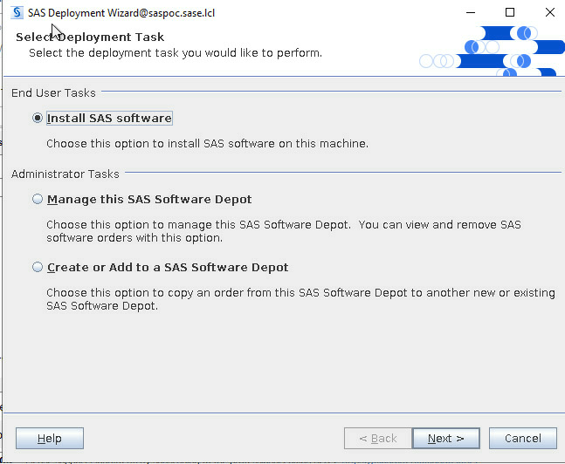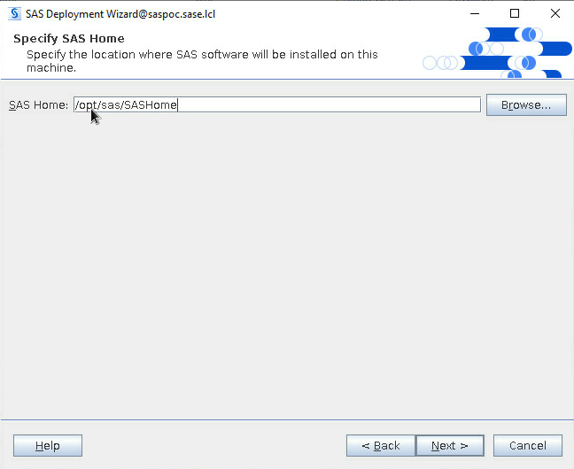
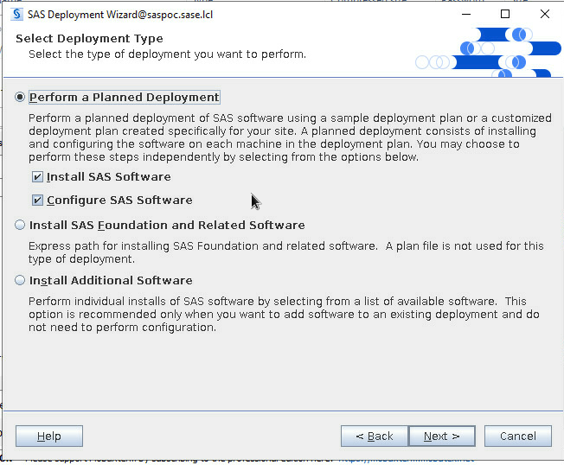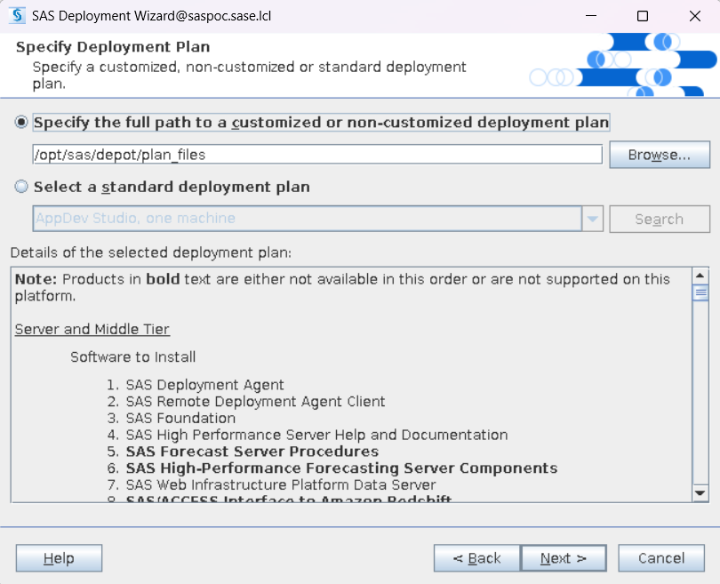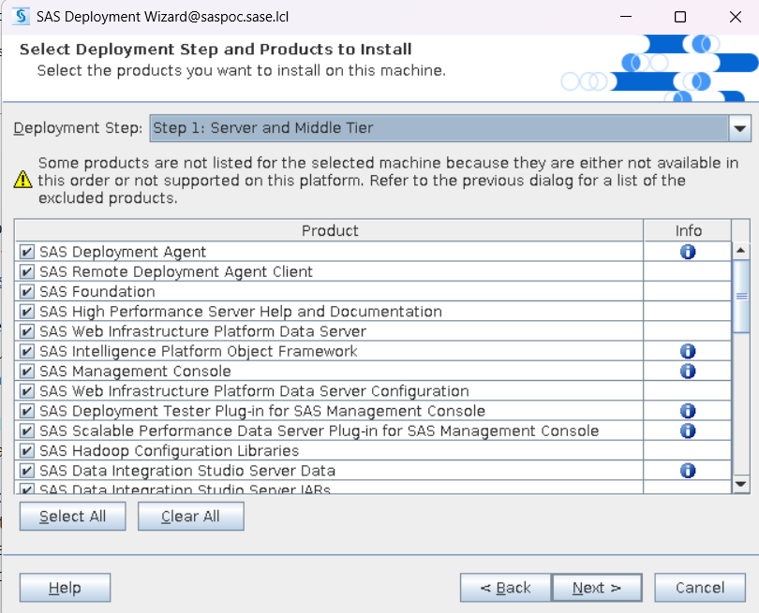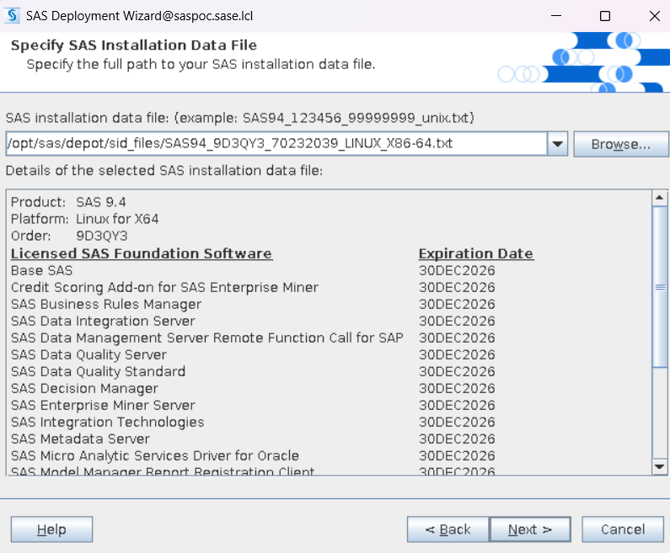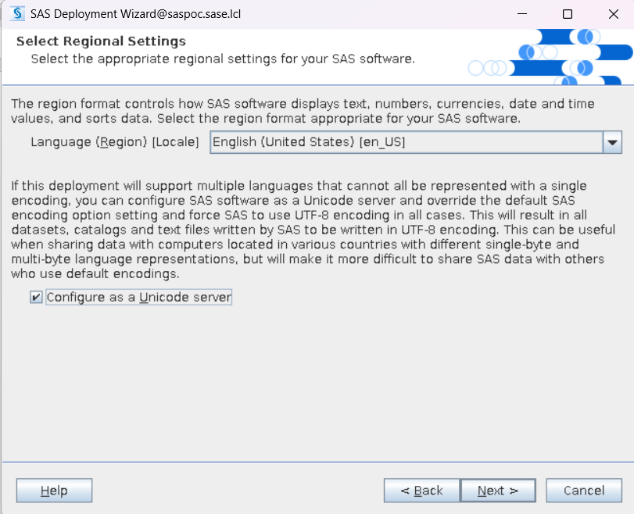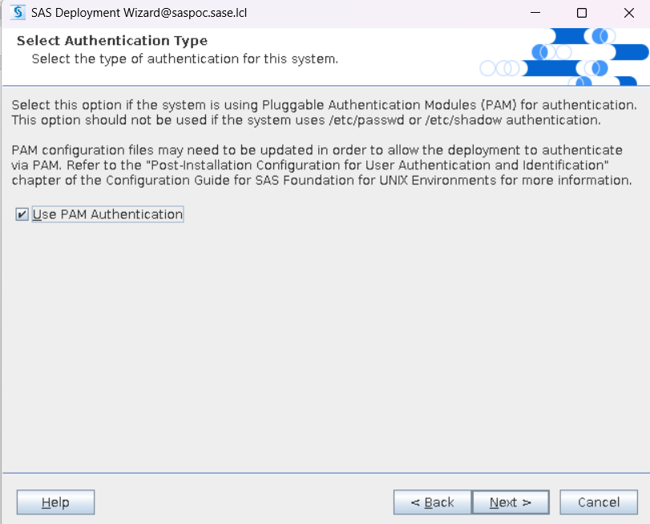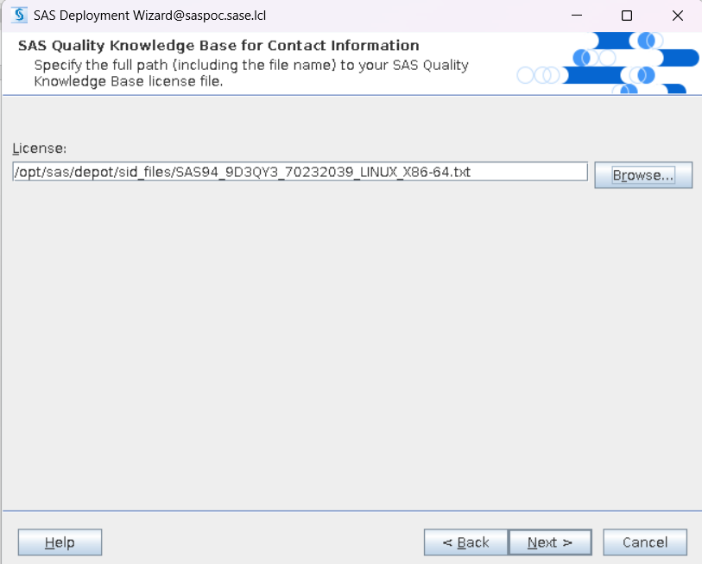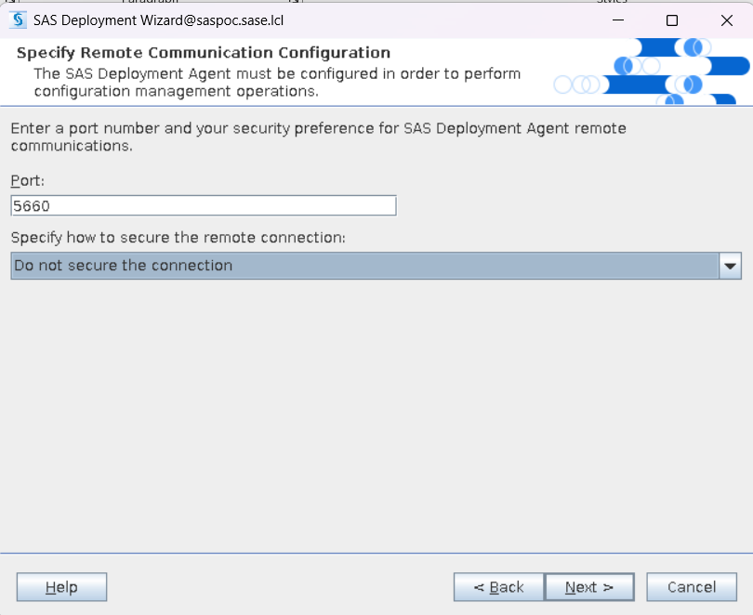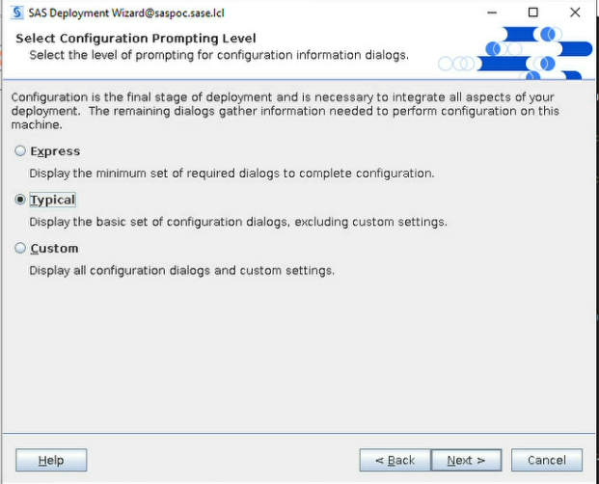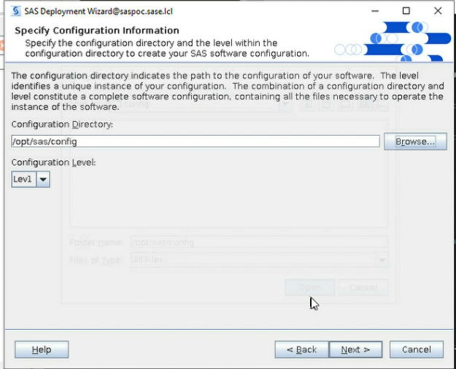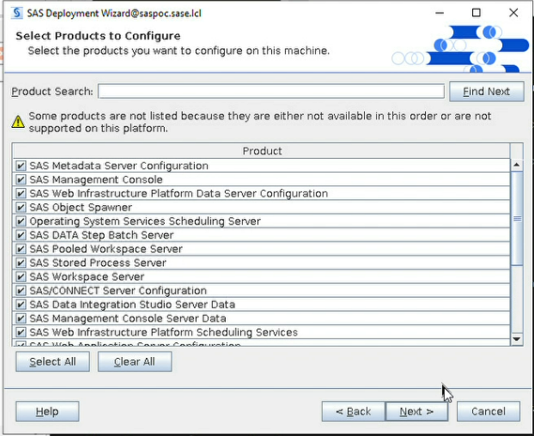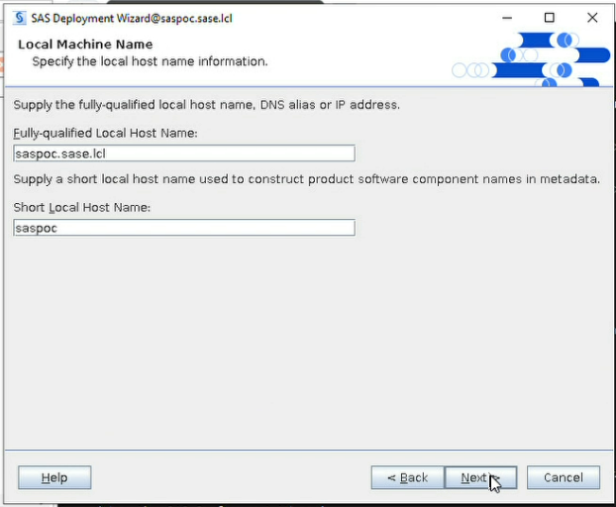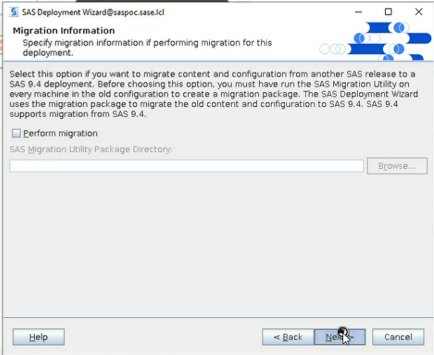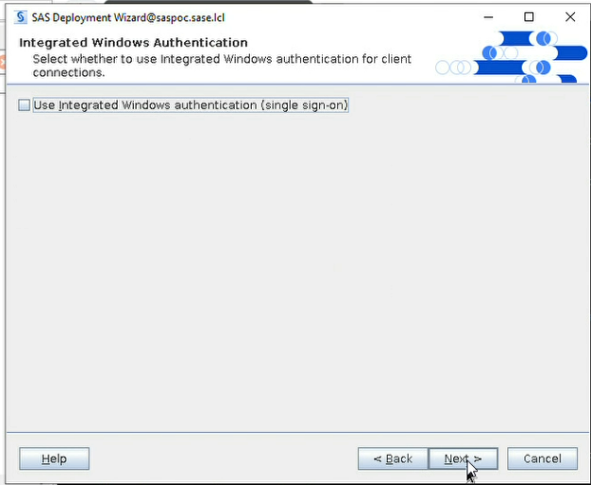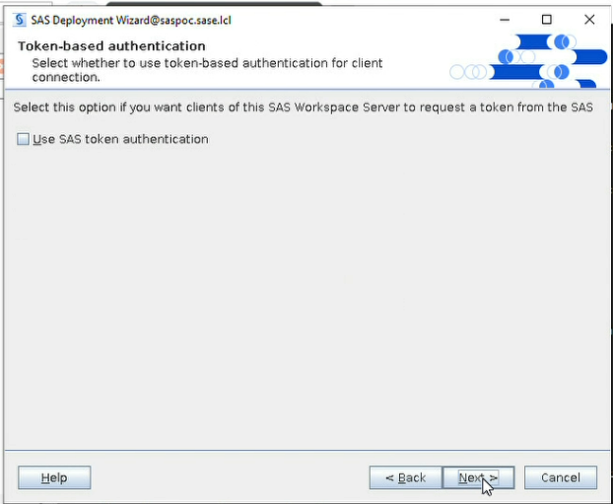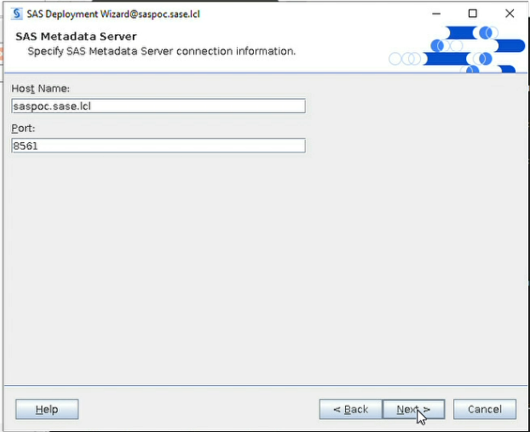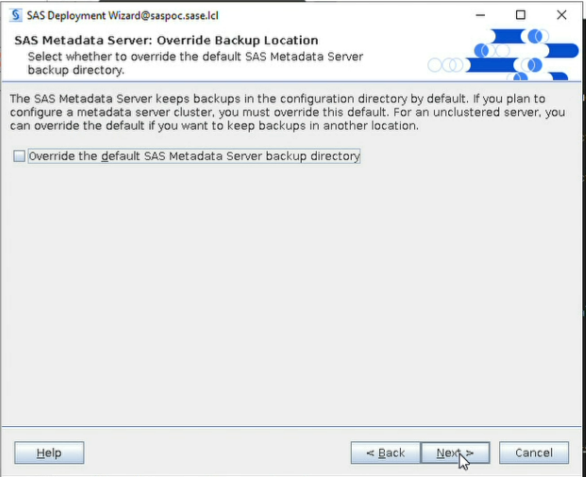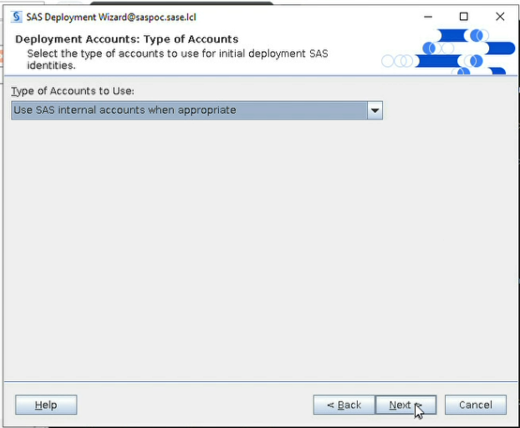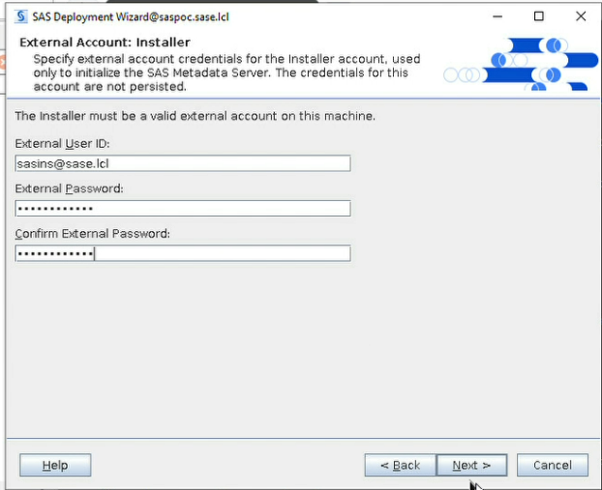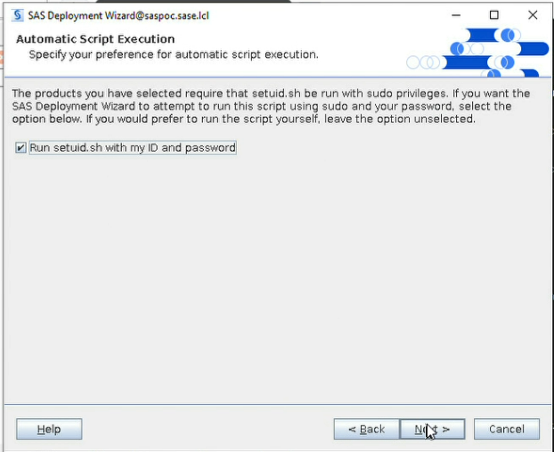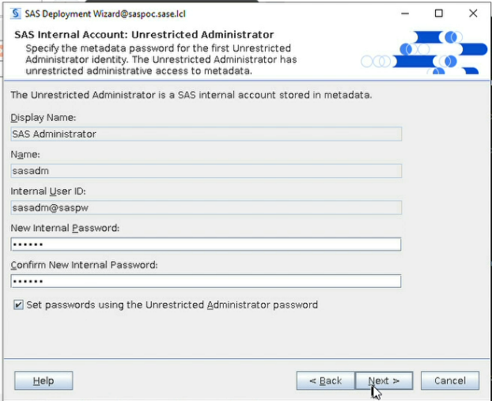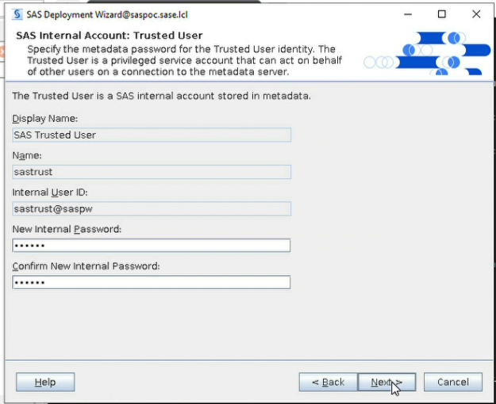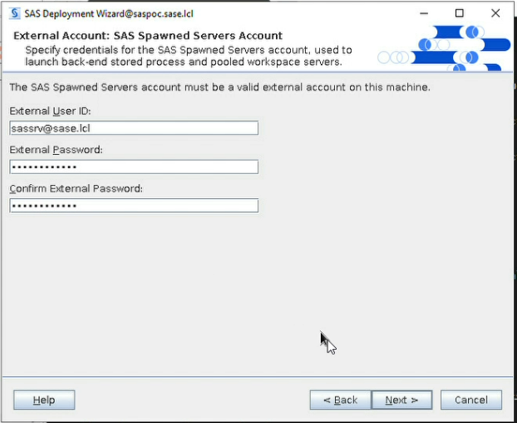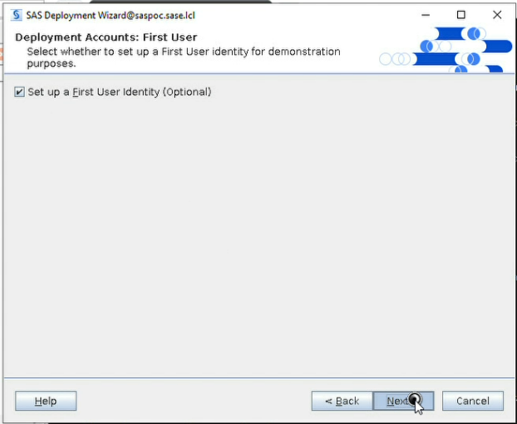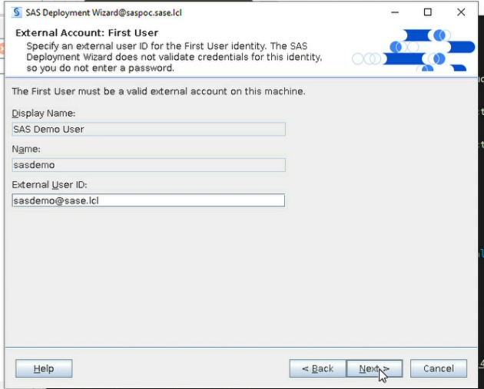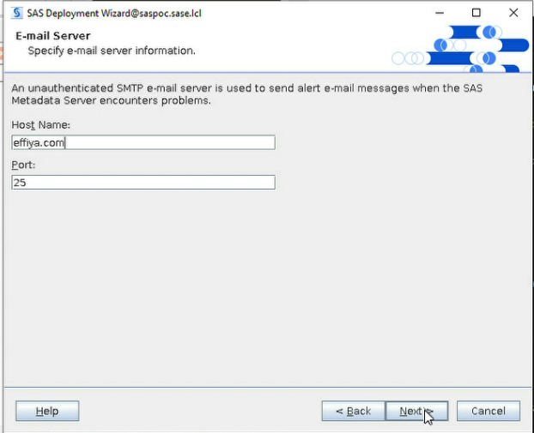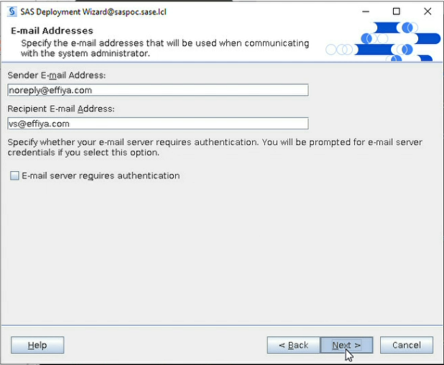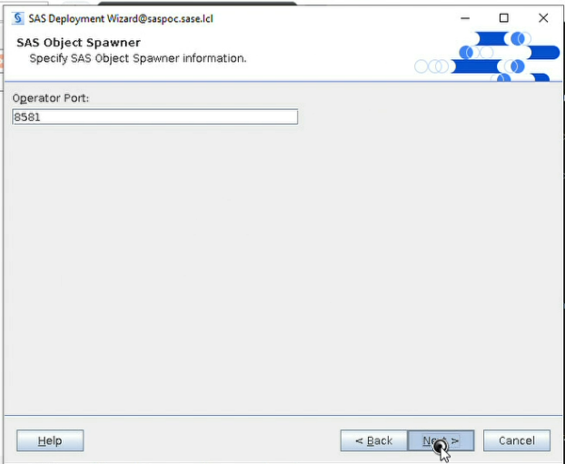
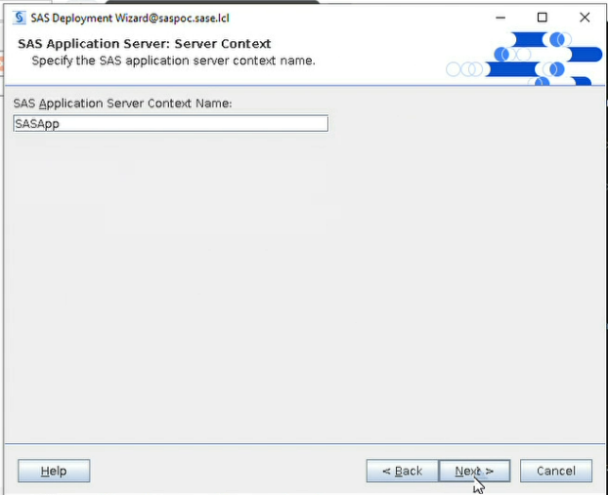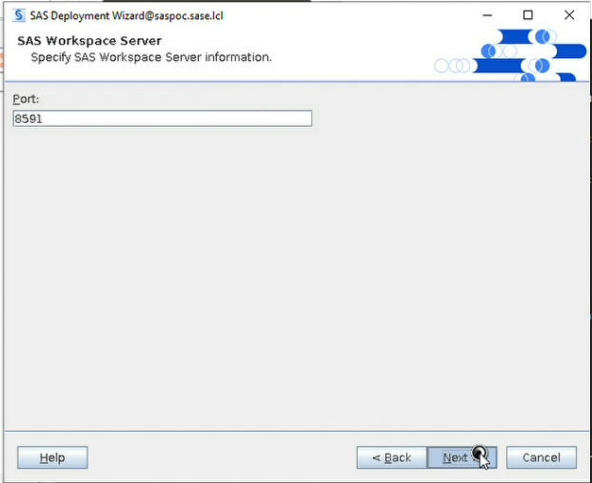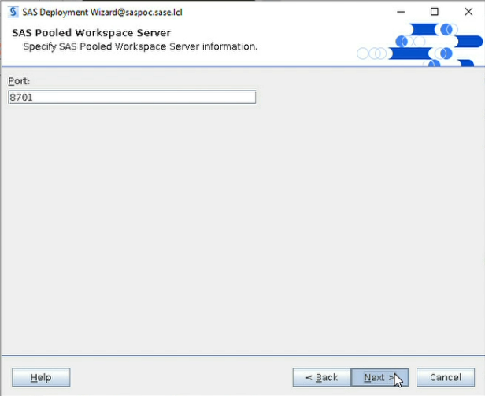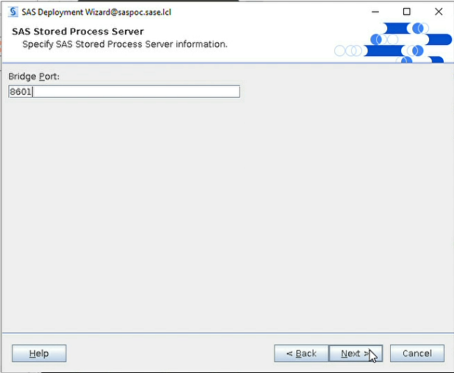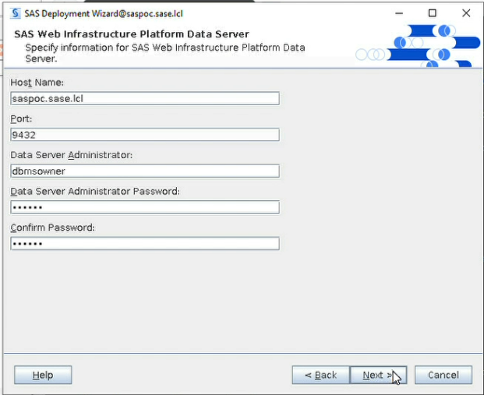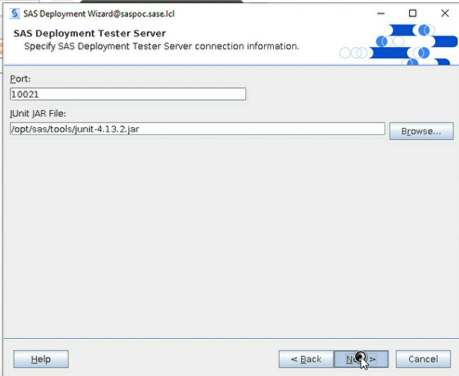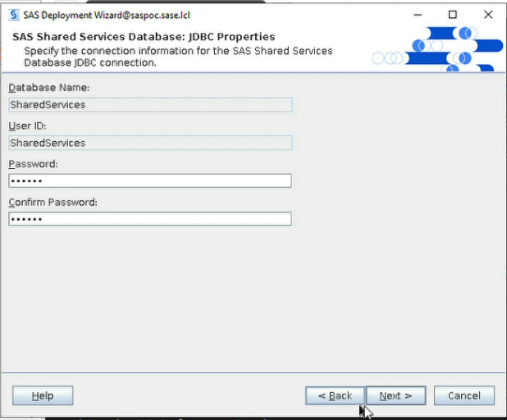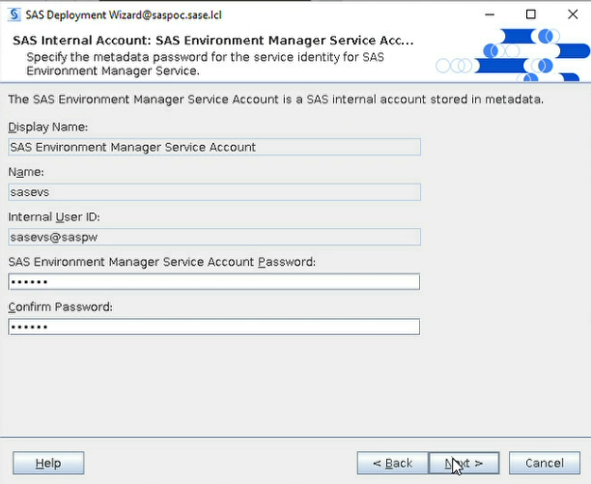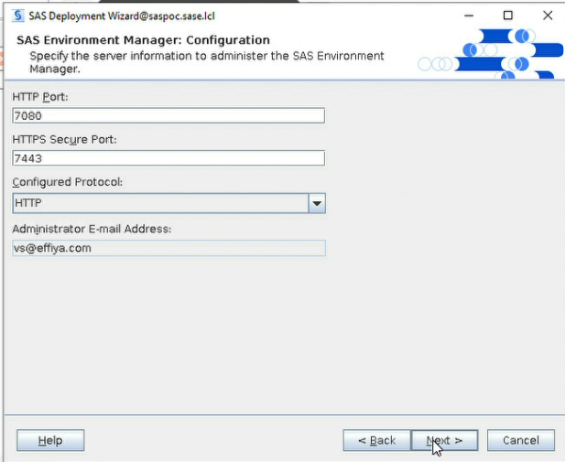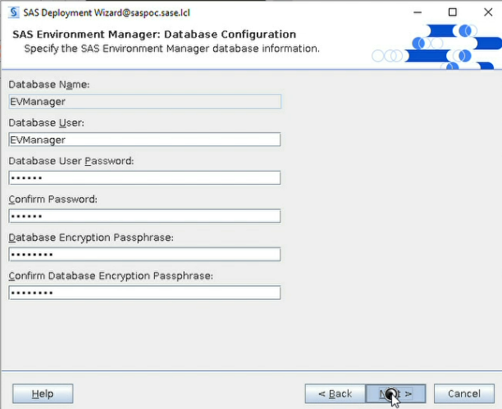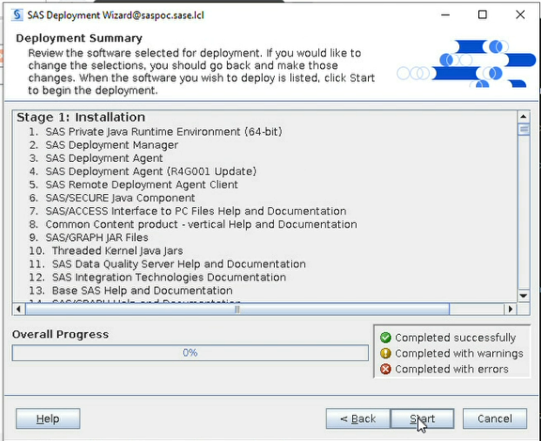

9. Post-Installation Validation

9.1 Check SAS Servers Status
After deployment, verify that the SAS servers are running
cd /opt/sas/config/Lev1/
./sas.servers status
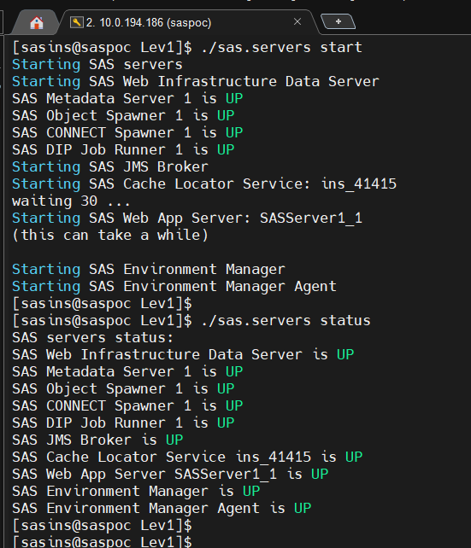

9.2 Access SAS Management Console
After deployment, verify that the SAS services are running and that the environment can be administered through SAS Management Console.
cd /opt/sas/SASHome/SASManagementConsole/9.4/
./sasmc
- Log in with the authorized internal SAS metadata administrator/unrestricted user.
- Verify that the metadata server is reachable.
- Verify the SAS Object Spawner and Workspace Server.
- Confirm that configured application users can authenticate.
- Confirm that SAS Management Console can browse servers, libraries and users.
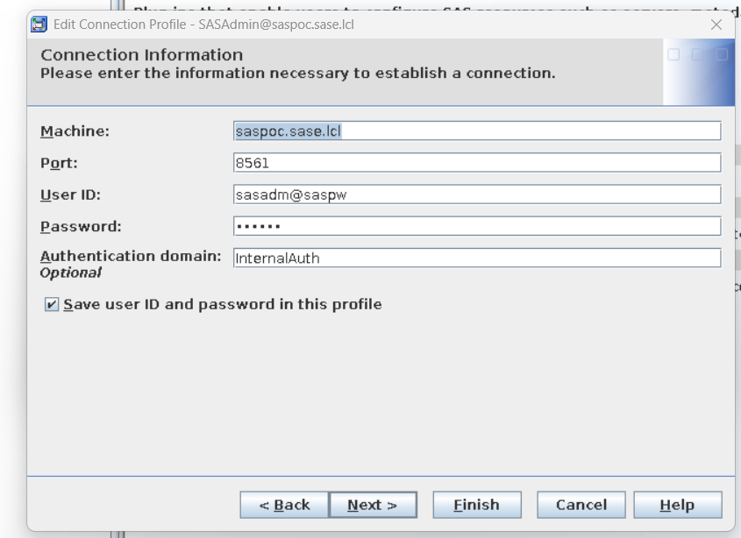

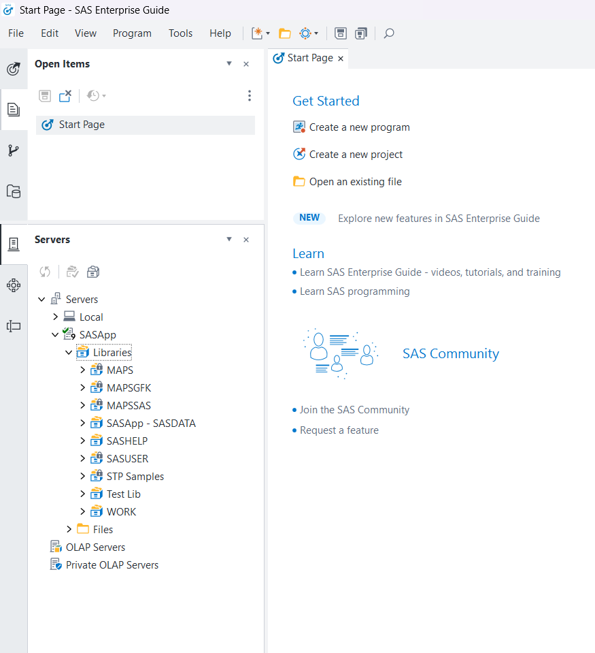

10. SAS Management Console Initial Configuration

10.1 Create SAS Application Users in SMC
- Open SAS Management Console
- Right Click on User Manager and create new user
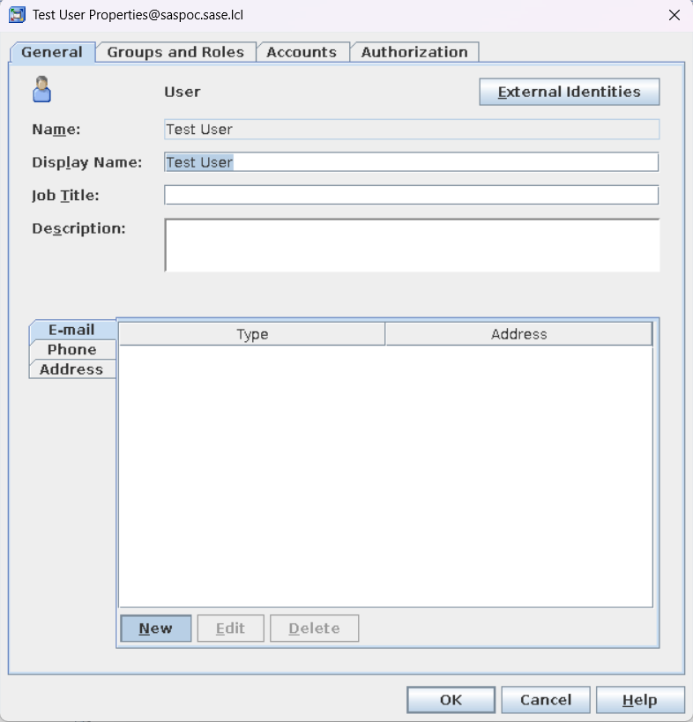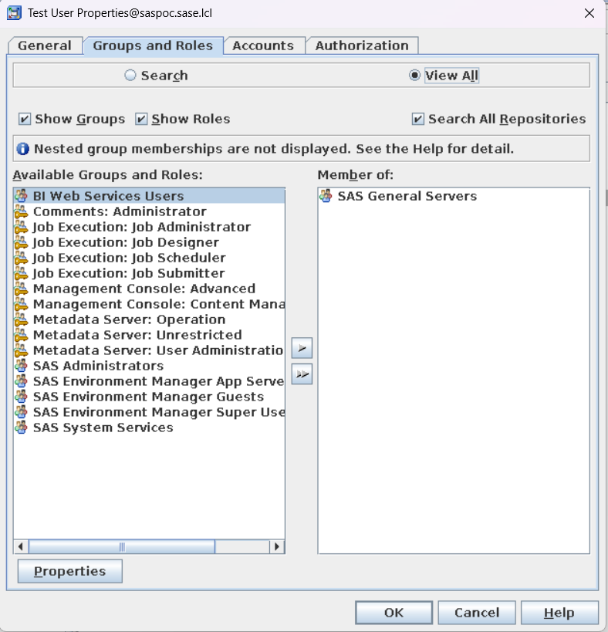
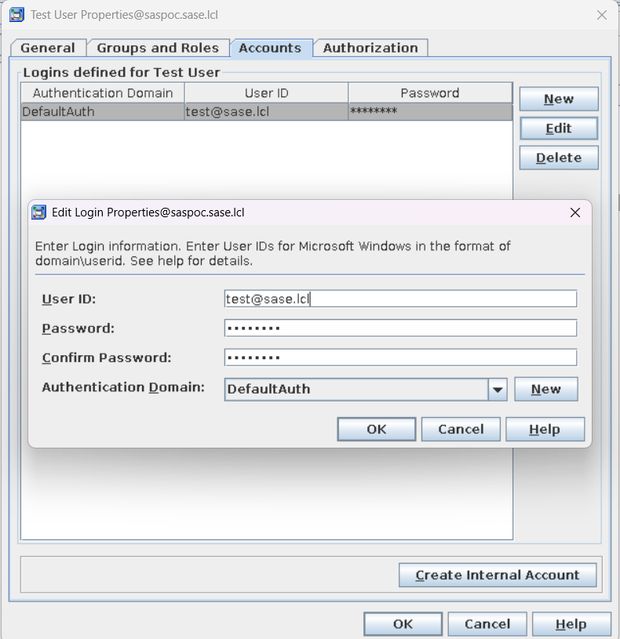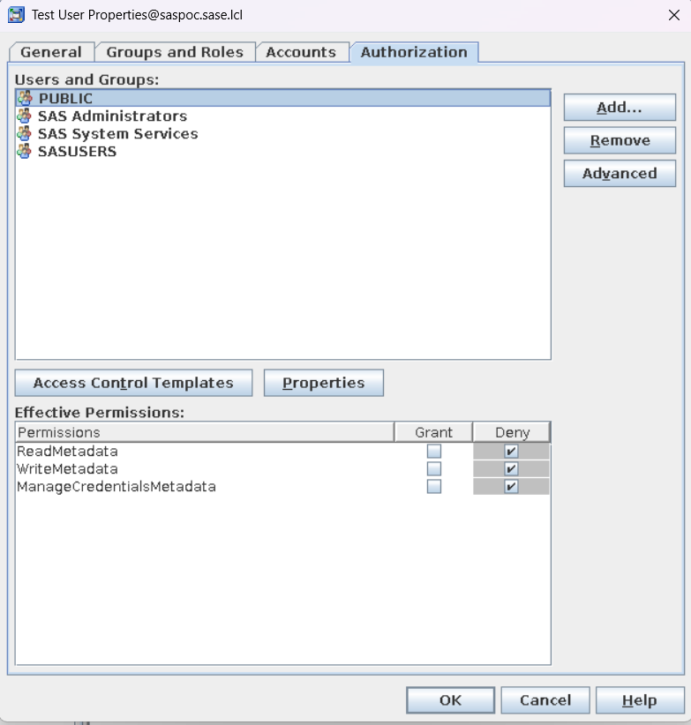

10.2 Create SAS Libraries
- Open SMC, Select Data Library Manager.
- Right Click on Libraries and create new Library.
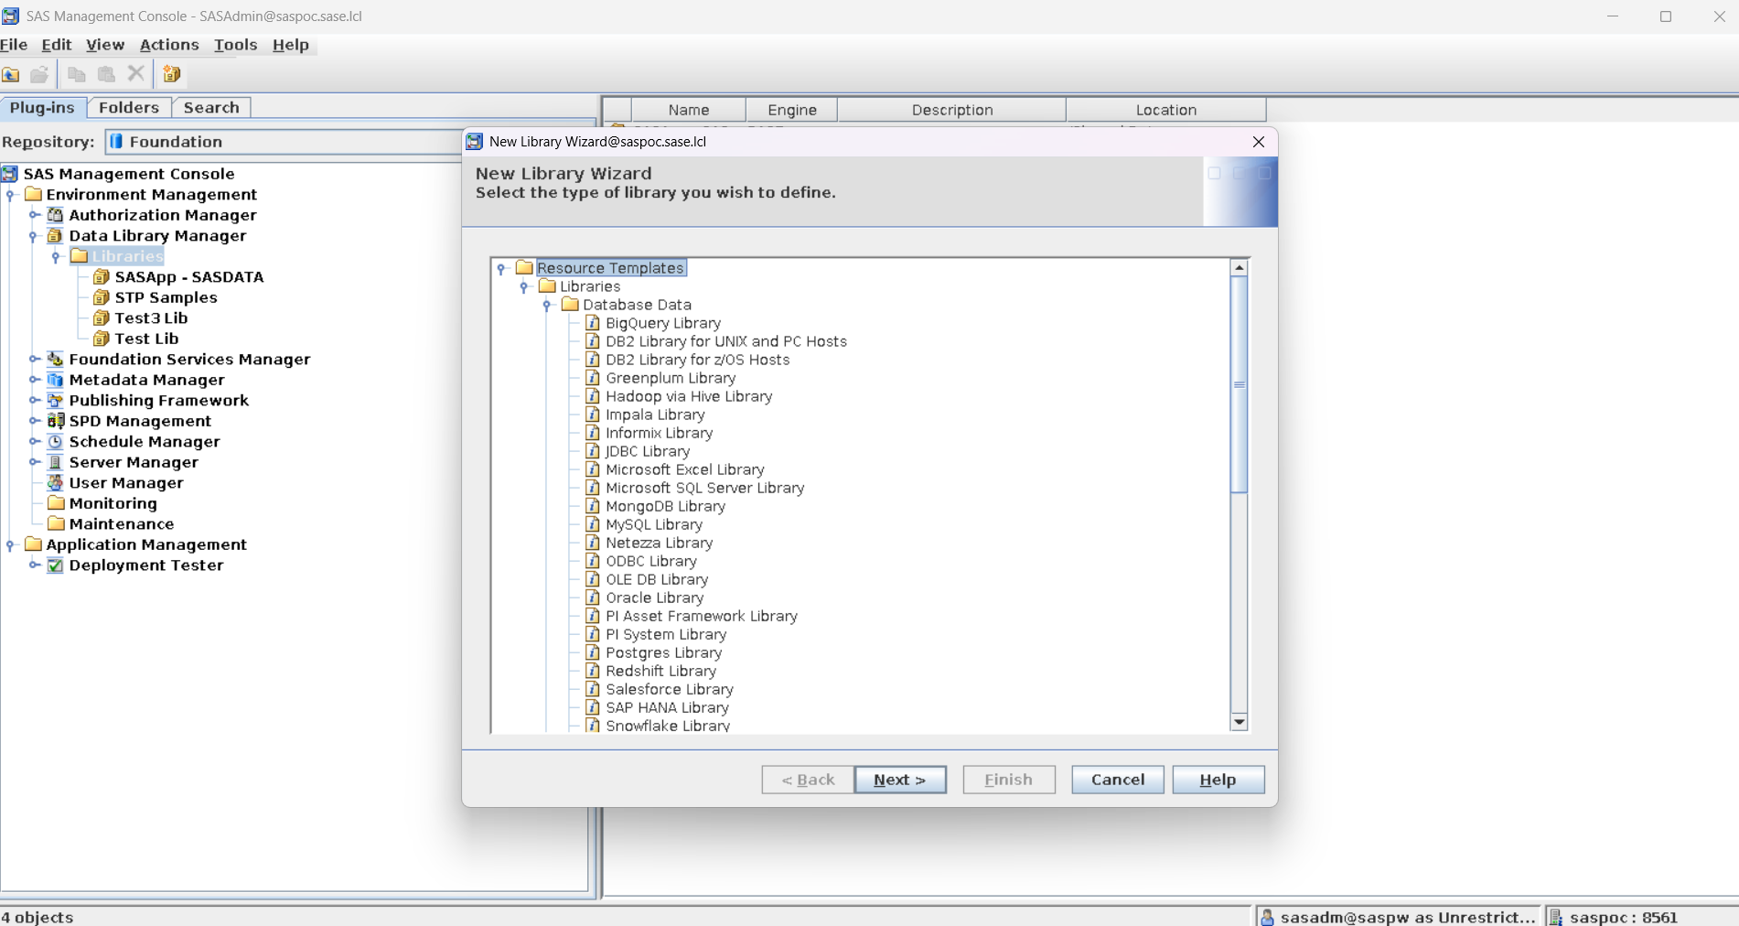

- Select SAS BASE Library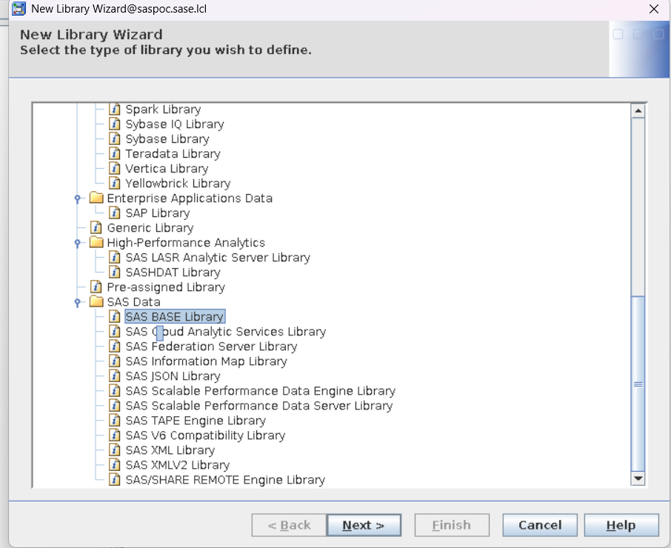

- Provide library details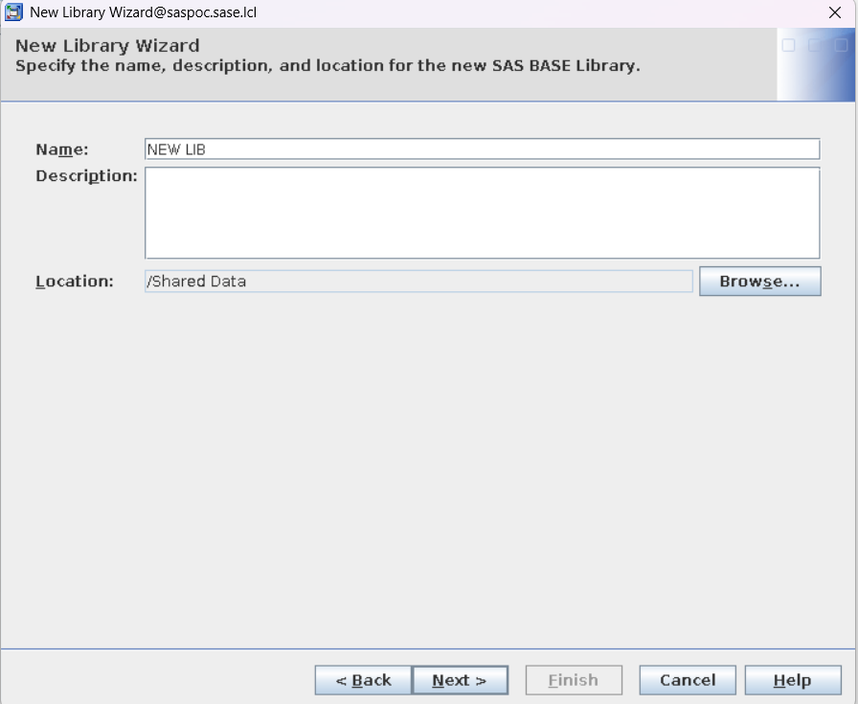

- Provide Libref and server-side filesystem path.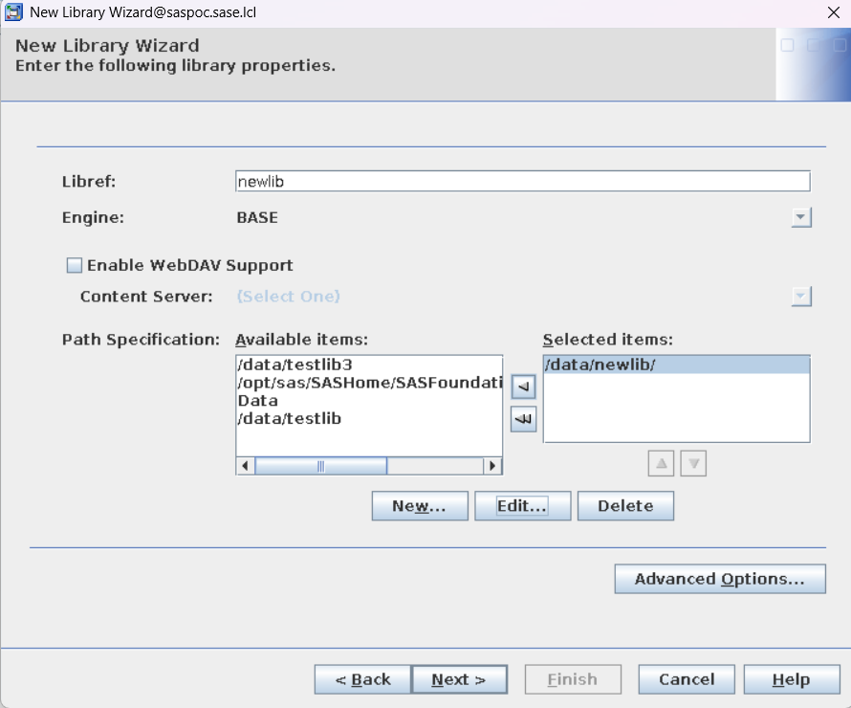

- Click Advance Options and select “Library is Pre-Assigned”.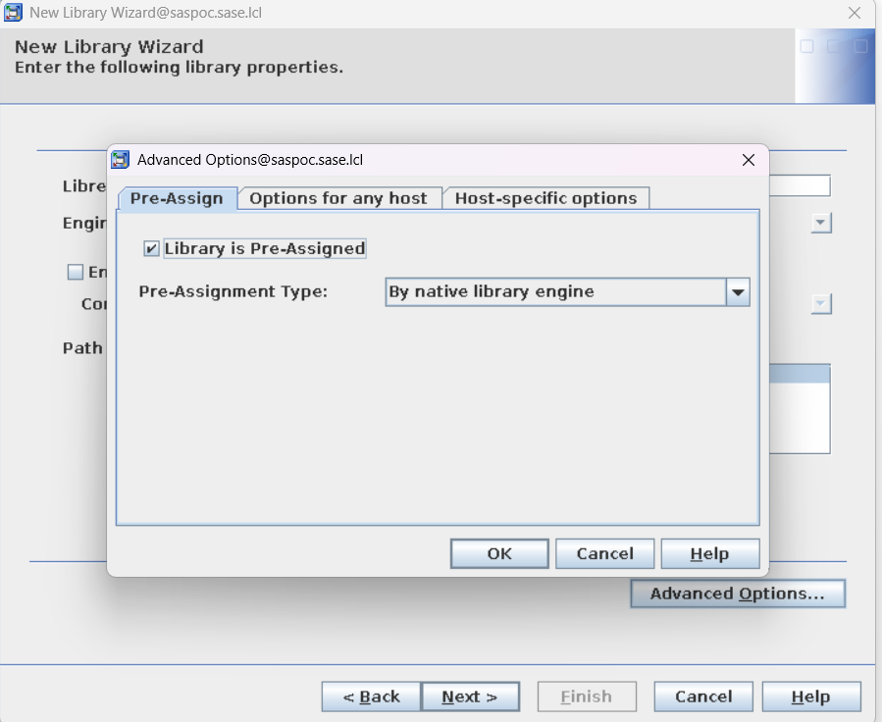

- Review Library details and create.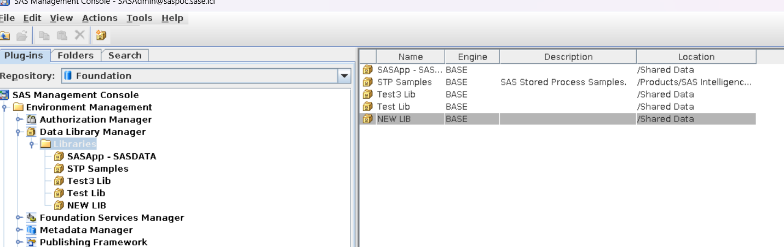

10.3 Give User access over SAS Data Library
- Open SMC → Libraries.
- Open properties of data libraries.
- On authorization tab, add the user or group and grant that users all permissions over library

Note: Make sure to remove PUBLIC permissions over library.
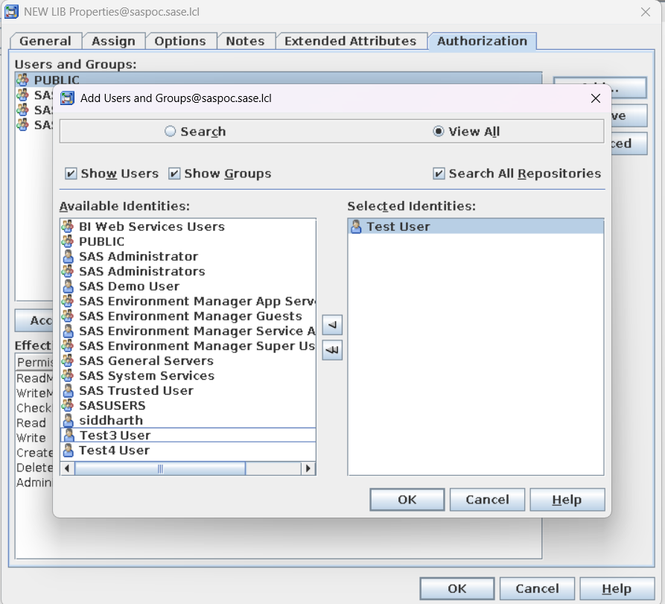
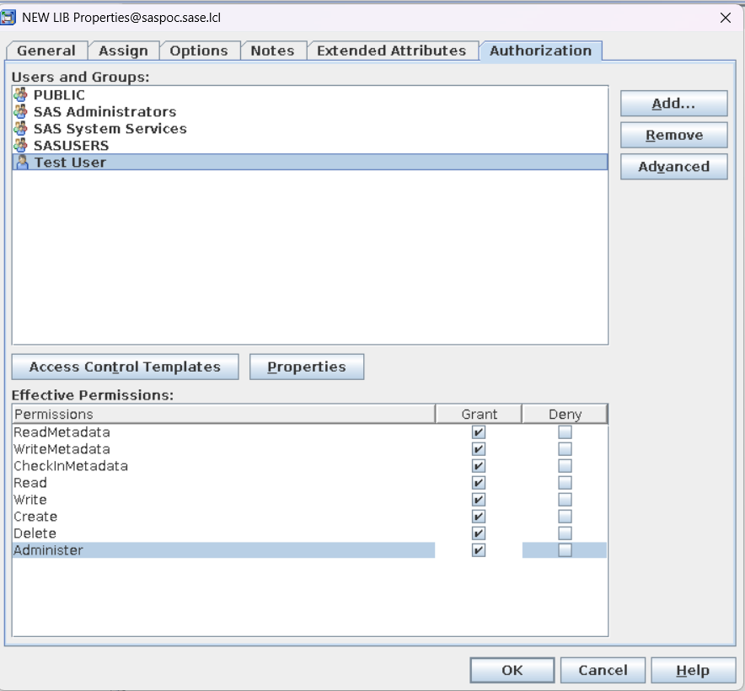

10.4 Allow XCMD and modify session timeout in SAS EG
- Open SMC, Server Manager → SASApp → SASApp - Logical Workspace Server → SASApp - Workspace Server → Properties → Options → Advanced Options → Launch Properties.
- Check Allow XCMD and modify Inactive client timeout (minutes) and apply.
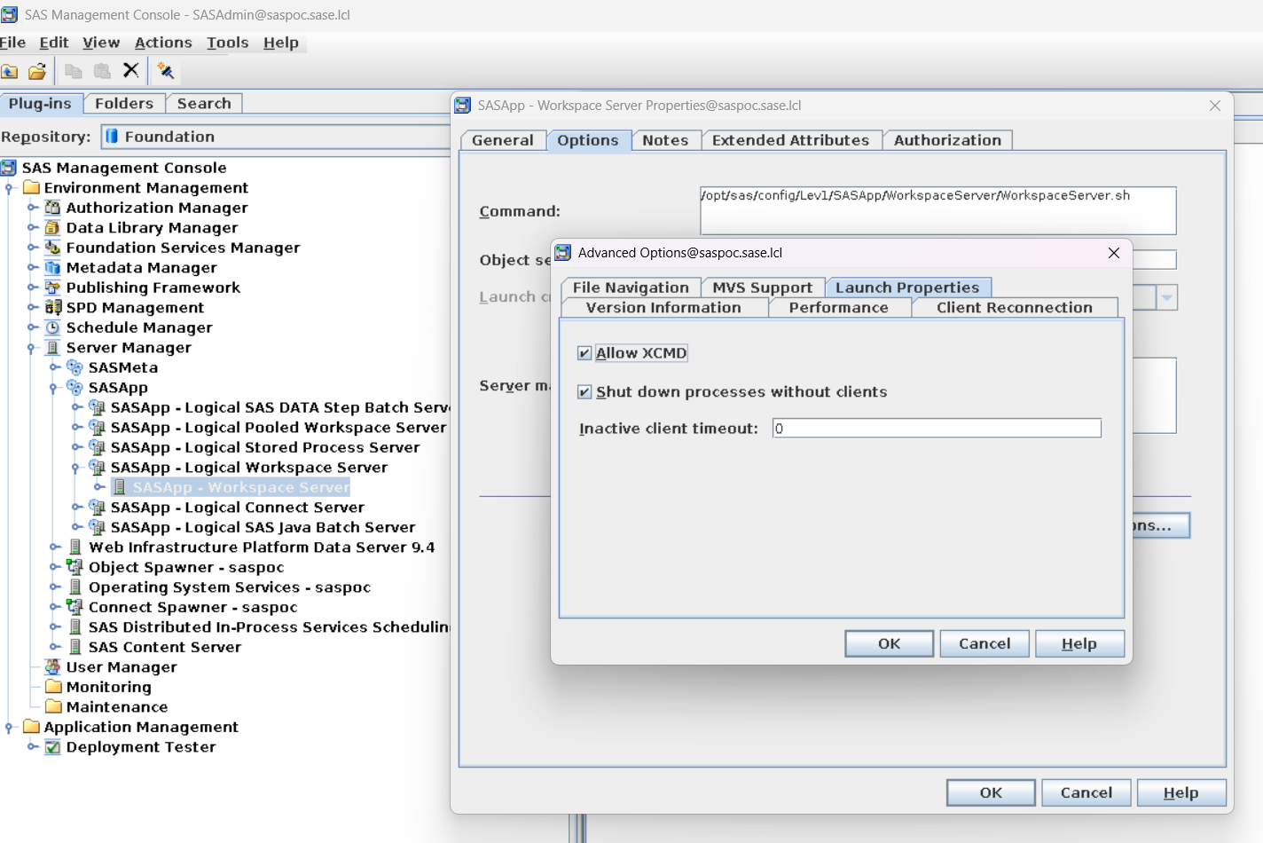

11. SASWORK and SASUTILLOC
If dedicated filesystems/directories have been provisioned for SAS temporary and utility data, update the SAS Foundation configuration file.
# /opt/sas/SASHome/SASFoundation/9.4/sasv9.cfg
-WORK /opt/sas/saswork
-SASUTILLOC /opt/sas/sasutil
Create the directories first, assign appropriate ownership/permissions to the SAS service accounts, and verify sufficient disk capacity. Changes should be validated with a test SAS session.
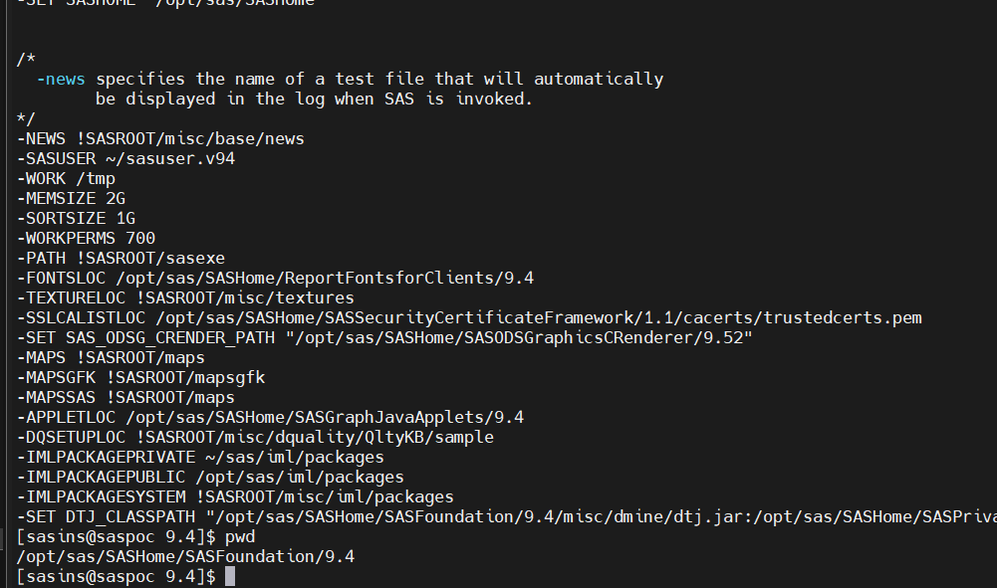

12. SAS Enterprise Guide

12.1 SAS Enterprise Guide Installation on Client/Jump Server
Copy the approved SAS Enterprise Guide independent installer from the SAS Software Depot to the Windows client/jump workstation and run it with appropriate Windows privileges.
sas-depot\standalone_installs\SAS_Enterprise_Guide_Independent_Installer\8_6\SASEnterpriseGuide86_x86_x64.exe
After installation, open SAS Enterprise Guide and configure the SAS server connection using the approved application account.

12.2 Verify SAS Enterprise Guide Installation
Confirm that SAS Enterprise Guide has been installed successfully.
- Open the Windows Start menu.
- Search for SAS Enterprise Guide.
- Launch the application.
- Expected Result
SAS Enterprise Guide launches successfully without any errors.
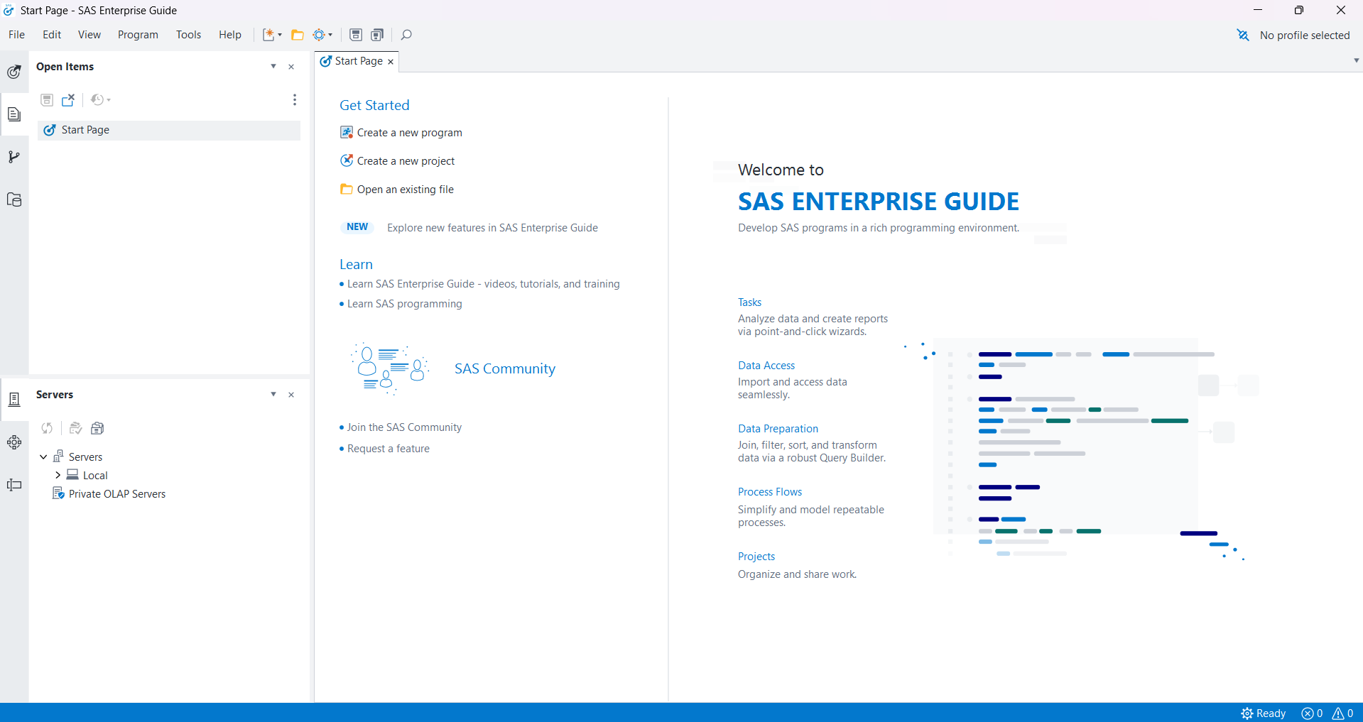
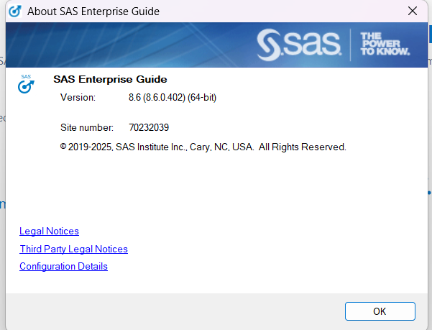

12.3 SAS Enterprise Guide Connection
- Open SAS Enterprise Guide.
- Go to Tools → Connection → Profiles.
- Select Add.
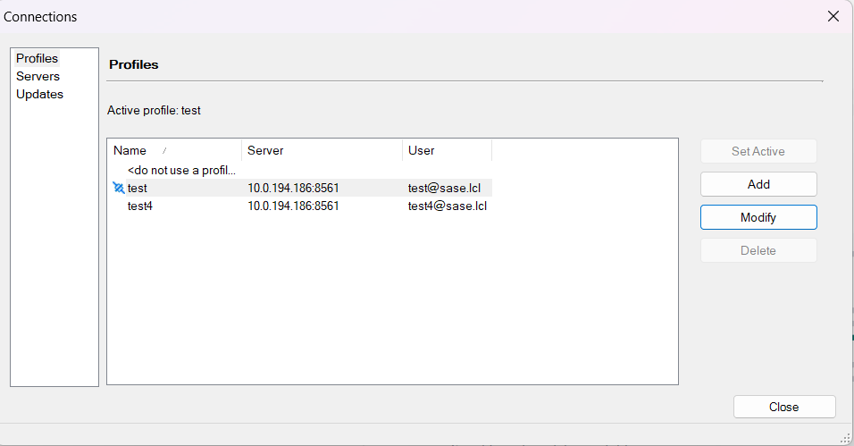
- Enter the SAS metadata/server connection details supplied for the DIB environment.
- Enter the authorized application username and authentication details.
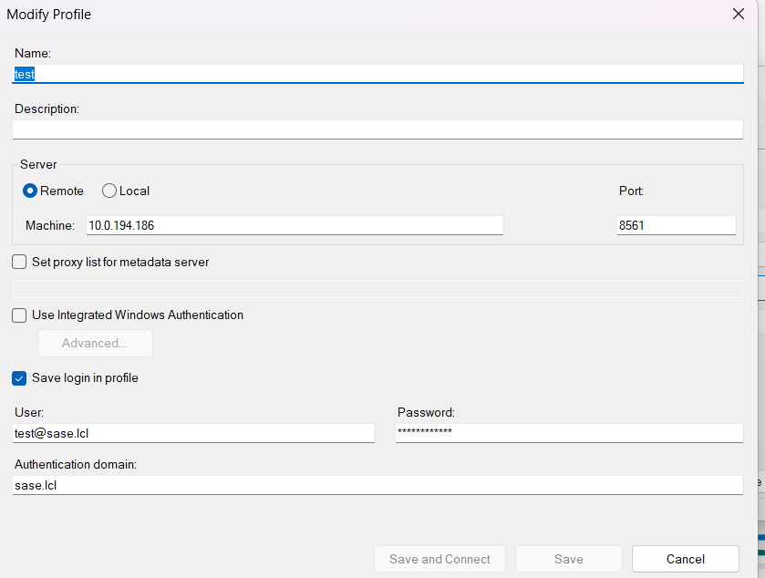
- Connect and verify that SASApp resources are visible.

12.4 Validate SAS License from SAS EG
Verify that the SAS license has been applied successfully.
Execute the following SAS program.
proc setinit;
run;
Expected Result
- The SAS log displays the license information.
- The site number and expiration date are displayed.
- No ERROR or WARNING messages are reported.
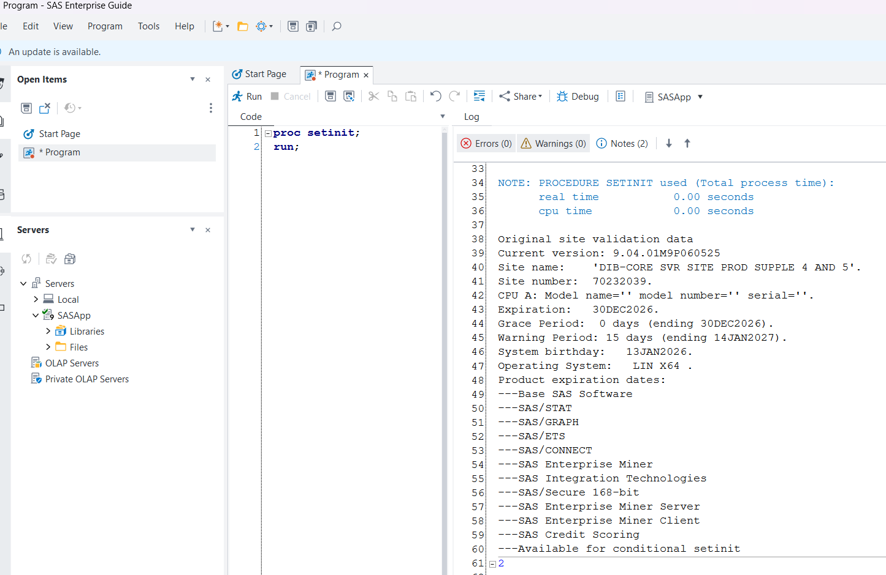

13. Shared Data Directory in SAS EG
- Create a Shared data directory on SAS Server machine on path /data/shared

- To make this shared data directory for users in SAS EG
sudo ln -s /sasdata/shared/ /home/<user1>/
sudo ln -s /sasdata/shared/ /home/<user2>/
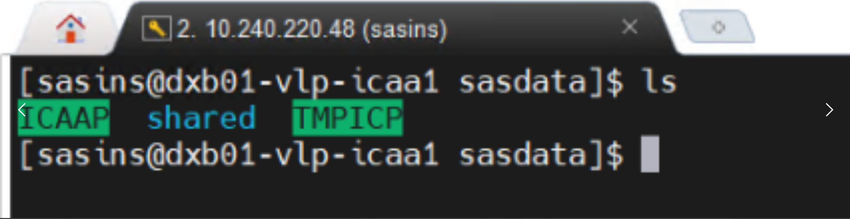

- Verify shared directory in SAS EG using user1 and user2 profile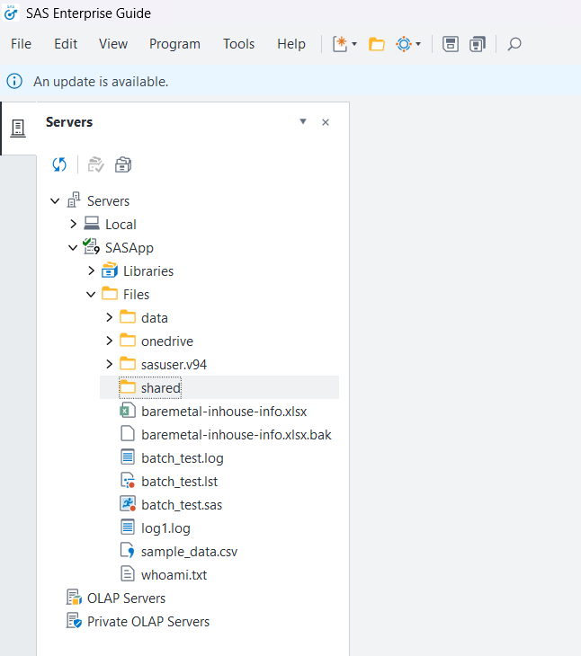

14. SAS/ACCESS to DB2

14.1 Install IBM DB2 Client
The SAS/ACCESS Interface to DB2 requires the IBM DB2 Client to be installed on the SAS server so that SAS can communicate with the DB2 database using the native DB2 CLI libraries.

Download the IBM DB2 Client
Download the IBM Data Server Client installation package from the IBM Support / Fix Central site:
- IBM site: https://www.ibm.com/support/fixcentral
- An IBM login (IBM ID) is required to download the package.
- Package used for this installation: v11.5.7_linuxx64_client.tar

Select the Linux x86_64 client package matching the DB2 client version required (v11.5.7 in this case), and download it to the SAS server or transfer it to the server after downloading.
Extract the Installation Package
Copy the downloaded tar file to a working directory on the SAS server and extract it:
$ tar -xvf v11.5.7_linuxx64_client.tar
This creates a client directory (typically named client) containing the db2_install script and related installation files.

Run the DB2 Client Installation
Run the db2_install script as the SAS installation owner (or with appropriate privileges) and specify the target installation directory when prompted:

$ cd client
$ ./db2_install

Once the installation completes, the DB2 client libraries and utilities are available under the installation path (/home/sasins/sqllib), including the following key subdirectories:
- bin – DB2 client executables and utilities
- lib32 / lib64 – DB2 client shared libraries (32-bit and 64-bit)
- gskit – GSKit security libraries used for SSL connections
- db2profile – environment setup script for the DB2 instance

Verify the installation by confirming the sqllib directory structure:
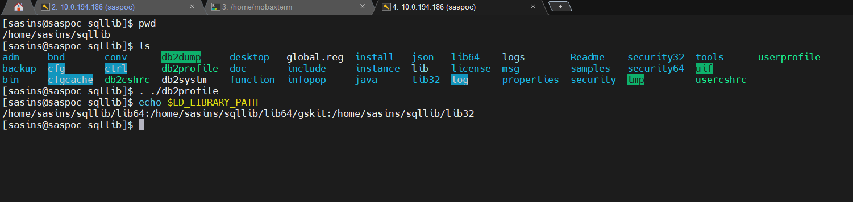

14.2 Setup ODBC Drivers
SAS/ACCESS to DB2 connects through ODBC, so an ODBC driver manager and the DB2 ODBC driver definitions must be configured on the SAS server.
- Install the unixODBC driver manager at the /sasinst/ODBC path using the package manager:
sudo dnf install unixODBC.x86_64

- Configure odbc.ini with DB2 Server Details
Edit /sasinst/ODBC/etc/odbc.ini to define the DB2 data source(s) that SAS will connect through. Each data source is defined as a named stanza, for example: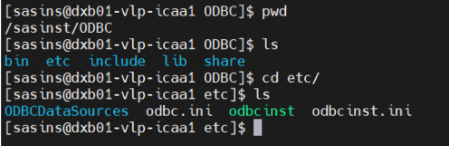

[BLUDB]
Driver=/home/sasins/sqllib/lib64/libdb2o.so.1
Description=Sample DB2 ODBC Database
DriverUnicodeType=1

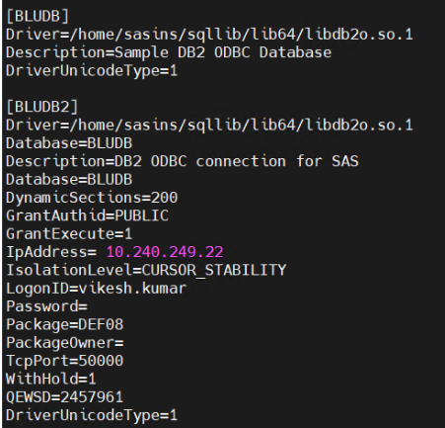

14.3 Configure DB2 Path in SAS
SAS must be able to locate the DB2 client libraries and the ODBC configuration files at startup. This is done through the SAS configuration file and the local SAS environment script.
Edit /sasinst/SASHome/SASFoundation/9.4/bin/sasv9.cfg the SAS configuration file to reference the DB2 and ODBC environment:
Add or confirm entries so that LD_LIBRARY_PATH includes the DB2 client libraries, DB2DIR points to the DB2 client installation, and the db2profile script is sourced at SAS startup.
ODBCINI=/sasinst/ODBC/etc/odbc.ini
export ODBCINI
ODBCSYSINI=/sasconf/config
export ODBCSYSINI

. /home/sasins/sqllib/db2profile
export LD_LIBRARY_PATH=/usr/lib64:$LD_LIBRARY_PATH
export DB2DIR=/home/sasins/sqllib

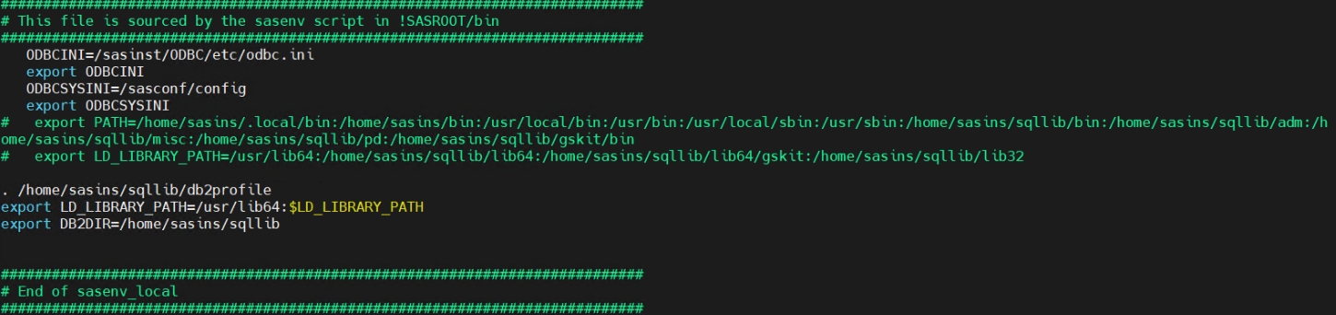

14.4 Create DB2 Libraries in SAS Enterprise Guide
With the DB2 client, ODBC driver, and SAS environment configured, DB2 libraries can be defined in a SAS program using the SAS/ACCESS DB2 engine. Open SAS Enterprise Guide, create a new program, and submit the following:
OPTIONS COMPRESS=YES;
%LET my_password = "{SAS004}**************************************";
%LET my_id = "<USER_ID>";

LIBNAME VCDRDB2 DB2 DATASRC=BLUDB SCHEMA=DMP_VCDR
USER=&MY_ID. PASSWORD=&MY_PASSWORD.
DIRECT_EXE=DELETE PRESERVE_TAB_NAMES=YES;

LIBNAME ANOVADB2 DB2 DATASRC=BLUDB SCHEMA=DMP_ANOVA
USER=&MY_ID. PASSWORD=&MY_PASSWORD.
DIRECT_EXE=DELETE PRESERVE_TAB_NAMES=YES;

Once the libraries are created successfully, validate the connection by retrieving data from a DB2 table through the new library.
In SAS Enterprise Guide, submit a simple procedure against a table in the DB2 library, for example:
PROC MEANS DATA=ANOVADB2.AA_MD501_CST_VAR;
RUN;
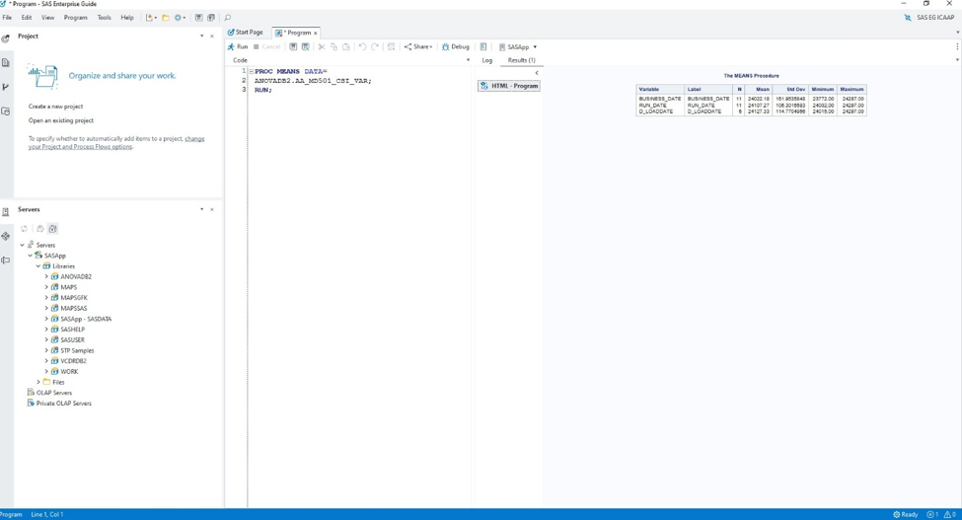
A successful configuration returns the summary statistics from the DB2 table (N, Mean, Std Dev, Minimum, Maximum) in the SAS Enterprise Guide results pane, confirming that SAS is able to connect to DB2 through the configured ODBC/SAS-ACCESS setup and read data from the DMP_ANOVA schema.

15. Home directory for application users
Create a Home directory for new created domain user, which will going to use SAS application.
Run a /sasconf/create-ad-homes.sh script to create Home directory on SAS Server machine for AD user who are part of SAS Application group.
cd /sasconf
./create-ad-homes.sh

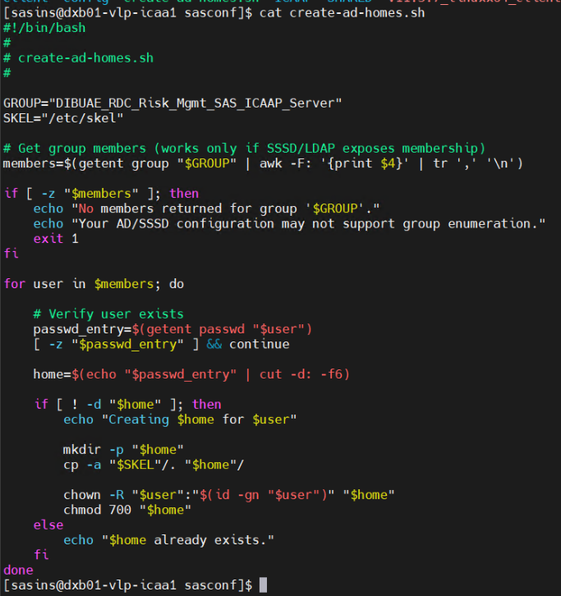

16. References
- SAS Download Manager: https://www.sas.com/downloadmgr
- SAS Plan Application: https://support.sas.com/planapp
- SAS Support: https://support.sas.com/
- SAS 9.4 Intelligence Platform: https://support.sas.com/en/documentation/install-center/94/intelligence-platform.html
- SAS third-party software reference: https://support.sas.com/en/documentation/third-party-software-reference/9-4/support-for-other-products.html
- IBM Site: https://www.ibm.com/support/fixcentral

