

APPLICATION PROGRAMMING PRACTICLE FILE

INDIAN INSTITUTE OF INFORMATION TECHNOLOGY, SONEPAT



Ravi Sehrawat

CSE

11911009

**INDEX**

|  |  |
| --- | --- |
| SR.  NO. | PROGRAM NAME |
| 1. | Write a program for creating HTML Form |
| 2. | Write a program for creating Homepage using HTML |
| 3. | Write a program to understand XHTML and CSS |
| 4. | Setting up and configuration of apache Tomcat server |
| 5. | Understanding modification of Web.XML(in separate file) |
| 6. | Write a program for Creating Website using PHP |
| **7.** | Write a program to understand the JavaScript |
| **8.** | Create web application which has front-end in JS and back-end in PHP which runs from apache local server |
| **9.** | Writing and understanding program in python |
| **10.** | Using python libraries to do scientific calculations |

## Write a program for creating HTML Form

1

HTML Code :

|  |
| --- |
| <!DOCTYPE html> |
|  | <html lang="en"> |
|  | <meta charset="utf-8"> |
|  | <head> |
|  | <title>HTML Forms</title> |
|  | <link rel="stylesheet" type="text/css" href="style.css"> |
|  | </head> |
|  | <body> |
|  | <div class="a"> |
|  | <h1>Student Form</h1> |
|  | <img src="http://iiitsonepat.ac.in/iiits-content/uploads/2019/06/logonew.png" alt="Logo" width="60%"> |
|  | </div> |
|  | <div class="abc"> |
|  | <form class="" action="Submit.html" method="post"> |
|  | <div class="ab"> |
|  | <table width="100%"> |
|  | <tr> |
|  | <td>Name:</td> |
|  | <td><input type="text" placeholder="Enter Your Name Here" required></td> |
|  | </tr> |
|  | <tr> |
|  | <td>Roll No:</td> |
|  | <td> <input type="text" placeholder="Enter Your Roll No here" required></td> |
|  | </tr> |
|  | <tr> |
|  | <td>Mobile No:</td> |
|  | <td><input type="tel" placeholder="Enter Your Number Here" pattern="[789][0-9]{9}" required></td> |
|  | </tr> |
|  | <tr> |
|  | <td>E-mail:</td> |
|  | <td><input type="email" placeholder="Enter Your E-mail Here" required></td> |
|  | </tr> |
|  | <td>College:</td> |
|  | <td><input type="text" placeholder="Enter Your College Name"></td> |
|  | </table><br><br><br> |
|  | <table width="100%"> |
|  | <tr> |
|  | <td><input type="submit" value="Submit"></td> |
|  | <td><input type="reset" value="Clear"></td> |
|  | </tr> |
|  | </table> |
|  | </div> |
|  | </form> |
|  | </div> |
|  |  |
|  | </body> |
|  | </html> |

CSS CODE:

|  |
| --- |
| body{ background-color : white; |
|  | } |
|  | .abc{ margin :0px 300px 200px 300px ; |
|  | } |
|  | .ab{ margin : auto; |
|  | background-color: grey; |
|  | } |
|  | input[type=text],input[type=email]{ width : 90%; |
|  | } |
|  | .a{ padding : 20px; |
|  | text-align :center; |
|  |  |
|  | } |

HTML SUBMIT CODE :

|  |
| --- |
| <!DOCTYPE html> |
|  | <html lang="en"> |
|  | <meta charset="utf-8"> |
|  | <head> |
|  | <title>Successful Submission</title> |
|  | </head> |
|  | <body> |
|  | <h1>You have succesfully submitted the form!!</h1> |
|  | <button onclick="document.location = 'form.html'">click here to submit another form</button> |
|  | </body> |
|  | </html> |

OUTPUT :

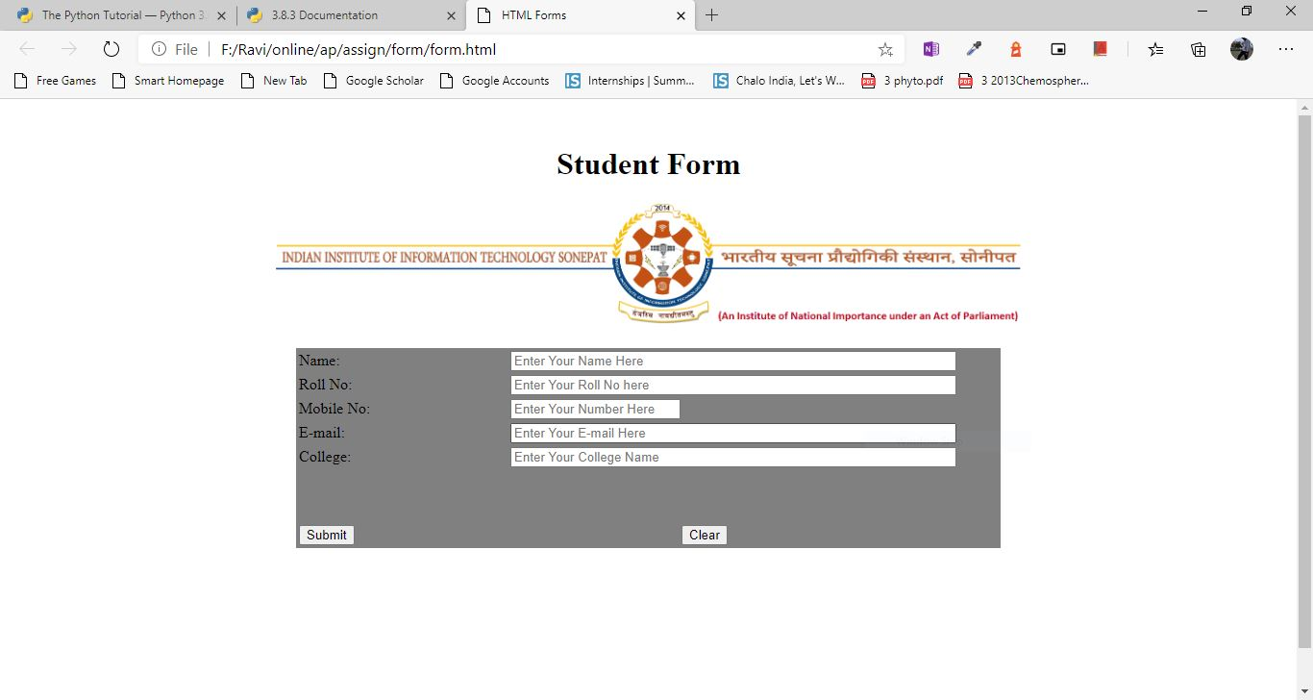

## Write a program for creating Homepage using HTML

2

HTML Code :

|  |
| --- |
| <!DOCTYPE html> |
|  | <html> |
|  | <meta charset="UTF-8"> |
|  | <head> |
|  | <title> homepage </title> |
|  | <link rel="stylesheet" type="text/css" href="style.css"> |
|  | </head> |
|  | <body> |
|  |  |
|  | <div> |
|  | <img src="http://iiitsonepat.ac.in/iiits-content/uploads/2019/06/logonew.png" alt="Logo" width="100%"> |
|  | </div> |
|  |  |
|  | <div class="navbar"> |
|  | <a href="#">Home</a> |
|  | <a href="#">Admission</a> |
|  | <a href="#">Academics</a> |
|  | <a href="#" class="right">Covid-19 Notes</a> |
|  | </div> |
|  |  |
|  | <section> |
|  | <img class="mySlides" src="http://iiitsonepat.ac.in/iiits-content/uploads/2018/06/new-banner3.jpg" style="width:100%"> |
|  | <img class="mySlides" src="http://iiitsonepat.ac.in/iiits-content/uploads/2018/06/new-banner2.jpg" style="width:100%"> |
|  | <img class="mySlides" src="http://iiitsonepat.ac.in/iiits-content/uploads/2018/06/new-banner4.jpg" style="width:100%"> |
|  | </section> |
|  |  |
|  | <script> |
|  |  |
|  | var myIndex = 0; |
|  | carousel(); |
|  |  |
|  | function carousel() { |
|  | var i; |
|  | var x = document.getElementsByClassName("mySlides"); |
|  | for (i = 0; i < x.length; i++) { |
|  | x[i].style.display = "none"; |
|  | } |
|  | myIndex++; |
|  | if (myIndex > x.length) {myIndex = 1} |
|  | x[myIndex-1].style.display = "block"; |
|  | setTimeout(carousel, 3000); |
|  | } |
|  | </script> |
|  |  |
|  | </body> |
|  | </html> |

CSS CODE :

|  |
| --- |
| .navbar { |
|  | overflow: hidden; |
|  | background-color: #333; |
|  |  |
|  | } |
|  |  |
|  | .navbar a { |
|  | float: left; |
|  | display: block; |
|  | color: white; |
|  | text-align: center; |
|  | padding: 14px 20px; |
|  | text-decoration: none; |
|  | } |
|  |  |
|  | .navbar a.right { |
|  | float: right; |
|  | } |
|  |  |
|  | .navbar a:hover { |
|  | background-color: #ddd; |
|  | color: black; |
|  | } |

OUTPUT :

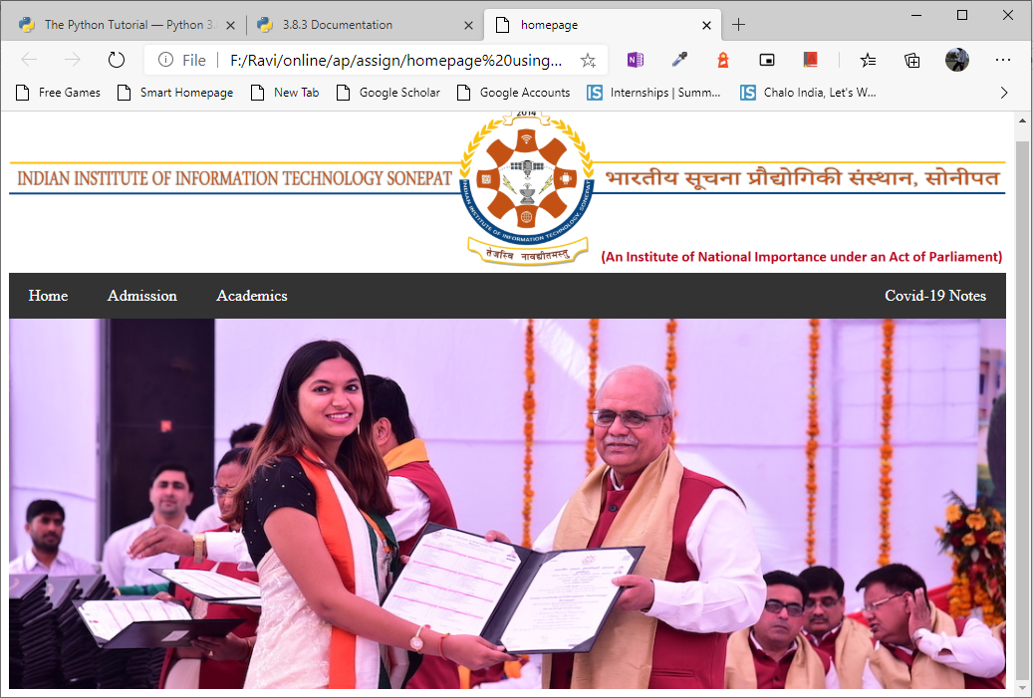

## Write a program to understand XHTML and CSS

## 3

HTML CODE :

|  |
| --- |
| <!DOCTYPE html PUBLIC "-//W3C//DTD XHTML 1.1//EN" |
|  | "http://www.w3.org/TR/xhtml11/DTD/xhtml11.dtd"> |
|  | <html xmlns="http://www.w3.org/1999/xhtml"> |
|  | <head> |
|  | <title>xhtml & css</title> |
|  | <link rel="stylesheet" type="text/css" href="a.css"/> |
|  | </head> |
|  | <body> |
|  |  |
|  | <p> |
|  |  |
|  | <a href="mailto:abc@gmail.com"><img src="https://encrypted-tbn0.gstatic.com/images?q=tbn%3AANd9GcRMyYneZ0ipxdRWLHnuKMPv0Re7vtVNHAwIK34m-AbHEhMhpuBH&usqp=CAU" alt="imgage as email link" /></a> |
|  | <br/> |
|  | <hr/> |
|  | <img src="https://cdn0.tnwcdn.com/wp-content/blogs.dir/1/files/2018/04/Gmail-dfs-new.jpg" alt="This is Gmail logo"/> |
|  | <br/> |
|  | <hr/> |
|  | <a href="mailto:abc@gmail.com"><img src="https://encrypted-tbn0.gstatic.com/images?q=tbn%3AANd9GcRstEPEvHHb-HKtVnZo9gHR4I6f8RmgH9ZreSnrHfGx2SDOoxKR&usqp=CAU" alt="This is gmail link"/></a> |
|  | </p> |
|  |  |
|  | </body> |
|  | </html> |

CSS CODE:

body{background-color:#fccfcc}

OUTPUT:

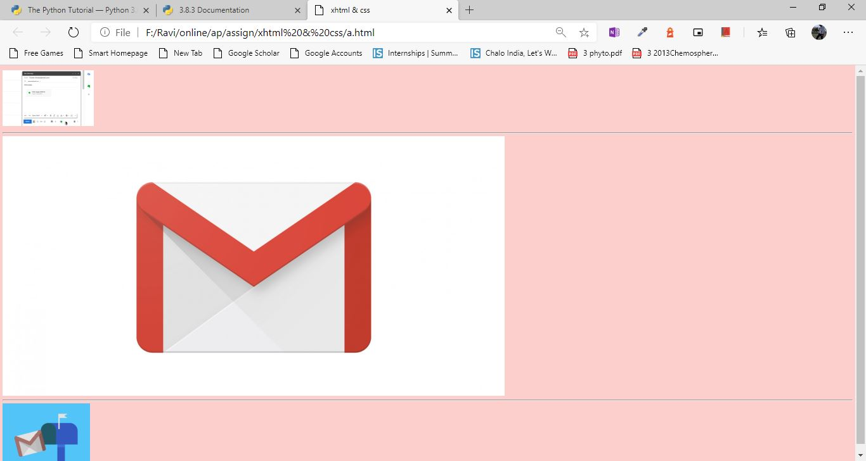

## Setting up and configuration of apache Tomcat server

## 4

s

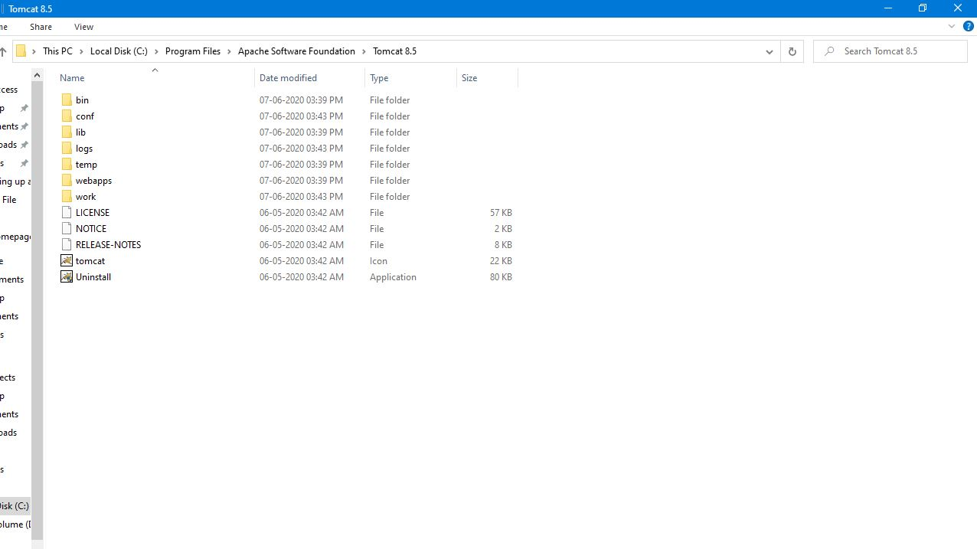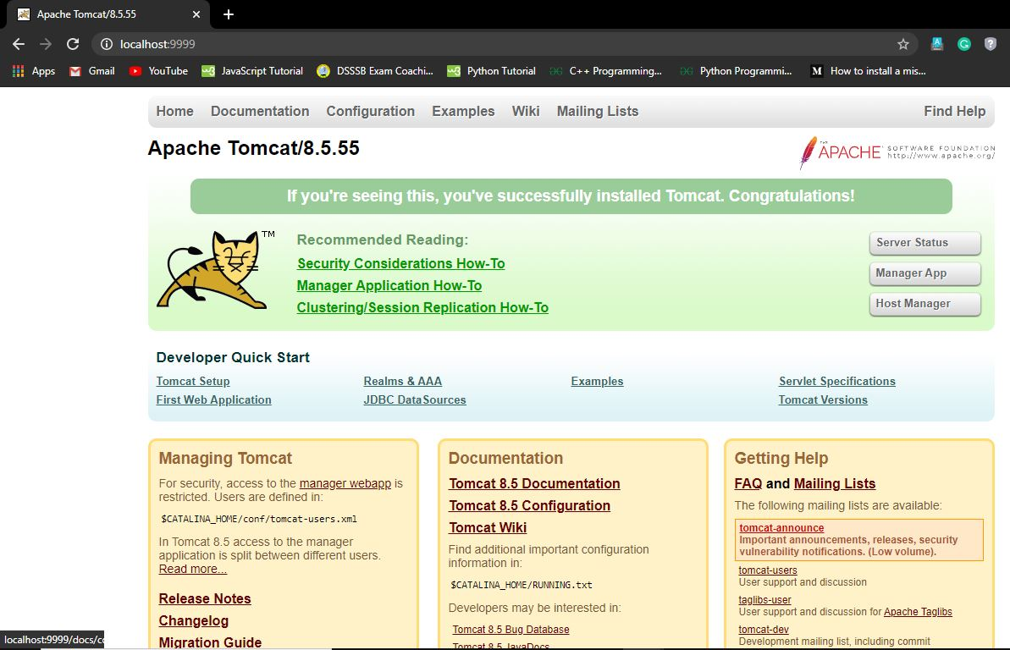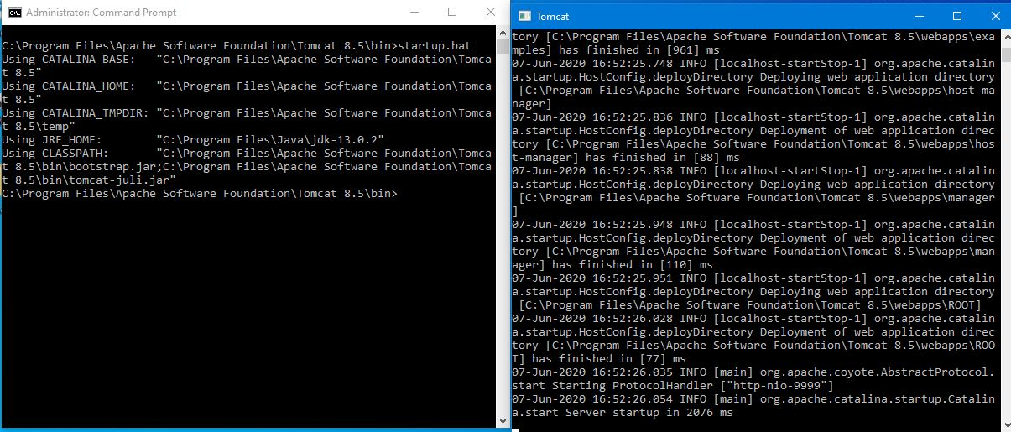

## 6

## Write a program for Creating Website using PHP

HTML code:

|  |
| --- |
| <!DOCTYPE html> |
|  | <html> |
|  | <meta charset="UTF-8"> |
|  | <head> |
|  | <title> homepage </title> |
|  | <link rel="stylesheet" type="text/css" href="style.css"> |
|  | </head> |
|  | <body> |
|  |  |
|  | <div> |
|  | <img src="http://iiitsonepat.ac.in/iiits-content/uploads/2019/06/logonew.png" alt="Logo" width="100%"> |
|  | </div> |
|  |  |
|  | <div class="navbar"> |
|  | <a href="1.php">Home</a> |
|  | <a href="#">Admission</a> |
|  | <a href="#">Academics</a> |
|  | <a href="#" class="right">Covid-19 Notes</a> |
|  | </div> |
|  |  |
|  | <section> |
|  | <img class="mySlides" src="http://iiitsonepat.ac.in/iiits-content/uploads/2018/06/new-banner3.jpg" style="width:100%"> |
|  | <img class="mySlides" src="http://iiitsonepat.ac.in/iiits-content/uploads/2018/06/new-banner2.jpg" style="width:100%"> |
|  | <img class="mySlides" src="http://iiitsonepat.ac.in/iiits-content/uploads/2018/06/new-banner4.jpg" style="width:100%"> |
|  | </section> |
|  |  |
|  | <script> |
|  |  |
|  | var myIndex = 0; |
|  | carousel(); |
|  |  |
|  | function carousel() { |
|  | var i; |
|  | var x = document.getElementsByClassName("mySlides"); |
|  | for (i = 0; i < x.length; i++) { |
|  | x[i].style.display = "none"; |
|  | } |
|  | myIndex++; |
|  | if (myIndex > x.length) {myIndex = 1} |
|  | x[myIndex-1].style.display = "block"; |
|  | setTimeout(carousel, 3000); |
|  | } |
|  | </script> |
|  |  |
|  | </body> |
|  | </html> |

CSS CODE:

|  |
| --- |
| .navbar { |
|  | overflow: hidden; |
|  | background-color: #333; |
|  | } |
|  |  |
|  | .navbar a { |
|  | float: left; |
|  | display: block; |
|  | color: white; |
|  | text-align: center; |
|  | padding: 14px 20px; |
|  | text-decoration: none; |
|  | } |
|  |  |
|  | .navbar a.right { |
|  | float: right; |
|  | } |
|  |  |
|  | .navbar a:hover { |
|  | background-color: #ddd; |
|  | color: black; |
|  | } |

PHP CODE:

<?php echo file_get_contents("a.html");?>

Output:



## Write a program to understand the JavaScript

## 7

## HTML CODE:

|  |
| --- |
| <!DOCTYPE html> |
|  | <html lang="en"> |
|  | <head> |
|  | <title>Regular expression</title> |
|  | <script> |
|  | function validate() |
|  | { |
|  | var username=document.getElementById("uname").value; |
|  | var regx=/ABC/; |
|  | if(regx.test(username)) |
|  | { |
|  | alert("valid username"); |
|  | } |
|  | else{ |
|  | alert("invalid username"); |
|  | } |
|  | } |
|  | </script> |
|  | </head> |
|  | <body> |
|  | <form action="message.html"> |
|  | <input id="uname" placeholder="username" type="text"/> |
|  | <button onclick="validate()" type="button" >submit</button> |
|  | </form> |
|  | </body> |
|  | </html> |

Output:

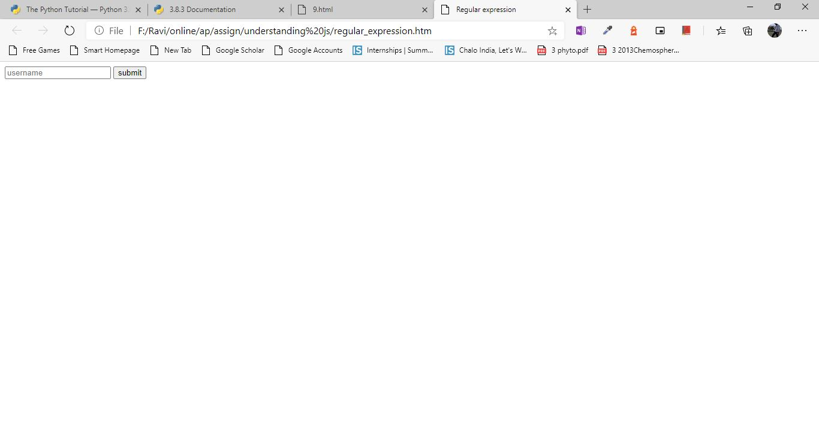

HTML CODE:

|  |
| --- |
| <!DOCTYPE html> |
|  | <html lang="en"> |
|  | <head> |
|  | <script> |
|  | function create() |
|  | { |
|  | if(document.myform.username.value=="") |
|  | { |
|  | alert("enter some value"); |
|  | return; |
|  | } |
|  | var cookievalue=escape(document.myform.username.value); |
|  | document.cookie="name="+ cookievalue; |
|  | document.write("setting cookie :"+"name=" + cookievalue)' |
|  | } |
|  | </script> |
|  | </head> |
|  | <body> |
|  | <form name="myform"> |
|  | <input type="text" name="username"/> |
|  | <input type="button" value="set cookie" onclick="create();"/> |
|  | </form> |
|  | </body> |
|  | </html> |

Output:

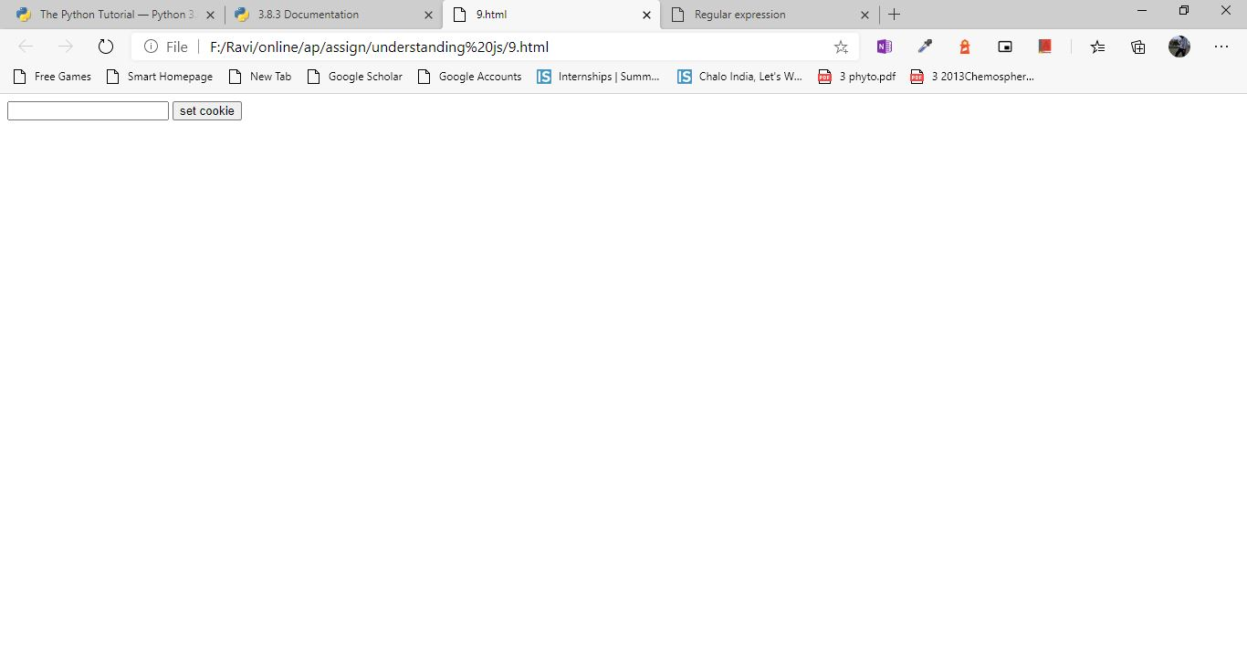

## Create web application which has front-end in JS and back-end in PHP which runs from apache local server

## 8

## Html code:

|  |
| --- |
| <?php |
|  |  |
|  | if(isset($_POST['submit'])) |
|  | {$usrnm=$_POST['username']; |
|  | $pss=$_POST['password']; |
|  | if((strlen($usrnm)<=5) or (strlen($pss)<=8) ) |
|  | { |
|  | echo "Username must be 5 characters long and Password must be 8 characters long"; |
|  | } |
|  | } |
|  | ?> |
|  | <html> |
|  | <head> |
|  | <title>Registration Form</title> |
|  | <link rel="stylesheet" href="style.css"> |
|  | <script type="text/javascript" src="js.js"> |
|  | </script> |
|  | </head> |
|  | <body> |
|  | <div class="a"> |
|  | <table width="100%"> |
|  | <th class="a"><h1>Registration Form</h1></th> |
|  | </table> |
|  | </div> |
|  | <form method="POST" action=" " name="regform" onsubmit="return validate()"> |
|  | <fieldset> |
|  | <div class="abc"> |
|  | <table width="100%"> |
|  | <th><label width="50%">Username:</label> |
|  | <input type="text" placeholder="Enter your username here" name="username" ></th> |
|  | <th><label>Password:</label> |
|  | <input type="password" placeholder="Enter your password here" name="password" id="a1"></th> |
|  | </table> |
|  | <br> |
|  | </div> |
|  | </fieldset> |
|  | <hr> |
|  | <fieldset> |
|  | <legend><b>Personal details<b></legend> |
|  | <table width="100%"> |
|  | <th><label>First Name:</label> |
|  | <input type="text" placeholder="Type your first name here" id="a2"></th> |
|  | <th><label>Last Name:</label> |
|  | <input type="text" placeholder="Type your last name here" > |
|  | </th> |
|  | </table> |
|  | <label class="abcd">Gender</label> |
|  | <input type="radio" name="ab" value="male">Male |
|  | <input type="radio" name="ab" value="female">Female |
|  | <input type="radio" name="ab" value="others">Others |
|  | <br> |
|  | </fieldset> |
|  | <hr> |
|  | <fieldset> |
|  | <legend><b>Contact Info</b></legend> |
|  | <table width="100%"> |
|  | <th><label>E-mail:</label> |
|  | <input type="email" id="a3" placeholder="Enter your e-mail here" required></th> |
|  | <th><label>Mobile No:</label> |
|  | <input type="tel" id="a4" placeholder="Enter your mobile number" pattern="[789][0-9]{9}" required></th> |
|  | </table> |
|  | <br> |
|  | <fieldset> |
|  | <legend><b>Address</b></legend> |
|  | <table width="100%"> |
|  | <th><label>Permanent Address:</label> |
|  | <br> |
|  | <textarea name="name" rows="5" cols="40" id="a5" placeholder="Type your permanent address here"></textarea></th> |
|  | <th><label>Correspondence Address:</label> |
|  | <br> |
|  | <textarea name="name" rows="5" cols="40" placeholder="Type your correspondence address here"></textarea></th> |
|  | </table> |
|  | </fieldset> |
|  | </fieldset> |
|  | <table width="100%"> |
|  | <th><input type="submit" value="Submit" name="submit"></th> |
|  | <th><input type="reset" value="Clear"></th> |
|  | </table> |
|  | </form> |
|  | </body> |
|  | </html> |

CSS CODE:

|  |
| --- |
| body{box-sizing: border-box; |
|  | border: 3px solid green; |
|  | border-radius: 2px; |
|  | background-color: SlatebLUE} |
|  | legend{color: aqua;} |
|  | .abc{text-align: center; |
|  | margin: auto;} |
|  | input[type=text],input[type=Password],input[type=email],textarea{background-color: lightgrey;} |
|  | input[type=radio]{margin-left:70px; } |
|  | .abcd{margin-left: 200px;} |
|  | input[type=submit],input[type=reset]{background-color: ;; |
|  | width:40%; |
|  | height: 30px;} |
|  | .a{ text-align: center; |
|  | background-color: grey;} |

Javascript code:

|  |
| --- |
| function validate() |
|  | { var a= document.getElementById('a1').value; |
|  | var b=document.getElementById('a2').value; |
|  | var c= document.getElementById('a3').value; |
|  | var d=document.getElementById('a4').value; |
|  | var e=document.getElementById('a5').value; |
|  | var f=document.getElementById('ab').value; |
|  | if(a==" " || a==0) |
|  | { |
|  | alert("Please Enter Password"); |
|  | return false; |
|  | } |
|  | if(b==" " || b==0) |
|  | { |
|  | alert("Please Enter First Name"); |
|  | return false; |
|  | } |
|  | if(c==" " || c==0) |
|  | { alert("Please Enter a Valid E-mail"); |
|  | return false;} |
|  | if(d==" " || d==0 || d.length<10) |
|  | { alert("Please Enter a Valid Number"); |
|  | return false;} |
|  | if(e==" ") |
|  | { alert("Please Enter a valid address"); |
|  | return false;} |
|  | } |
|  | if(f==" ") |
|  | { alert("Please Enter a valid gender"); |
|  | return false;} |
|  | } |

PHP CODE:

|  |
| --- |
| <?php |
|  |  |
|  | if(isset($_POST['submit'])) |
|  | {$usrnm=$_POST['username']; |
|  | $pss=$_POST['password']; |
|  | if((strlen($usrnm)<=5) or (strlen($pss)<=8) ) |
|  | { |
|  | echo "Username must be 5 characters long and Password must be 8 characters long"; |
|  | } |
|  | } |
|  | ?> |

Output:

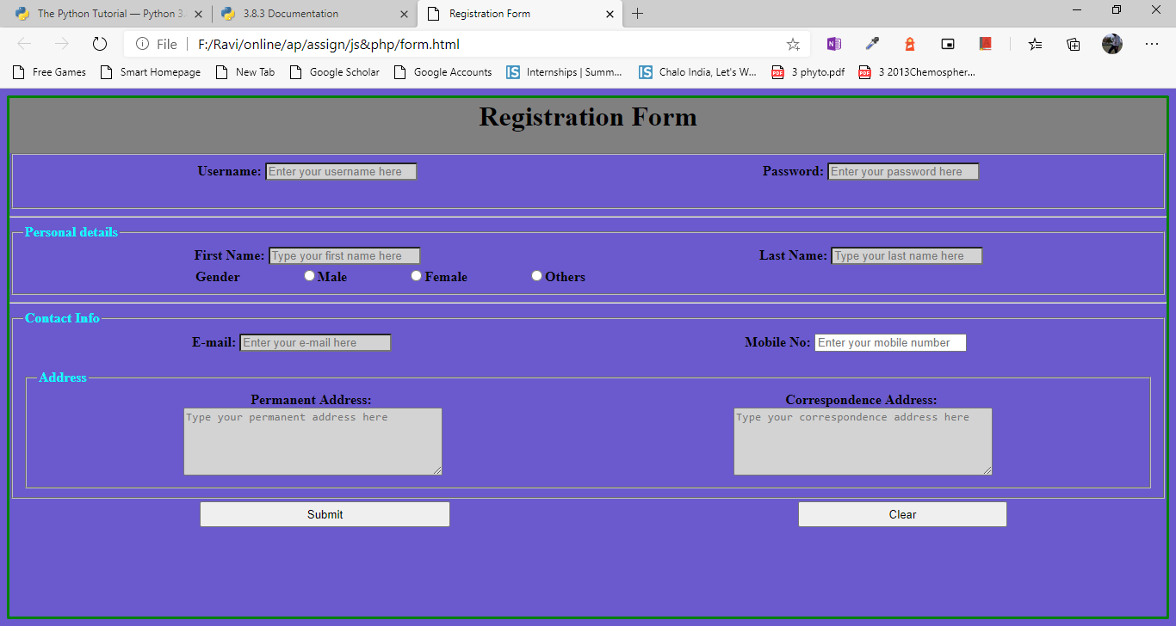

## Writing and understanding program in python

## 9

CODE:

|  |
| --- |
| x = input("Type a number: ") |
|  | y = input("Type another number: ") |
|  |  |
|  | sum = int(x) + int(y) |
|  |  |
|  | print("The sum is: ", sum) |
|  |  |

OUTPUT:

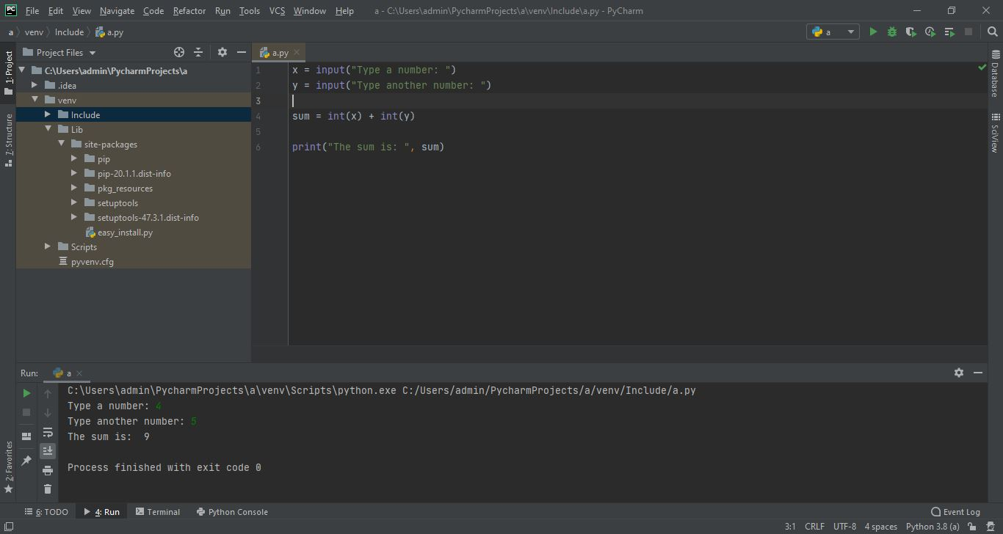

## Using python libraries to do scientific calculations

## 10

CODE:

|  |
| --- |
| import math |
|  | x = math.sqrt(64) |
|  | print(x) |
|  | y = pow(4, 3) |
|  | print(y |

OUTPUT:

