**Project: Sales Analyzer**

**Repository:** [**Datafactz Project**](https://github.com/ravish0409/datafactz-project)

**Overview**

The **Sales Data Dashboard** is an interactive application that visualizes sales data using Python's Tkinter library for the graphical user interface (GUI) and Matplotlib for generating visual charts. It allows users to explore various aspects of the sales data through charts, such as revenue by region, profit by country, sales by item type, and revenue over time. This project uses a CSV file (5000 Sales Records.csv) as the data source and processes it with Pandas.

The dashboard includes multiple types of visualizations and sorting mechanisms for easy data interpretation. Users can select different views and sort data in ascending or descending order.

**Project Dependencies**

To run this project, ensure that the following Python libraries are installed:

* tkinter: for creating the GUI
* pandas: for data manipulation and analysis
* matplotlib: for generating charts and plots
* matplotlib.backends.backend_tkagg: for embedding Matplotlib figures in the Tkinter window

**Project Structure**

1. **Dashboard Class**: The core class responsible for the creation of the GUI, loading the data, and displaying various visualizations.

**Attributes**:

* root: Main window for the GUI.
* data: The sales data loaded from a CSV file.
* sort_var: Controls the sorting order (ascending, descending, or none).
* active_button: Tracks the currently active button to display the relevant chart.
* region_var: Stores the selected region for region-based filtering.

1. **Methods**:
   * **__init__()**: Initializes the GUI, loads the data, and sets up the layout.
   * **load_data()**: Reads and preprocesses the sales data from the CSV file. Handles missing or non-numeric values and converts date columns.
   * **create_header()**: Creates the header section of the dashboard.
   * **create_sidebar()**: Sets up the sidebar with buttons to select different visualizations and sorting options.
   * **create_main_content()**: Configures the main content area where charts and summary reports are displayed.
   * **update_chart()**: Refreshes the chart and displays the updated summary based on user interaction.
   * **add_BM()**: Utility function to format large numbers as millions (M)
   * **annotate_bars()**: Adds labels to bars in bar charts for clarity.
   * **apply_sorting()**: Sorts data based on user selection.
   * **sort_with_col()**: Sorts DataFrame columns based on the sorting option selected.
   * **highlight_active_button()**: Highlights the button for the currently selected chart.
   * **create_table_str()**: Formats data into a table-like string format for display in the summary.
   * **create_df_str()**: Creates a formatted string for displaying DataFrame summaries.

**Data Preprocessing**

The data is loaded using the pandas library through the load_data() method. It performs the following steps:

1. **Loading the CSV**: Attempts to load 5000 Sales Records.csv.
   * Handles errors, including FileNotFoundError and ValueError.
2. **Data Cleaning**:
   * Removes missing values and duplicate rows.
   * Converts date columns (Order Date and Ship Date) to datetime format.
   * Converts numerical columns (e.g., Units Sold, Total Revenue, etc.) to the correct data types.
   * Strips extra whitespace from string columns.

**Dashboard Layout**

The dashboard is divided into three main sections:

1. **Header**: Displays the title "Sales Data Analysis with Python".



1. **Sidebar**: Contains buttons to display different charts and sorting options.
   * Buttons include:
     + Revenue by Region
     + Profit by Country
     + Sales by Item
     + Revenue Over Time
     + Sales by Channel
   * Sorting Options: None, Ascending, Descending

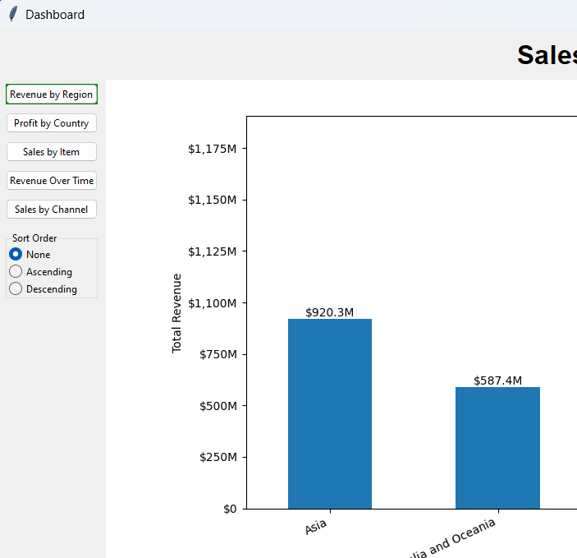

1. **Main Content Area**: Displays the chart and summary report based on the selected button.

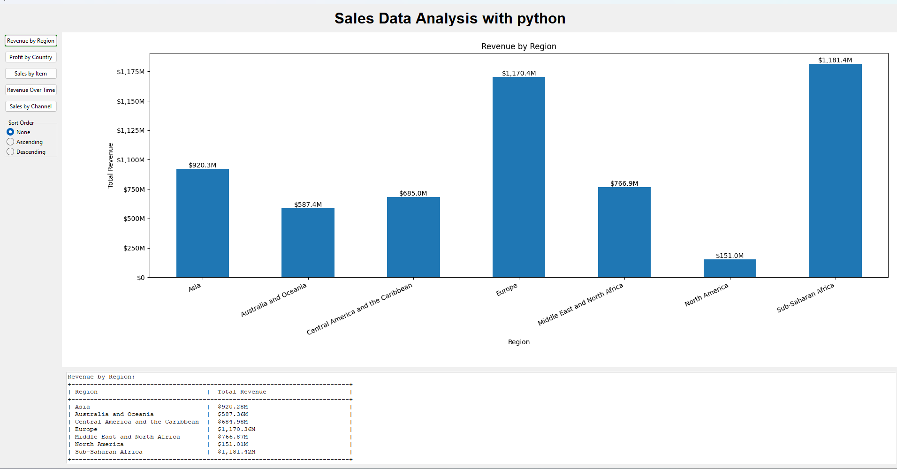

**Functionality and Visualization**

1. **Revenue by Region** (show_revenue_by_region()):
   * Displays a bar chart showing total revenue for each region.
   * Includes sorting (ascending/descending) and automatic annotation for better readability.
   * The summary report is a textual representation of total revenue by region, formatted with millions (M).

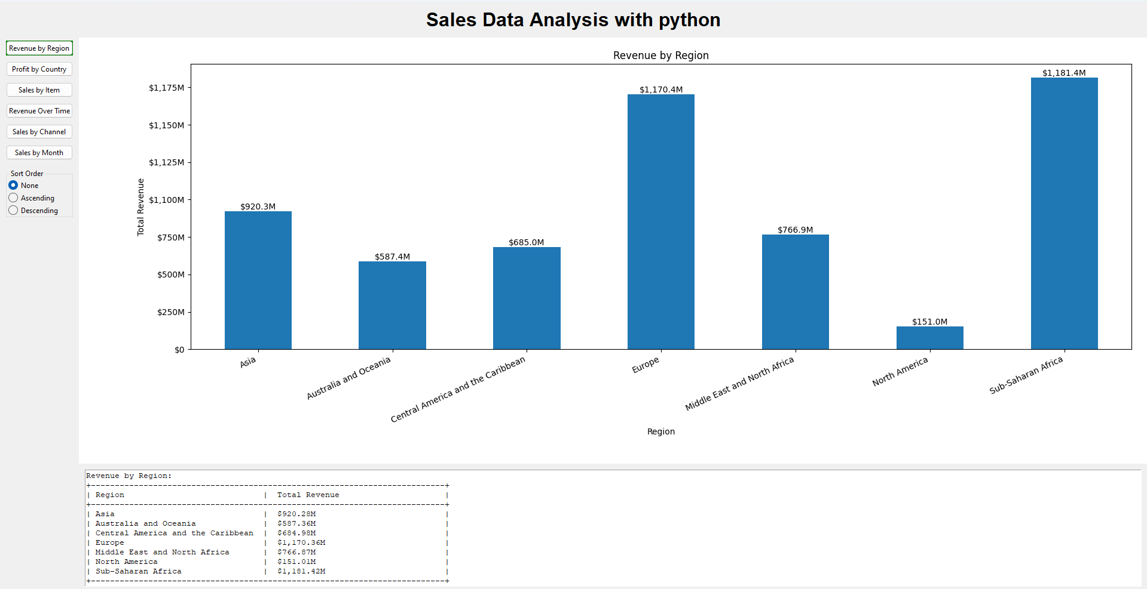

1. **Profit by Country** (show_profit_by_country()):
   * Displays a bar chart of total profit by country within a selected region.
   * Users can select a region from a dropdown menu, and the chart updates accordingly.
   * The summary report shows the profit figures in the selected region.

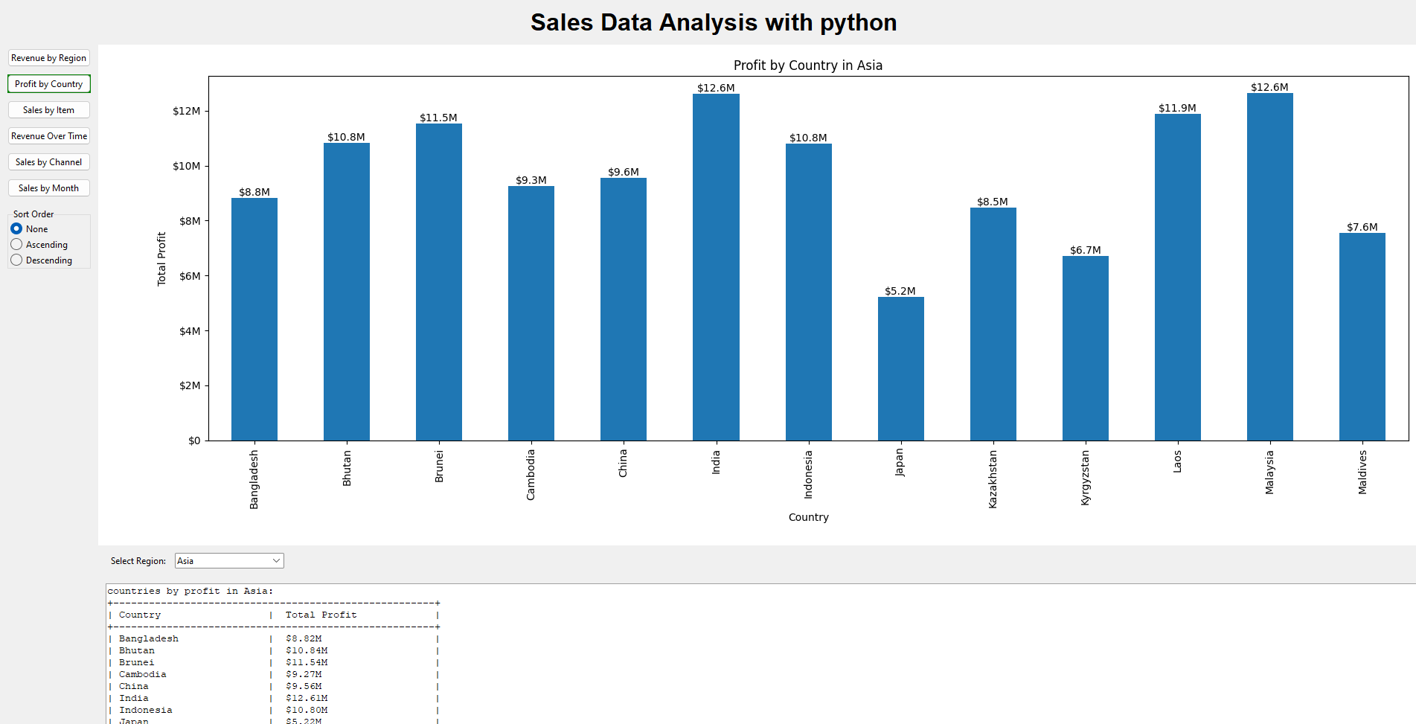

1. **Sales by Item** (show_sales_by_item()):
   * Displays a bar chart of units sold by item type.
   * Includes additional metrics in the summary: average unit price, average unit cost, and total profit for each item type.

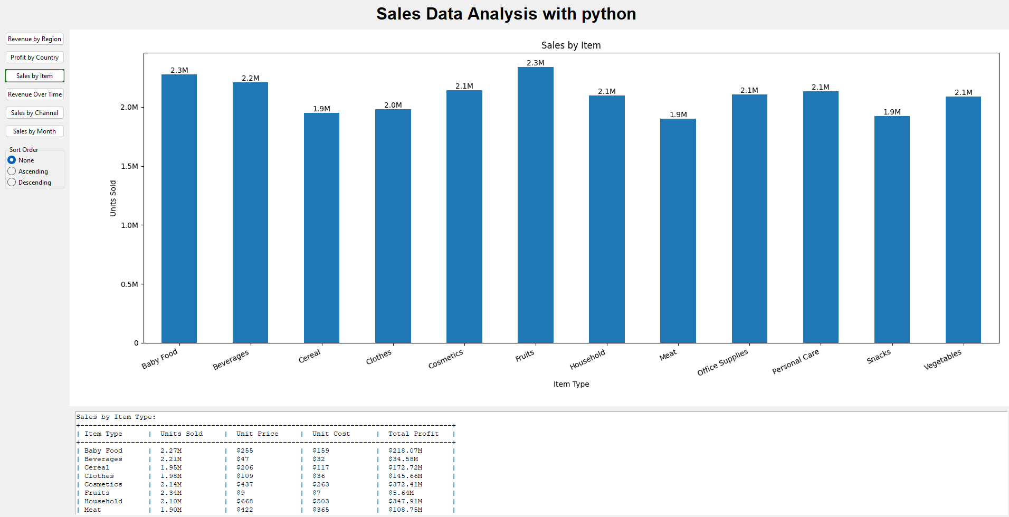

1. **Revenue Over Time** (show_sales_over_time()):
   * Displays a line chart of total revenue over time, aggregated by year.
   * The chart includes annotations for each year’s revenue.
   * The summary report shows revenue by year, with sorting options applied if selected.

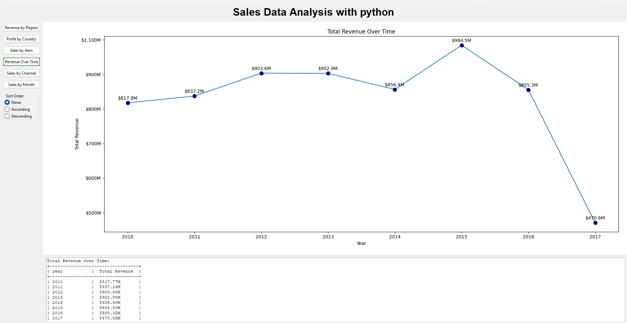

1. **Sales by Channel** (show_sales_by_channel()):
   * Displays a pie chart showing the percentage of total revenue from different sales channels (e.g., Online and Offline).
   * The summary report presents revenue figures for each channel

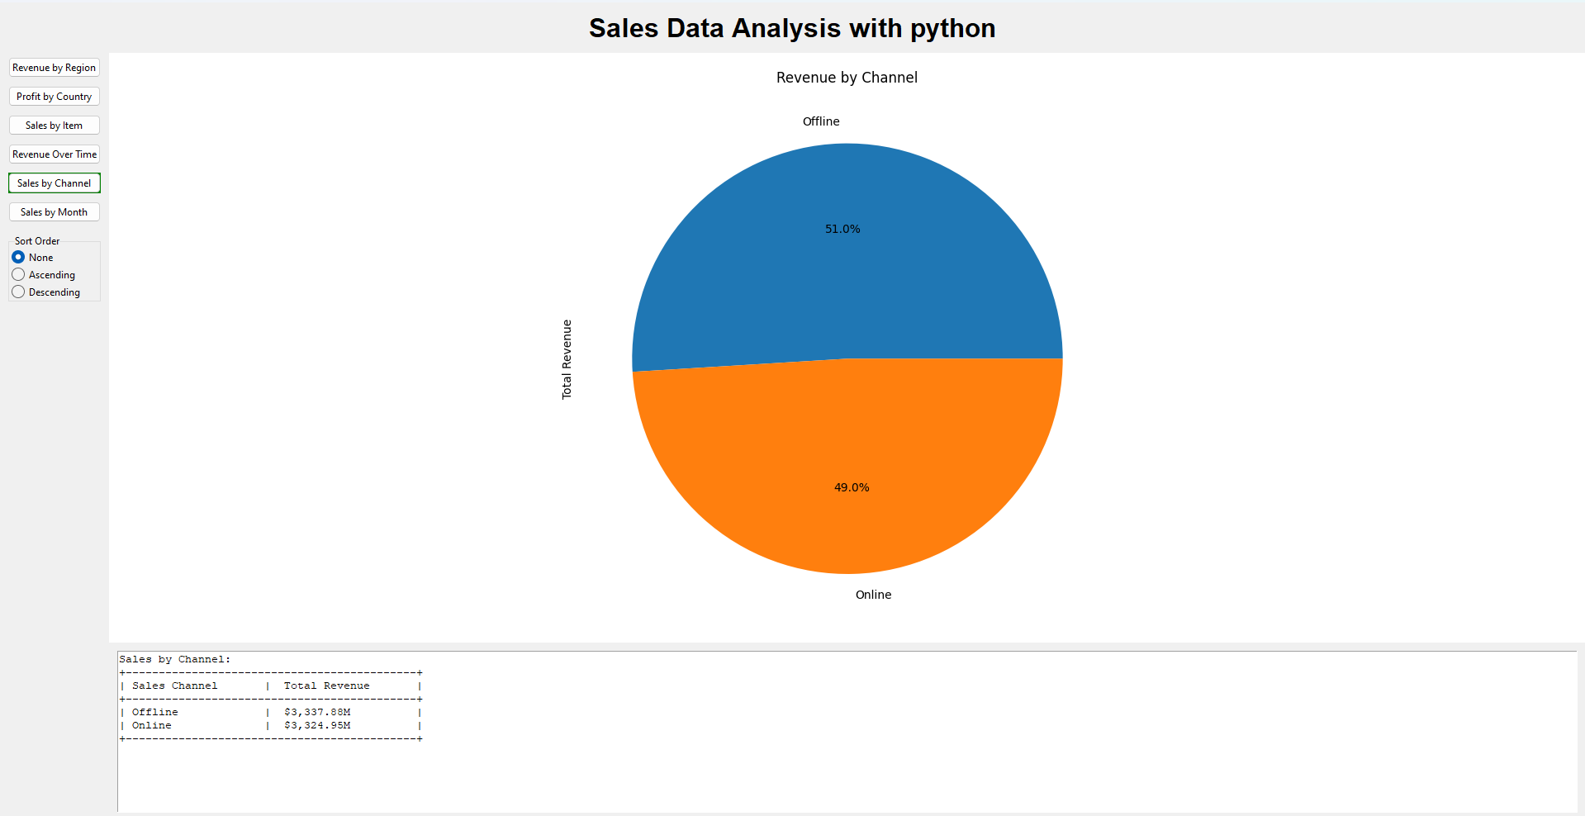

1. **Sales by month** (show_sales_by_month()):
   * This will display the line chart, showing each item type’s sales vary from month to month.
   * allowing users to observe **seasonal trends** in sales for different item types.
   * A summary table is generated, showing the average revenue values for each item type across the months. The values are formatted for easy reading.

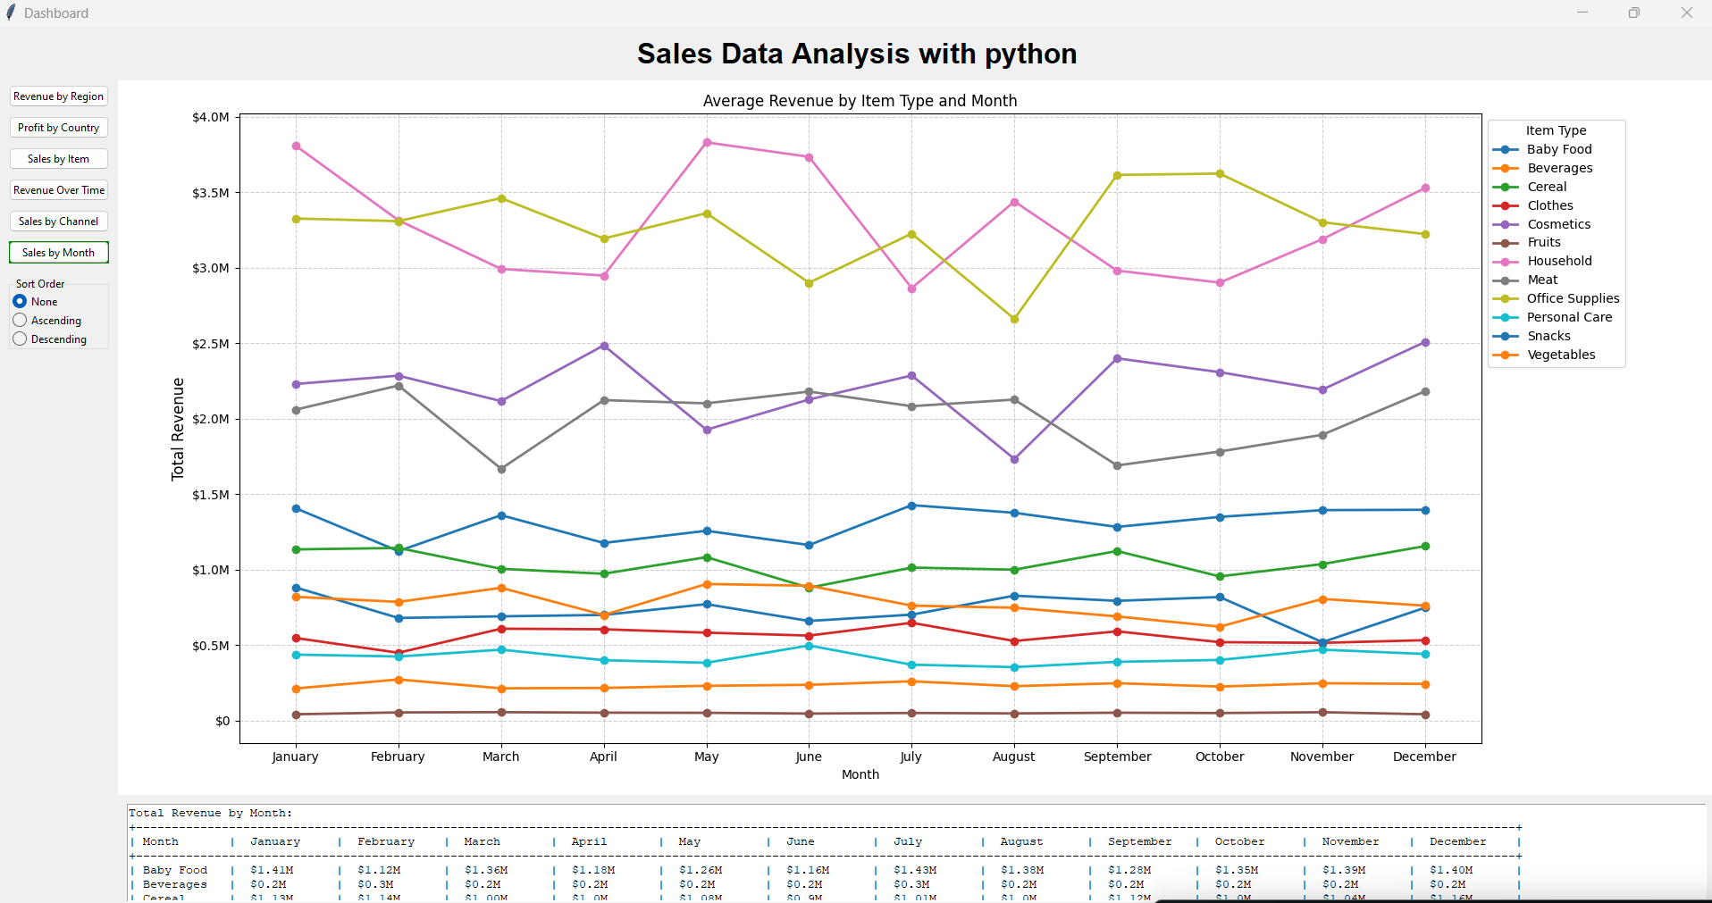

**Sorting Mechanism**

The sorting feature allows users to view data in ascending, descending, or no particular order. This functionality is controlled by the apply_sorting() and sort_with_col() methods. Depending on the sorting selection, the data is reordered before visualization and shown in the chart accordingly.

* **None**: No sorting applied (default order).
* **Ascending**: Data is sorted in increasing order.
* **Descending**: Data is sorted in decreasing order.

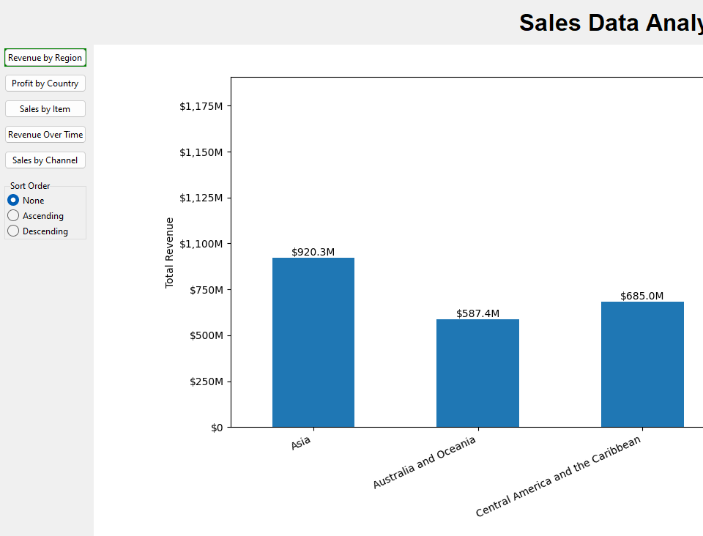

**Chart Customization**

Each chart is dynamically generated using Matplotlib, and the following features are included for better visualization:

* **Bar Chart Annotation**: Bars are annotated with values (e.g., millions) for quick reference.
* **Y-Axis Formatting**: Y-axis values are formatted in an easily readable format, such as millions (M). using mtick.FuncFormatter().
* **Interactivity**: Dropdowns (e.g., region selection) dynamically update the charts based on the user's selection.

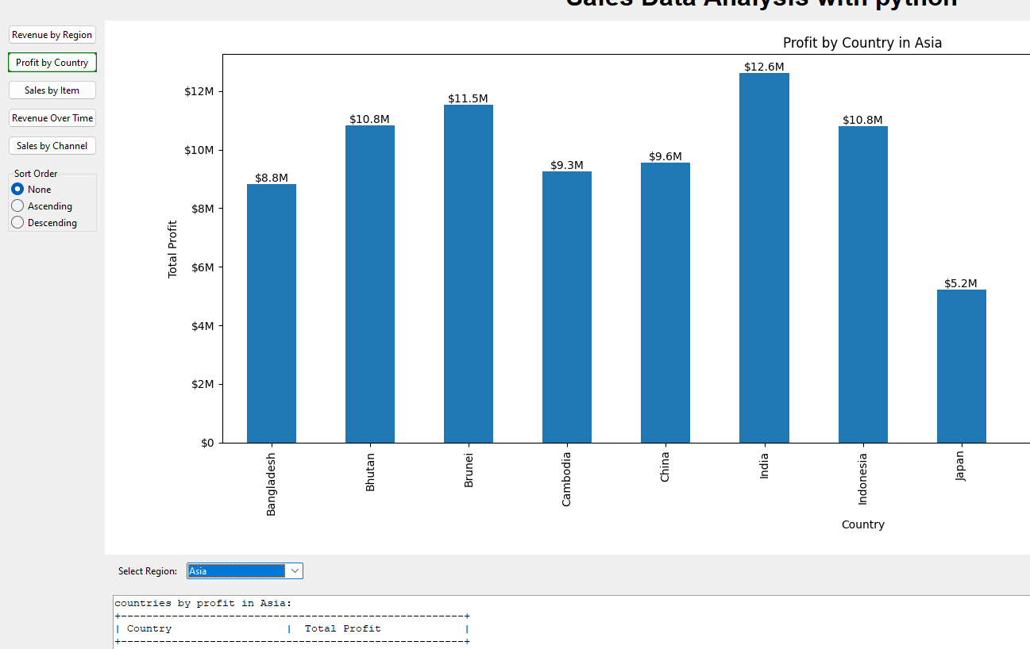

**Bar Chart Annotation**

**Y-Axis Formatting**

**Error Handling**

The application includes basic error handling in the load_data() method. If the CSV file is not found or contains invalid data, appropriate error messages are displayed. For example:

* **FileNotFoundError**: If the file 5000 Sales Records.csv is not found, an error message is printed.
* **KeyError**: If there are any missing columns they are handled gracefully.

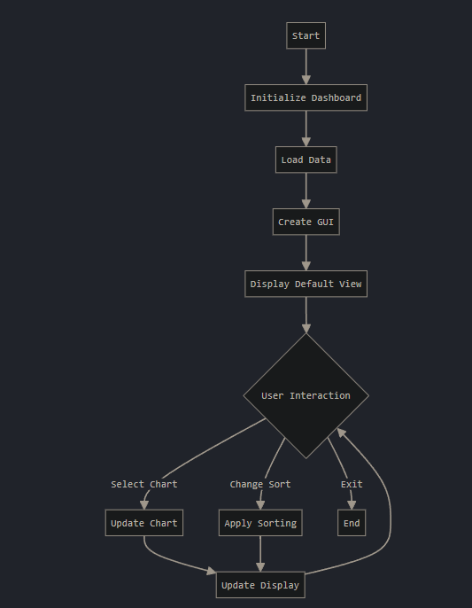

**Testing**

Testing ensures that everything works as expected.

Manual Testing:

* UI Testing: Check that all parts of the interface work properly.

Steps:

* + Run the sales_analyze.py script.
  + Make sure the window opens correctly.
  + Test loading data and using the sorting feature.
  + Check that graphs update correctly when data is changed.
  + Ensure the app doesn't crash during use.
* Data Verification: Compare the loaded data with the source to make sure it is accurate.

**Future Enhancements**

* Additional Filtering: Add more ways to filter the data, like by product type or date.
* Exporting Reports: Allow users to save the graphs and insights as PDF or Excel files.
* Improving the performance for larger datasets by implementing lazy loading or data chunking

**Project Timeline**

This project was developed over several days, with key milestones documented in the commit history on GitHub. Below is a summary of the significant updates:

* **August 26, 2024**: Initial dashboard setup.
* **August 27, 2024:** created functions and filtering methods for visualization
* **August 28, 2024**: Added summary report and clarified graph visuals.
* **August 29, 2024**: Finalize the project name and integrated data cleaning scripts.
* **August 30, 2024**: Added radio buttons for improved user interaction.
* **August 31, 2024**: Structured the summary report and added a selector field.
* **September 2, 2024**: Updated README and project requirements for documentation.

**Challenges Faced**

* **Data Cleaning:**
  + **Missing Values and Duplicates:** Cleaned data by handling missing values and removing duplicates using the load_data() function.
  + **Data Type Conversion:** Converted columns like dates and numbers to the correct format for calculations and plots.
* **Handling Large Numbers:**
  + **Formatting:** Created add_BM() to format large numbers, displaying millions as 1M and billions as 1B.
* **UI Layout and Chart Display:**
  + **Chart Layout:** Used pack() and grid() in Tkinter to fit charts properly without overlap.
  + **Embedding Matplotlib:** Integrated Matplotlib charts into Tkinter using FigureCanvasTkAgg, ensuring smooth updates and rendering.
* **Sorting and Interactivity:**
  + **Sorting Options:** Managed sorting (ascending/descending) for different visualizations without breaking the display.
  + **Updating Views:** Built update_current_view() and update_chart() to refresh the charts smoothly when the user interacts with the app.
* **Month-Based Data Grouping:**
  + **Month Order:** Used pd.Categorical to ensure months appear in the correct order (January to December) when grouping data by month.
  + **Multi-level Grouping:** Used groupby() and unstack() to structure data for grouping by both Item Type and Month, ensuring correct plotting.

**Execution**

**1. Clone the Repository:**

First, clone the repository from GitHub to your local machine:

Copy and paste this in cmd:

|  |  |
| --- | --- |
| $  $ | git clone https://github.com/ravish0409/datafactz-project.git  cd datafactz-project |

**2. Set Up a Virtual Environment (Optional but Recommended):**

Setting up a virtual environment helps manage dependencies and avoid conflicts with other projects.

|  |  |
| --- | --- |
| $  $ | python -m venv venv  venv\Scripts\activate |

**3. Install Dependencies:**

Once the environment is active, install the required dependencies listed in the requirements.txt file:

|  |  |
| --- | --- |
| $ | pip install -r requirements.txt |

**4. Run the Project:**

After installing the dependencies, you can launch the dashboard by running the sales_analyze.py script:

|  |  |
| --- | --- |
| $ | python sales_analyze.py |