# git clone

<https://github.com/shubhamkushwah123/war-test>

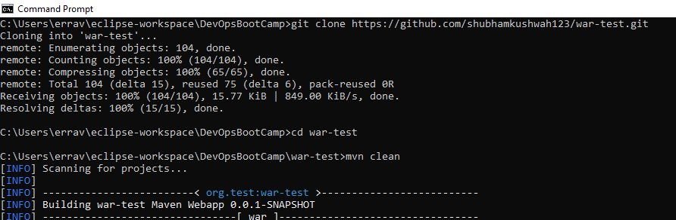

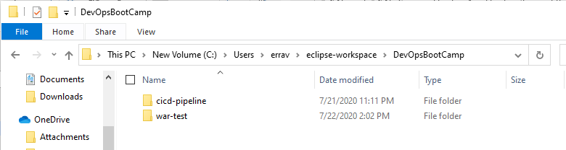

# mvn package

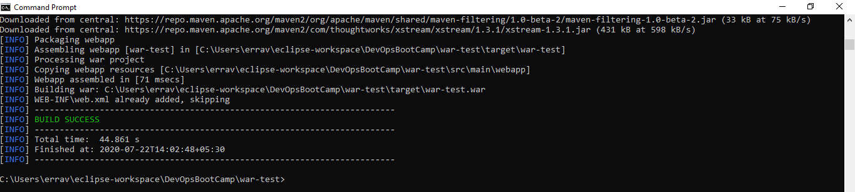

# docker –version

# docker ps

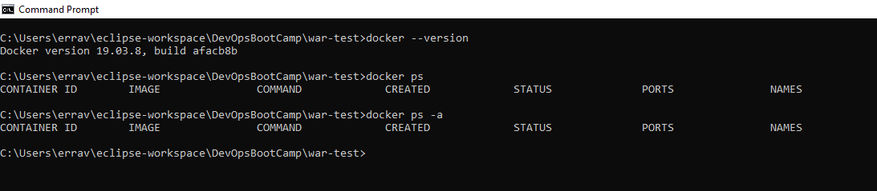

# docker build

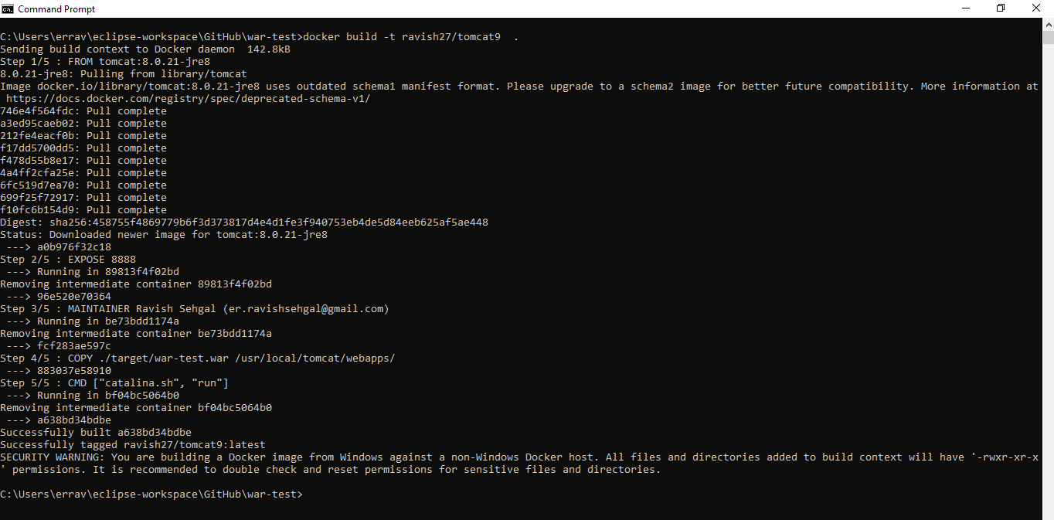

# docker images

# docker login

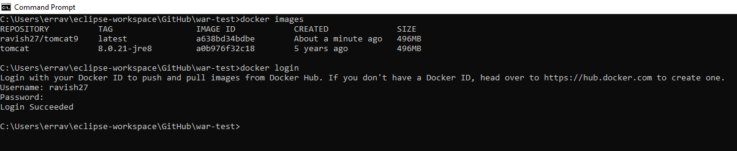

# Docker push

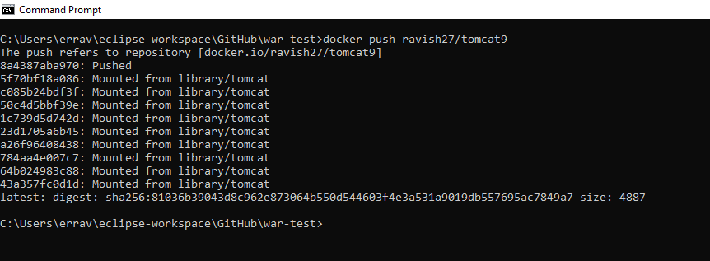

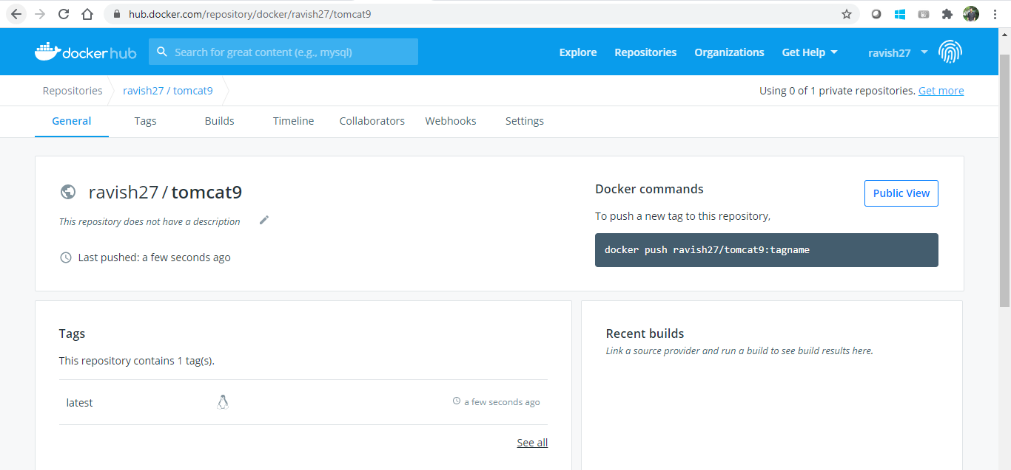

# Run container

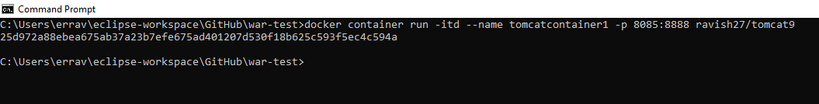

# Check deployment files on container

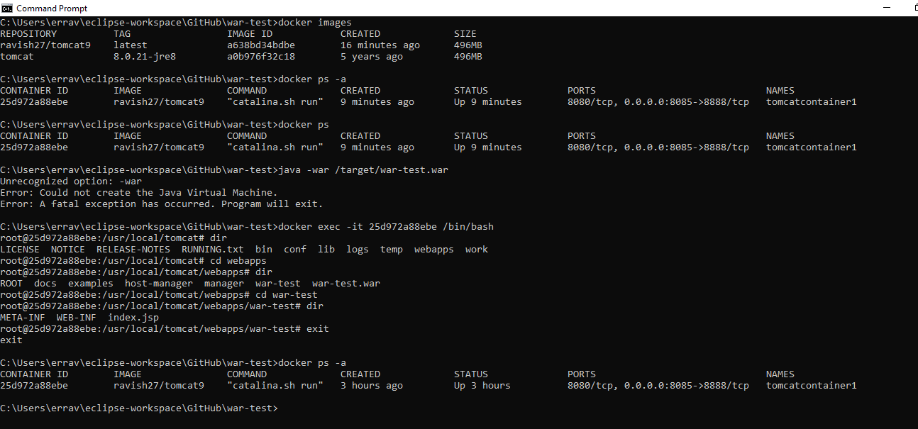

# docker compose validate

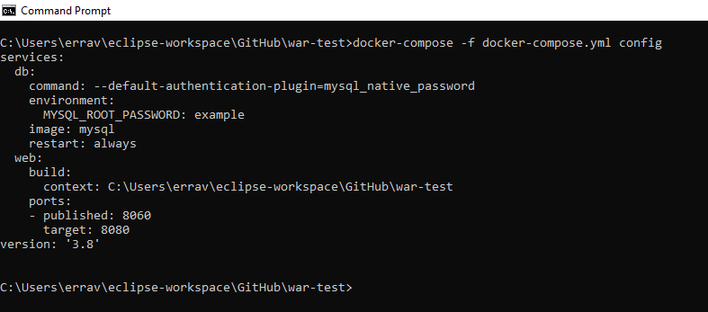

# docker compose up

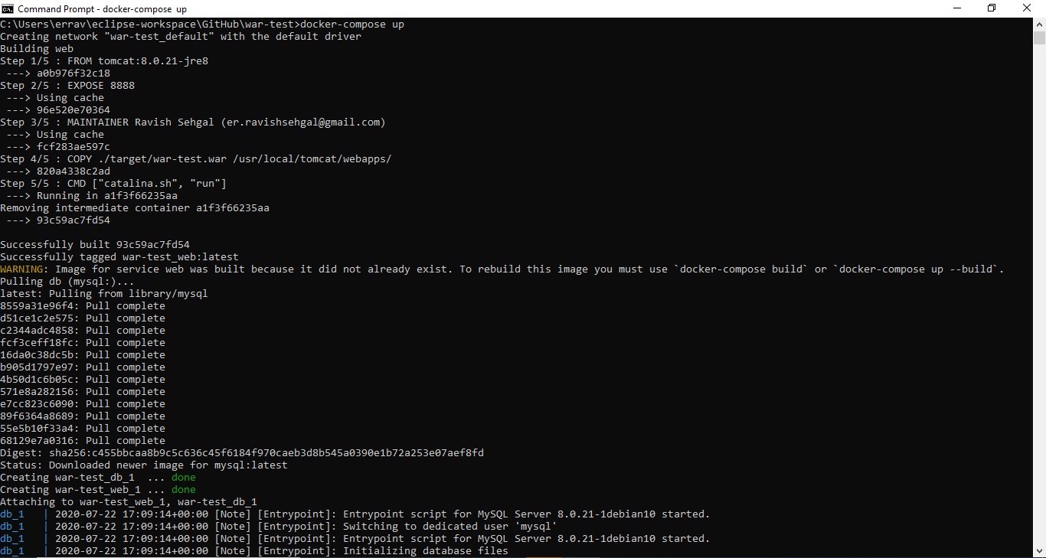

# Check web container is running

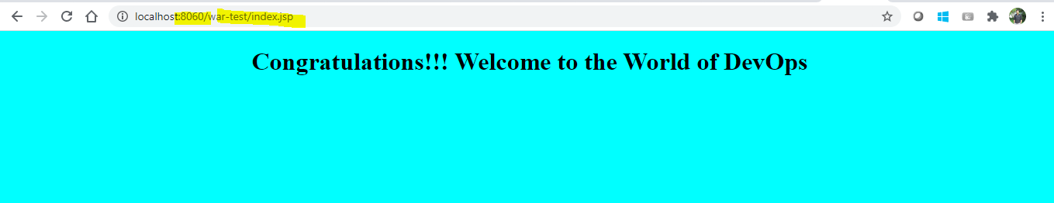

# docker ps -a

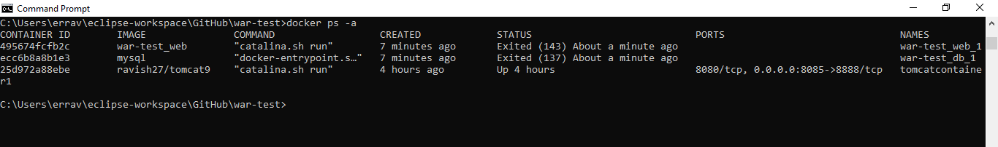

# Git repo url with all files and screen shots

<https://github.com/ravish27/war-test>