Patel, Ravish

12/04/2016

Assignment 2

Secure Programming

**Assignment-2**

Application is running on Amazon EC2 instance :

ec2-35-164-188-52.us-west-2.compute.amazonaws.com

I have used MongoDB as my database.

I have implemented two static analysis tools: **rats** and **flawfinder**

Some of the snippets are attached below:

**Login page**

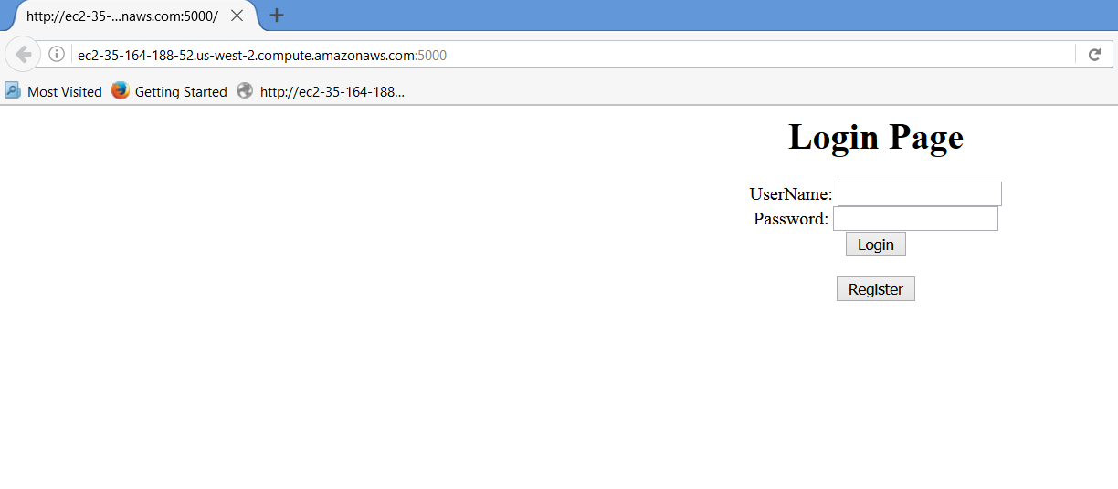

Application is running on Amazon EC2 instance :

ec2-35-164-188-52.us-west-2.compute.amazonaws.com

**Signup Page**

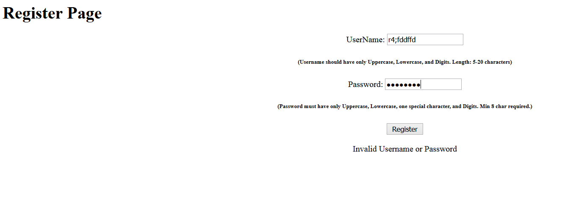

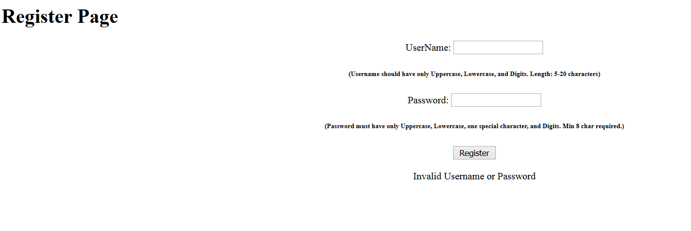

**User Already registered Error**

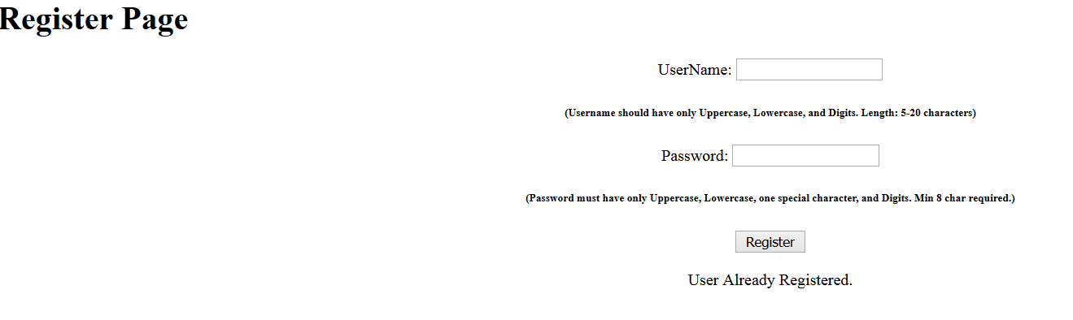

Invalid Username or Password

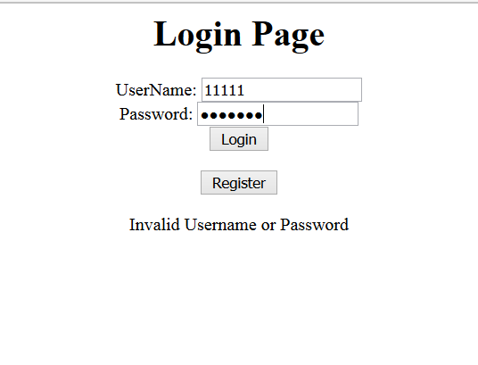

Invalid file type:

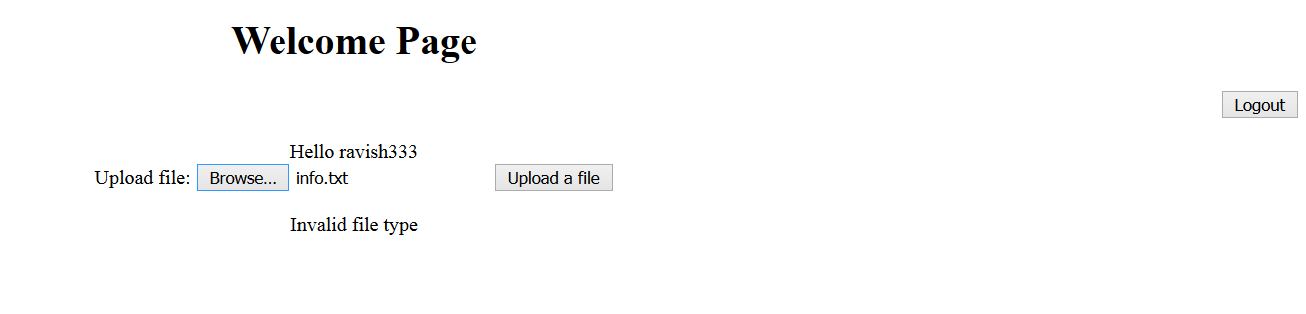

Output for a valid file

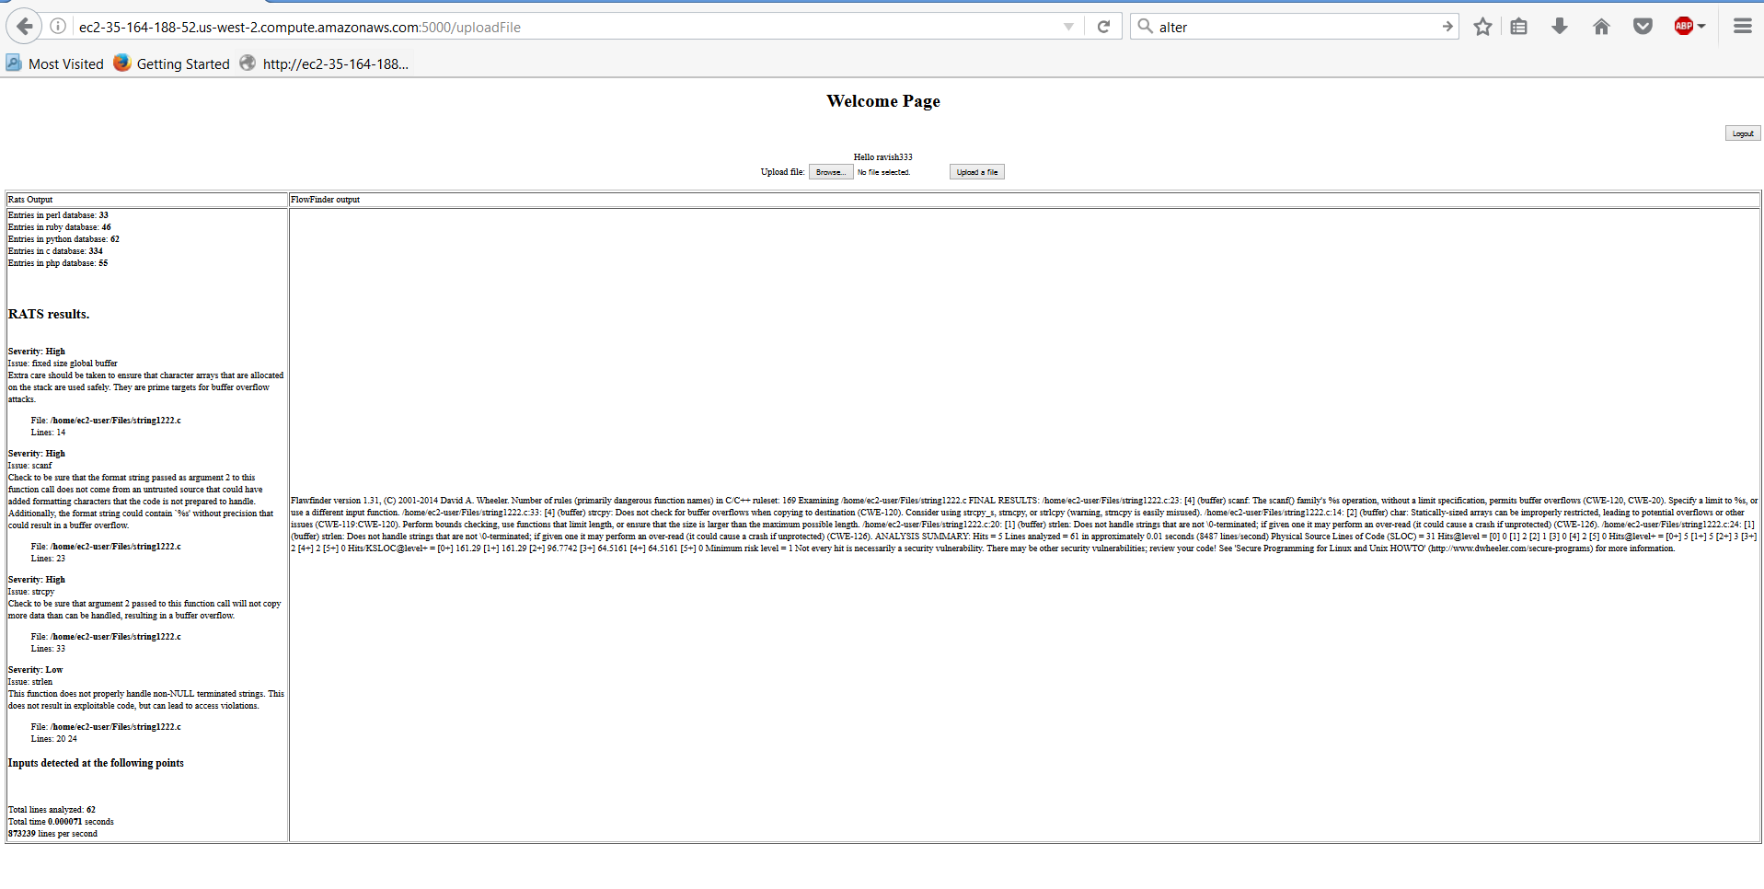

Console that receives various http requests:-

