**Chapter 3**

**Software Design**

* 1. **Software Design:**

**Data Flow Diagrams :**

**Level 0 DFD:**

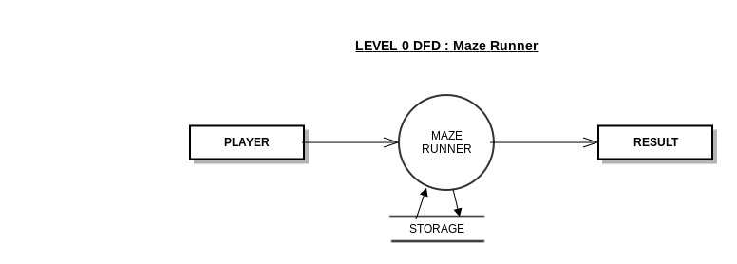

Fig 1: level 0 DFD

**Level 1 DFD:**

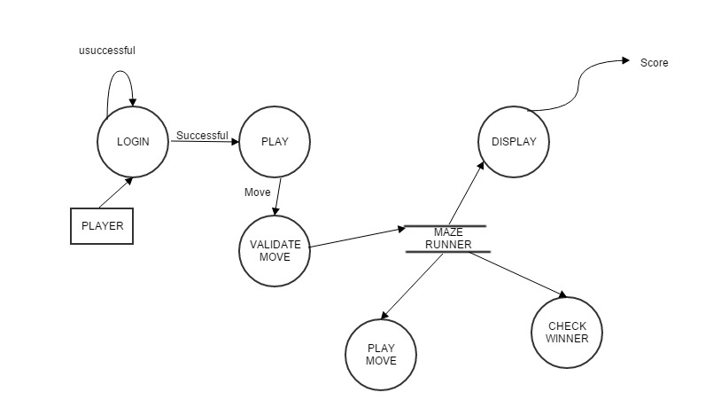

Fig 2: level 1 DFD

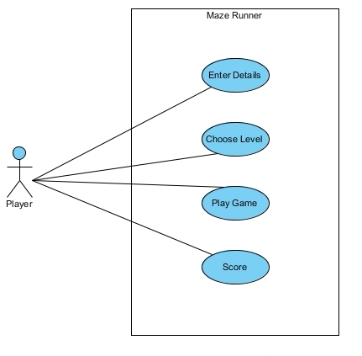**Use Case Diagrams:**

Fig 3: Use Case Diagram for The Maze Runner Game

**ER Diagram:**

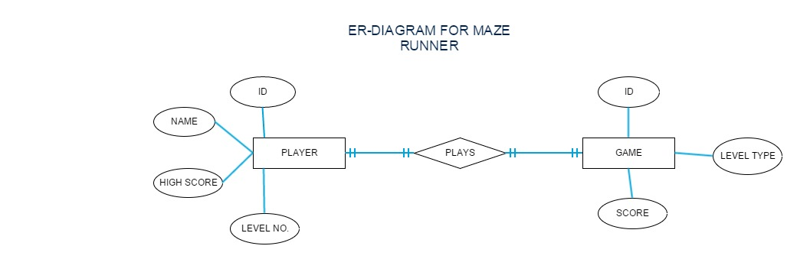

Fig 4: ER Diagram for Maze Runner