**Chapter 5**

**Implementation and User Interface**

**Front Page:**

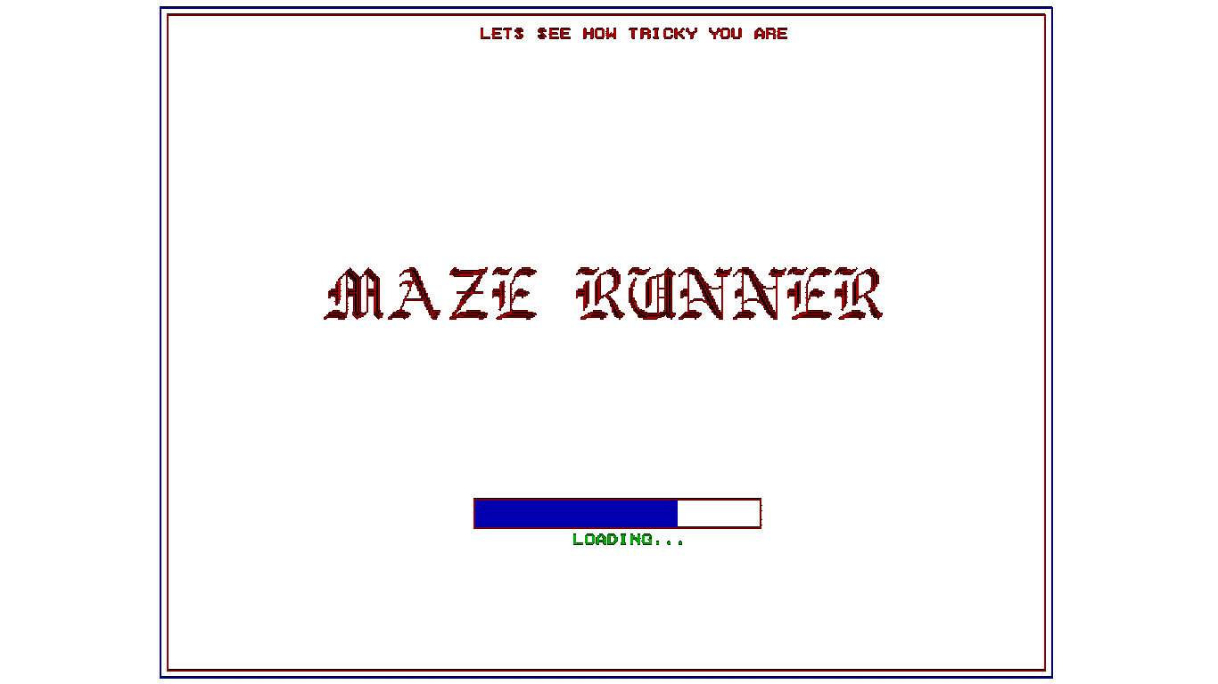

Fig 5: Front Page

**Login Page:**

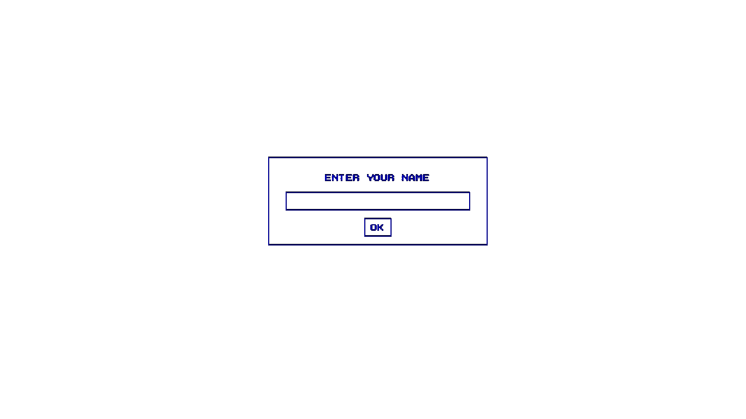

Fig 6: Login Page

**Level Selection Page:**

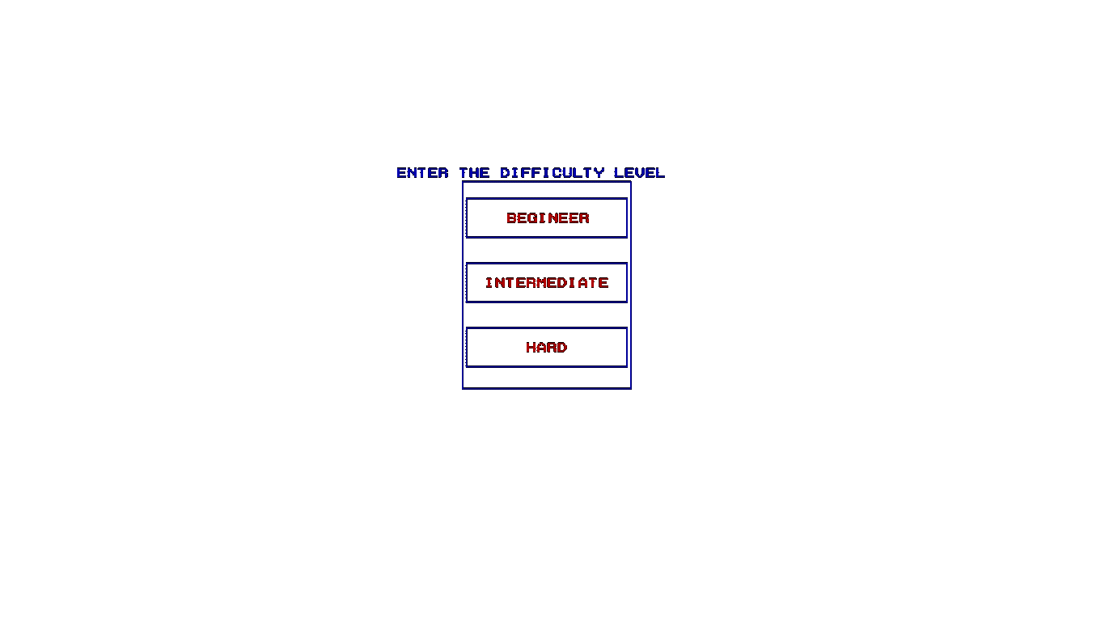

Fig 7: Difficulty Level Page

**Level 1:**

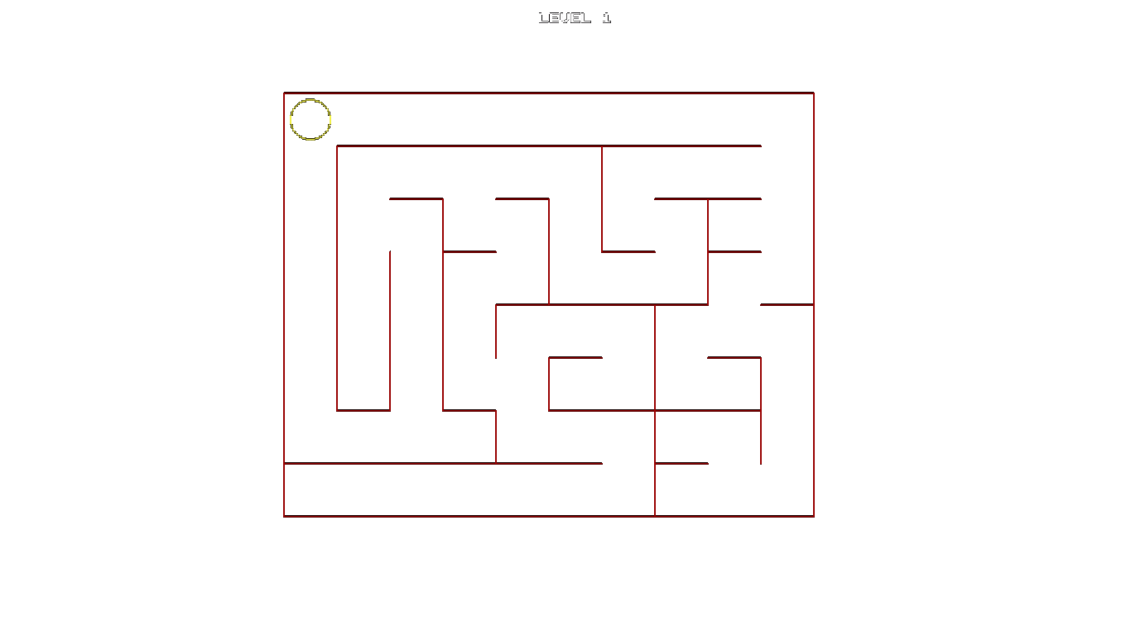

Fig 8: level 1

**Level 2:**

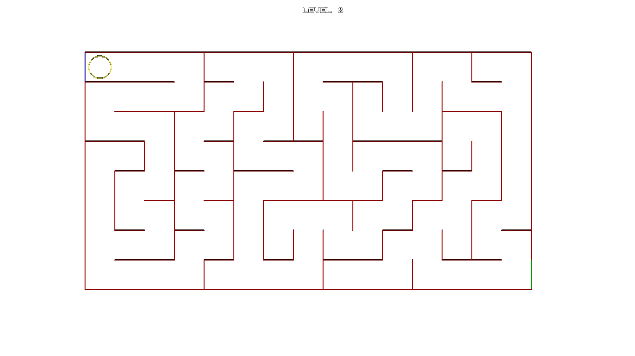

Fig 9: level 2

**Level 3:**

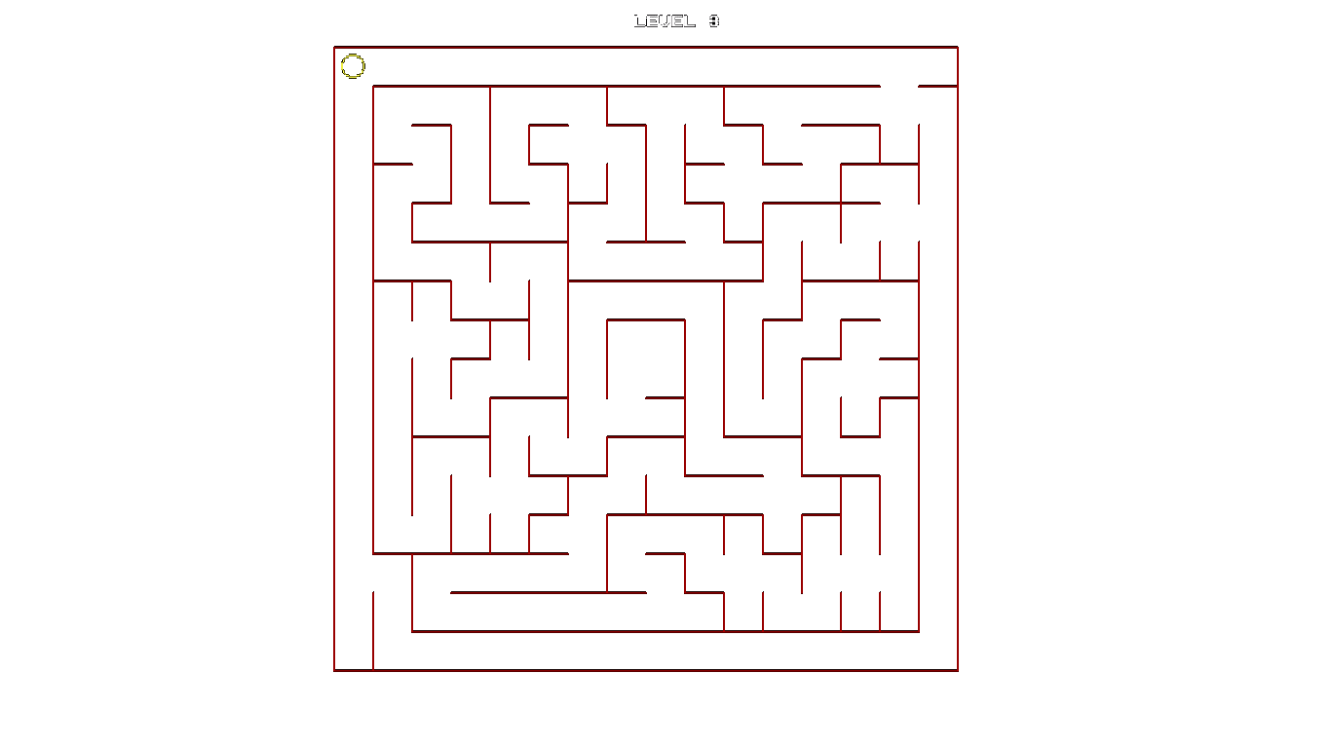

Fig 10: level 3

**You Won:**



Fig 11: You Won