**Setting up Auth Server – Spring OAuth2 and JWT**

1. **Create project –**

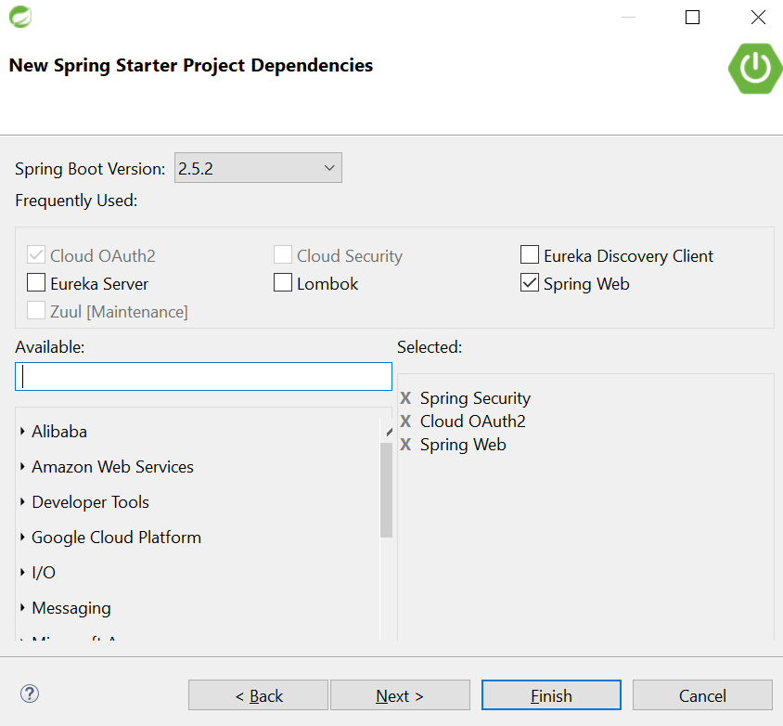

**And Additional Maven Dependency :**