**Setting up Eureka**

1. Go to <https://start.spring.io/> or Navigate to STS (Spring Tool Suite): STS > File > Spring Starter Project

Showing Example from STG:

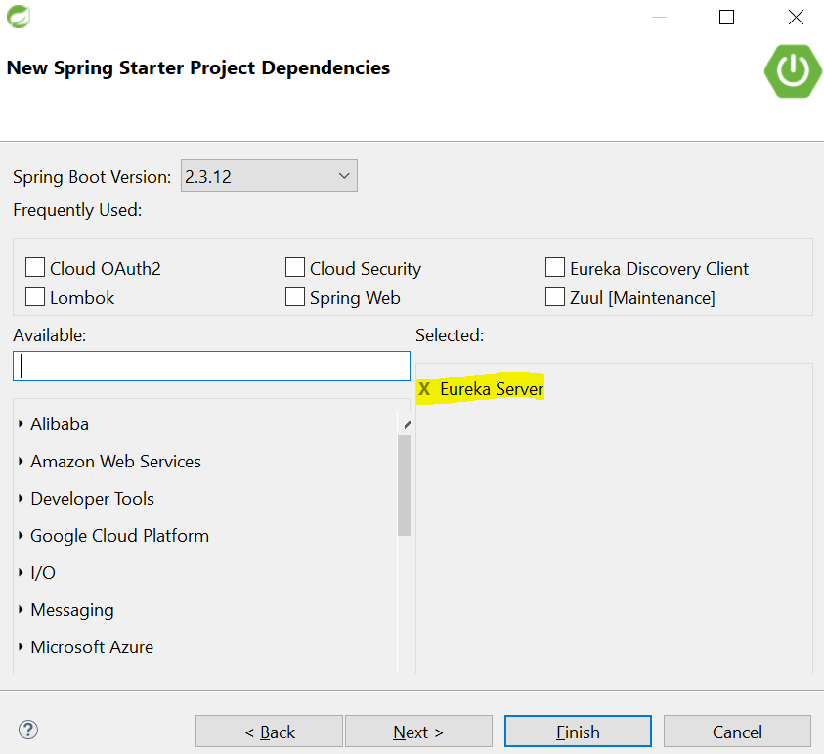

1. Add the Dependencies as shown above.
2. Project will be download within the STS

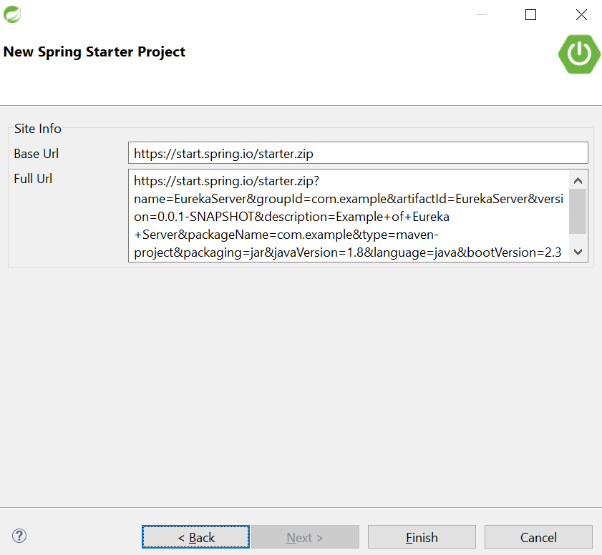

1. Go to application.properties and add app name-

spring.application.name=eureka-server

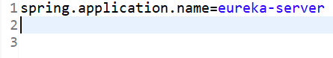

1. Create application.yml and add below –

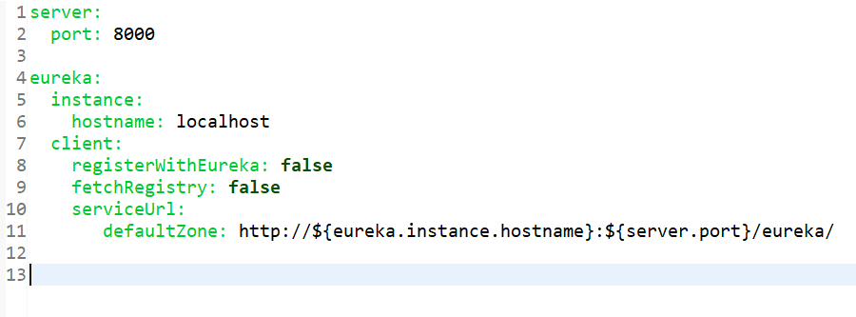

1. Add the annotation @EnableEurekaServer to main class as shown below, this will make this ass as Eureka Server.

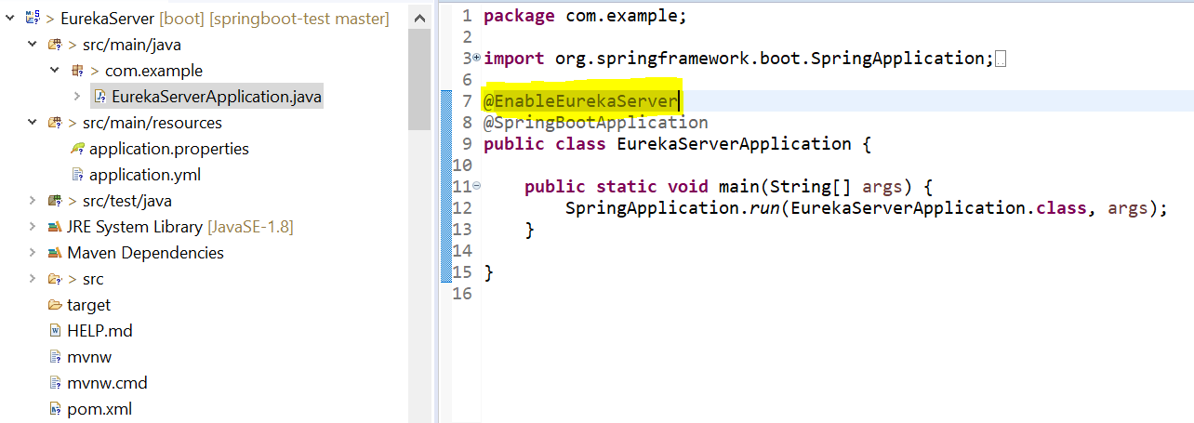

1. Eureka is now set up.
2. Go to <http://localhost:8000/>
3. This will load the Eureka Registry Dashboard-

