**Setting up Zuul**

1. Go to <https://start.spring.io/> or Navigate to STS (Spring Tool Suite): STS > File > Spring Starter Project

Showing Example from STG:

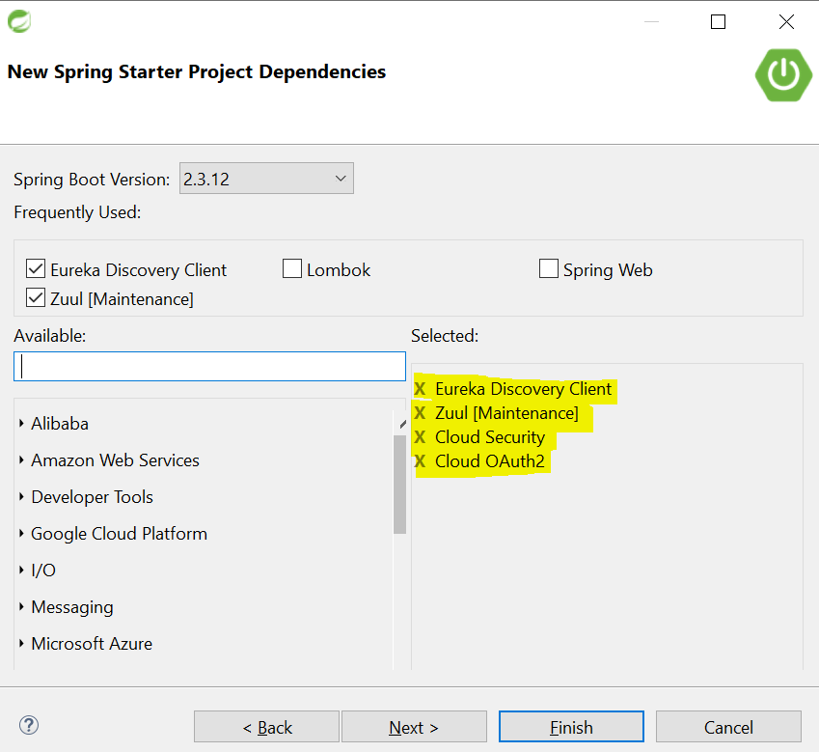

1. Add the Dependencies as shown above.
2. Project will be download within the STS

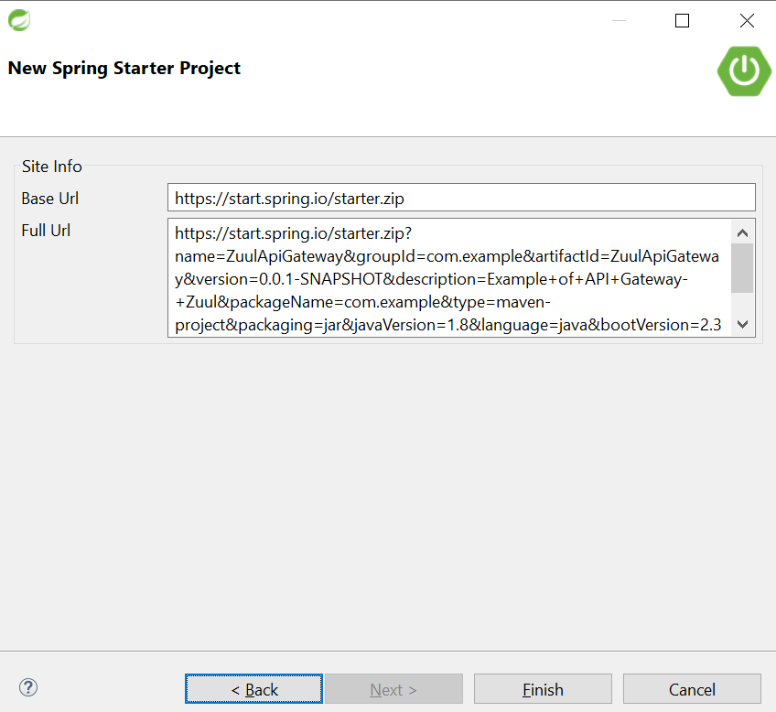

4.